**Avalanche**

I’d read all about it, and I’d even taken a course on it, but to experience it was to really come to know it. I'm talking about an avalanche.

Saturday December 12, 2009 just before noon my friend Lucy and I were about 4 to 4.5 miles into our climb of Lightning Peak. We had started at the Telford Ranch, wander a mile or so west to the Great Western trail, and had followed that trial south for 3.5 miles where we turned east on to the Windy Pass trail, see picture 3 below. We had been in snow the whole time, and by this time more of it was falling steadily. We’d put our snowshoes on about a quarter of a mile before we left the Great Western trail.

The Windy Pass trail travels across the north face of Lightning Peak gaining about 1400 vertical feet in two miles as it reaches the pass at 8900 feet. Even at 7500 feet we noticed the snow pack was cracking around our snowshoes. Nevertheless, and in spite of ascending on a North face I still felt very safe as the trail passes through large densely populated pine trees and runs along the base of vertical rock buttresses usually too steep to hold snow. Also, the storm we were out in had just begun and was only the second storm of any significance so far this season, so the snow pack wasn’t typical much deeper than a foot and a half.

As we approached somewhere near 8,000 feet, I pulled out ahead of Lucy as the trail approached a place where it crosses an obvious avalanche chute. My immediate concern was that a natural avalanche could easily come down from above what appeared to be a summer waterfall (a buttress above 12 feet high to the south of the trail), see pictures 1 and 2. For a second I even thought I should wait for Lucy before attempting to cross the chute but instead I donned my goggles and took a step forward. No sooner had I taken that step then I heard the infamous “whumph” which sounded a lot like a gun shot. I wasn't shocked, I didn't panic, and I was acutely aware of what was happening.

The first thing I did was yell out something about having triggered an avalanche, and in a split second I instinctively did a quick 180 degree turn away from the avalanche chute where I figured the main flow would go. As I turned and as the snow began to slide I yelled out “here it comes” and the next thing I knew my snowshoes were buried and I felt like they were dragging me down into the sliding snow.

I felt powerless as I tried unsuccessfully to lift my feet above the snow in an effort to get out of the slide path. Realizing that I was stuck and feeling like I was would soon be swept away I looked around for something to grab on to and I spotted some willows to my right which I dove for as the slide was about to knock me down. Immediately I was sliding and the snow began to cover me. Quickly I reached out and grabbed the willows, and a moment later the slide stopped. I was face down with snow all around but surprisingly the snow remained soft and I was able to easily stand up.

Once back on my feet I noticed I had been transported only about five feet and that the slab had broken out about 30 feet above me with a width of about 15 - 20 feet. The slab had initiated on a steeper, estimated 45 degree, section below the waterfall buttress and had crossed a lower angle slope to where I had stood, see pictures 1 and 2.

I took a quick inventory of myself finding nothing more wrong than a pain in my right knee which must have hit a rock. For several minutes I just stood there waiting for Lucy and thinking about which way I should go, with the pressing thought that the snow might slide again. Eventually Lucy arrived, and I walked over to her as she asked me what had happened. She said she had heard me yell "here it comes" and had seen a dust cloud, but that it really hadn't registered as anything to concern her. I pointed out the fractures and debris above, and told her about the ride I’d taken.

I'm actually glad for the experience because it didn't have a catastrophic outcome, and it was a really great learning experience. Nothing could have better supplemented all the studying of avalanches I had done then to have experienced a minor one in person. The encounter didn't shake me up, but it did wake me up to the real dangers of avalanches, and how easily and quickly they happen and to how powerless a victim is to the massive force. In spite of it, I was willing to continue on to our Windy pass destination, but after a second thought, as I stepped back onto the avalanche path, I realized it was time to head back home.

I really didn't think the level of snow was enough to cause deep slab failure, and that is one of the reasons why I had ignored earlier warning signs and had been willing to cross a north aspect. I was also overly excited about the new snow and was a little too eager to enjoy it. I'm very glad I was in the lead, and the one caught rather than my friend Lucy who is new to the backcountry and who was trusting me to keep us both safe. Most of all I was lucky that this avalanche was only a minor one.

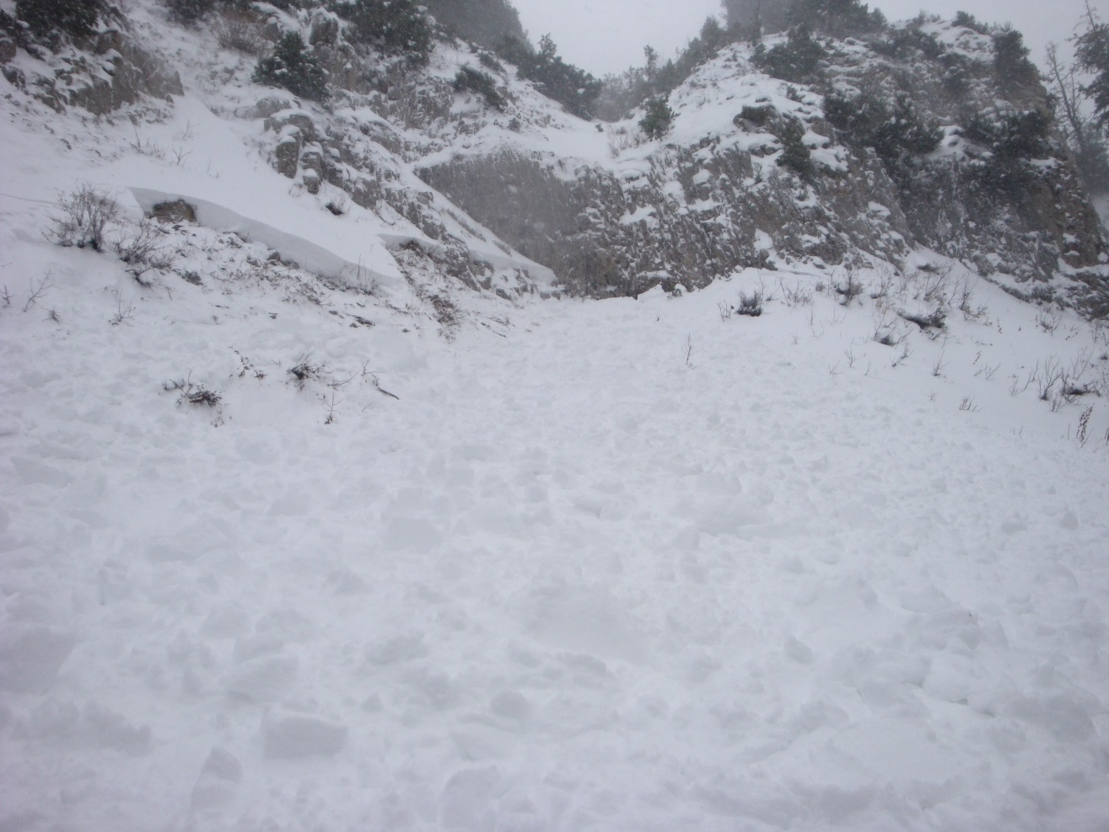

1. Looking south from the spot I was carrier to by the avalanche. The summer waterfall is clearly visible.

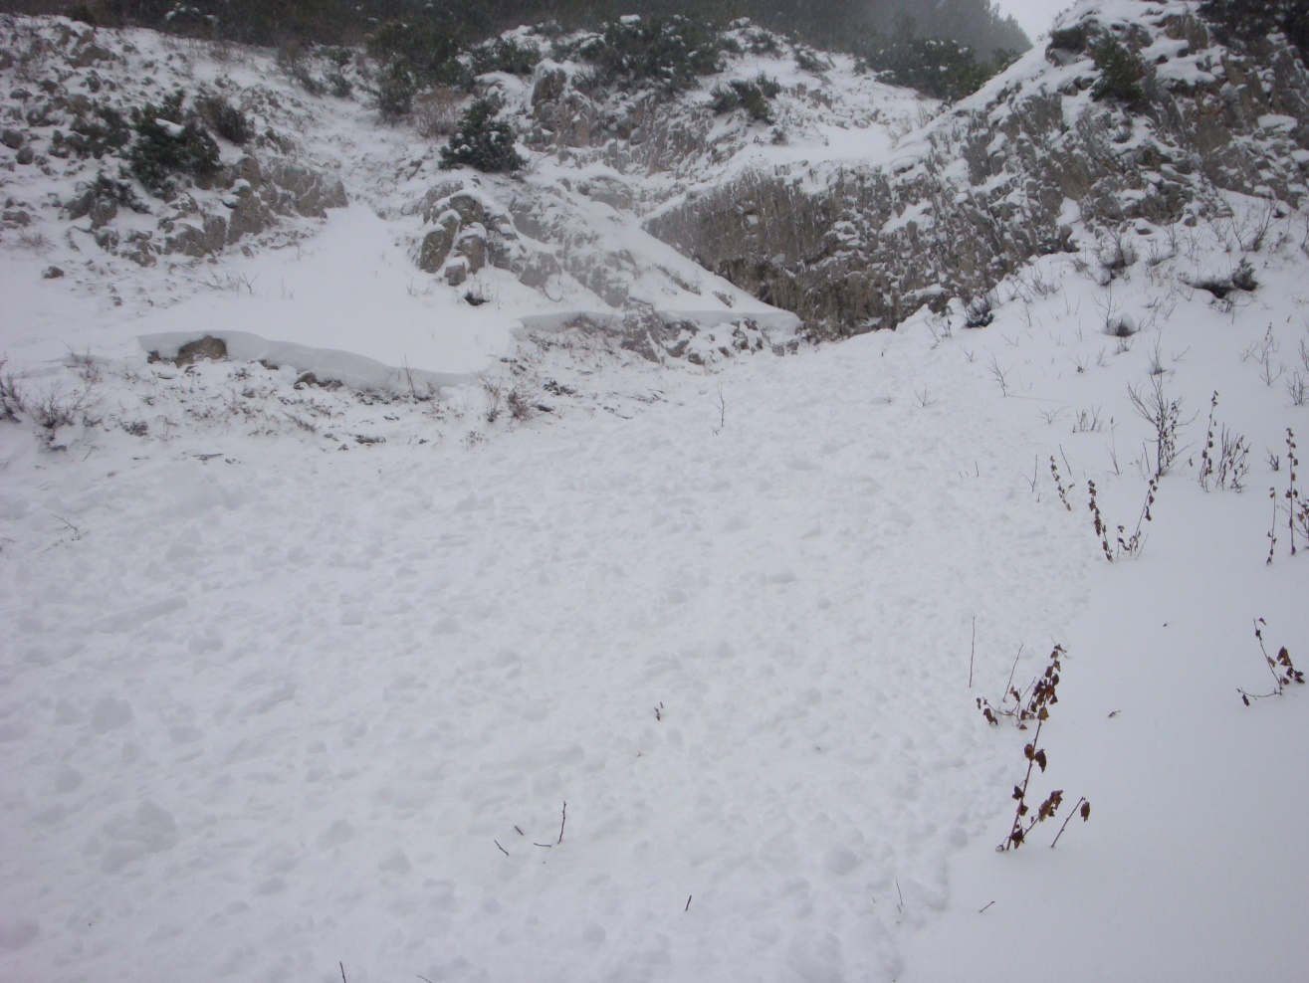

2. Having walked to the west edge of the slide I looked back and took this picture.

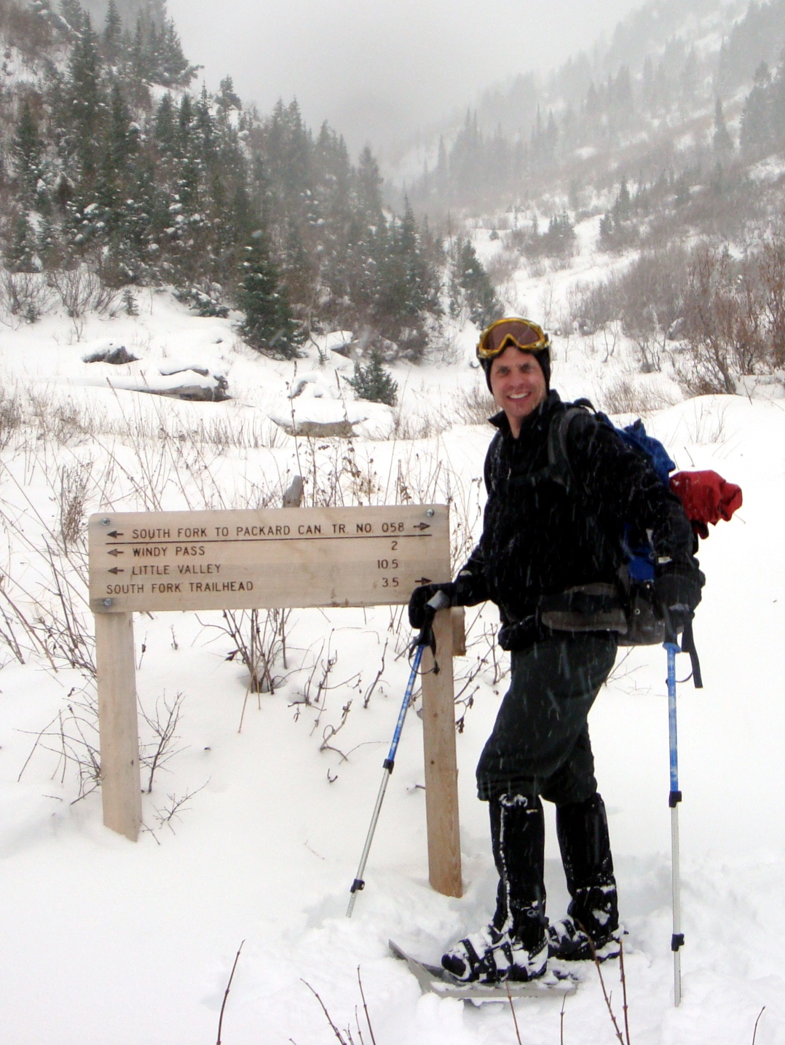

3. Leaving the GW Trail en route to Windy Pass. This picture shows how little snow there was.