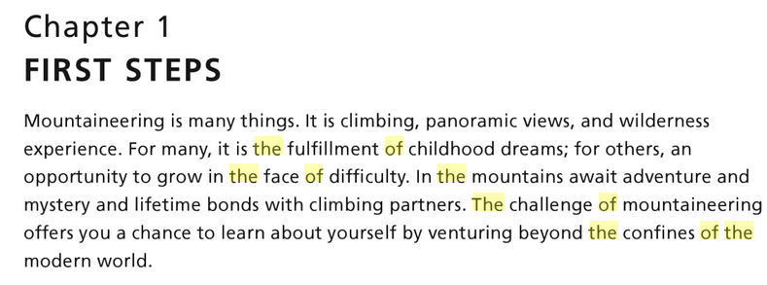

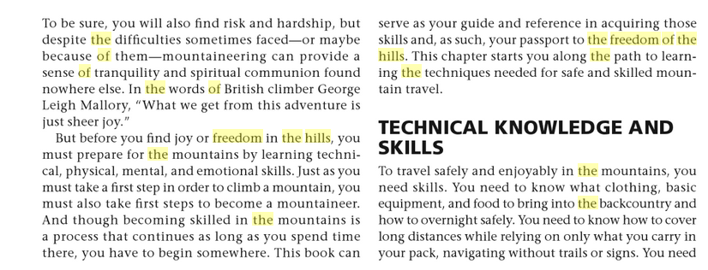

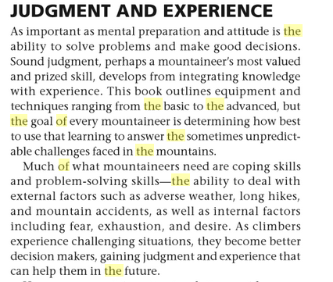

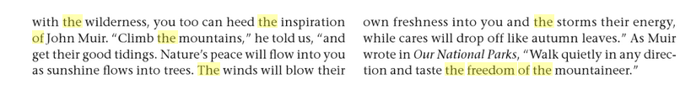

**My Journey to the Highest Point In Each of the US States**

**What is highpointing?**

By definition highpointing is the pursuit of reaching the tallest point within a specific area. However in practice it is many things – its traveling, exploring, mountain climbing, hiking, fulfillment, planning, exercise, sightseeing, self-discover, and much more.

My pursuit of visiting the highest point in each of the 50 US States is just one example of highpointing. Another example is reaching the top of the tallest mountain on each continent, dubbed the Seven Summits. Comparably, one might choose to reach the highest point of each county in his home state, or whatever region and subdivision he is interested in.

In the late 1980’s a fellow named Jack Longacre fathered the “Highpointers Club” consisting of people with the common interest of attaining the highpoint of each of the 50 US states. By the turn of the century his club had grown to over 2000 members.

Nevertheless, Mr. Longacre didn’t start the pursuit of highpointing. Apparently as far back as 1909 National Geographic did an article entitled "The Highest Point in Each State" relating to US state highpoint, and according to Wikipedia, “The first person to successfully climb each U.S. state highpoint was A.H. Marshall, who completed the task in July, 1936, when there were only 48 states.” Jack Longacre became the seventh person to achieve standing on the summits of all 50 US states.

The continental United States is 2,800 miles wide (from west to east) and 1,582 miles tall (from north to south). Plus, it is close to 2100 miles from my home town of Orem Utah to Anchorage AK, and around 2800 miles from Orem to Hawaii. As such, a lot of miles have to be covered in pursuit of reaching the highest point in each of the 50 US states, and typically it takes many years to cover all these miles and as such a relatively few number of people have reached the highest point of each of the 50 US States. From information on the Highpointers club’s website, I estimate that as of September, 2019 likely under 350 people have successfully reached the top of each U.S. state. [Footnote -The number I found on the High Pointers website is from 7/22/2018 and for that date it states 305 have obtained the highest point of each US State.] Also, it seems that on average under 25 people per year reach their 50th (final) US State Highpoint.

**About the US state Highpoints**

The US state highpoints range from landmarks as low as 345 feet to mountains as tall as 20,320 feet. Some highpoints can be driven to, requiring little or no walking effort, whereas others take skilled mountain climbers’ days or even weeks to scale on foot.

Too often people incorrectly equate the effort of reaching one highpoint to that of reaching another; unconsciously assuming that since all are highpoints all amount to equal effort. However, with the highpoints having such a wide range of geographical makeup there are many factors which influence their individual difficulty.

Traits such as prominence, isolation, type of terrain, vertical gain, weather, distance from a road, and natural dangers all influence the struggle (or lack of struggle) of reaching a highpoint. Likewise factors such as personal fitness, experience level, sensitivity to altitude, preparation, risk tolerance, time available, gear required, team size/dynamics, and mental clarity, just to name a few, also influence difficulty.  As such difficulty/effort rankings tend to be (and rightly so) mostly a matter of opinion, and personal experience.

One highpointer might avoid walking when a driving option is available, use guides to lead him up the most challenging summits, and/or only venture out in fair weather. Whereas another might tackle highpoints solo or only during winter months, and avoid driving in favor of hiking.

Adding to the confusion, the Highpointers Club offers no hard and fast rules for obtaining a highpoint indorsing “any route to the top” be it by horse, automobile, foot, helicopter, or what have you – leaving the means of ascent to personal choice.

Furthermore, one might also incorrectly assume that a list of the 50 US state highpoints ordered by elevation would suffice as a list of difficulty. Unfortunately, that too falls short. For example, Mt Marcy of New York stands shorter than Nebraska’s Panorama Point with the latter being nothing more than a spot on a prairie requiring no uphill walking and the former being a mountain rising over 3000 feet from the trailhead.

**About me**

I considered myself to be an outdoors enthusiast. Very few activities provide me with as much joy as hiking, camping, skiing, mountain biking, rock climbing, ice climbing and exploring.

This passion began in my childhood. At the young age of 10 years, I climbed Chief Mountain in Glacier Park, MT. At the age of 12 years, with my scout troop, I did a 26 mile back-packing trek from Chief Mountain Customs (USA/Canada border) over Stoney Indian Pass to Goat Haunt at the head of Waterton Lakes Alberta. In 1981 & 1982 I camped and hiked in Kananaskis country Alberta, first at the Canadian Boy Scout Jamboree and again for the World Jamboree Hike Master Camp. As a teen I fished a lot of the lakes and streams in Southern Alberta, and Northern Montana. In college, I took a High Country Backpacking class.

I can brag about having hiked every marked-trail in Waterton Park, Alberta, and even a few of the now closed ones such as over the cliff into Lineham Lakes. While driving in Glacier Park, MT I was once charged by a moose. Twice on mountain bikes in Waterton I have crossed trails with grizzly bears, and another time spotted a cougar. In 1993 I biked the 330-km Golden Triangle from Banff, Alberta through Radium and Golden BC. I have rock climbed at Stone Hill, MT, ice climbed in Ouray CO, scaled the Grand Teton, and explored the Grand Canyon. My mother, brother and myself, at the stroke of midnight, welcomed in the 21st century from Bear's Hump, and I spent the rest of that day skiing at Castle Mountain. I have white-water rafted on the Gauley River in WV and the Youghiogheny River in PA. During the 1998-2005 time frame I did countless hikes in the GW Forest, and Shenandoah Park, VA; with a favorite being from the park boundary to White Oaks Falls. I have sky-dived. In 2003 I completed biking the 184.5 mile long C&O canal trail from Washington, DC to Cumberland, MD. During the 2005/2006 ski season I skied 21 full days (did the same number of days in the 2006/2007 season). Between December 2007 and July 2008 I climbed at least one mountain or spent at least one day skiing a week for 29 weeks in a row. Between August 23, 2007 and August 11, 2008 I climbed 52 peaks exceeding my goal of 40 peaks in one year! The 2013/14 ski season I got in 32 days at Sundance for a total of 431 lift rides/runs. June 7, 2014 I summited the highest mountain in North America, namely Denali.

Bearing the description above in mind, a list of hikes, and other outdoor adventures, it seems, would run on endlessly, but I will say that I have completed over 350 mountain climbs.

Along with my love of the outdoors I enjoy building, creating, repairing things, and I considered myself to be a handyman.

Growing up in a small town I learned to do things myself. As a child I used to repair and modify my bicycle. As a teenager I worked in the summers as a construction laborer mainly in stucco, drywall, and painting. In high school I took the industrial arts class of wood shop and mechanics. In college I started out studying engineering and found that I prefer hands-on engineering over theoretical textbook engineering. I have remodeled two houses, and got to rebuild both following a fire in 2014. I am constantly doing home improvement, and DYI projects.

As the Internet was just starting to take off in 1997 I taught myself how to do web development. In 2000 I went into this line of work full time, and twenty years later I'm still hard at it. The creative side of it, and the problem solving are what I enjoy.