Will Vaughn
996G5A: Computer Vision Final Project:
Face Alignment, Segmentation, and Image Processing
using Cascaded Regression and Convolutional Networks
Spring 2026

Abstract
In this project, I design, build and evaluate two systems for performing face alignment to locate five facial landmarks on a series of sample images. I use a SIFT based cascaded regression and simple convolutional network pipelines, including image pre-processing, feature selection and representation, landmark prediction, and their respective training, tuning, and performance. Additionally, I touch briefly on the computational requirements and environments used including some of the challenges I encountered and how I treated them. I will also address some of the possible ethical concerns that these sorts of solutions pose, especially considering the performance and accuracy challenges I encountered. Finally, I will illustrate the effectiveness of the winning approach using a simple face segmentation routine and graphical manipulation of the masked image areas predicted to align to faces in the sample images.

1. Introduction
Face alignment is the task of locating a set of facial landmarks that describe the shape and pose of a face. These landmarks provide a geometric reference that can be used for higher-level tasks such as face recognition, augmented reality filters, facial animation, image editing, and other forms of face-based analysis.
Section 2 covers the data sets used, consisting of two groups of data – one for training and one for testing, each with a series of face images, and in the case of the training data, the landmark coordinates.
In sections 3 and 4, I cover two different approaches to landmark prediction. The first is a classical approach using a cascaded regression model and the second involves a slightly more complex CNN model. Both predict landmarks on unscored / un-landmarked images.
Sections 5 and 6 outline the results of the models and how they compare to each other, along with a review of their failures. Finally, sections 7 and 8 cover the use of the resulting landmarks to create a segmentation mask and apply a visual effect to illustrate a practical application of the landmarking process.

2. Data and Preprocessing
Notebook 01_eda.ipynb loads the two data files provided for the assignment and does basic data exploration. I used the provided code to load and visualise the initial data and then took an average of each of the landmark’s data sets, along with an average pixel value across the training images, and plotted the resulting landmark and image data. The output provided a good visual guide to what an “average” face geometry looks like as follows:
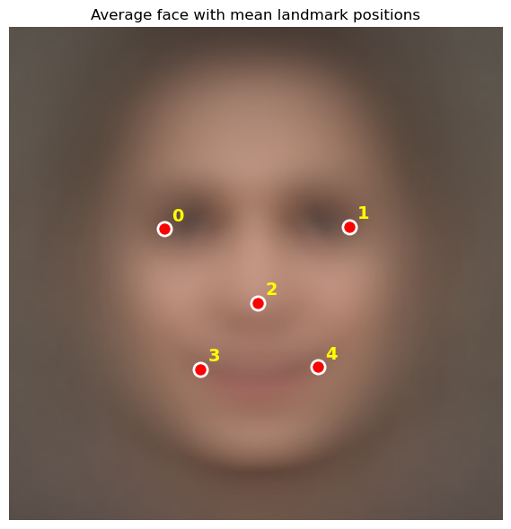
Next, I split the 2811 image training data to create a training and validation data set with an 85/15% split resulting in 2390 training images and 421 validation images.
As a basic sanity check, I checked landmark coordinates to explore their minimum and maximum values and ensure they fall within the dimensions of the images. I also calculated metrics regarding the distance between the two eye coordinates (Inter-Ocular Distance, or IOD) and then computed the per-channel RGB mean and standard deviation across the training set, used later for input normalisation in the CNN.
I also plotted the landmark’s mean and its variance around the against the average face image to determine for each landmark the amount of variation in the data set.
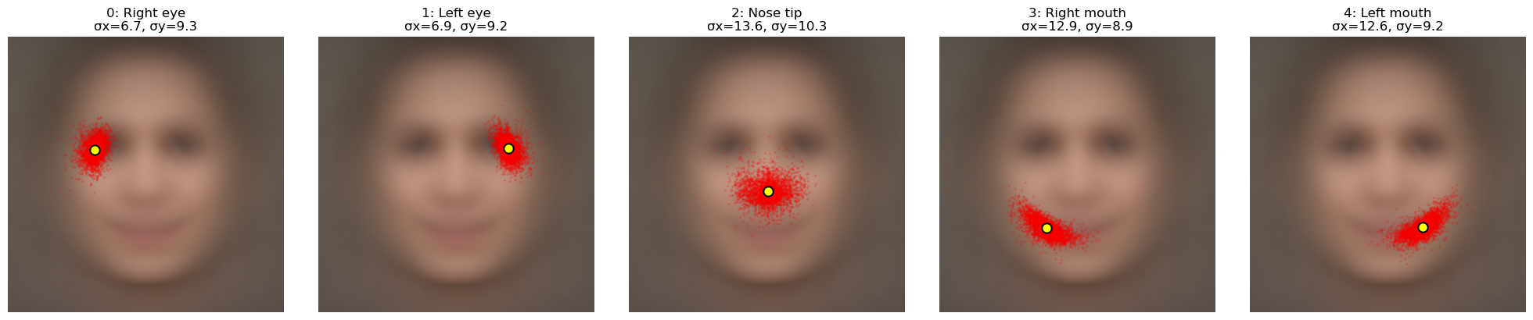
Finally, with the image size, number of landmarks, normalised mean, and normalised standard deviation determined, I save them into the config.py file for use in later processing pipelines.

3. Method 1 — Classical Baseline
Notebook 02_baseline_sift.ipynb uses the same scaffolding established earlier to set up the runtime, load the dataset, and establish the train/validation split.
I then took the mean landmark shape and used it to predict each validation face’s landmarks to establish a baseline to compare the rest of the models to – effectively guessing the landmarks using the average values of the training data. I plotted this across a few sample images to illustrate the concept and potential failures.
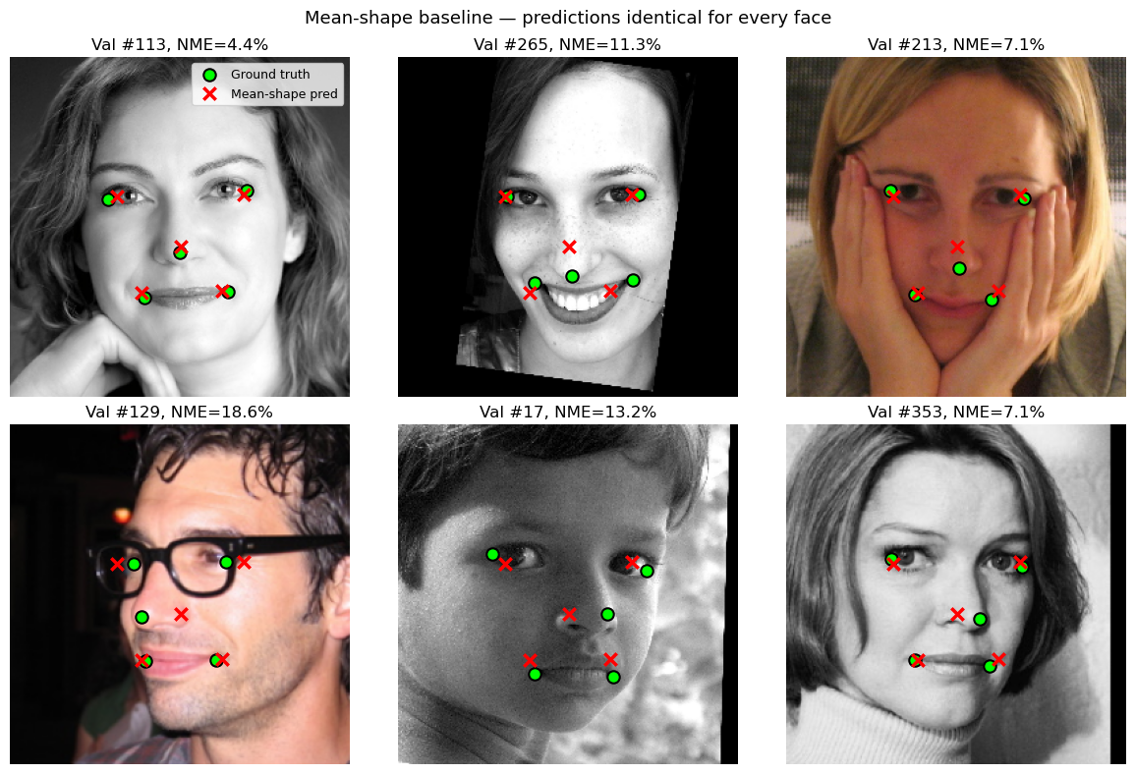

Next, I used the sample SIFT code from Lecture 4, Feature Detection and related lab for the rough template and used the scikit-learn Ridge regression module as it provides regularisation to help deal with the relatively complex SIFT dataset across a relatively small sample size. SIFT is 128 dimensions and there are 5 landmarks, the total feature vector is 5 x 128 = 640 per image. With ~2800 images this is a moderately high number of features to samples, making overfitting a possibility without regularisation. I first use a single stage regression model starting with the initial mean landmark template and perform a single regression against the known good landmarks in the training data to train a model for prediction of offset values for each landmark.
Then, following the approach from Xiong & De la Torre, (2) I added a cascade process to the model as outlined in the Face Alignment, Cascaded Regression lecture, looping through a [template -> regression -> offset -> template +offset -> cascade] cycle 4 times to further refine the predicted offsets, culminating with the final template + offset result, providing the 5 landmark x,y coordinate predictions. The tuneable parameters of the SIFT patch size (16), and the regularisation alpha (10) were chosen based on prior lab work. The number of cycles were chosen based on the point where the net mean error improvements began to plateau.
The training cycle was very quick (under 60 seconds in CoLab and under 20 seconds on my local MacBook Air M4, and the results were much better than both the mean-shaped baseline and single stage regression. I started with the mean-shape baseline NME of 12.60%, single-stage regression at 4.99%, and landed on 3.86% on the 4 pass cascaded regression approach. Failure rates likewise improved dramatically, with the mean-shape baseline failures at 60.3%, the single stage regression achieving 3.6%, and the cascaded regression coming in at an impressive 0.7%.

4. Method 2 — CNN Direct Regression
In notebook 03_cnn.ipynb I implemented a CNN-based regression model to predict the five landmark (x, y) coordinates directly from the input image. Unlike the cascade, this model learns visual features from the pixels rather than relying on hand-crafted SIFT descriptors. I built the network from scratch using material from the lectures, labs, and DebuggerCafe.com rather than using a pre-trained architecture such as ResNet so that I could compare two relatively simple approaches without introducing transfer learning as an additional factor.
The CNN used a preprocessing pipeline implemented in PyTorch, following the general pattern of the official PyTorch face-landmarks tutorial and OpenCV affine transformation routines. Each sample began as a 256 x 256 x 3 RGB image with five landmark coordinates. During training, the pipeline could apply affine augmentation (rotation, scale, and translation), horizontal flipping with landmark index swapping, and brightness/contrast jitter. The image was then converted from [0,255] to [0,1], standardized using the dataset RGB mean and standard deviation calculated during EDA, transposed from HWC to CHW, and paired with landmark coordinates normalized into [-1, 1] relative to the image centre.
My initial implementation started with the RGB image being passed into the feature extraction blocks. This takes the 3 channel (R/G/B) image and successively shrinks the dimensions of the image, while increasing the number of channels, going from a 3 channel, 256x256 dataset to a 32 channel, 128x128 data set, then to a 64 channel 64x64 data set, then to a 128 channel 32x32 data set and finally to a 256 channel 16x16 data set. After feature extraction the initial model applied global average pooling over a 16x16 patch (effectively the entire remaining image size post feature extraction). This results in a single average pixel value for each of the 256 channels in the 256x16x16 data set, significantly compressing the data set by averaging out all the features. I later discovered this had the unfortunate side effect of losing all the spatial data (more on that below.)
Next the prediction head layer then passes them through a ReLU (Rectified Linear Unit) function to activate the interesting features. I set the defaults to the mean landmarks at the start of the model, giving it a head start for prediction. Finally in the forward pass, the model takes the image and outputs the predicted landmarks.
In practice, the model’s predictions were almost identical across validation images and closely resembled the mean-shape baseline, indicating that the network had collapsed to predicting an average face rather than image-specific landmarks. The key issue was that landmark regression depends on absolute position, but the global average pooling I was using compressed the remaining spatial information. The network knew facial features were present but lost the information about where they were. This made it easy for the model to settle into a low-variance, mean-shape solution:
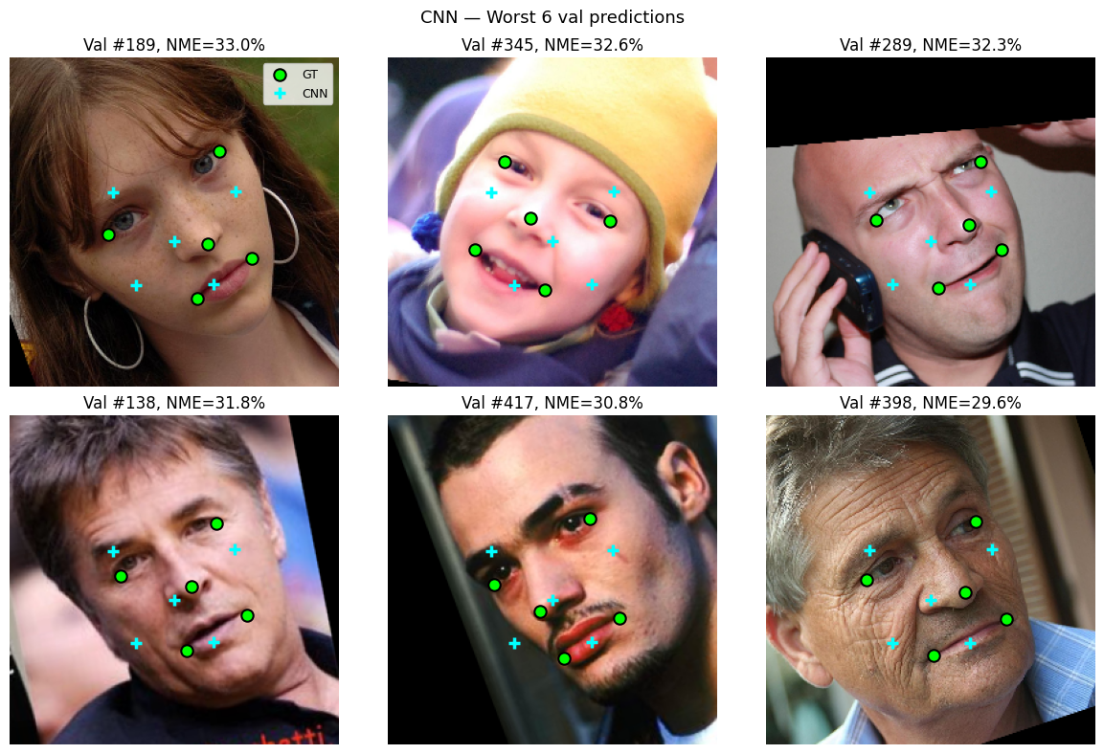
Pre

Making matters worse, every training run was taking around 30 minutes so the cycle time on experimenting was lengthy. Before I fully diagnosed the collapse, I also exhausted my available Colab GPU credits. When I moved the notebook to my local MacBook Air, the Colab-oriented setup failed to use Apple’s GPU acceleration and fell back to the CPU, making training even slower. I used OpenAI Codex as a development assistant at this stage to help convert the notebooks into a dual Colab/local workflow and debug environment-specific issues, which allowed me to continue experimenting on the Mac.
In revisiting the CNN lecture material, I realized that my original architecture had effectively reproduced the shift-invariant pattern discussed in the “advanced architectures” lecture: it was good at recognizing that a face was present, but poor at preserving the spatial structure needed for direct coordinate prediction.
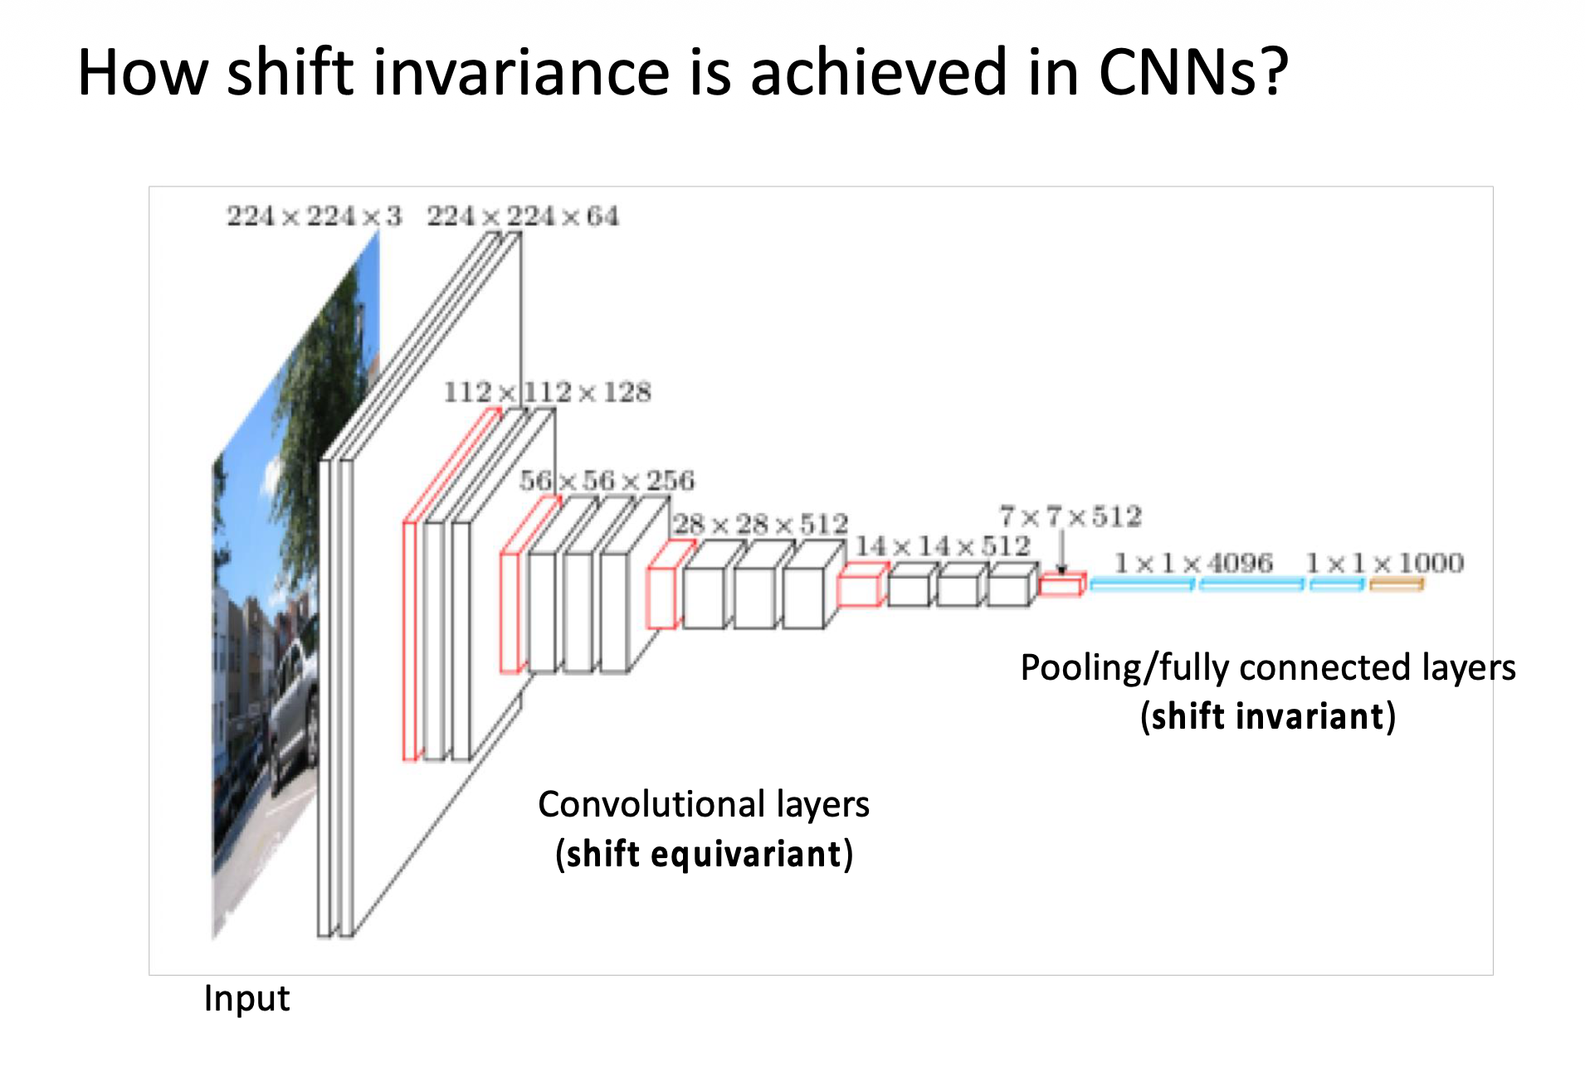
To address this, I introduced a CoordConv-style input representation, following Liu et al. (3) This simply augments the RGB input with two additional channels containing the normalized x and y coordinates of each pixel. This gives the convolution access to positional information.
I also addressed the Global Average Pooling that was collapsing spatial information down to a single value. In the CoordConv example, a spatial head preserved a small pooled grid before the fully connected layer, allowing the model to retain layout information instead of averaging it away. In later refinements I also replaced BatchNorm with GroupNorm to improve stability for smaller local batch sizes, and added a tanh output so the model’s predictions matched the normalized landmark target range. The final layer bias was initialized to the dataset mean landmark shape, giving the network a head start on prediction while still allowing the weights to learn image-specific information.(4)
While the training time was substantially longer than the Cascade Regression (around 30 minutes for 50 epochs) the results were almost (but not quite) as good. The model achieved a 4.4% NME versus the Cascade’s 3.86. Failure rates were the same at 0.7%. Compared to the mean collapsed version you can see the improvement below - the model is clearly compensating for different face configurations:
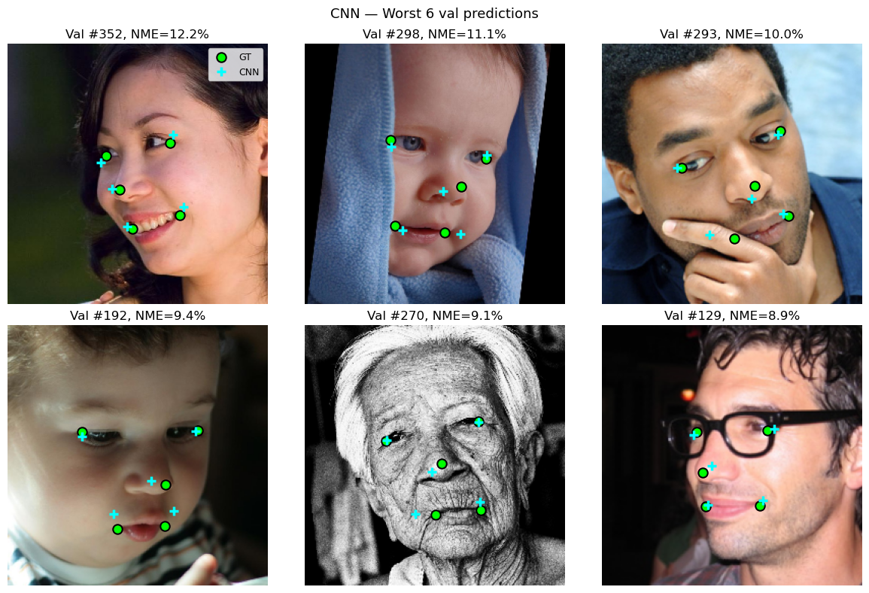

5. Results and Comparison
Using a version of the Euclidean distance calculation provided with the assignment and normalising for overall face size (as estimated by Inter Ocular Distance) I calculated the Normalised Mean Error (NME) of the predicted points versus the ground truth.
For a visual benchmark I added a 10% threshold as an indicator where landmarks become obviously wrong when plotted on the image. In a 256x256 image, a 10% error would be generally less than 10 pixels off in any given direction – more variance than this becomes increasingly obviously wrong.
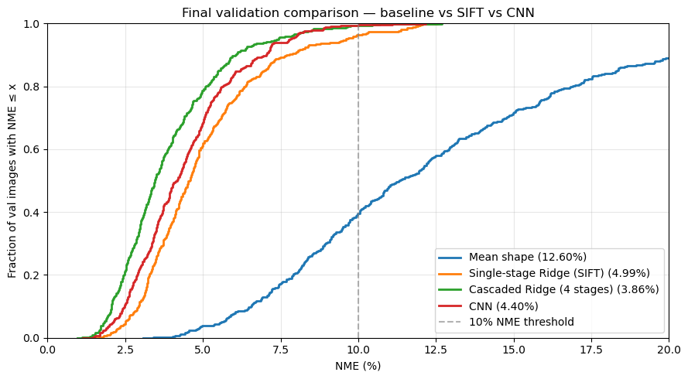
The Mean shape approach fails on 60% of images at the 10% NME cutoff suggesting that an observer would find only 40% of the predictions credible. In contrast the Cascaded SIFT Ridge regression achieved a 3.86% NME with a failure rate of only 0.7%, meaning that over 99% of images would look credibly mapped using this model. While the CNN approaches this number with a 4.4% NME and similar failure rate it comes at the cost of a much more expensive training effort.
Results summary at the 10% NME threshold:
Model | NME mean | Failure rate (>10%)
Mean-shape baseline | 12.60% | 60.3%
Single-stage Ridge | 4.99% | 3.6%
Cascaded Ridge (4-stage) | 3.86% | 0.7%
CNN (LandmarkCNN) | 4.4% | 0.7%

The performance of the cascaded Ridge model is likely due to the structure of the problem and the size of the dataset. With only 2811 labelled training images and fairly constrained facial geometry, the classical pipeline benefits from strong built-in assumptions: it starts from the mean face, extracts local SIFT descriptors at plausible landmark locations, and learns residual corrections rather than absolute positions from scratch. This gives it a very data-efficient way to refine landmark placement.
You can see this visually in the per landmark mapping, with tight groupings of each landmark.


The CNN, by contrast, must learn its own features directly from the pixels, which is more flexible but also more demanding in terms of optimization and data. My experience with Google CoLab helped to reinforce this training time is not “free” and in this case the trade-offs in terms of outcomes aren’t worth the additional costs. In the metrics above and sample images below its evident the two models are quite close.
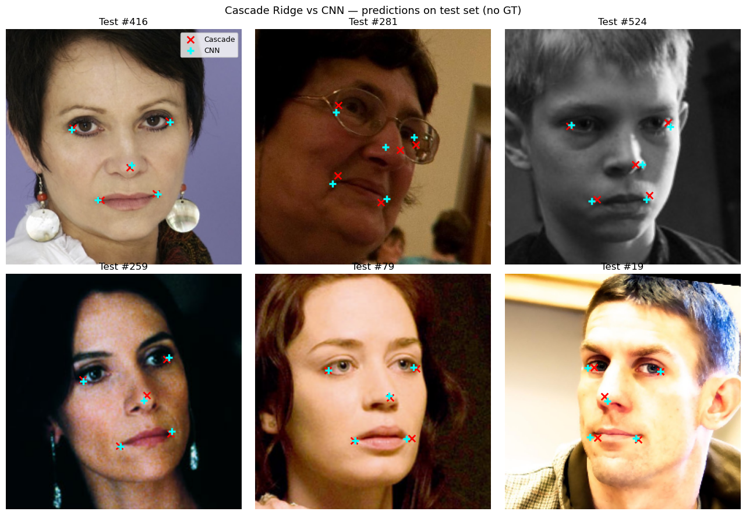

6. Failure Analysis
As good as they were, neither of the two learned models achieved perfect performance at the 10% NME threshold, and their failure cases were often similar. The most difficult images tended to involve faces that were far from the dataset average, including heavy obstruction from hair, hands, or objects, unusual lighting, odd poses, and very young or elderly subjects. Both models also struggled with profile or near-profile views where one or more features were partially obscured or seen at an oblique angle.
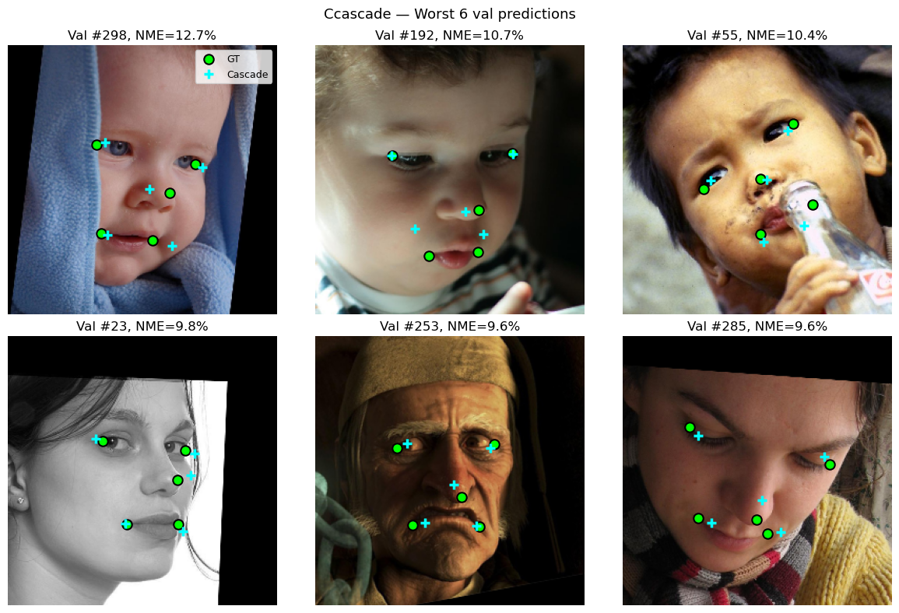


The commonality in the failures above suggests that these errors are driven less by the specific model and more by the limits of the training data and task setup. If unusual poses, age groups, lighting conditions, or obstructions are underrepresented in training, both methods are likely to perform poorly on those cases. This was also alluded to in the “300 faces in-the-wild challenge” (5) where the 300-W dataset was specifically chosen to cover “a large variation of identity, expression, illumination conditions, pose, occlusion and face size.”
This has an important ethical implication. A model can fail systematically on underrepresented faces or conditions even when there is nothing unusual or problematic about the subject. In low-stakes settings this may simply produce an unconvincing result, but in high-stakes applications such as biometric authentication, medical imaging, or law enforcement, the same pattern of failure can become much more serious. For that reason, failure analysis is not just a technical exercise: it is necessary for understanding whether a model is appropriate for the environment in which it will be deployed.

7. Face Segmentation
For face segmentation, I extrapolated the boundaries of faces from the landmark data predicted by the Cascade model, based on some simple polygon construction using the landmarks as reference points.
I started with a simple approach based on the “rule of thirds” and “rule of fifths” (common ratios for artistic face ) to extrapolate the browline, down through the mouth corners, and then a chin point. My initial implementation was disappointing, as it resulted in a very triangular mask, broad across the brow, and coming to a point below the chin point, which was often misaligned with the image.
This challenge is alluded to in the 300 Faces in the Wild text as well, where they specifically state “the standard deviation is high for landmarks that do not have a clear semantic meaning. The chin is the most characteristic example of this category, as it demonstrates the highest variance.”
I expanded the triangle with extrapolated points, adding a “hairline” point centred between the eyes (using the midpoint of the IOD) and up 1 and 1/3 of the “eye to nose” distance. I also introduced cheek/jaw line points with a similar extrapolation down from the eyes, and again with the chin dropping down from the nose. This gave me a rough polygon that I feathered out with a gaussian blur based CV2 routine. (6,7)
My approach is rooted in the landmarks I was predicting without introducing any further face segmentation logic to keep all operations keyed off the same base framework. This kept my development and debugging in a single failure mode rather than introducing additional complexity with multi-factor segmentation. I briefly considered an edge detection or some other approach but felt the results I got with the polygon extrapolation were adequate for my use case.
The final approach has an 8-point polygon. See below for a sampling of this method plotted over their respective images.

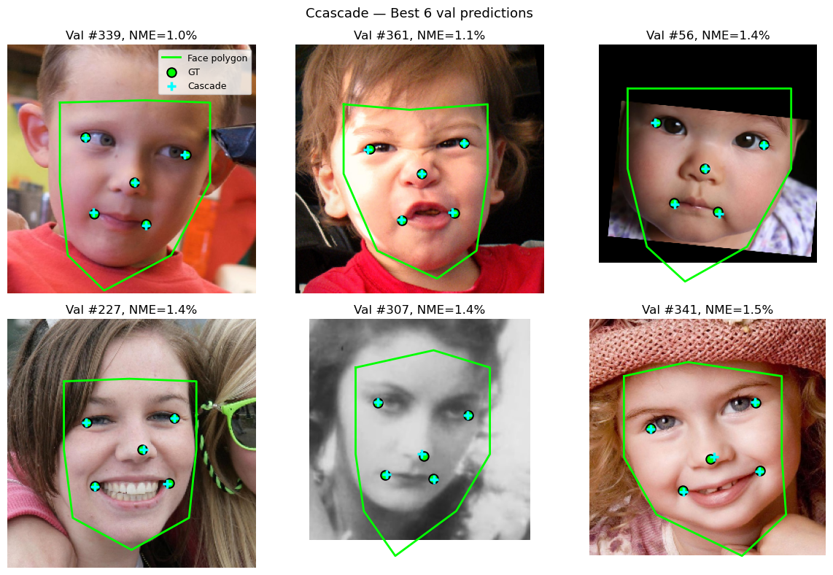
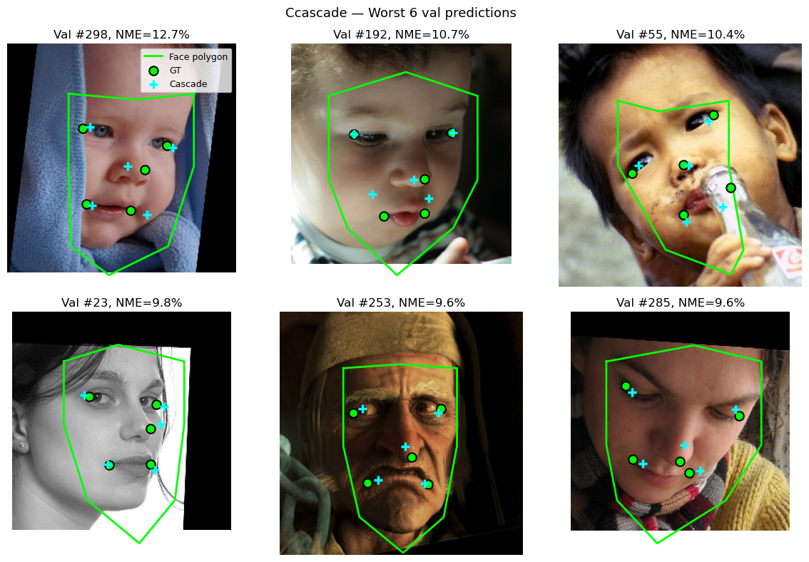

The limitations of the approach are more evident in the overlay of the poly-filled mask, but as you can see in the Graphical Effect section, it was surprisingly effective in spite of the obvious limitations: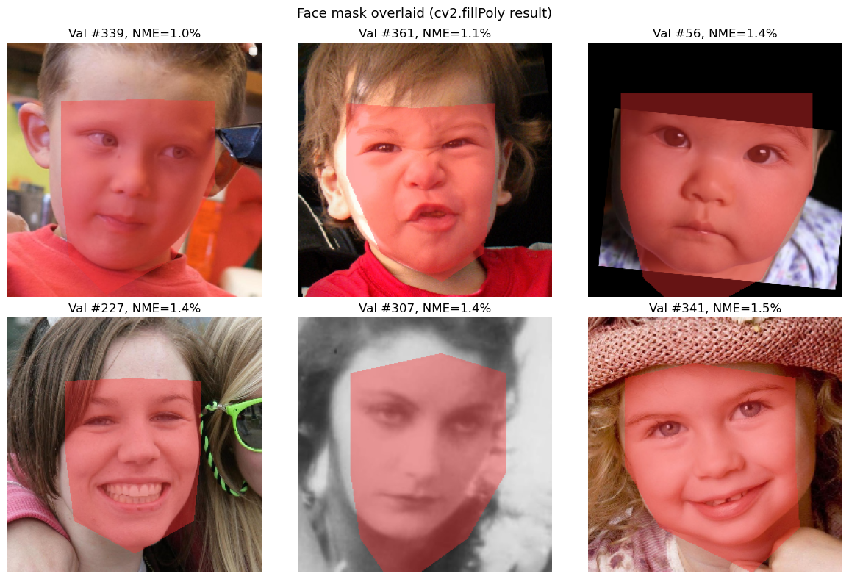
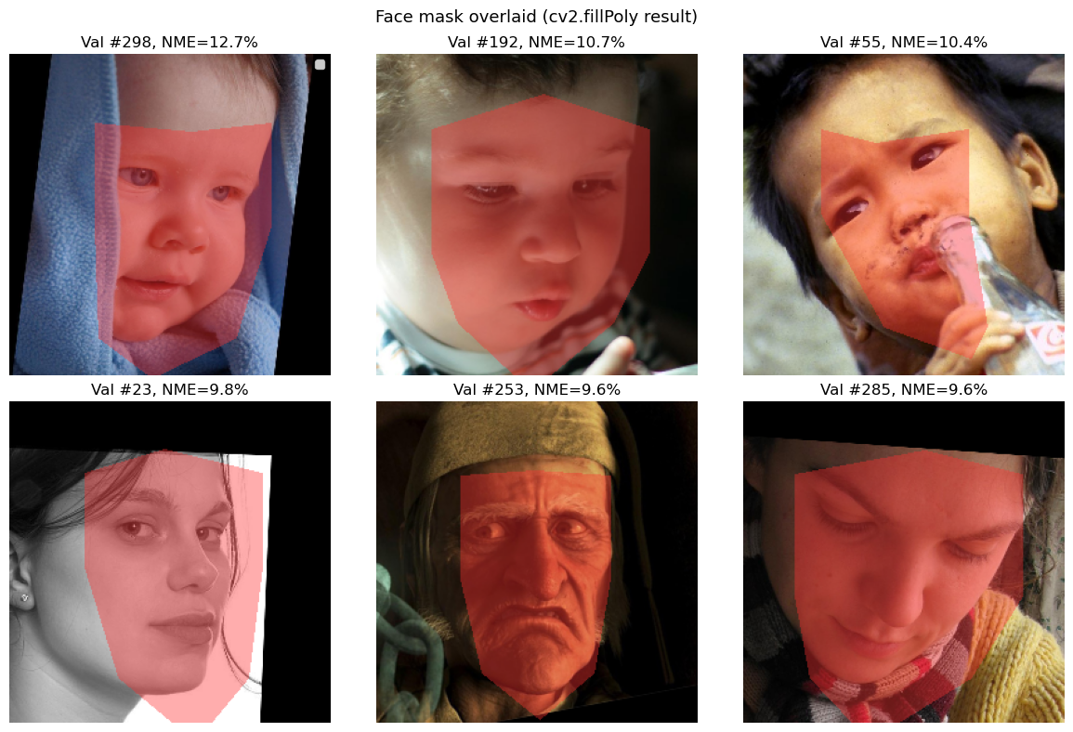

8. Graphical Effect — Take On Me Stylisation (~200 words)
As a child of the 80’s there was a generational moment of awe when Ah-Ha released their video for “Take On Me” on MTV in 1985, which won six awards at the 1986 MTV music video awards. (8) The animation took around 16 weeks to complete, as it was drawn and integrated by hand. (9)
This makes the subsequent appearance of NPRQuake in 2000 all the more impressive where you could alter the appearance of the category-defining 3D first person shooter Quake from id software to render the entire game, real-time, in the style of the Ah Ha video. (10)
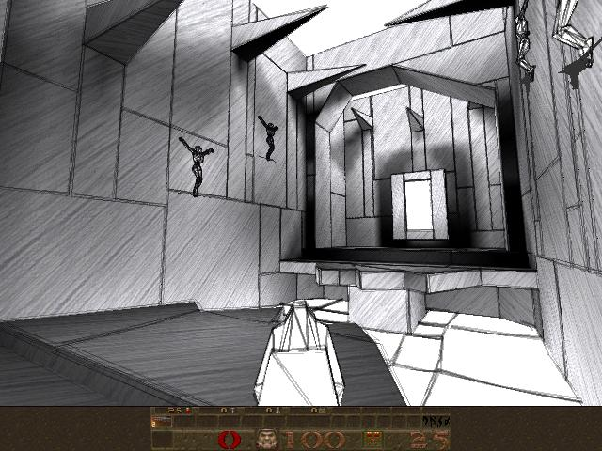
To demonstrate a downstream use of the segmentation mask, I implemented a simple “Take On Me”-style stylisation effect inspired by the hand-drawn pencil shading. The effect is a OpenCV pipeline that converts the image to grayscale, posterises it, detects edges with Canny after Gaussian blur, multiplies the edges into the posterised image, applies a warm paper tint, and composites the result over the original image using the feathered face mask.
Although simple, the effect works well on low-error masks and remains broadly acceptable even on some weaker segmentations. On images with low NME scores the mask adhered close enough to the original face that when coupled with the effect, it was almost like I was back to my childhood, and even those images where NME scored the worst, the effect is generally passable:
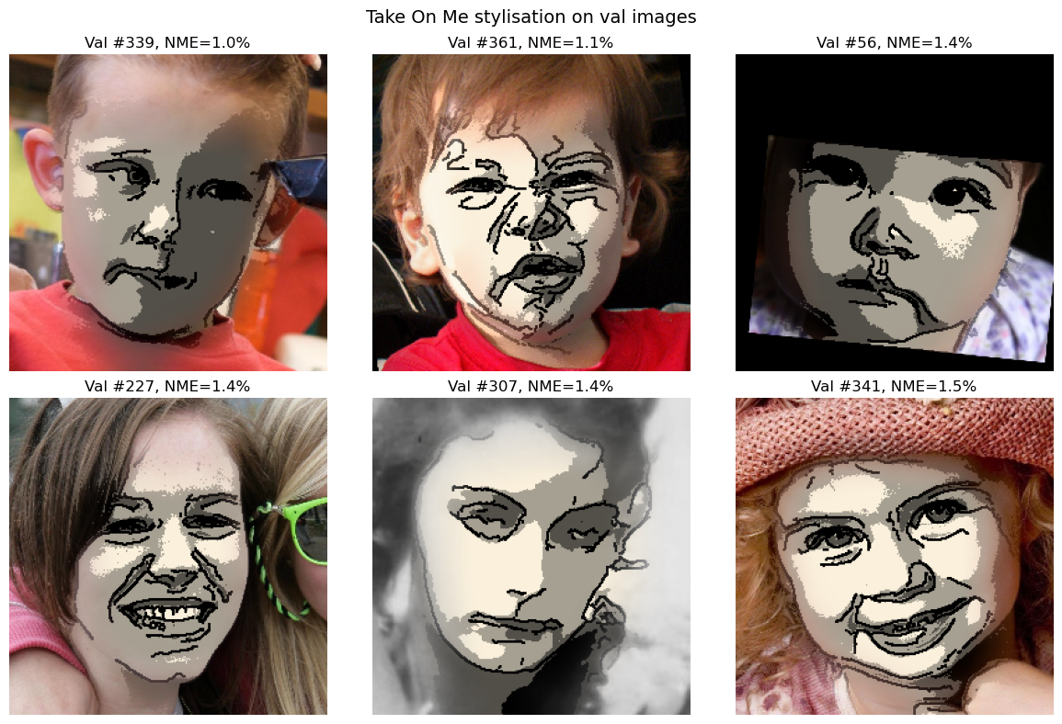
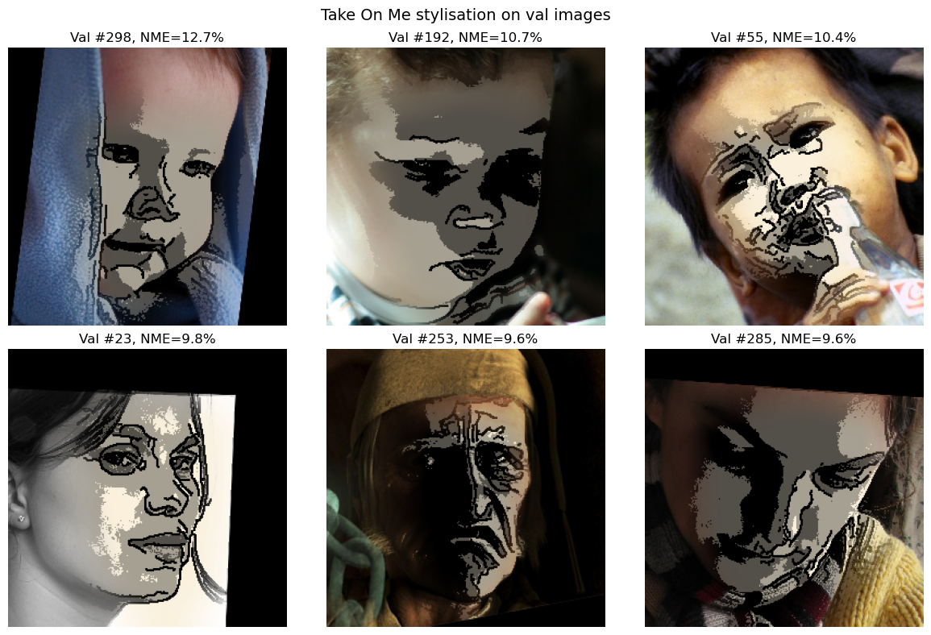

9. Conclusion
My whimsical attempt at recreating 80’s and 2000’s nostalgia aside, I now have two credible models to predict 5 facial landmarks on reasonably bounded images where the face is the centred, primary feature of the image. My cascaded ridge regression on SIFT features achieves a solid 3.86% NME, with my CNN coming in at a close 4.4% NME.
The ridge regression model is functional and provides surprisingly good results despite its obvious limitations when looking at the mask in isolation.
Were I to take this project forward, I’d like to explore a few additional approaches including:
- Integrating and predicting a more extensive set of landmarks, like those used in the 300 Faces in the Wild project to get a more robust mapping of facial features.
- Implementing a more robust CNN, potentially incorporating face detection into the model in addition to landmark prediction.
- Implementing a more sophisticated segmentation approach that gives me a much more fitted mask.
- Implementing a more artistic rendering of the “Ah Ha” effect that more closely resembles the pencil drawings of the original 1985 music video.

References
- Generative AI
- Anthropic's Claude (claude.ai) was used as a coding and design discussion partner throughout this project, used for drafting the project plan, debating architectural choices, reviewing code, and debugging errors. All notebooks were executed manually by me; no agent autonomously analysed the dataset or generated results. Sample code from my conversations was reviewed, adapted to my use case, and tested before being committed. The report was written by me, and final decisions about architecture, configurations, and selection of the winning model and masking / graphical manipulation demonstrating its capabilities was exclusively mine.
- One notable exception was where I used OpenAI’s Codex to quickly port Google Colab native notebooks into dual-mode notebooks that would run both on Colab and my local MacBook using Apple’s proprietary GPUs. Codex (guided by me) was given access to my Git repository and prompted to make modifications to the Bootstrap / Set Up cells to accommodate running both locally or in Colab. This enabled me to quickly pivot between compute environments when I exhausted my available GPU allocations in Colab and was no longer able to efficiently run my CNN model. This was also discussed in more detail in the model performance evaluation. Codex refactored code check ins are noted in the
- Xiong & De la Torre 2013 — Supervised Descent Method (cascade)
- Liu et al. 2018 — CoordConv ("An Intriguing Failing of Convolutional Neural Networks and the CoordConv Solution") https://proceedings.neurips.cc/paper_files/paper/2018/hash/60106888f8977b71e1f15db7bc9a88d1-Abstract.html
- Wu & He 2018 — Group Normalization (NeurIPS)
- Sagonas et al. 2016 — 300 Faces in-the-wild challenge (dataset/task context)
- Pyimagesearch.com - https://pyimagesearch.com/2017/04/10/detect-eyes-nose-lips-jaw-dlib-opencv-python/
- DebuggerCafe.com - https://debuggercafe.com/getting-started-with-facial-keypoint-detection-using-pytorch/
- Wikipedia History of Take On Me - https://en.wikipedia.org/wiki/Take_On_Me
- Animation Magazine - https://www.animationmagazine.net/2022/04/take-on-me-revisiting-the-making-of-a-has-trailblazing-animated-music-video/
- NPRQuake - https://www.cs.wisc.edu/graphics/Gallery/NPRQuake/
- Python Libraries:
- numpy>=1.24
- matplotlib>=3.7
- opencv-python>=4.8
- scikit-learn>=1.3
- torch>=2.1
- jupyter>=1.0
- tqdm>=4.65

