**Screen shots for 2017 and 2018 with and without refactoring,**

**For 2017, Before refactoring, execution time** **of 0.8125**

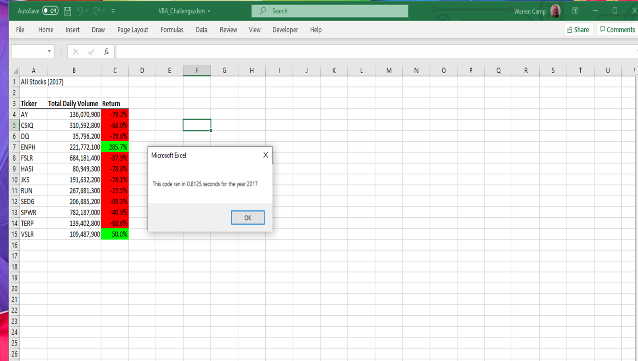

**For 2017 After refactoring, execution time improved from 0.8125 to 0.2617188,** **a reduction in time of 0.5508 or 68%**

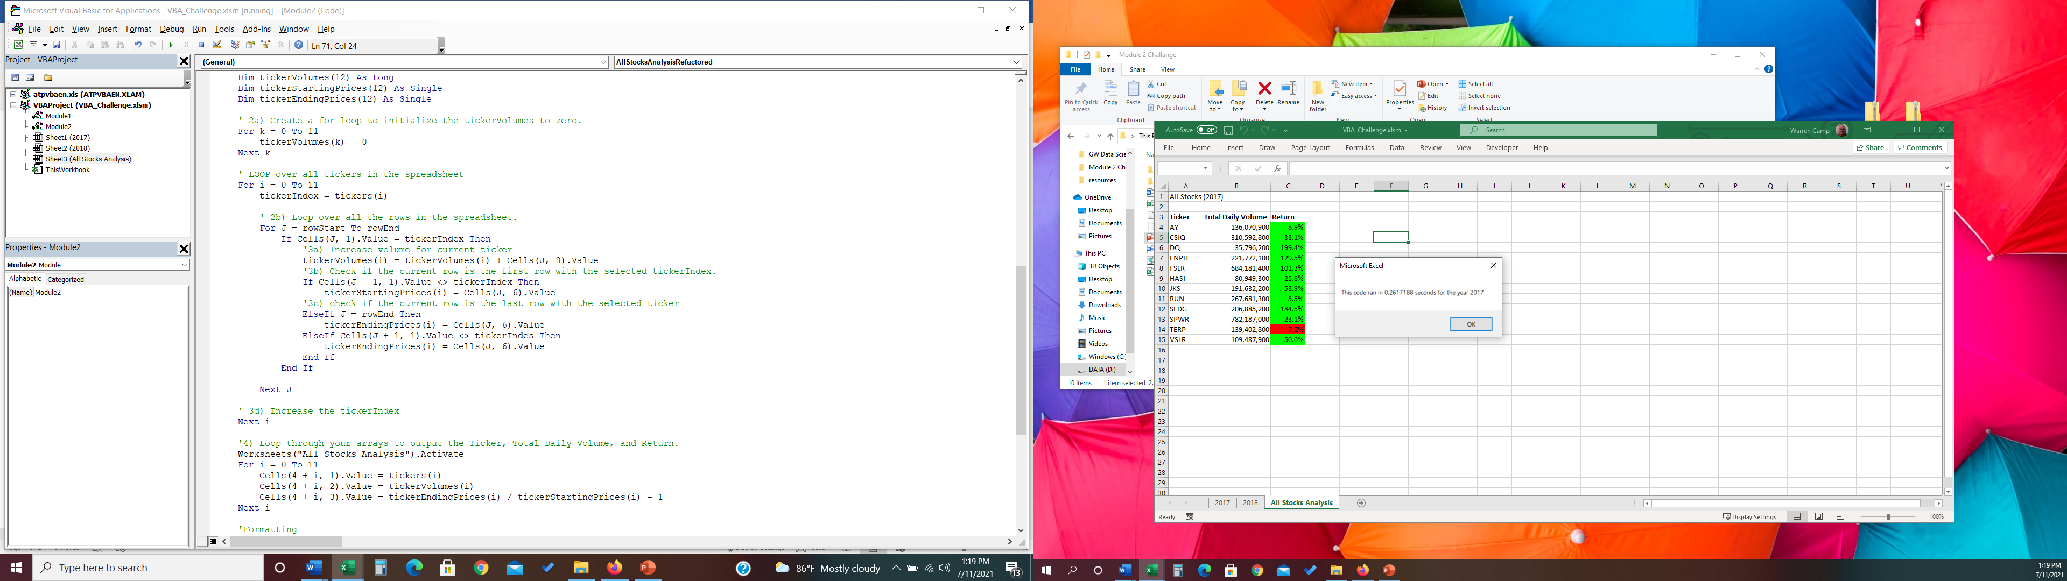

**For 2018, Before refactoring, execution time of** **0.7929688**

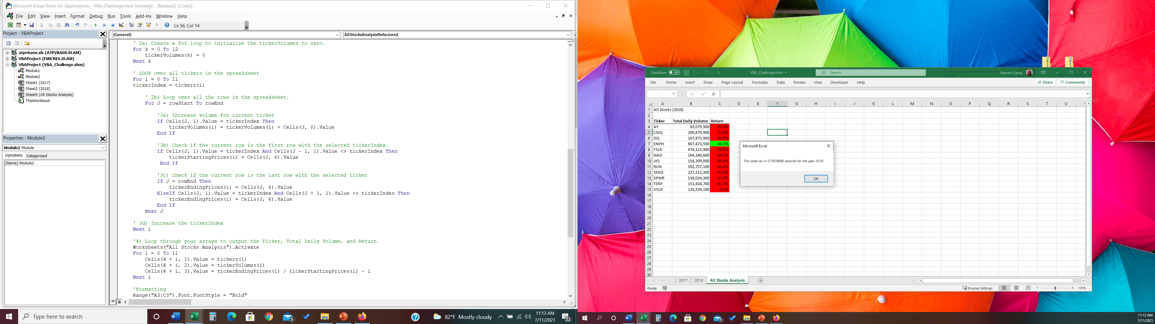

**For 2018 After refactoring, time improved from 0.7929688 to 0.265625 a reduction in time of 0.5273438 or 66.5%**

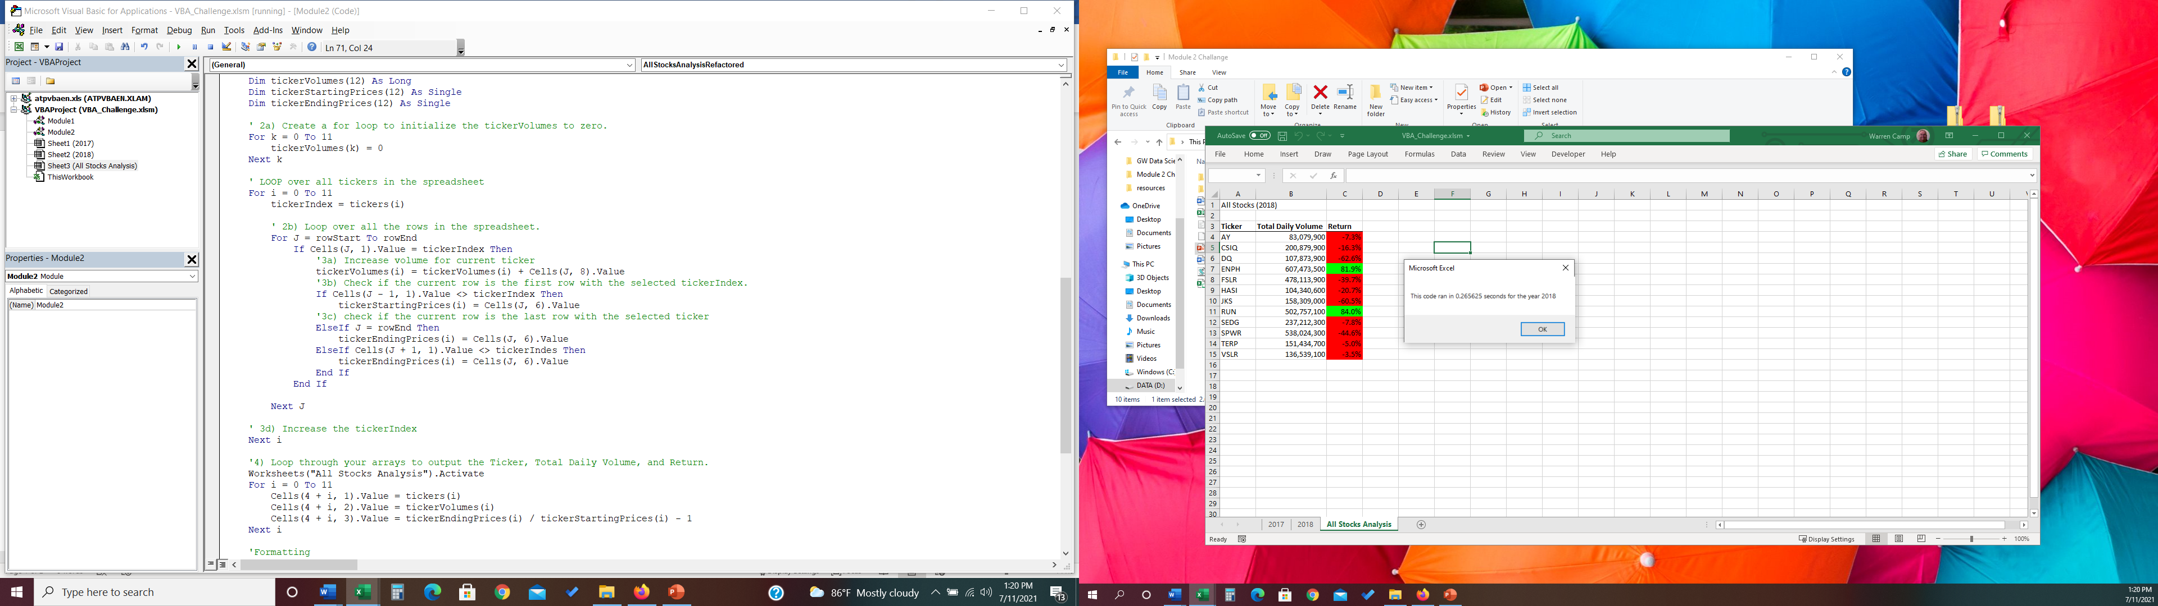

He decrease in execution times was achieved by rewriting the decision logic for determining the first and last records by using embedded IF statements which reduce the number of comparsions. See code below:

' LOOP over all tickers in the spreadsheet

For i = 0 To 11

tickerIndex = tickers(i)

' 2b) Loop over all the rows in the spreadsheet.

For J = rowStart To rowEnd

If Cells(J, 1).Value = tickerIndex Then

'3a) Increase volume for current ticker

tickerVolumes(i) = tickerVolumes(i) + Cells(J, 8).Value

'3b) Check if the current row is the first row with the selected tickerIndex.

If Cells(J - 1, 1).Value <> tickerIndex Then

tickerStartingPrices(i) = Cells(J, 6).Value

'3c) check if the current row is the last row with the selected ticker

ElseIf J = rowEnd Then

tickerEndingPrices(i) = Cells(J, 6).Value

ElseIf Cells(J + 1, 1).Value <> tickerIndes Then

tickerEndingPrices(i) = Cells(J, 6).Value

End If

End If

Next J

' 3d) Increase the tickerIndex

Next i

Versus the original code with separate IF statements:

' LOOP over all tickers in the spreadsheet

    For i = 0 To 11

    tickerIndex = tickers(i)

        ' 2b) Loop over all the rows in the spreadsheet.

        For J = rowStart To rowEnd

            '3a) Increase volume for current ticker

            If Cells(J, 1).Value = tickerIndex Then

                tickerVolumes(i) = tickerVolumes(i) + Cells(J, 8).Value

            End If

            '3b) Check if the current row is the first row with the selected tickerIndex.

            If Cells(J, 1).Value = tickerIndex And Cells(J - 1, 1).Value <> tickerIndex Then

                tickerStartingPrices(i) = Cells(J, 6).Value

             End If

            '3c) check if the current row is the last row with the selected ticker

            If J = rowEnd Then

                tickerEndingPrices(i) = Cells(J, 6).Value

            ElseIf Cells(J, 1).Value = tickerIndex And Cells(J + 1, 1).Value <> tickerIndes Then

                tickerEndingPrices(i) = Cells(J, 6).Value

            End If

        Next J

    ' 3d) Increase the tickerIndex

    Next i