Changed ‘application’ to ‘default’ in

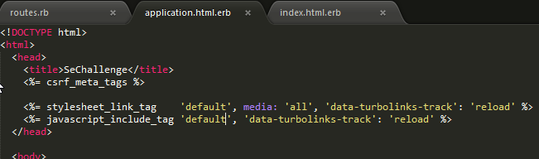

Because apparently windows doesn’t like ‘application’. Might have to change this back.

Expense_controller

* POST
  + Accept expense object as param
  + Insert into DB
  + Returns bool for success
* Do I accept just csv text as body in the ‘create’ method? Or should I make it accept only hashes, and preprocess the csv?

Expense Model

* Date - string
* Category - string
* employee name - string
* employee address - string
* expense description - string
* pre-tax amount - numeric
* tax name - string
* tax amount - numeric

*rake db:migrate* to create table

rails generate migration <migrationName> to modify the existing database table

rake db:test:prepare before running first unit test

Not sure if it is bad practice to have both @expenses and @expense_totals within the same controller and one view.

Future Considerations