Multi-Site Infrastructure Sizing Proposal
2 clusters sized independently

Executive Summary
This proposal consolidates 2 sites — today 0 hosts running 80 active VMs across 45.0 TB of data — onto the Scale Computing SC//HyperCore platform. Each site is sized independently for N-1 resilience and 5-year growth, so any one site keeps full performance even with a node down. Across all sites the proposed solution totals 12 nodes, 340 CPU cores, 7.9 TB of memory and 176.6 TB of usable capacity. The sections below give the combined solution at a glance, the platform capabilities, and the detailed sizing for each site.

Solution at a Glance
Cluster | Model | Nodes | Cores | RAM | Usable Storage
Site A | HE151 | 8 | 88 | 4.0 TB | 119.04 TB
Site B | HE500 | 4 | 252 | 4.0 TB | 57.6 TB

Total nodes (all sites) | 12
Total CPU cores (all sites) | 340
Total memory (all sites) | 7.9 TB
Total usable storage (all sites) | 176.6 TB

Why Scale Computing SC//HyperCore
Scale Computing SC//HyperCore simplifies your systems and moves beyond traditional IT silos. The award-winning, self-healing platform identifies, reduces, and corrects problems in real-time — making application uptime easier for IT to manage and more affordable to run. Its lightweight, all-in-one architecture eliminates the need to combine separate virtualization software, disaster recovery software, servers, and shared storage from different vendors, deploying fully integrated, highly available virtualization right out of the box. Designed to scale as the business grows without downtime, disruption, or rigid hardware requirements, it lets teams spend less time on infrastructure maintenance and more on strategic projects.

Management & Operations
Scale Computing HyperCore runs the hypervisor, storage, and orchestration as a single integrated fabric — managed from one interface with no external SAN, no separate hypervisor licensing, and no specialist virtualization administration required.
Single-pane management — compute, storage, networking, and VMs are administered from the built-in HyperCore web interface; no separate storage console or vCenter-equivalent.
SC Fleet Manager — cloud-based monitoring, alerting, and fleet-wide management across clusters and sites from one dashboard.
Self-healing storage — RF2 mirroring rebuilds automatically on a disk or node failure, with no administrator intervention.
Non-disruptive operations — rolling updates and node additions complete with VMs running; scale out by adding a node, no forklift upgrades.
Built-in data protection — native VM snapshots and replication for backup and DR without third-party software.

HEAT — HyperCore Enhanced Automated Tiering
Optimizing storage efficiency with HEAT. In flash-equipped SC//HyperCore nodes, HyperCore Enhanced Automated Tiering (HEAT) meters real-time IOPS for each virtual disk and intelligently places data blocks across the flash and spinning tiers based on block I/O heat mapping assessed from historical activity — striking the correct balance of IOPS efficiency across virtual disks and VMs.
Per-disk flash priority — configurable flash allocation at the individual virtual-disk level through an easy-to-use slide bar in the HyperCore UI.
Intelligent data placement — data-block priority based on block I/O heat mapping assessed from historical information.
Automatic warm-up — new writes are assigned to the flash tier until SCRIBE can accurately assess their activity.
Exponential priority scale — the 0–11 scale is exponential; raising a virtual disk from 4 to 5 doubles its priority for flash placement.
Flexible tiering — setting 0 keeps static data off flash, while setting 11 multiplies flash priority by an order of magnitude.

SCRIBE Block Engine
Efficiency redefined. The Scale Computing Reliable Independent Block Engine (SCRIBE) is a critical software component of the SC//HyperCore virtualization suite — an enterprise-class, clustered, block storage layer purpose-built to be consumed directly by the KVM-based SC//HyperCore hypervisor. By interfacing directly with the hypervisor rather than repurposing a traditional file system, SCRIBE eliminates the performance bottlenecks, latency, and alignment issues associated with repurposed file systems.
Performance — hypervisor-integrated block storage eliminates file-system latency, disk-partition misalignment, and snapshot delta-file merging.
Simplified management — complex storage management tasks are abstracted away for automated storage with minimal manual intervention.
Reliability — avoiding intermediary file-system abstractions minimizes the risk of data corruption or performance degradation.
Native snapshots — fast, native snapshots with no merge penalties or performance hit.
Storage efficiency — purpose-built for virtualized workloads with zero alignment issues.
Effortless scale — simply add nodes; SCRIBE scales storage automatically with no downtime.
Hardware-agnostic — runs on industry-standard hardware.

AIME — Autonomous Infrastructure Management Engine
AIME by Scale Computing — the AIOps platform for intelligent infrastructure. AIME is the artificial-intelligence orchestration and management functionality that powers the SC//HyperCore virtualization suite. Acting as a digital twin — a hand-built model of the environment the cluster runs in — it continuously thinks about the state the system is in, modelling the hardware, cluster operations, and surrounding environment so SC//HyperCore can handle day-to-day operational and maintenance tasks automatically. AIME monitors for security, hardware, and software errors, remediates issues where possible, and identifies root causes to minimize impact when automatic repair isn't feasible.
Reduce manual intervention — comprehensive monitoring, proactive problem detection, and automated remediation keep the cluster healthy.
Simplified troubleshooting — precise problem determination and actionable insights replace the guesswork of log interpretation.
Autonomous remediation — automatically addresses issues to minimize downtime.
Predictive anomaly detection — continuous monitoring surfaces problems before they escalate.
Zero-touch deployment — automated provisioning of new nodes and resources.
Resource optimization — dynamic workload balancing and automatic resource rerouting.
Policy-based security automation — enforced without manual scripting.

Site — Site A
Site A currently runs 40 active VMs (180 vCPU, 900 GB, 22.5 TB in use). The configuration below is sized for that workload with N-1 resilience and 5-year growth.

Recommended Configuration
Recommended platform | HE151 · 8 node(s) · single cluster
Per-node CPU | 1 x Xeon 4310
Per-node cores / threads | 12 cores / 24 threads
Per-node RAM | 512 GB
Per-node storage | 4x 7.68TB NVME
Cluster cores | 88
Cluster RAM | 4.0 TB
Cluster usable storage | 119.04 TB
Cluster net IOPS | 1,200,000
N-1 (resilient) | 77 cores · 3.5 TB · 119.04 TB usable
vCPU : core ratio | 3.77 : 1

Sizing Rationale
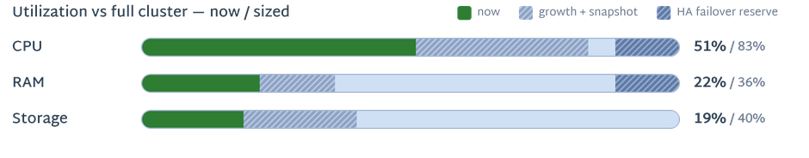

Determined by CPU performance — this cluster delivers 104% of your current environment's compute demand (rated throughput scaled to 30% measured peak utilization, grown to the horizon); the node count was raised to clear that floor.
Each bar is 100% of the full cluster: solid = today's load, light hatch = growth + snapshot reserve the workload is sized to, dark hatch = HA failover capacity held back so the cluster still meets the workload with one node down (N-1).

Capacity Planning — 5-Year Projection
Resource | Current | Year 5 | Proposed (N-1)
vCPUs | 180 | 290 | 77 cores @ 3.8:1
RAM | 900 GB | 1.4 TB | 3.5 TB
Storage | 22.5 TB | 47.91 TB | 119.04 TB usable

Site — Site B
Site B currently runs 40 active VMs (180 vCPU, 900 GB, 22.5 TB in use). The configuration below is sized for that workload with N-1 resilience and 5-year growth.

Recommended Configuration
Recommended platform | HE500 · 4 node(s) · single cluster
Per-node CPU | 2 x Xeon 6338
Per-node cores / threads | 64 cores / 128 threads
Per-node RAM | 1.0 TB
Per-node storage | 4x 7.68TB NVME
Cluster cores | 252
Cluster RAM | 4.0 TB
Cluster usable storage | 57.6 TB
Cluster net IOPS | 600,000
N-1 (resilient) | 189 cores · 3.0 TB · 57.6 TB usable
vCPU : core ratio | 1.53 : 1

Sizing Rationale
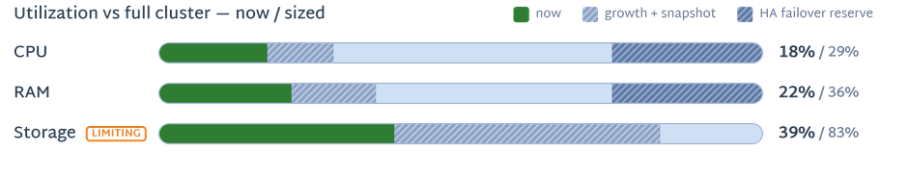

Determined by Storage — 47.9 TB required, vs 57.6 TB available at N-1 (20.2% headroom).
Each bar is 100% of the full cluster: solid = today's load, light hatch = growth + snapshot reserve the workload is sized to, dark hatch = HA failover capacity held back so the cluster still meets the workload with one node down (N-1).

Capacity Planning — 5-Year Projection
Resource | Current | Year 5 | Proposed (N-1)
vCPUs | 180 | 290 | 189 cores @ 1.5:1
RAM | 900 GB | 1.4 TB | 3.0 TB
Storage | 22.5 TB | 47.91 TB | 57.6 TB usable

Assumptions & Notes
Each site is sized independently for its own workload with N-1 resilience (a full node can fail without service interruption); replication targets additionally reserve capacity for their inbound replicas.
No LAG — networking is active/passive failover across two switches.

