Project 1

Jonathan Sahagun & Wilbert Veit

Special Instructions to Run:
- To see the results for part 1 of the project, run the main method from the SDES class. It should look as follows:

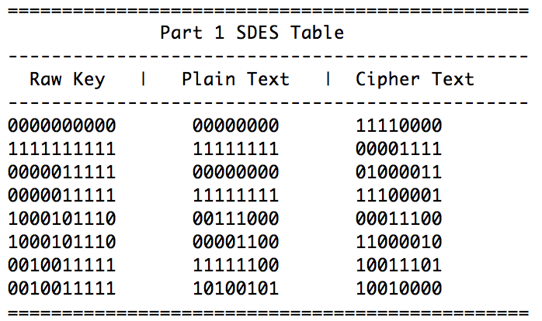

- To see the results for part 2 of the project, run the main method from the TripleSDES class. It should look as follows:
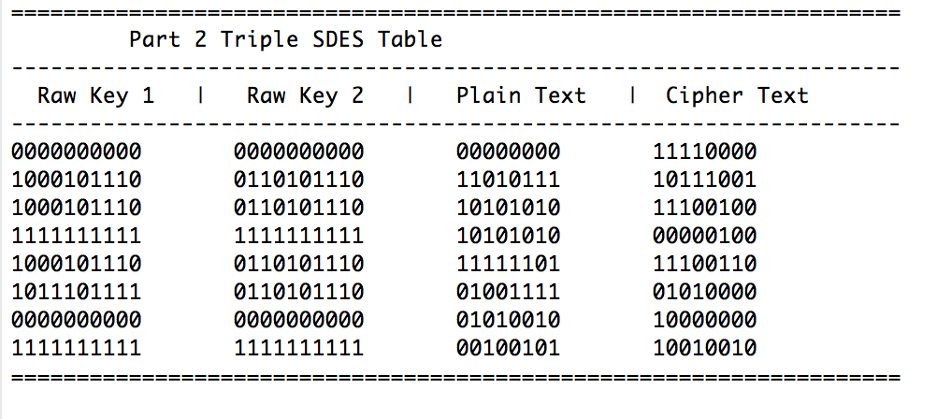

- To see the results of part 3 of the project, run the main method from the Crack class. It should look as follows:

