DataSense / SmartML Dashboard
Reference UI & Feature Teardown — for build/IDE handoff
Source: screen-recorded walkthrough of a reference implementation (video, ~7m16s, localhost:3000). Frames extracted and analyzed directly; all screenshots below are stills from that recording.

1. Purpose of this document
This document exists to give an IDE / coding agent (and any developer) a complete, screenshot-grounded spec of a reference AutoML/data-analytics product called "DataSense", so its features can be evaluated against and folded into an existing build (working name: SmartML Dashboard). It is organized by screen/route, with what's on each screen, what it implies about data model and API surface, and how it differs from the original 6-step build prompt this project started from.
Read this alongside the original prompt (six-step flow: Upload → Analyzing → Dataset Config → Training → Results, with a persistent AI Assistant sidebar). Anything below not covered by that prompt is a genuine gap or an upgrade opportunity — called out explicitly in each section.

2. High-level architecture difference
The most important structural finding: the reference app is NOT a single-page 6-step wizard. It is a multi-route application with a persistent top navigation bar (Home, Upload, Cleaning, Visualization, Feature Analysis, AI Insights, Predictions) and its own client-side routing:
- /signin — auth
- / (home) — marketing landing page
- /upload — dataset upload + dataset library
- /preview?datasetId=N — dataset preview + row browser
- /cleaning?datasetId=N — Data Cleaning Studio
- /visualization?datasetId=N — chart builder
- /feature-analysis?datasetId=N — feature relationships & redundancy
- /ai-insights?datasetId=N — AI-generated analytics + PDF export
- /predictions?datasetId=N — model training / forecasting
Each dataset is a persistent object (datasetId), not a transient job_id tied to one session. Users can navigate away and resume. This is a bigger decision than a UI tweak — it changes the backend data model from "job" to "dataset" as the core entity, with jobs/runs as children of a dataset.

3. Screen-by-screen breakdown

3.1 Sign In (/signin) — NOT in original spec
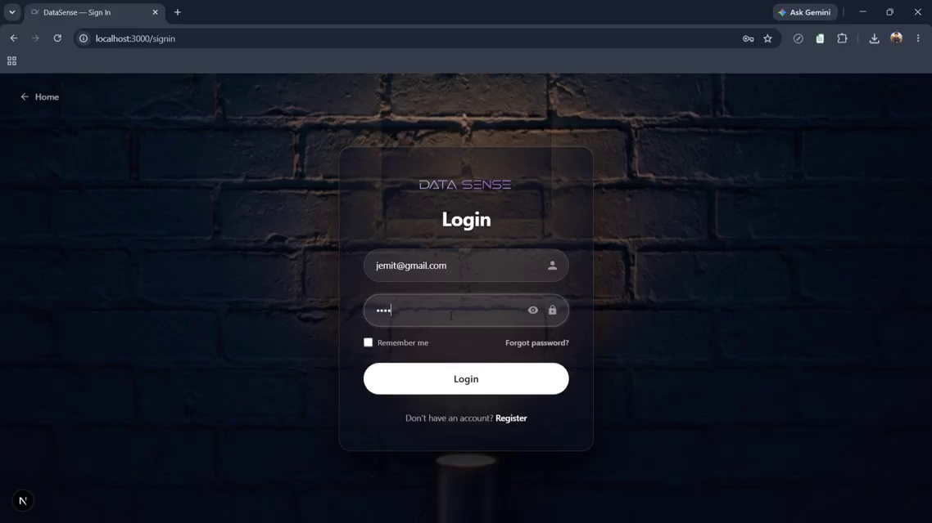
Fig 1. Sign-in screen. Dark background (brick photo texture, heavily darkened), centered glass-panel card.
Fields: Username, Password (with show/hide toggle), "Remember me" checkbox, "Forgot password?" link, primary Login button (white pill, full width), secondary "Register" link below.
- Decide deliberately whether the build needs auth at all for a portfolio demo, or whether this is skipped in favor of a single implicit session.
- If added: needs /signin, /register, forgot-password flow, and a session/JWT layer gating all other routes.

3.2 Landing / Home (/) — NOT in original spec
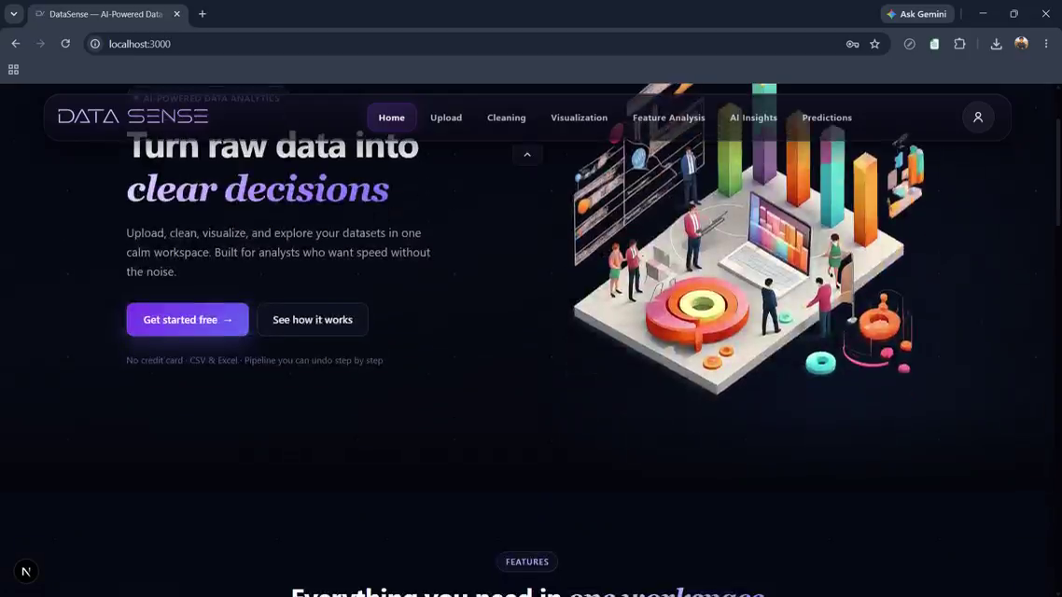
Fig 2. Hero section: headline "Turn raw data into clear decisions", subtext, two CTAs ("Get started free", "See how it works"), isometric illustration on the right.
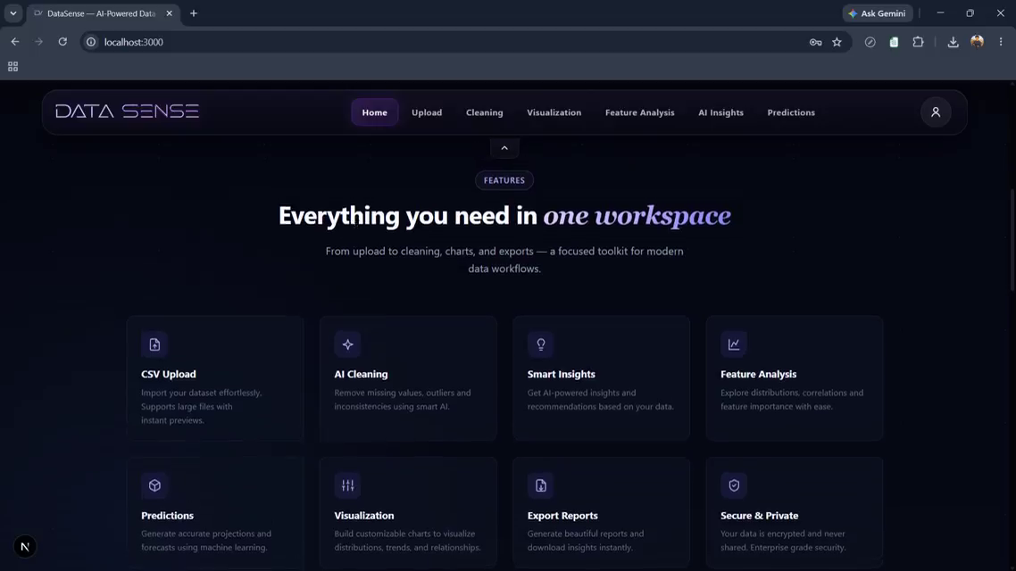
Fig 3. Feature grid section ("Everything you need in one workspace"): cards for CSV Upload, AI Cleaning, Smart Insights, Feature Analysis, Predictions, Visualization, Export Reports, Secure & Private — each a short label + one-line description.
Also present further down (seen in scrub, not screenshotted in full): a pricing section with Free / Pro / Enterprise tiers. Irrelevant to core functionality but confirms this is built/positioned as a SaaS product, not just a demo tool — informs whether you want a marketing shell around your app.

3.3 Upload & Dataset Library (/upload)
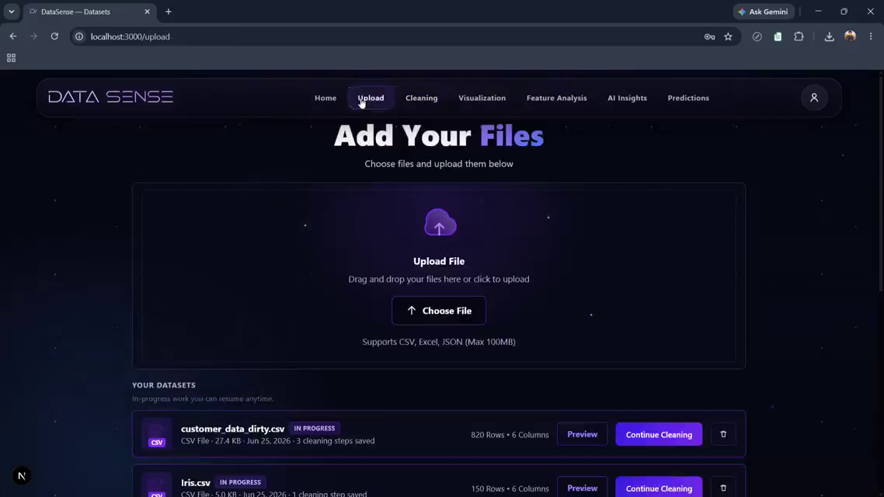
Fig 4. Upload screen: drag-and-drop zone with cloud icon, "Choose File" button, supported formats note (CSV, Excel, JSON, Max 100MB).
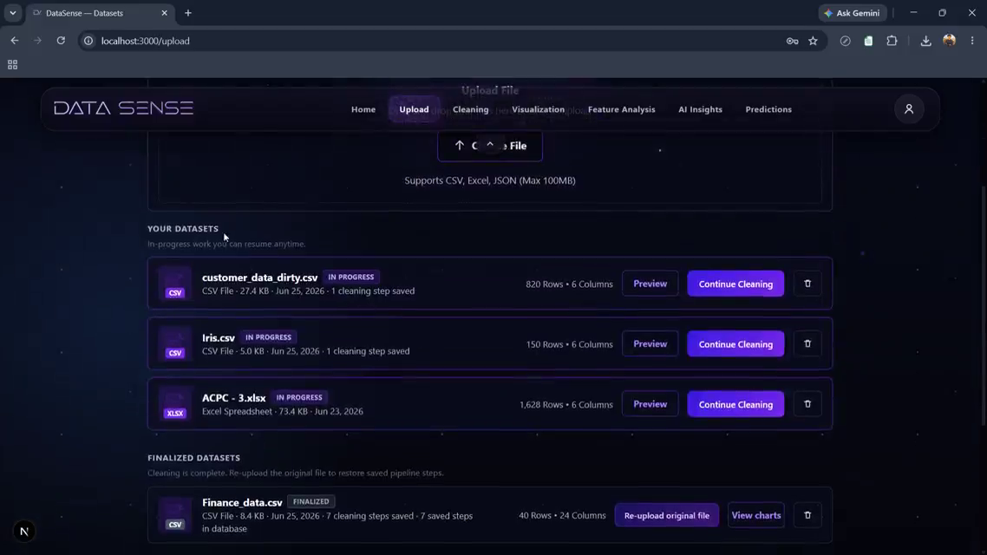
Fig 5. Below the upload zone: "Your Datasets" library, split into an in-progress section and a "Finalized Datasets" section.
Per-dataset row shows: file-type icon, filename, status badge (IN PROGRESS / FINALIZED), file type + size + upload date, "N cleaning steps saved", row count, column count, and action buttons that change by status:
- In progress: Preview · Continue Cleaning · Delete
- Finalized: Re-upload original file · View charts · Delete
This confirms cleaning state is saved per-dataset and resumable — matches the architecture note in section 2.

3.4 Dataset Preview (/preview)
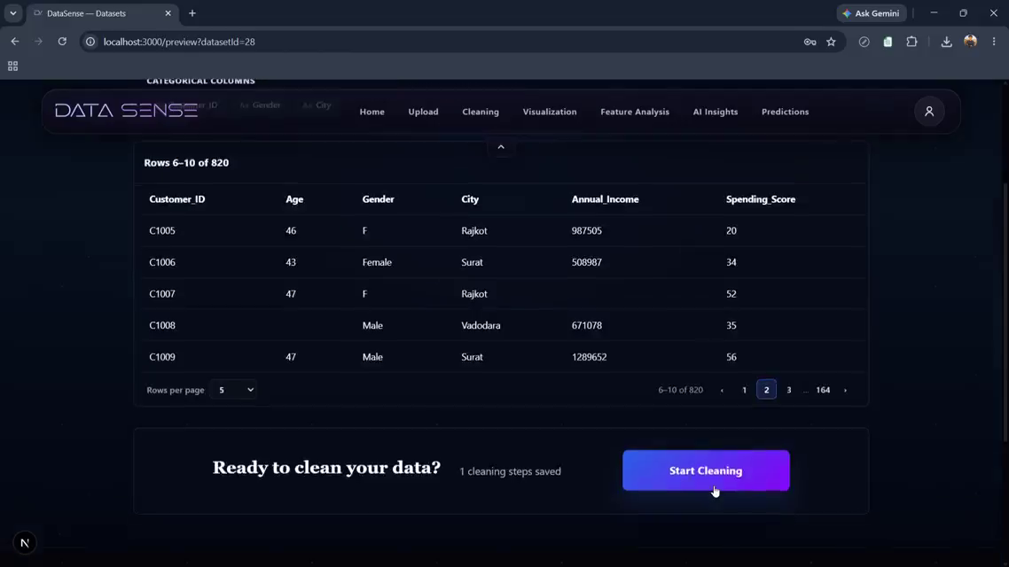
Fig 6. Row-level table view: Customer_ID, Age, Gender, City, Annual_Income, Spending_Score columns shown, with "Rows X–Y of N" label, a rows-per-page selector, and numbered pagination (1, 2, 3 … 164).
Bottom of the page has a "Ready to clean your data?" prompt with a gradient "Start Cleaning" button — this is the bridge into the Cleaning Studio. Original spec's "Dataset Preview" was a static first-10-rows card; this is a full paginated table browser.

3.5 Data Cleaning Studio (/cleaning) — biggest gap vs. original spec
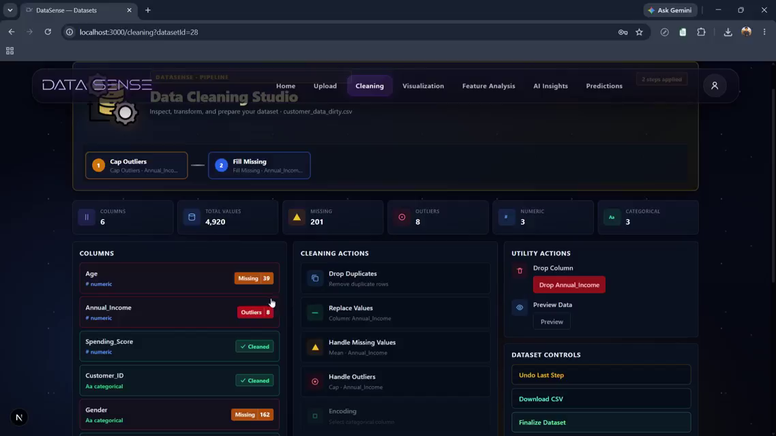
Fig 7. Full cleaning workbench layout, three-column body under a metrics strip.
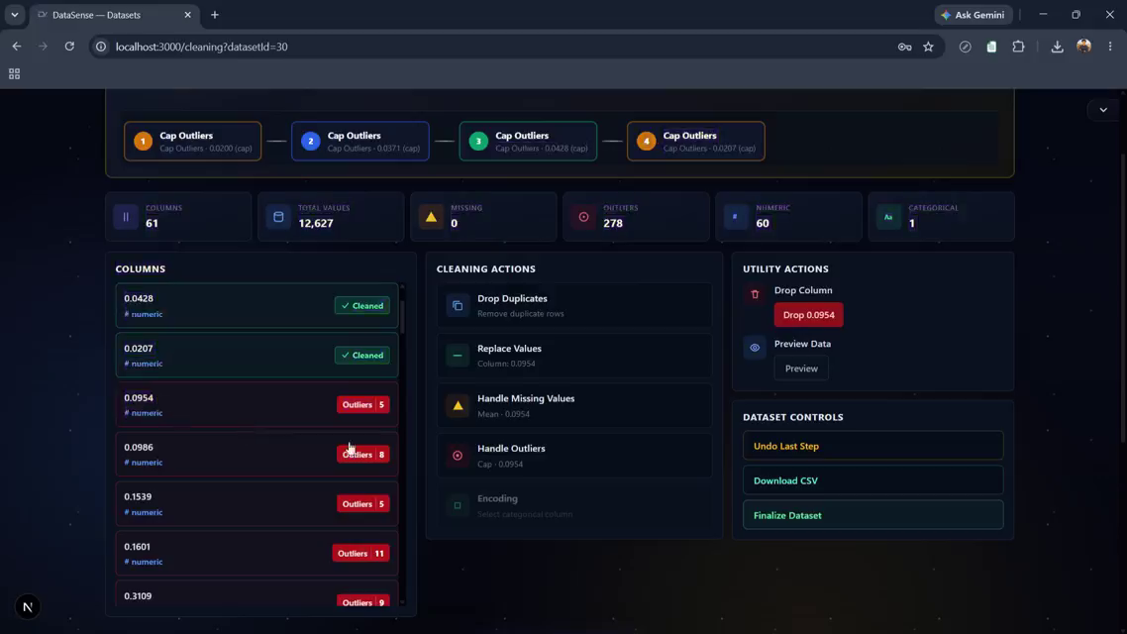
Fig 8. Pipeline breadcrumb at top of page: numbered chips (1, 2, 3, 4…) each showing the action + target column (e.g. "Cap Outliers · Annual_Income"), connected left-to-right — a visible, sequential history of every cleaning step applied so far.
Page header includes dataset name, an "N steps applied" badge, and a gear/pipeline icon block.

Metrics strip (5 cards)
- Columns — total column count
- Total Values — total cell count
- Missing — missing cell count
- Outliers — detected outlier count
- Numeric / Categorical — column type split

Left panel — Columns list
Every column listed with its detected type icon (# numeric / Aa categorical) and a status chip: a green "✓ Cleaned" tag once addressed, or a red count badge ("Missing 39", "Outliers 8") while unresolved. Clicking a column presumably scopes the middle panel's actions to it.

Middle panel — Cleaning Actions
- Drop Duplicates — remove duplicate rows
- Replace Values — on the selected column
- Handle Missing Values — with a strategy selector (e.g. Mean)
- Handle Outliers — with a strategy selector (e.g. Cap)
- Encoding — for categorical columns

Right panel — Utility & Dataset Controls
- Drop Column (destructive, shown in red) — targets the currently selected column
- Preview Data — inline preview button
- Undo Last Step
- Download CSV — export current cleaned state
- Finalize Dataset — locks the dataset, moves it to "Finalized" in the library
Implied backend surface for this screen alone:
POST /api/datasets/{id}/cleaning/actions
{ "action": "drop_duplicates" | "replace_values" | "handle_missing"
| "handle_outliers" | "encode" | "drop_column",
"column": "Annual_Income", "strategy": "mean" | "cap" | ... }
-> { "step_id", "pipeline": [...], "metrics": {...} }
POST /api/datasets/{id}/cleaning/undo -> { "pipeline": [...] }
GET /api/datasets/{id}/cleaning/download -> CSV blob
POST /api/datasets/{id}/finalize -> { "status": "finalized" }

3.6 Visualization (/visualization) — upgrade vs. original spec
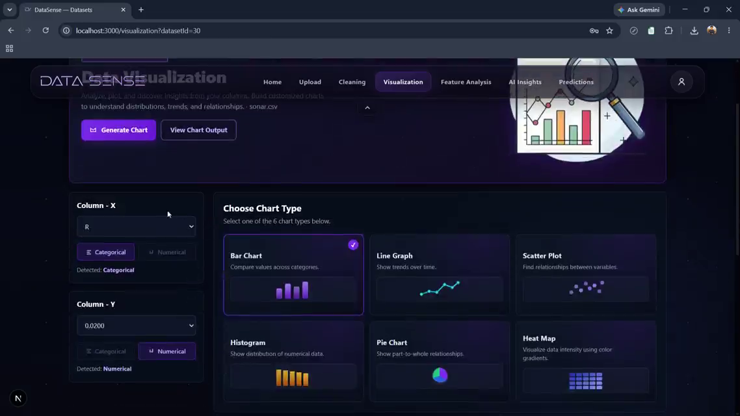
Fig 9. Column-X and Column-Y selectors on the left, each with a Categorical/Numerical toggle and an auto-detected type label ("Detected: Numerical"). Right side: six chart-type cards (Bar Chart, Line Graph, Scatter Plot, Histogram, Pie Chart, Heat Map), each with a one-line description and a small preview glyph. Selected type is outlined + check-marked.
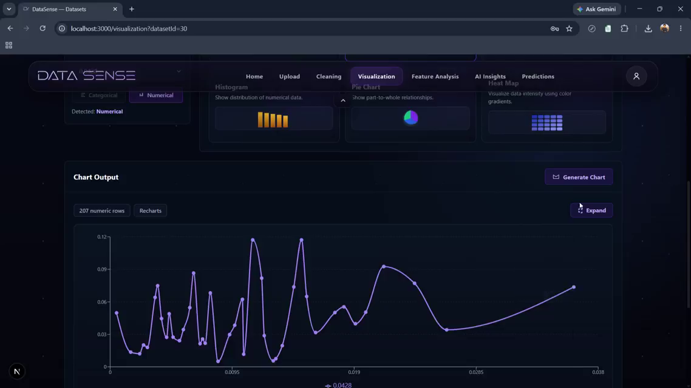
Fig 10. Chart Output area after "Generate Chart": renders via a stated charting library ("Recharts" tag visible next to a row-count tag), with an "Expand" control for full-screen view.
Original spec: one dropdown, one column, one auto-rendered distribution. Reference app: full bivariate exploration (X vs Y, 6 chart types, explicit generate action, expand-to-fullscreen). This is a meaningfully bigger visualization module than what was originally scoped.

3.7 Feature Analysis (/feature-analysis) — NOT in original spec
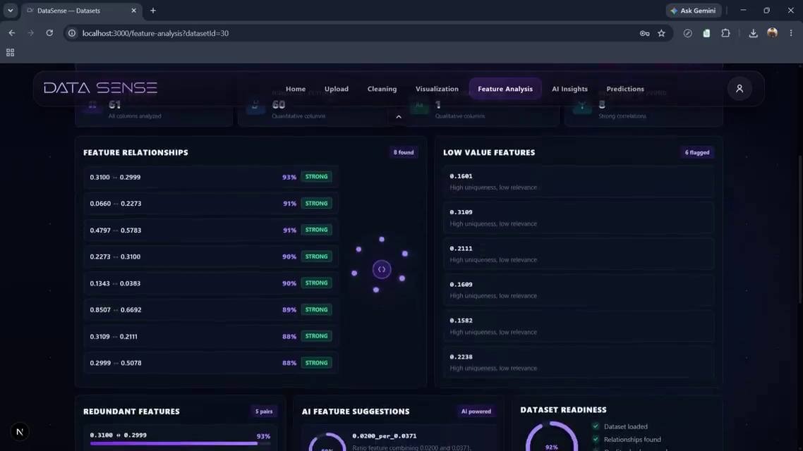
Fig 11. Three-panel layout: "Redundant Features" (left, pairs of highly-correlated columns with a similarity % and bar), "AI Feature Suggestions" (middle, AI-generated derived-feature ideas — e.g. a ratio feature or interaction term — each with a confidence ring and a "Generate Feature" button), "Dataset Readiness" (right, a circular ML-readiness score with a checklist: dataset loaded, relationships found, quality checks passed, numeric features present, ML-ready status).
This is a dedicated pre-training diagnostics step: it tells the user which columns are redundant and offers to synthesize new features before they hit Train. Nothing like this exists in the original spec — closest analog is the AI-suggestion banner in Step 3, but that's target-column suggestion only, not feature engineering.

3.8 AI Insights (/ai-insights) — spec has a banner, reference has a full module
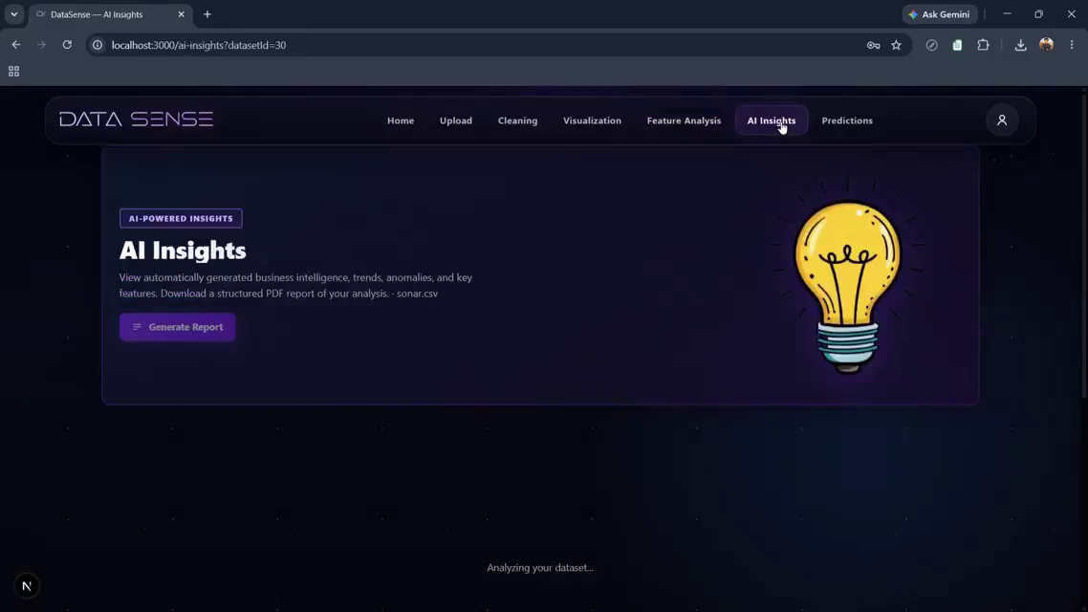
Fig 12. Section intro: "AI Insights" headline, description, and a single "Generate Report" action that kicks off analysis ("Analyzing your dataset..." loading state).
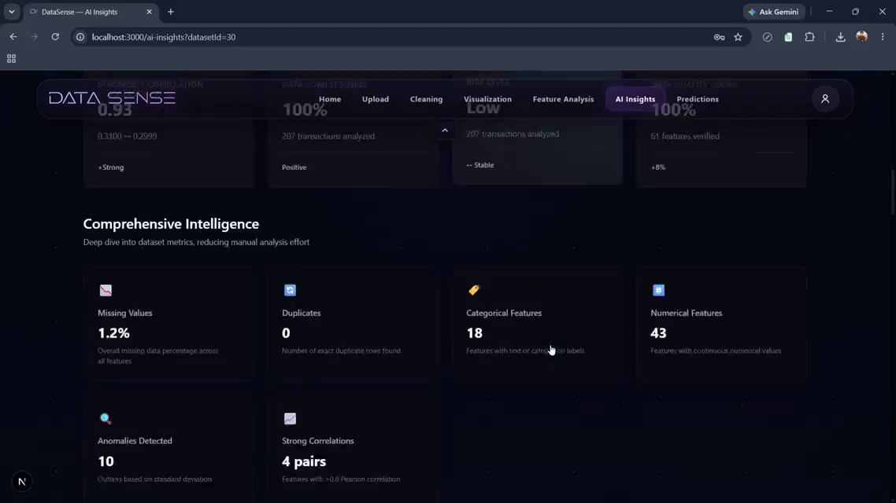
Fig 13. Top metric row (Dataset Correlation, Data Completeness, Risk Level, Data Quality Score, each with a supporting stat like "207 transactions analyzed" and a trend note) followed by a "Comprehensive Intelligence" grid: Missing Values %, Duplicates, Categorical Features count, Numerical Features count, Anomalies Detected count, Strong Correlations (pair count).
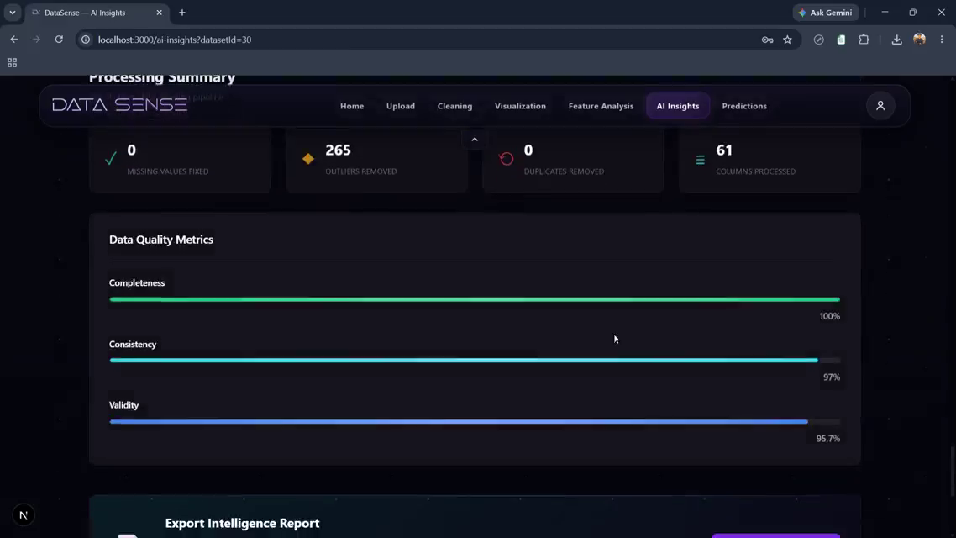
Fig 14. "Processing Summary" + "Data Quality Metrics": Missing Values Fixed / Outliers Removed / Duplicates Removed / Columns Processed counters, plus Completeness / Consistency / Validity progress bars with percentages.
Also generates a narrative section, "The Data Story" — an auto-written paragraph in plain English summarizing the dataset (row/column counts, general character of the data, e.g. "business operational data"), followed by an "Executive Summary" block. See section 3.10 for the exported PDF version.

3.9 Business Risk Assessment (part of AI Insights flow)
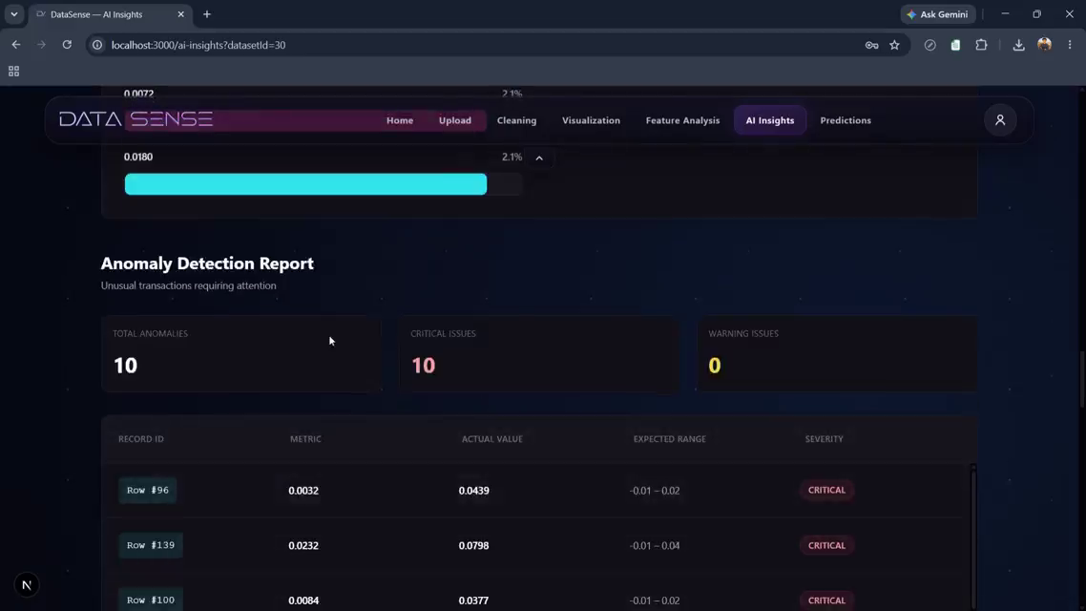
Fig 15. "Overall Risk Assessment" — a circular score/gauge (e.g. "3"), followed by "Risk Breakdown by Category": Revenue Risk, Expense Risk, Operational Risk, Data Quality Risk, each as a labeled progress bar. Below that, a "Recommended Actions" list (short imperative bullets, e.g. conduct a review, implement a monitoring dashboard, schedule a data-quality audit).
This reframes part of the tool from "train a model" to "assess business risk from this dataset." Bigger scope than the original spec intended — flag as an explicit scope decision, not an assumed add-on.

3.10 Anomaly Detection Report (part of AI Insights flow)
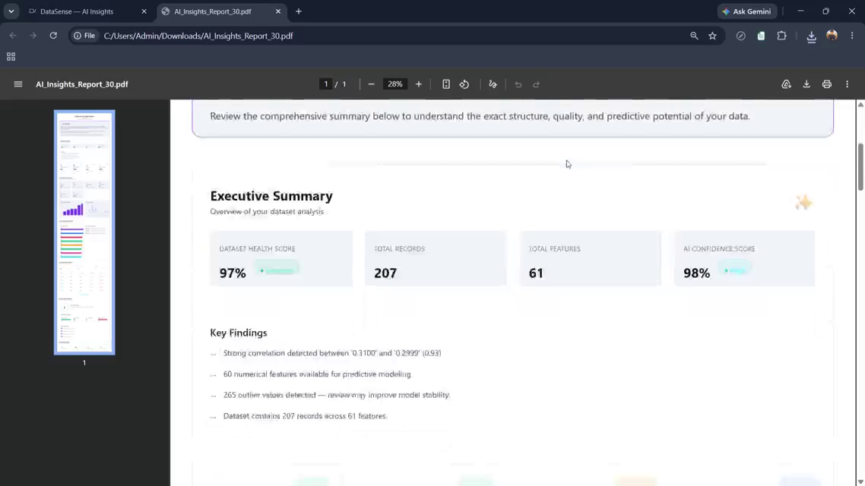
Fig 16. Dedicated anomaly table: Total Anomalies / Critical Issues / Warning Issues counters, then a row-level table — Record ID, Metric, Actual Value, Expected Range, Severity (badge: CRITICAL/WARNING) — for every flagged record.
Distinct from the aggregate "Anomalies Detected" count on the main AI Insights grid — this is the drill-down, row-by-row view.

3.11 Exported PDF Report — genuinely new deliverable, not in spec
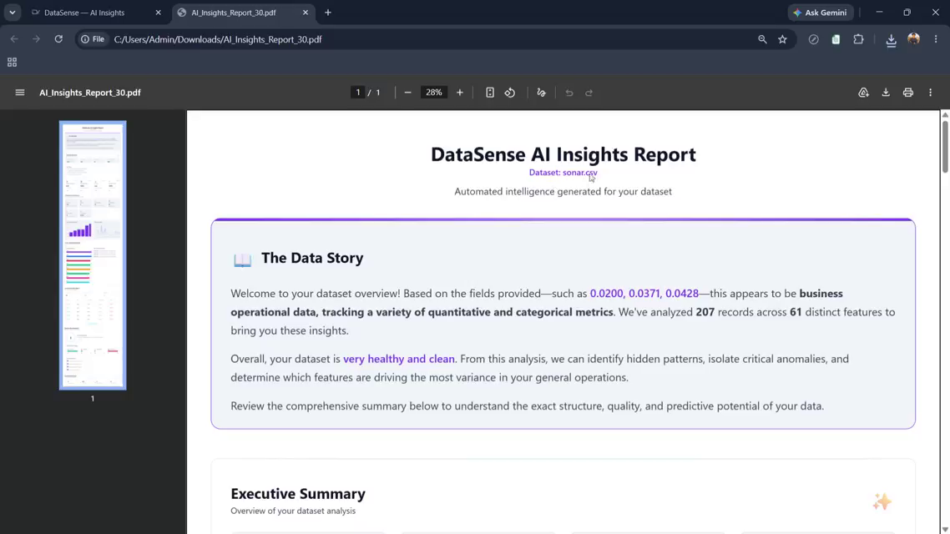
Fig 17. "Generate Report" produces a real downloadable PDF (seen opened in a new browser tab: AI_Insights_Report_{datasetId}.pdf). Contains: title, dataset name, "The Data Story" narrative panel, "Executive Summary", and further down the same Processing Summary metrics seen in-app.
This is worth building: it demonstrates the product can turn model/analysis output into a shareable, non-technical document — a strong signal in a portfolio context, and moderate effort if you're already computing the underlying stats (server-side HTML → PDF, e.g. via a headless-browser render or a PDF templating library).

3.12 Predictions (/predictions) — different problem type than original spec, not just a UI variant
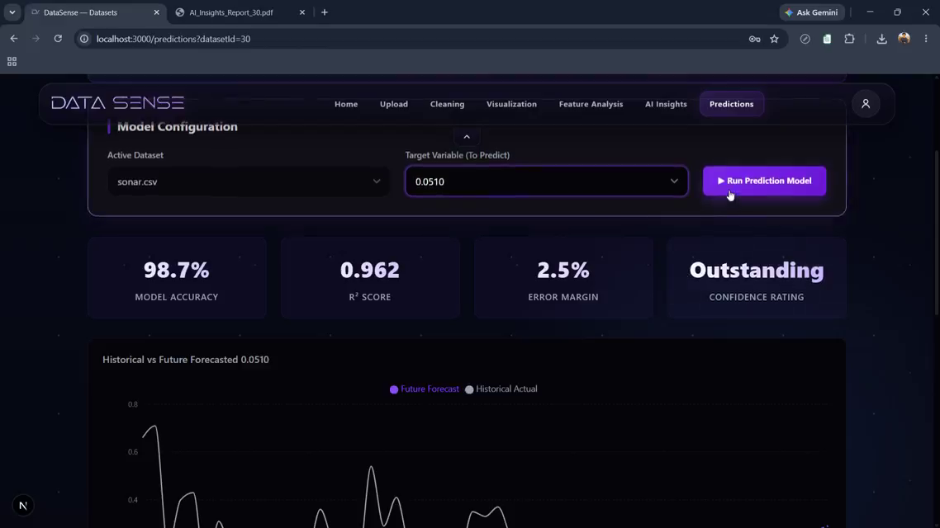
Fig 18. "Predictive Intelligence" header ("Leverage advanced XGBoost and gradient ensemble models to forecast metrics with high accuracy"). "Model Configuration" panel: Active Dataset dropdown, Target Variable dropdown, "Run Prediction Model" button. On run: circular loading state with status text ("Initializing compute cluster...", "Fitting gradient ensemble models..."), then a "Training Model..." button label.
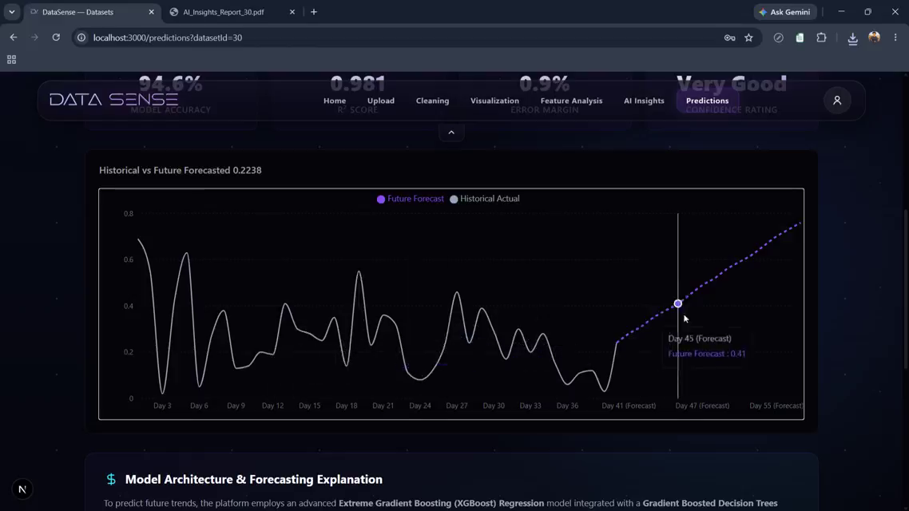
Fig 19. Result state: four metric cards — Model Accuracy %, R² Score, Error Margin %, Confidence Rating (text label such as "Very Good" / "Excellent" / "Outstanding") — followed by a "Historical vs Future Forecasted" line chart. The line is solid for historical actuals and switches to a dotted purple line for the forecast horizon (axis labeled Day 3 → Day 55 (Forecast)), with a hoverable tooltip on forecast points (e.g. "Day 45 (Forecast): 0.41").
Below the chart: "Model Architecture & Forecasting Explanation" — an auto-generated plain-English paragraph naming the actual algorithm (e.g. "Extreme Gradient Boosting (XGBoost) Regression integrated with Gradient Boosted Decision Trees") and why it was chosen.
Important distinction — flag this clearly to whoever scopes the build:
- Original spec's Step 4/5 = classic AutoML: train 10 named models (Logistic/Ridge Regression, Decision Tree, Random Forest, Gradient Boosting, XGBoost, LightGBM, SVM, KNN, Neural Net), rank by classification/regression metrics on a leaderboard.
- Reference app's Predictions screen = single-model time-series forecasting: one active model, a forecast horizon in days, historical-vs-future chart. This is a different ML problem type (forecasting vs. tabular classification/regression), not a restyled leaderboard.
- Do not assume the leaderboard UI and the forecast UI are interchangeable skins on the same backend — they require different pipelines. Decide whether to build both, replace one with the other, or keep the original leaderboard and add model-explanation text only (cheapest, still valuable).

4. Design system reference (extracted from frames)

4.1 Color palette
Swatch use | Approx. hex | Where seen
Page background | #0B0F19 – #0E1220 | Global app background (near-black navy); confirmed via page theme-color meta tag on the deployed build
Card / panel background | #151A2C – #1A2036 | Metric cards, panels, table rows
Primary accent (brand) | #7C3AED – #8B5CF6 (violet/indigo) | Primary buttons, active nav item, chart accents, gradient CTAs
Secondary accent | #4F46E5 (indigo) blended with violet | Gradient buttons ("Start Cleaning", "Start Free Trial")
Success / positive | #22C55E – #34D399 (green) | "Cleaned" tags, completeness bars, low-risk labels
Warning | #F59E0B (amber) | Missing-value badges, warning issue counts
Danger / critical | #EF4444 – #F87171 (red) | Outlier badges, Drop Column button, critical severity tags
Text — primary | #F5F5F7 (near white) | Headlines, primary body text on dark background
Text — muted | #8A8FA3 (gray) | Secondary/help text, captions, placeholder text

4.2 Typography
- Headline / display: bold geometric sans-serif, wide letter-spacing on the "DATA SENSE" logotype specifically (looks like a display/tech font, letters spaced out — not the same font as body copy).
- Body / UI: clean grotesque sans-serif (rounded terminals visible on lowercase a/e) — consistent with something in the Inter / General Sans / Manrope family; exact font not verifiable from screenshots alone.
- Numeric metrics (stat cards): large bold weight, tight tracking, often gradient-filled text on hero stats (e.g. accuracy %, confidence rating).
- Recommend confirming exact font family by inspecting computed styles in devtools if pixel-perfect matching matters; otherwise Inter (UI) + a wide-tracking display face for the logo is a safe close match.

4.3 Visual language / effects
- Dark glassmorphism: translucent panels with subtle blur and thin light borders over the dark background (most visible on the login card over the brick photo).
- Glow accents: soft violet glow/shadow around primary buttons and active nav pills.
- Rounded corners throughout — cards, buttons, inputs all use a consistent medium radius (approx 12–16px).
- Gradient buttons (violet → indigo) reserved for primary/high-commitment actions: Start Cleaning, Start Training/Run Prediction Model, Start Free Trial.
- Status badges are pill-shaped, color-coded by state (green = good/cleaned, amber = warning/in progress, red = critical/error).
- Subtle dot-grid background texture on darker empty sections (visible behind cards in Feature Analysis, Visualization output panels).
- Persistent top nav bar stays fixed across all authenticated routes, with the active section highlighted as a filled pill.

5. Summary: what to add, by priority
Feature | Priority | Why
Data Cleaning Studio (interactive, per-column actions, undo, pipeline history) | High | Biggest functional gap vs. spec; makes the product feel real instead of a demo
Model explanation text on results | High | Cheap to add, strong portfolio signal (shows interpretability)
AI-generated PDF report export | High | Turns analysis into a shareable artifact; good demo moment
Dataset library with persistence/resume | Medium | Mostly UI + a datasetId-based data model instead of job_id
Visualization X/Y + 6 chart types | Medium | Straightforward upgrade of an already-planned screen
Feature Analysis (redundancy + AI feature suggestions) | Medium | Good differentiator, moderate effort if correlation logic already exists for the AI-insights step
Business Risk Assessment | Low / optional | Scope creep into a different product angle — only add if you want that positioning
Time-series forecasting (Predictions) | Low / decide explicitly | Different ML problem type from the planned leaderboard — real engineering effort, don't fake it
Auth (login/register) | Low / optional | Only needed if this becomes multi-user; skip for a single-demo portfolio piece
Marketing landing page + pricing | Low / optional | Cosmetic wrapper, not functional — nice-to-have, not core
— End of document —

