Week 1 Task: Data Science Project Planning and Strategy Design
T20 Cricket Match Score Prediction & Performance Analytics
Prepared by: SRIRAJ W.V.P.S

1. Introduction & Background

Hypothetical Problem
T20 franchise cricket generates vast amounts of ball-by-ball data, but teams often struggle to translate raw statistics into real-time, actionable strategies. A data science approach utilizing Python can identify hidden patterns in player matchups, pitch conditions, and venue history.
Motivation
Predicting match outcomes and optimizing player selection using data-driven insights provides a competitive edge in high-stakes tournaments.

2. Project Objectives & Scope

Objectives
1. Develop a machine learning model to predict the first-innings score based on the first 6 overs (Powerplay).
2. Analyze player matchups (e.g., specific batter vs. spin bowlers) to recommend optimal playing XIs.
In-Scope
Historical ball-by-ball data, player statistics, venue data, and toss decisions.
Out-of-Scope
Real-time weather forecasting, ticket sales analytics, and stadium attendance metrics.

3. Methodology & Strategy

Data Collection
Acquire historical T20 match datasets containing ball-by-ball logs.
Data Cleaning
Handle missing values in player names, standardize venue names, and filter out rain-affected or truncated matches.
Exploratory Data Analysis (EDA)
Visualize run rates across different phases of the game and plot player strike rates against specific bowling types.
Modeling
Train regression models for score prediction and classification models for match-winner prediction.
Evaluation
Use metrics like Mean Absolute Error (MAE) for score prediction and accuracy/F1-score for win classification.
Diagram: Data Science Lifecycle
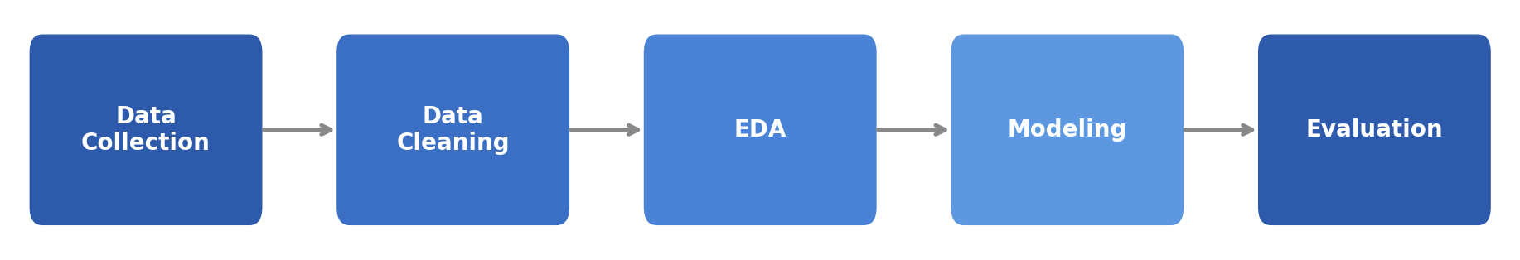

4. Timeline & Tools (35 Hours)

Phase 1 (Hours 1-5)
Project Scoping & Data Acquisition (Python libraries: requests, BeautifulSoup).
Phase 2 (Hours 6-12)
Data Cleaning & Preprocessing (Python libraries: pandas, numpy).
Phase 3 (Hours 13-20)
EDA & Visualization (Python libraries: matplotlib, seaborn, plotly).
Phase 4 (Hours 21-30)
Model Building & Evaluation (Python libraries: scikit-learn, xgboost).
Phase 5 (Hours 31-35)
Final Review & Documentation (Tools: Jupyter Notebook, MS Word).

5. Expected Outcomes & Challenges

Expected Outcomes
A robust predictive model capable of estimating scores with a defined margin of error, and a comprehensive dashboard mapping key player matchups.
Anticipated Challenges
High variance in T20 matches, changes in squad compositions, and sparse data for newly debuted players.
Mitigation Strategy
Implement rolling averages for player form rather than relying solely on career statistics, and utilize ensemble learning methods to handle variance.

