Exploratory Data Analysis (EDA) & Visualization Framework
1. Executive Summary & Introduction

Exploratory Data Analysis (EDA) is a fundamental step in the data science pipeline. It serves as an initial investigation process designed to understand the underlying structure, detect anomalies, test statistical assumptions, and uncover patterns within raw data before applying formal predictive modeling.
EDA Pipeline Overview
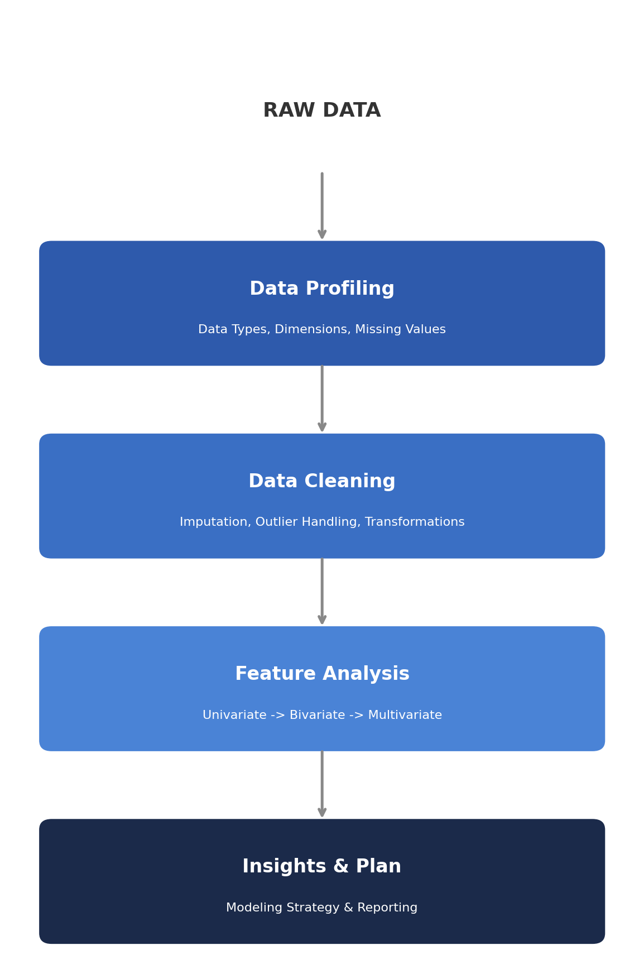
Strategic Objectives of EDA
- Assess Data Quality: Identify missing values, duplicate entries, inconsistent formats, and erroneous data points.
- Understand Variable Distributions: Evaluate central tendency, dispersion, skewness, and modality across numeric and categorical features.
- Evaluate Relationships: Uncover correlations, feature dependencies, and interaction dynamics between target variables and predictors.
- Inform Feature Engineering: Decide which transformations (e.g., log scaling, encoding, binning) will optimize downstream model performance.
2. Taxonomy of Data Types

A robust EDA process begins by categorizing features into explicit data types, as each type dictates specific handling and visualization methods:
Category | Sub-type | Examples | Preferred Summary Metrics
Numerical | Continuous | Height, Temperature, Income | Mean, Std Dev, Median, IQR, Skewness
Numerical | Discrete | Patient counts, Web page visits | Median, Mode, Range, Frequency Tables
Categorical | Nominal | Country, Eye color, Marital status | Mode, Relative Frequency (%)
Categorical | Ordinal | Education level (BSc, MSc, PhD), Rating (1-5) | Median, Mode, Quantiles
Temporal / Spatial | Datetime / Coordinates | Timestamp, GPS Lat/Long | Min/Max Range, Aggregated Freq. by Interval

3. Data Exploration & Preparation Techniques

3.1 Missing Data Management
Missing data can significantly distort modeling results if handled incorrectly. The underlying mechanism determines the appropriate treatment.
Classify Missingness Mechanism
- Missing Completely at Random (MCAR): Missingness is unrelated to any variable in the dataset.
- Missing at Random (MAR): Missingness depends on observed data but not on the missing data itself.
- Missing Not at Random (MNAR): Missingness depends on the unobserved value itself (requires domain-specific modeling).
Treatment Protocol
- Threshold Dropping: Features missing more than 40-50% of values are dropped unless domain-critical.
- Numerical Imputation - Normal distributions: Mean Imputation.
- Numerical Imputation - Skewed distributions: Median Imputation.
- Numerical Imputation - Complex correlations: K-Nearest Neighbors (KNN) or Multivariate Imputation by Chained Equations (MICE).
- Categorical Imputation: Mode imputation or setting missing entries as a distinct categorical level ("Unknown").
3.2 Outlier Detection & Mitigation
Outliers can bias statistical estimates such as the mean and variance.
Detection Methods
Interquartile Range (IQR) Rule — for non-normally distributed data, a point x is flagged as an outlier if:
IQR = Q3 − Q1
x < Q1 − 1.5 × IQR or x > Q3 + 1.5 × IQR
Z-Score Method — for normally distributed features, data points with an absolute Z-score greater than 3 are flagged:
Z = (x − μ) / σ
Mitigation Options
- Winsorization (Capping): Clip values at the 1st and 99th percentiles to preserve sample size while muting extreme values.
- Mathematical Transformation: Apply log(x + 1) or Box-Cox transformations to reduce right-skewness.
- Removal: Trim entries only when proven to be data collection errors or irredeemable corruption.
3.3 Analytical Methods
A. Univariate Analysis
Explores features individually to establish baseline properties.
- Metrics: Summary statistics (Mean, Median, Standard Deviation, Skewness, Kurtosis).
- Visuals: Histograms, Kernel Density Estimations (KDE), Boxplots, Frequency Bar Plots.
B. Bivariate Analysis
Examines the relationship between pairs of variables.
- Numeric vs. Numeric: Pearson/Spearman correlation coefficients, Scatter plots.
- Numeric vs. Categorical: Grouped Boxplots, Violin plots, ANOVA testing.
- Categorical vs. Categorical: Cross-tabulations, Contingency Tables, Stacked Bar Charts, Chi-Square test of independence.
C. Multivariate Analysis
Evaluates complex interdependencies among three or more features.
- Correlation Heatmaps: Visual representation of correlation matrices.
- Dimensionality Reduction Visualizations: PCA or t-SNE projections to identify natural clusters in high-dimensional data.
- Pairplots & Facet Grids: Multi-panel plots displaying scatter distributions filtered by categorical slices.

4. Visualization Framework & Plotting Strategies

Selecting the correct visual format ensures patterns are clearly communicated:
Chart Type | Input Dimensions | Core Purpose | Key Insight Uncovered
Histogram / KDE | 1 Continuous | Distribution shape evaluation | Normality, bimodality, skewness
Box Plot | 1 Continuous (+ optional Categorical) | Dispersion & Outliers | Outliers, median alignment, IQR spread
Bar / Count Plot | 1 or 2 Categorical | Frequency comparison | Category dominance, class imbalance
Scatter Plot | 2 Continuous (+ optional Categorical hue) | Relationship detection | Linearity, clusters, variance heteroscedasticity
Correlation Heatmap | Matrix of Continuous | Multicollinearity assessment | Feature redundancy, strong predictors
Line Chart | 1 Datetime + 1 Continuous | Trend over time | Seasonality, cyclic behavior, structural breaks
Violin Plot | 1 Continuous + 1 Categorical | Density distribution across groups | Multi-modal distributions inside categories

5. Technical Stack & Python Libraries

Library | Key Purpose & Contribution in Framework
pandas | Primary framework for data ingestion, cleaning, aggregation, boolean masking, time-series resampling, and structural profiling.
numpy | High-performance array operations, linear algebra calculations, vectorization, and statistical operations.
matplotlib | Foundation plotting library for creating custom visuals, controlling figure geometry, axes layout, and file export formatting.
seaborn | High-level statistical visualization layer providing attractive themes, default statistical aggregations, heatmaps, and pair plots.
plotly | Interactive graphics generator used for exploratory hover details, dynamic zooming, filtering, and responsive web integration.
ydata-profiling (Optional) | Automated initial profiling tool to generate comprehensive overview reports (distributions, missing values, duplicates) in HTML format.

6. Reporting, Documentation & Communication Plan

A thorough EDA plan culminates in a structured diagnostic report designed for both technical and non-technical stakeholders.
Structure of the Final EDA Report
Executive Summary
- Overview of dataset scope, sample size, and high-level findings.
- Critical business insights and immediate data risks.
Data Health & Quality Diagnostics
- Summary of missingness patterns and implemented imputation strategies.
- Identified anomalies, outliers, and data collection issues.
Feature Distribution & Trend Analysis
- Core univariate insights (key variable distributions).
- Key bivariate and multivariate relationships illustrated with annotated visual plots.
Actionable Recommendations for Next Phases
- Candidate features for transformation, encoding, or engineering.
- Recommendations on algorithm selection based on data characteristics (e.g., non-linear models for non-normal continuous features).

