Week 3 Task: Python-Based Machine Learning Model Development & Evaluation Plan
T20 Cricket Match Score Prediction & Win Chance Analytics
W V P S SRIRAJ

1. Problem Definition & Business Justification

Problem Statement
In T20 cricket, predicting final scores and win chances in real-time is difficult. Simple historical averages fail because stadium sizes, pitch behavior, and individual player matchups change constantly.
Solution Concept
Build a Python machine learning system with two main goals:
- Score Predictor: Estimate the total first-innings score right after the Powerplay (Over 6.0).
- Win Predictor: Estimate which team has a better chance of winning at key points during the match.
Business Value
Helps team managers make data-backed choices about target scores, bowling choices, and player matchups.
2. Data Preprocessing & Feature Engineering Plan

Data Cleaning
- Remove matches stopped by rain or altered by DLS rules to keep data consistent.
- Fill in missing text items (like bowler types) using the most common values.
- Fill in missing numbers (like pitch ratings) using middle values (median).
Feature Engineering
- Recent Form: Calculate batter strike rates and bowler economy rates over their last 5 matches.
- Stadium Stats: Calculate average scores and boundary numbers for each venue.
- Matchups: Track how specific batters perform against specific bowling types (e.g., right-handed batter vs. left-arm spin).
Encoding & Scaling
- Convert text categories (teams, stadium names) into numbers using OneHotEncoder.
- Adjust numerical ranges (scores, run rates) using StandardScaler so large numbers do not distort model training.
Preventing Data Leakage
Use only data recorded before Over 6.0 so the model never uses future information to make past predictions.

3. Machine Learning System Architecture & Workflow

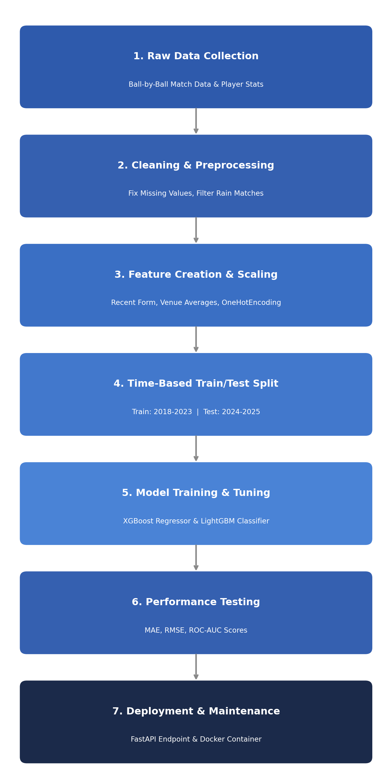
4. Model Selection & Tuning Strategy

Prediction Task | Basic Model | Chosen Advanced Model | Reason for Selection
Score Prediction | Linear Regression | XGBoost Regressor | Handles complex connections well (e.g., stadium size + wickets lost) without getting confused by extreme scores.
Win Prediction | Logistic Regression | LightGBM Classifier | Fast, handles categorical details smoothly, and works well when team statistics vary.

Hyperparameter Tuning
Use automated tools like Optuna to test different settings (like tree depth or learning speed) to find the setup with the lowest error.
5. Performance Evaluation & Validation Strategy

Validation Method
Avoid random shuffling. Instead, split the data by time (years). Use older matches (2018-2023) to train the model and newer matches (2024-2025) to test it.
Evaluation Metrics
- Mean Absolute Error (MAE): Shows how many runs off the score prediction is on average.
- ROC-AUC Score: Measures how accurately the model ranks win probabilities across different match situations.

6. Model Deployment & Maintenance

Deployment
Package the model with FastAPI so it can deliver instant predictions over web requests. Place everything inside a Docker container so it runs smoothly on any server.
Monitoring & Updates
Use tools like Evidently AI to check if new tournament rules (like the Impact Player rule) change how matches play out. Automatically retrain the model every week with new match results.

