Untitled

Wouter Van Rossem

3/23/2020

When you click the **Knit** button a document will be generated that includes both content as well as the output of any embedded R code chunks within the document. You can embed an R code chunk like this[1]

# R Markdown

This is an R Markdown document. Markdown is a simple formatting syntax for authoring HTML, PDF, and MS Word documents. For more details on using R Markdown see <http://rmarkdown.rstudio.com>.

When you click the **Knit** button a document will be generated that includes both content as well as the output of any embedded R code chunks within the document. You can embed an R code chunk like this:

summary(cars)

1. ## speed dist   
   ## Min. : 4.0 Min. : 2.00   
   ## 1st Qu.:12.0 1st Qu.: 26.00   
   ## Median :15.0 Median : 36.00   
   ## Mean :15.4 Mean : 42.98   
   ## 3rd Qu.:19.0 3rd Qu.: 56.00   
   ## Max. :25.0 Max. :120.00

# Including Plots

You can also embed plots, for example:

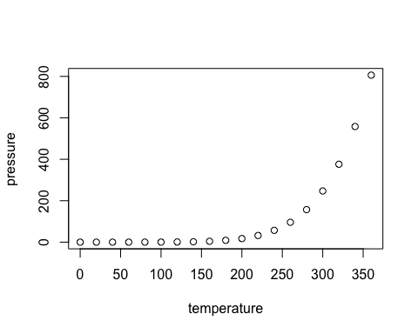

Note that the echo = FALSE parameter was added to the code chunk to prevent printing of the R code that generated the plot.

The following is a test block text:

Lorem ipsum dolor sit amet, consectetur adipiscing elit, sed do eiusmod tempor incididunt ut labore et dolore magna aliqua. Congue eu consequat ac felis donec. Risus commodo viverra maecenas accumsan lacus vel facilisis volutpat.

## Heading two point one

First a list:

1. Lorem ipsum dolor sit amet, consectetur adipiscing elit, sed do eiusmod tempor incididunt ut labore et dolore magna aliqua. Congue eu consequat ac felis donec. Risus commodo viverra maecenas accumsan lacus vel facilisis volutpat.
2. Lorem ipsum dolor sit amet, consectetur adipiscing elit, sed do eiusmod tempor incididunt ut labore et dolore magna aliqua. Congue eu consequat ac felis donec. Risus commodo viverra maecenas accumsan lacus vel facilisis volutpat.

Some new text. Next, a table

|  |  |  |
| --- | --- | --- |
|  |  |  |
|  |  |  |

Body text and next a bullet list:

* Bullet 1
* Bullet 2

### Subsubheading

Some text again.

#### Heading 4

Test

# Definitions

Text

Panel 1

Since the method described here is cross-disciplinary, we also take a cross-disciplinary approach to writing.

Some text

1. Test