**Jessa Mae F. Nopueto**

**2021-1-CIT207-BSCS2AAI**

**BSCS 2A AI**

**DEFINING TERMS**

1. Class

-A class can be defined as a template that describes the behavior or state that the object of its type support.

2. Object

- Object is an instance of a class.

3. Instantiate

- Instantiate in Java means to call a constructor of a Class which creates an instance or object, of the type of that Class. Instantiation allocates the initial memory for the object and returns a reference

4. Instance Variable

- Instance variables are declared in a class, but outside a method, constructor or any block.

5. Instance Method

- Instance method are methods which require an object of its class to be created before it can be called. To invoke an instance method, we have to create an Object of the class in within which it defined.

6. Class Variables or static member variables

- A static variable is common to all the instances (or objects) of the class because it is a class level variable.

7. Constructor

-A constructor is a special method used in declaring initial values for objects and their attributes.

**JAVA SCAVENGER HUNT**

1. Look for a method that checks if a certain String ends with a certain suffix. For example, if the given string is "Hello", the method should return true the suffix given is "lo", and false if the given suffix is "alp".

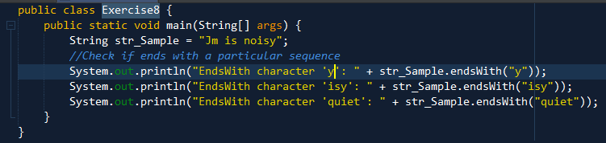

METHOD DECLARATION:

public boolean endsWith(String suffix)

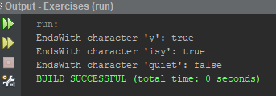OUTPUT:

2. Look for the method that determines the character representation for a specific digit in the specified radix. For example, if the input digit is 15, and the radix is 16, the method would return the character F, since F is the hexadecimal representation for the number 15 (base 10).

Class: Character

Method Declaration:

public static char forDigitRad(int digit, int radix)

Sample Usage:

char charValue = Character.forDigit(15, 16);

System.out.println(charValue);

Output: F

3. Look for the method that terminates the currently running Java Virtual Machine

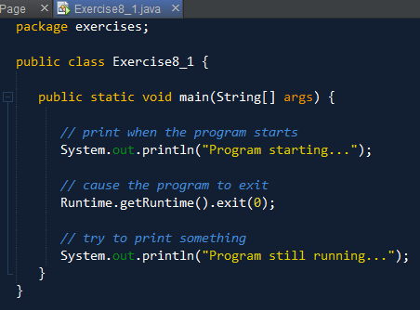

Sample Usage:

Runtime.getRuntime().halt(0)

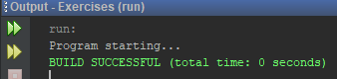Output:

4. Look for the method that gets the floor of a double value. For example, if I input a 3.13, the method should return the value 3.

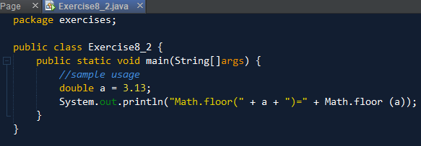

Output:

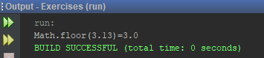

5. Look for the method that determines if a certain character is a digit. For example, if I input '3', it returns the value true.

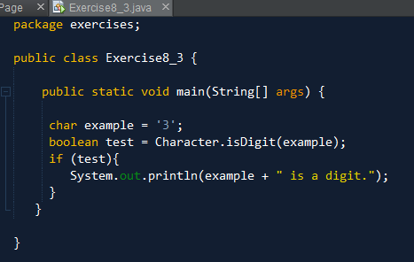

Output:

