Welcome to the American Congress Digital Archives Portal (ACDAP)!

We are excited that you are exploring our site and hope you have the opportunity to learn from these papers. The ACDAP is a work in progress. What you see today might be even larger the next time you visit, as we keep inviting more institutions and their collections.

The purpose of an archive is to house original documents that help tell a broader, more detailed story of American history. We invite you to think of the ACDAP as a portal. It brings all our contributors together in one place, helps organize all the documents, and then transports you to their site to see the originals. This enables us to compare viewpoints and materials from numerous members of Congress and tell a more complex and nuanced story.

Our archive focuses on the personal papers of our lawmakers. They include memos, letters to constituents, campaign materials, and much more. What you will find on the site is meant for you, the high school historian, but also for university historians, librarians, archivists, students working on their master’s degrees and PhDs, congressional researchers, and anyone interested in understanding our history through the lens of our members of Congress.

This scavenger hunt aims to introduce you to the ACDAP. The first section will “train” you on how the site is structured, the second section will ask you to apply what you've learned, and the third will challenge you to use the portal on your own.

Enjoy exploring our archives and learning the skills of practicing historians and archivists!

Section 1: Training
Task 1 | Training  - Spend a few minutes exploring the American Congress Digital Archives Portal.  - Click on the various buttons on the left side of the home screen to explore how the documents are organized.  Take a moment to hypothesize what you think the relationship is between the collections and the contributing institutions.  What do you think the relationships are?  ANSWER:
Task 2 | - Select “home” or “start over” to reset the portal  - Let’s do an experiment:  - Discover what happens when you type voting rights into the search bar.  - What happens when you put quotations around it? (“voting rights”)  - What happens when you just search vote?  - What happens when you also select a category from the menu on the left?  Why do you think the results change when you use different search strategies?  ANSWER:
Task 3 | Follow these steps:  - From the menu on the left side of the screen:  - Select “Policy Area” from one of the windows.  - Select: “Armed Forces and National Security”  - You will see many results from this search  - If you wanted to narrow your search so that there are fewer results, how might you do it?  (Multiple Choice)  - Select a member of Congress’ collection  - Put in a date range  - Choose a contributing institution  - All of the above
Task 4 | Let’s put these skills to work!  - From the menu on the left enter the date range from 1940-1941 (be sure to click “apply”)  - And the contributing institution select West Virginia University  - Find and select the clipping titled “U.S. Engineers Mapping Asiatic Routes for Flood of War Supplies to Russia” from 1941.  - Verify your work: You should be on the U.S. Engineers Mapping Asiatic Routes page  - Compare and contrast with the home page your teacher is projecting  - You should observe three things:
#1 Observe how the information on this page compares to the buttons on the home screen.
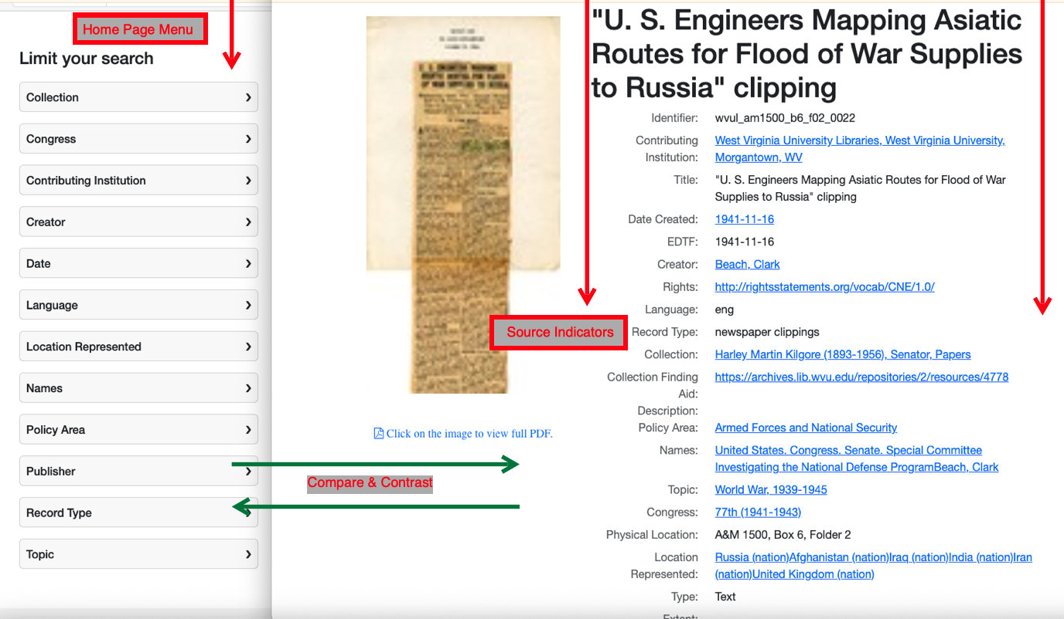

#2 Observe how the URL is congressarchives.org
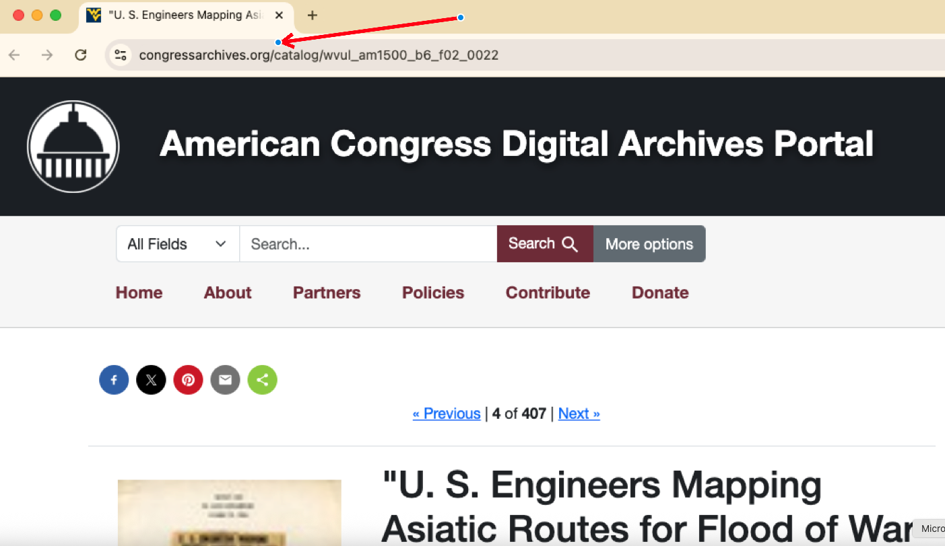

Task 5 | Now, click on the image to view the full PDF (located on the left side of the screen).  - Notice that the URL has changed, and the identifiers are now no longer linked.  - Verify your work: You should be on the U.S. Engineers Mapping Asiatic Routes page at West Virginia University.  - Once again, select: “click on the image to view full PDF”.
Task 6 | Based on what you have learned so far, why do you think the URL changed from americancongress.org to mcppc.lib.evu.edu?  - WVU is a contributing organization and has the original documents for Senator Kilgore, who represented West Virginia  - Clark Beach graduated from WVU  - WVU is the only organization that has WWII congressional documents
Task 7 | Select “home” or “start over” to reset the portal.  As you explore different collections, you'll notice that some institutions organize and label their information slightly differently.  For example, click on the contributing institution button and select Hawai’i Congressional Papers Collection.  Select any document and “click on the image to view full PDF”  You will notice that the University of Hawai’i at Mānoa Library does not have a thumbnail image and labels their files using alphanumeric characters.
Task 8 | Select “home” or “start over” to reset the portal.  Click on the “contributing institution” button and select Robert J. Dole Institute of Politics.  Select any document and “click on the image to view full PDF”  You will notice that the Robert J. Dole Institute of Politics takes you to their site, where the document is opened for you.
Task 9 | All of that is normal with any collection of archives. Just keep in mind, as you start exploring the ACDAP, that every document can be viewed, even if they have different formatting.  Take a moment to browse through the various contributors and observe how they are arranged.
Task 12 | You have finished the training section. Now it's time to put what you've learned to the test! Click on “Start Scavenger Hunt” to get started!

Section 1 Answer Key
Task | Answers
Task 1 | Great thinking! The contributing institutions can be independent organizations or Universities and will house the papers of members of Congress. Most contributing institutions house papers from several different members of Congress. For example, try selecting the University of Hawaii as a contributing institution. Then, when you select ‘collection’ you should see the names of several members of Congress including Senators Inouye and Matsunaga.
Task 2 | Well done! When you search using a single word, there is no need to use quotation marks. However, when you search a topic like voting rights, and do not put quotations around it, the search will provide documents about both voting and rights. But when you put quotations around it, it will only look for “voting rights” together. That is why you see more results when you search voting rights vs. “voting rights”
Task 3 | Any of the tabs on the left side will help you to narrow your search. In fact, you can choose several of them at the same time, to narrow your search even more.
Task 6 | Good work. WVU is a contributing organization and has the original documents for Senator Kilgore. Each contributing organization stores its documents on its own website. The ACDAP helps you locate and access them.

Section 2: Scavenger Hunt

Tasks | Student Instructions
Task 1 | American Congress Digital Archives Scavenger Hunt  For each question, unless otherwise indicated, always click “home” or “start over” before starting to reset your search.
Task 2 | In the search box, type Civil Rights, and click search.  On the left side, select ‘date’ and enter the years 1954-1969. (This narrows your search from all documents to only those in this time frame.)  Representative Matsunaga delivered a speech in 1963 to the JACL in Philadelphia. On page 6, what does he say was a reason his party members didn’t want him to run for Senate?  ANSWER:
Task 3 | What is another way to refine your search results and still locate Representative Matsunaga’s 1963 speech?  - By Creator  - By Contributing Institution  - By Collection  - All of the Above
Task 4 | Senator Howard Sutherland received a letter on June 24, 1918, from Mrs. Margaret Robinson. Which organization did she represent?  ANSWER:
Task 5 | What did she argue “every Anti-American element in the country favors?”  ANSWER:
Task 6 | Who gave a speech called “True Americanism”  - Senator Inouye  - Congressman Harley O. Staggers  - Senator Hiram L. Fong  - Senator Robert J. Dole
Task 7 | In his speech, he discusses the sacrifice of wounded veterans, soldiers who died in action, and their families. What war was going on when he gave the speech? (You may want to open a new tab and search “what war was going on in 1964?” to find the answer!)  - Korean  - Vietnam  - WWII  - Gulf War

Section 2 Answer Key
Task | Answers
Task 2 | Answer: His Japanese Ancestry  Great job! Representative  Matsunaga was first elected to the U.S. House of Representatives in 1963, a year before the Civil Rights Act of 1964.
Task 3 | Answer: All of the Above  Representative Matsunaga is the creator of the speech, the University of Hawai’i Mānoa provided the source, and the collection is called “Senator Spark M. Matsunaga Papers.”
Task 4 | Answer: Women’s Anti-Suffrage Association of Massachusetts  Mrs. Robinson was part of an organization that opposed women’s voting rights and the 19th Amendment to the Constitution.
Task 5 | Answer: Women’s Suffrage  It might be hard to believe today, but some people, like Mrs. Robinson, linked socialism and pro-German sympathies with the Amendment. Just remember, this was just before World War I ended, and many people were more focused on the war than women’s rights.
Task 6 | Answer: Senator Robert J. Dole  Robert (Bob) Dole delivered this speech in 1964.
Task 7 | Answer: Vietnam  In 1964, the Vietnam War was still in its early stages, and JFK was still alive. Little did Senator Dole know that the war was about to worsen, and casualty rates would keep rising.

Section 3: Testing Your Knowledge
Tasks | Student Instructions
Task 1 | You have done excellent work so far. Now...for the challenge!
Task 2 | What penalty did Senator Dirksen propose for interfering with or obstructing school desegregation cases as part of his suggested edits to the Civil Rights Act of 1960?  ANSWER:
Task 3 | In 1951, Senator Richard Russell received a copy of General MacArthur’s speech in Boston. You’ll notice quickly that MacArthur is angry. What does he say he must take if he doesn’t follow blindly or stay silent?  ANSWER:
Task 4 | Open a new tab. What happened three months prior to the speech, and who do you assume he is mad at?  ANSWER:
Task 5 | In May of 1992, who opposed an amendment to a House bill that would have had a chilling effect on which industry?  - Dole; Steel  - Dirksen; Automotive  - Rahall; Coal  - Inouye; Shipping
Task 6 | What kind of pandemic was being prepared for in Hawaii in 2008?  - Ebola  - SARS  - Small Pox  - Influenza
Task 7 | Robert McFarlane, a US Marine Corps officer and NSA advisor to Reagan, proposed a fallback plan in 1985 to support the Nicaraguan Resistance. His ‘concept’ was that which people should contribute funds?  ANSWER:
Task 8 | Mr. and Mrs. Barns wrote separately to Congressman Staggers to express their concerns about the rising cost of gasoline. What were they both writing to oppose?  - Rationing  - The Watergate Crisis  - Roe v. Wade  - Ford’s Appointment to the Executive Branch
Task 9 | In his celebration of National Barrier Awareness Day, Bob Dole described Disabled America as ______.
Great job! Congratulations! You've finished the American Congress Digital Archives Portal Scavenger Hunt and now have enough knowledge of the portal to dive in and do your own research on a topic that interests you.

Section 3 Answer Key
Task | Answers
Task 2 | Answer: $10,000 or 2 years or both  Yes, Senator Dirksen suggested a significant penalty for violating the Civil Rights Act of 1960; however, if you continue to look to the right of the table, you will see that the House did not accept his suggested edit and reduced the penalty substantially.
Task 3 | Answer: The bitter consequences  General MacArthur’s tone in this speech is filled with anger and resentment. Look at the cover letter. It’s interesting that Mr. Stetson is encouraging a sitting Senator to write a letter of support to the General!
Task 4 | Answer: President Harry Truman  In your new tab, if you searched for General MacArthur in April 1951, you will see that President Harry Truman had just dismissed him for insubordination during the Korean War.
Task 5 | Answer: Rahall; Coal  Great catch! Yes, as a representative of West Virginia, a state that has historically relied heavily on coal mining, Nick Rahall encouraged his colleagues to vote against an amendment to a bill that would slow down coal production and harm West Virginia miners.
Task 6 | Answer: Influenza  Great thinking. Senator Inouye was discussing Hawaii’s preparedness for an influenza outbreak and how they could work with Asian nations to contain it. It is interesting to note that over a decade later, the world would have to learn to contain and prevent the COVID-19 pandemic.
Task 7 | Answer: The American People  This was a difficult document to locate because there were two documents addressing McFarlane’s fallback plan. You can find the link to "Exhibit OLN-147" here. The Iran-Contra Affair was a complex moment in foreign policy. It’s interesting that a government official suggested that the American people should send money to support the Nicaraguan Freedom Fighters.
Task 8 | Answer: Rationing  Both Mr. and Mrs. Barns wrote to Congressman Staggers about their concerns regarding gasoline rationing in 1973. The United States experienced a period called stagflation that year, largely due to the oil embargo imposed on the country and the effects of the Vietnam War. For a time, Americans had to ration their gasoline and could only fill their cars on certain days.
Task 9 | Answer: Strong  Throughout his career in Congress, Bob Dole dedicated a significant amount of his efforts to helping people with disabilities.
Great job! Congratulations! You've finished the American Congress Digital Archives Portal Scavenger Hunt and now have enough knowledge of the portal to dive in and do your own research on a topic that interests you.

