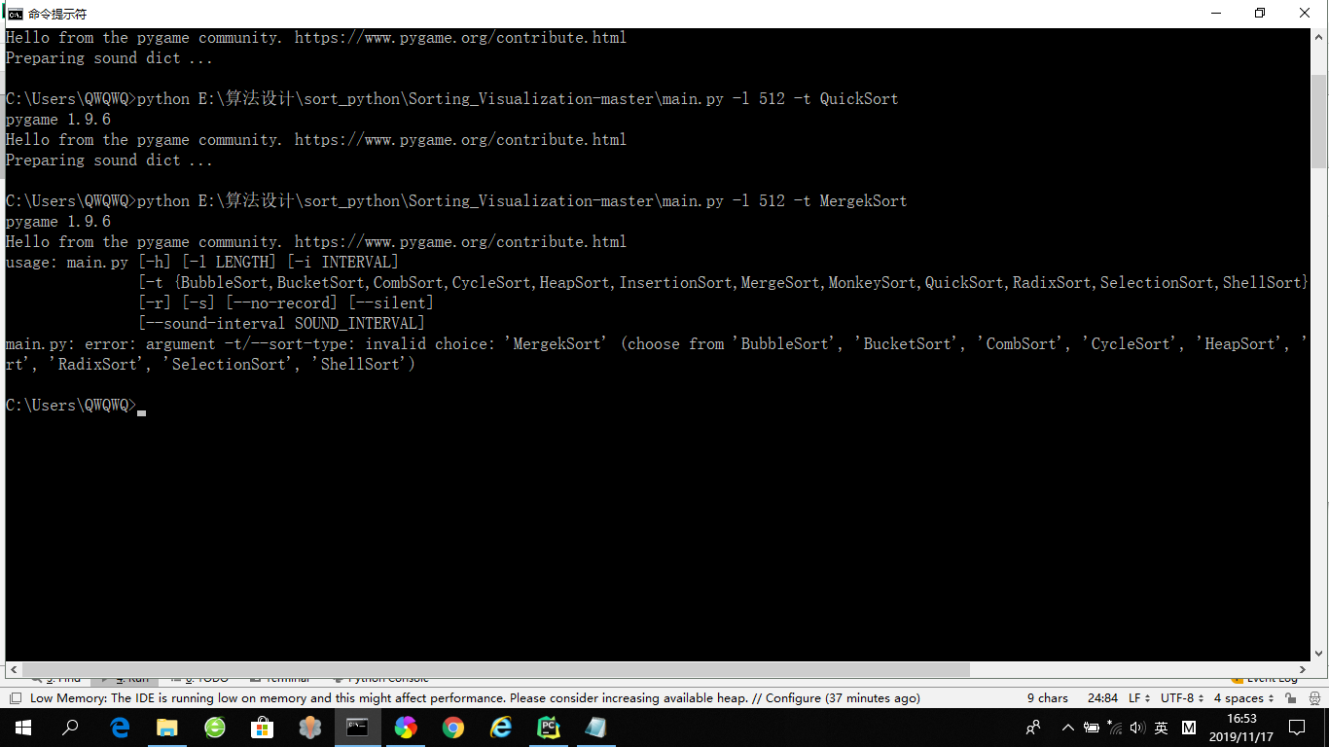

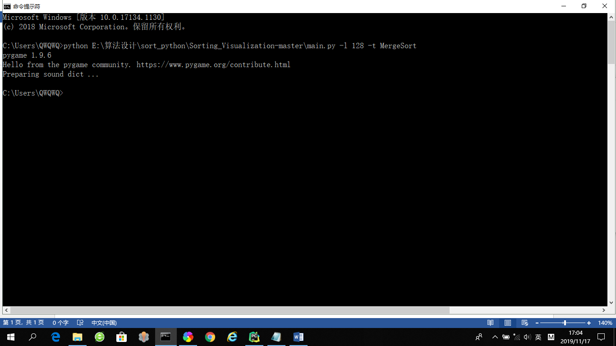

退出python ：Ctrl+z

将QWQWQ复制到C:\user

以管理员身份安装python_x64_v3.7.4，选择路径

C:\Users\QWQWQ\AppData\Local\Programs\Python\Python37

Cmd窗口下Ctrl+c结束python程序运行

c:>

大窗口：

将整个文件夹放在C:\

cd C:\Sorting_Visualization-master\venv\Scripts

C:\Sorting_Visualization-master\venv\Scripts>

python C:\Sorting_Visualization-master\main.py -h

python C:\Sorting_Visualization-master\main.py -l 100 -i 100 -t SelectionSort --silent

python C:\Sorting_Visualization-master\main.py -l 100 -i 100 -t BubbleSort

python C:\Sorting_Visualization-master\main.py -l 100 -i 100 -t QuickSort

python C:\Sorting_Visualization-master\main.py -l 100 -t MergeSort

'BubbleSort', 'BucketSort', 'CombSort', 'CycleSort', 'HeapSort', 'InsertionSort', 'MergeSort', 'MonkeySort', 'QuickSort', 'RadixSort', 'SelectionSort', 'ShellSort'

{BubbleSort,BucketSort,CombSort,CycleSort,HeapSort,InsertionSort,MergeSort,MonkeySort,QuickSort,RadixSort,SelectionSort,ShellSort}]

Hello from the pygame community. https://www.pygame.org/contribute.html

usage: main.py [-h] [-l LENGTH] [-i INTERVAL]

[-t {BubbleSort,BucketSort,CombSort,CycleSort,HeapSort,InsertionSort,MergeSort,MonkeySort,QuickSort,RadixSort,SelectionSort,ShellSort}]

[-r] [-s] [--no-record] [--silent]

[--sound-interval SOUND_INTERVAL]

main.py: error: argument -t/--sort-type: invalid choice: 'DicktionSort' (choose from 'BubbleSort', 'BucketSort', 'CombSort', 'CycleSort', 'HeapSort', 'InsertionSort', 'MergeSort', 'MonkeySort', 'Quick

Sort', 'RadixSort', 'SelectionSort', 'ShellSort')

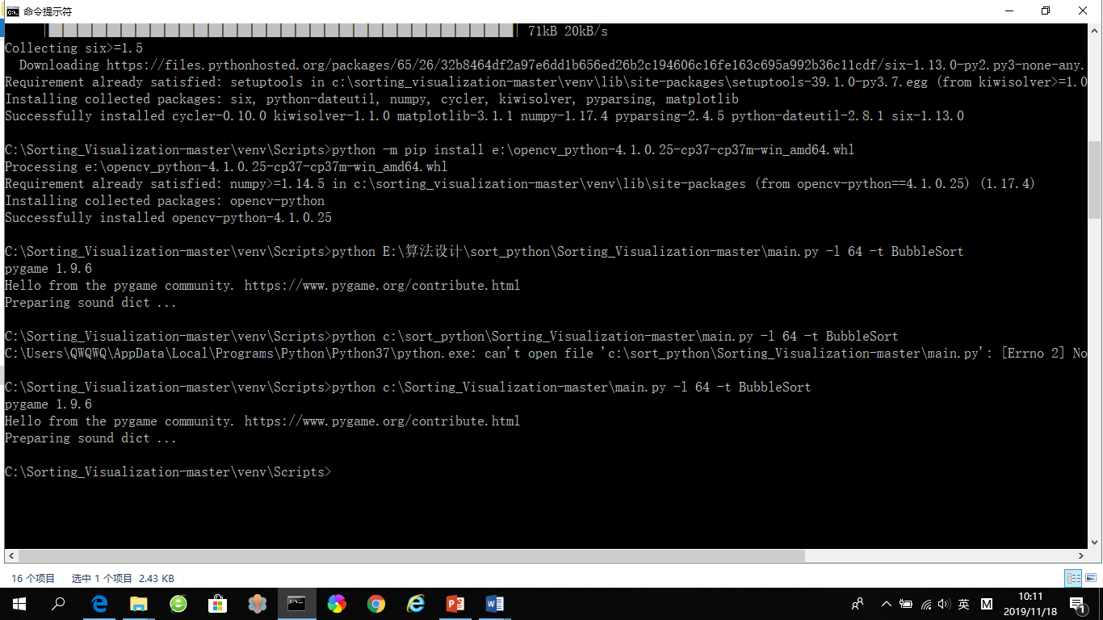

C:\Users\QWQWQ\AppData\Local\Programs\Python\Python37