测试用例：
import static org.junit.Assert.assertEquals;

import org.junit.Test;

public class trityptest {
trityp tri = new trityp();
@Test
public void testTriang_1(){
assertEquals(1,TritypMutantOne.Triang(2,3,4));
assertEquals(1,TritypMutantOne.Triang(5,4,3));
assertEquals(1,TritypMutantOne.Triang(3,4,2));
assertEquals(1,TritypMutantOne.Triang(5,3,4));
}
@Test
public void testTriang_2(){
assertEquals(2,TritypMutantOne.Triang(1,2,2));
assertEquals(2,TritypMutantOne.Triang(2,2,1));
assertEquals(2,TritypMutantOne.Triang(2,1,2));
}
@Test
public void testTriang_3(){
assertEquals(3,TritypMutantOne.Triang(2,2,2));
}
@Test
public void testTriang_4(){
assertEquals(4,TritypMutantOne.Triang(0,1,1));
assertEquals(4,TritypMutantOne.Triang(1,0,1));
assertEquals(4,TritypMutantOne.Triang(1,1,0));
assertEquals(4,TritypMutantOne.Triang(1,2,3));
assertEquals(4,TritypMutantOne.Triang(2,3,1));
assertEquals(4,TritypMutantOne.Triang(3,2,1));
assertEquals(4,TritypMutantOne.Triang(1,3,1));
assertEquals(4,TritypMutantOne.Triang(3,1,1));
assertEquals(4,TritypMutantOne.Triang(1,1,3));
}
}

覆盖截图：
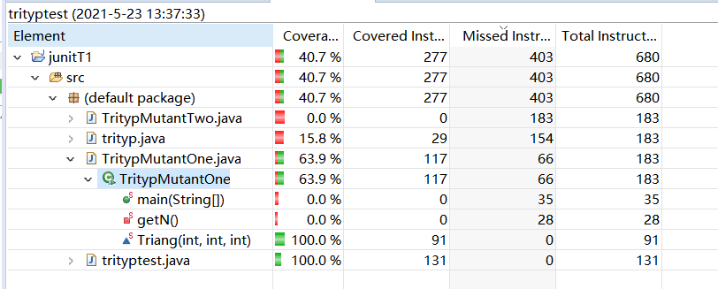

在把改成“+1”之前
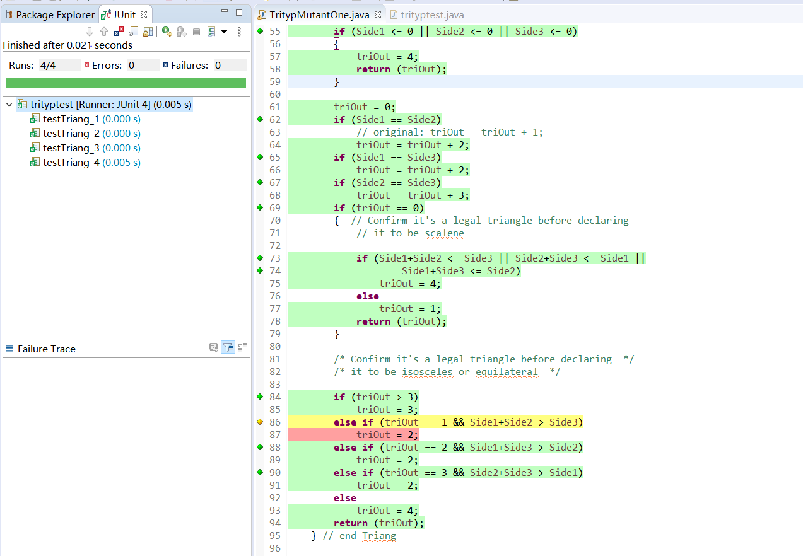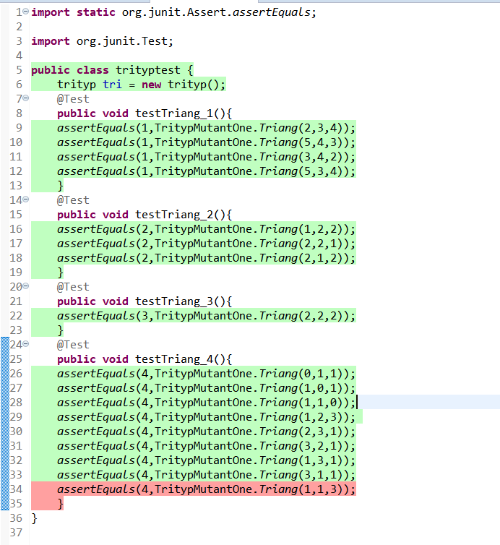

之后
