**MCIT Operational Status Tool**

**Purpose**

The Operational Status Tool is a portal for MCIT Staff to report status, condition, and provide information regarding the health of services that are visible throughout MCIT. The Operational Status Tool is for monitoring, declaring, updating and closing the operational status of an event.

**The Operational Status Tool does not replace calling a Major Incident.**All Major Incidents, per the Major Incident policy are initiated by calling the Service Desk at 232-9111.

**Overview**

Once an event is identified, it is Declared by being added as a New Event in the Operational Status Tool. After this, the event is Tracked, Monitored and Reported on until it is closed.

The following are summarized concepts for the use of the Operational Status Tool:

**Operational Status Tool consoles**

* + - There are two consoles in the Operational Status Tool: Event Console and the Management Console.
    - The Event Console is used to create, update, monitor and close an event.
    - The Management Console is used to manage the Operational Status structure: add or modify an email event notification Recipient List, Service or Service Group. It is also where you will inactivate an email event notification Recipient List, Service or Service Group.
    - Today, anyone with a level 2 ID and password on the UMHS network can manage an event.
    - Only individuals in the MCIT-CIOMT and MCIT performance groups can access the Management Console.

**Service Group and Service**

* + - A Service Group is likely to have multiple Services.
    - Every new event will have a Service and Service Group assigned.
    - Every event will be associated with a Service and Service Group.

**Event Lifecycle**

* + - Each event moves through a sequence of user actions: New, Update and Close.
    - An event is Active until it is closed. Once close it **cannot** be re-opened.

**Redundancy Data**

* + - This is collected event impact data as it relates to Redundancy and is used for the ISO Operational Status Redundancy report. *Details on Redundancy and Redundancy data on page 7.*

# Services, Service Groups and email Recipients

* All Services are used to provide finer granularity to the reporting of Operational Status events.
* All Services are added and managed using the Management Console.
* Recipient Lists are associated with Services.
* Additional Services are created as needed.
* When a Service is added, MCIT-CIOMT and MCIT-Change-Management are the two default recipient groups that are automatically added. These recipients cannot be deleted from the recipient list.
* When a Service is added, the Support Team is automatically added as a recipient.
* Upon the creation of a Service Group, a default service is automatically created. The default name can be edited to be an actual Service Group name.
* The Recipient List is notified whenever the status of an event changes.
* Recipient Lists are managed in the Management Console.
* Each Monday morning, the Support Team for all **Active Events older that one week**, will receive a reminder e-mail.
* Each Monday morning, the Support Team for all **Status Events that do not have completed Redundancy Data** will receive a reminder e-mail.

### **Multiple Status Events**

* Co-occurring events for a Service are viewed, tracked and managed individually.
* Status Summary displays the details of Active Events for Service Groups and Services

### **Status Event Lifecycle**

* Individual events associated with a Service.
* An individual event under a Service goes through a sequence of user-initiated actions. When a new event is added it is assigned a status of Yellow or Red. When an updates is performed the status of the event can be changed at that time.
* When an event is closed the event status will automatically be changed to Green.
* An event is considered active when it is opened and until it is closed.
* An individual event cannot be re-opened.
* If a service has 2 active events in Yellow status and 1 active event in Red status, the event line color displayed will be will be Red since it is the highest severity in the lifecycle of the Active Events.
* Green indicates there are no active events.

# Login and Navigating the Operational Status Tool

The Operational Status site is available through the MCIT Dashboard by using the following steps:

1. Begin by typing **miops.med.umich.edu** in the address bar of your browser. This will display the MCIT Dashboards.
2. You will see three tabs displayed:

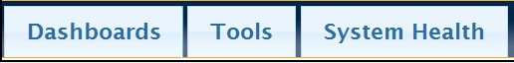

* **Dashboard**

*Image 1*

* **Tools**
* **Health System**

Click on the **Tools** tab to proceed.

*Image 2*

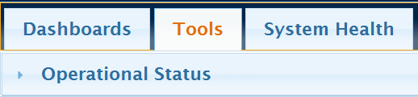

1. **Operational Status is** displayed under Tools:

1. When you click on the Operational Status link, your level 2 login will be required. Upon successfully logging in, the MCIT Operational Status Tool Event Console will be displayed. This location is also known as the Event Console.

## Event Console

The default window when entering the Event Console is Active Event. It is within the Event Console where you Declare, Track, Monitor and Report on an event.



a.

b.

c.

d.

f.



e.

*Image 3*

g.

1. The following are located in the **Event Console**
2. **Active Events** - Displays all active events
3. **Service Groups** - Displays a summary of all active events per Service Groups
4. **Reporting** - Provides a form for and information on Redundancy reporting
5. **New Event** -Used to add a new event to the Operational Status Event Console. This button is always displayed.
6. **Breadcrumbs** - Use the breadcrumbs to change levels
7. **Categories** - Displays by a predefined category
8. **Filter** - Displays what is typed into this field

# What is an event?

Operational Status Event in this documentation is identified as an Event. The Event is the declaration of a unique circumstance that places a service in a Yellow or Red status. All events are tracked as individual events for a Service.

## Adding a New Event

**Create New Event**

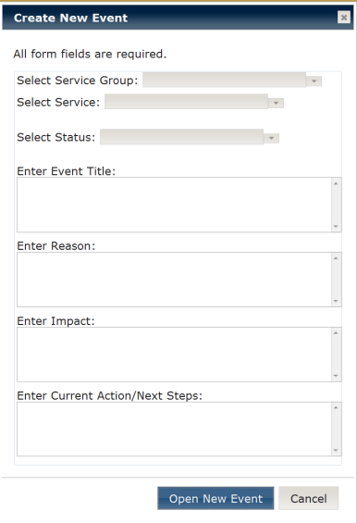

1. Click on the **New Event** button to display the **Create New Event** form. All fields require data.
2. The first three fields are drop-down menus. Select one item for each of the following fields: Service Group, Service and Status.
3. The rest are type-in text fields that require something entered. If the details are not available use something like Unknown or Not Available at this time.
4. When the form is complete, click on Open New Event to save, and open the event.

*Image 4*

## Active Events

In the **Active Events** window an event is declared by clicking on the **New Event** button. It displays all Active Events that have a status of Red or Yellow

**Viewing an Event**

Both Active Events and the Service Groups windows will provide different types of Views of an event and Actions that can be performed on an event.

* 1. Each Active Event has the **expand icon** located in **Event Title.** When this is clicked on the field expands to display the last update of Event Status, Impact, Current Action/Next Steps.

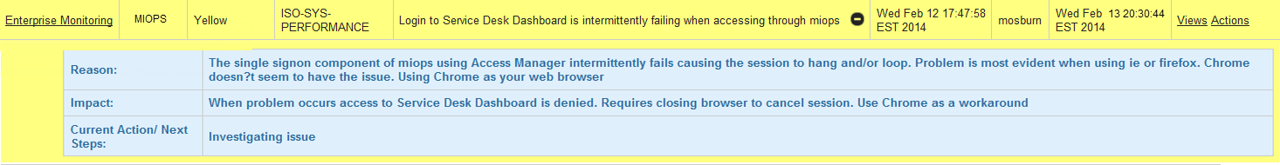

*Image 5*



*The Open and Last Update, date and time stamp are present*

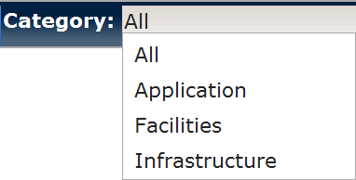

*Image 6*

2. **Category** filters a selected group. Whatever category is chosen from the drop-down list, only those relative events will be displayed. For example, selecting Application will display only events for the Service Groups identified in the Management Console as Category: Application. There will be more about the Management Console later in this document.

1. The **Filter** field will search for anything you type in here. An example of this is using “Arbor Lakes" in the filter field. Every event that has “Arbor Lakes” in **any** of the Active Event columns will be displayed. (*See below in Image 7).* It will also display any event that has Arbor **or** Lakes.

*Image 7*



**Note**: The Filter field is not case sensitive.

1. **Using the Views and Actions Link**
2. Views and Actions links are always located on the right side of the event line.
3. They provide either, options for viewing an event or the option of performing an action like updating or closing the event.
4. Depending on the window, you are in, the Views links and Actions links will offer different functionality. For example, the **Views** links on the top level of the **Active Events** window displays only **Event History**. Whereas, **Views** links on the top level in the **Service Group** window will display **Service Summary, Active Events and Closed Events**.
5. The **Actions** links in the top level of the **Active Events** window displays, **Update Event, Closed Event and Add/Complete/Update Redundancy Data**. Whereas, the **Actions** links the top level of the **Service Groups** window displays **New Event**.
6. Keep in mind, Views and Actions are available on multiple levels and used to drill down into the details of the event.

**Drill Down Navigation Feature**

As you navigate from view to view, you will sometimes notice that instead of seeing **Views** you will see **No Views**. If a view is not available, it will not be listed in the menu. For example, if there are no close events then that menu item will not be displayed until there is a close event for this specific Service Group.

## Active Events tab – Using the Views link

The **Active Events** window displays all Active Events that have a status of Red or Yellow. Since each event line has a Views link and Actions link, it’s important to note that the views and actions are relevant only to event line, which you are clicking on.



*Image 8*

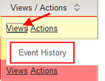

Event History

1. Clicking on **Views** will displaythe **Event History** link. When selected, it will provide a history for that specific event.

## Active Events tab– Using the Actions link

Actions provide you with options to Update or Close and event.

***Image 9***

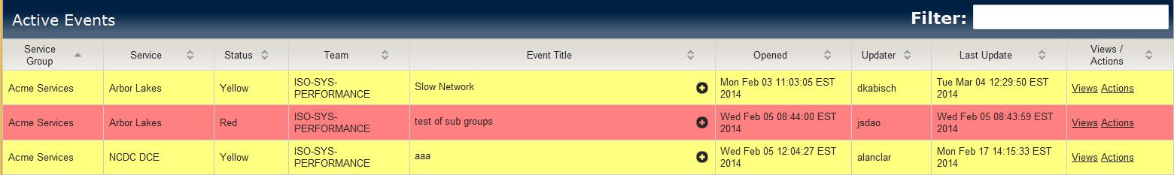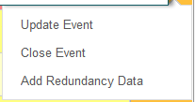

* + - 1. **Update Event** displays a form for updating the Status (yellow/red) of an event, Event Status, Impact, and Current Action/Next Steps.
      2. **Close Event** displays a form to close an event and modify any of the Event’s descriptive information: Event Status, Impact, Current Action/Next Steps. This occurs when the event is resolved.   
         ***Note:*** *Once an even is closed it disappears from this view since only active events are displayed.*
      3. **Add/Completed/Update Redundancy Data** displays the Redundancy Data entry Form. If Redundancy data has been partially filled in then you will see Completed Redundancy Data. Once all the data has been filled in then the Update Redundancy Data will be displayed.

## Redundancy

**What is Redundancy?**

The ITIL defines redundancy as use of one or more additional configuration items to provide fault tolerance.

**What is Redundancy Data?**

We take your responses to the questions on redundancy and use it to determine the impact redundancy has on a system or service managed by MCIT. It can be thought of as the justification for redundancy.

**Points to Remember** **about Redundancy**

1. Redundancy data is required for every event that is in the Operational Status Tool.

2. Fail over of a redundant system or service can be manual or automatic. The difference between the two is, manual fail over is likely to take longer for the system/service to recover. The fail over time is indicated in the min and max recovery time fields in the on-line form. A text field is provided for any comments you would like to provide about your responses to redundancy questions.

**Filling Out the Redundancy Information**

There are three sections to this questionnaire:

1. Questions (3)
2. Impact (numeric response)
3. Recovery Time (numeric response)

The question we begin with and then build on are; does the service (that had the event) have redundancy? If so, tell us the effects that redundancy had on the event by answering the following question: Did redundancy prevent or minimize an outage?

If your response is, yes to redundancy preventing or minimizing an outage, then did having redundancy prevent a disaster? Next, we want to measure the impact. What was the impact? For systems, this is about identifying the number of hosts this event affected. If this is an event for a service (ex., an application), how many users were affected?

**Two Important Points to Remember:**

1. Redundancy data needs to be completed for each event in the Operational Status Tool.
2. When it comes to recovery time, your response will be your best guesstimate, unless of course you know for sure.

## Service Groups tab - Using the Views link

This window provides event summary information for all Service Groups. Below, in the drop-down menu of image 10, we see have three ways to view service group information. They are Service Summaries, Active Events (by service groups), and Closed Events (by service groups).

**\*** **Top level,** selecting **Service Summaries** from the **View** link menu will display image 10

*Image 10*

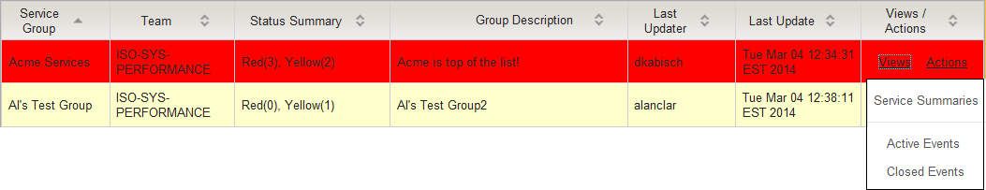

* + 1. **Service Summaries -** Summaries the selected Services in a Service Group

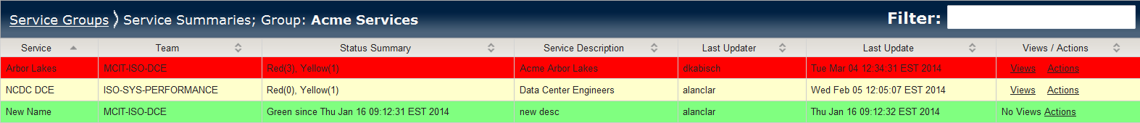

*Image 11*

Above, we see three service summaries for the Acme Services, Service Group. The service in Green (in image 11) indicates there are no active events. Notice, this service has been in Green since Thurs, Jan 16, 90:12:31 EST 2014.

1. **Active Events -** Lists all Active Events for the selected Service Group

The image below is a good example of using drilling down to find more details on active events. By selecting Active Events from the menu, this will display only the active events for this particular Service Group.

1. **Closed Events** - Lists all Closed Events for the selected Service Group. Once the closed event details are entered into the Closed Events form and saved, the event is stamped with the date and time.

*Image 12*

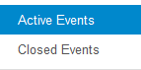

**\*** **2nd level,** clicking on **View > Active Events** will display more Arbor Lakes   
active events along and some event details, as seen below in image 13

The Arbor Lakes and NCDC DCE services have multiple events. Each service event can be viewed by continuing to click on the links. In image 10, we are on the 2nd level and by clicking on Active Events (image 12), this takes us to the 3rd level, where details are displayed for this active event, as seen in image 13. Clicking on View at this level will display Event History. This is the end of the drilldown links.

1. **Event History** – If you click on Active Events or Closed Events, then Views, Event History will provide a historical view of that event as seen below in image 13 & 14.

**\* 3rd level**, clicking on **View > Event History** displayed in image 13

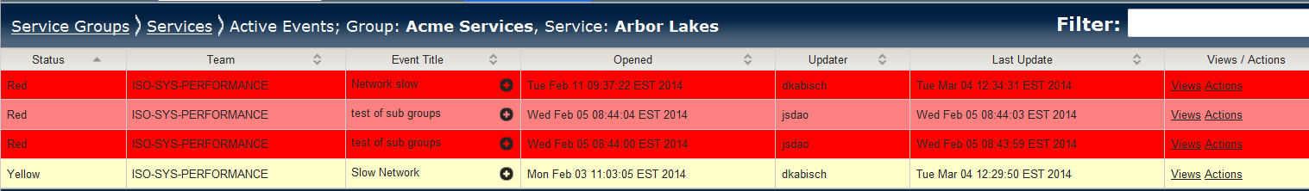

*Image 13*

Event History view

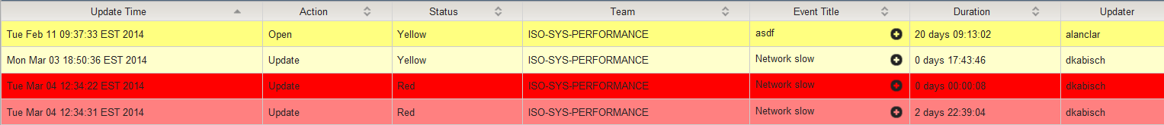

*Image 14*

**More about Service Group**

*Image 15*

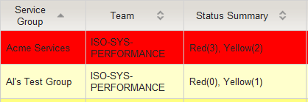

Here are a couple of points to remember about the Service Group window: In image 15, the **Status Summary** column displays a quick view summary of the events for each Service Group. The Acme Service Group has 3 red active events and 2 yellow active events. Al’s Test Group has zero red active events and 1 yellow active event.

It’s important to note that the event line color displayed, is the highest severity of all Active Events for that Service Group. For example, if there are 4 yellow active events and one red active event for a Service Group, the event line will be red.

## Reporting

Future location of posted standardized reports

An example of reports will be incomplete redundancy data summarizations.

## Management Console

Management Console is accessed from the Event Console. Its function is to create Recipients, Service Groups and Services that are utilized in the Event Console. This is also where we manage email recipients.

MCIT management will use the Management Console to add and modify Services, Service Groups, and the email notification Recipient Lists. After adding this information in the Management Console, it will then available in the Event Console. In addition to this, the Management Console is used to inactivate or activate a Recipient list, Service, and Service Group.

On the upper right hand of the Event Console is the link to access the Management Console.



If access is denied, you will see this screen:

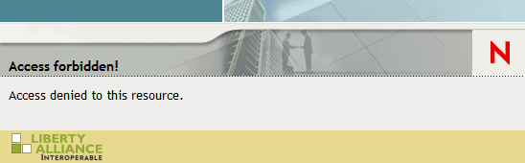

## Management Console

There are two tabs and a button in the Management Console view: Manage Recipients tab, Manage Service Groups tab and then the New Recipient button.



We will begin by creating a new Recipient since all first time users of the Event Console must start first by entering Recipient Lists, Service Groups, and Services so they will be displayed in the Management Console.

## Adding a New Recipient

**Create a Recipient**





It is here that a new recipient can be created by clicking on the **New Recipient** button.

1. Click on the **New Recipient** button to display the **Create a Recipient** form. All fields are required.

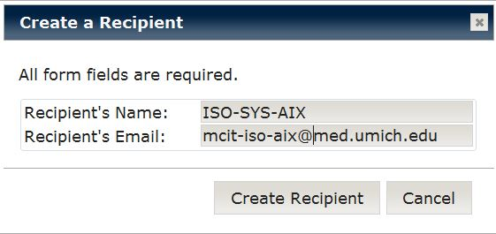

*Image 18*

1. The Recipient Name, and a Recipient Email are text fields. Remember to use the Remedy team name for the recipient name. The email address is the team’s outlook email address. For example, for the Remedy team ISO-SYS-AIX the corresponding outlook email address is mcit-iso-aix@med.umich.edu.
2. When the form is complete, click on Create Recipient. The new Recipient will appear in the listing of recipients.

## Managing Recipients

The **Manage Recipients** tab is to manage recipients.

**Important points to remember when managing recipients**

* A recipient is never an individual; it is always a team and we use Remedy team names.
* Each line in the Manage Recipient widow displays the recipient’s details (Name, Email and if they are Active) and a link for editing that recipient’s information.

## Modifying a Recipient

When a recipient is created, it is managed in the **Manage Recipients** window using the Edit Recipient link. .



**Managing a Recipient**

*Image 19 `*

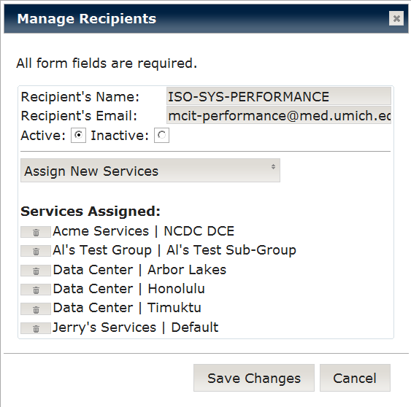

a.

1. Click on the **Edit Recipient** link to display the **Manage Recipients** form.

b.

1. There are four sections in the form:

d.

c.

**a.** is used to edit the same information that is in the Create Recipient form.

**b.** The radio buttons are used to change a recipient from active to inactive or inactive to active. When a recipient is first added, they are automatically Active.

**c.** is used to add Services that are associated with the Recipient.

**d.** This is the current Service list for the recipient.

1. To delete a Service from the list, click on the garbage can next to it. This displays a popup window. Click the Delete button to permanently remove this Service.

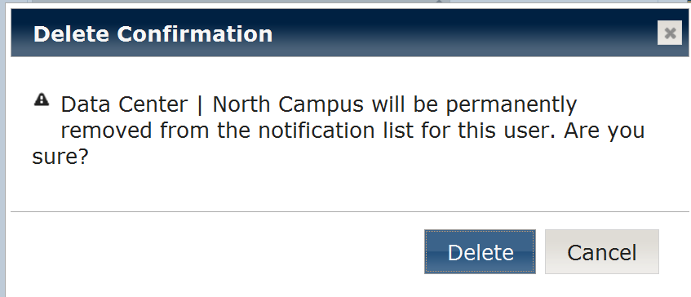

1. To save your changes, click on Save Changes. Your changes will appear in the Manage Recipients window.

## Managing Service Groups

The **Manage Service Groups** tab is to create and manage **Service Groups** and **Services.** It is the Manage Service Group display that lists all of the Service Groups that have been added.

Each line displays information on a Service Group with Edit Service Group and Manage Services link in the Actions column. We will click on the Manage Services link.



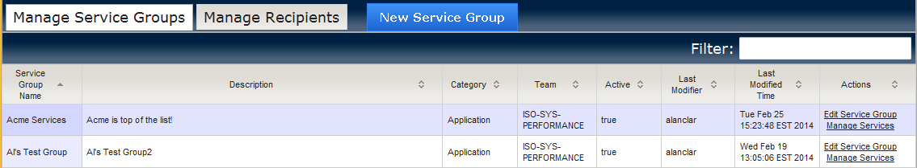

A new Service Group is created by clicking on the **New Service Group** button.

## Creating a New Service Group

**Adding a Service Group**

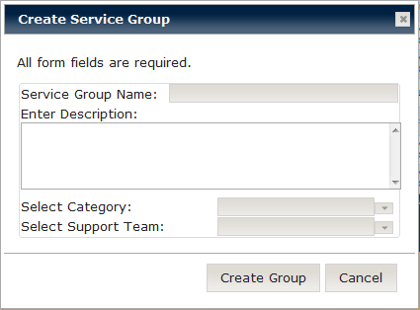

*Image 14*

1. Clicking on the **New Service Group** button will display the **Create Service Group** form. All fields are required.
2. The first two are text fields for the Service Group Name and description of the Service Group.
3. The last two fields are drop-down menus. Select one item from each of the following fields: Category, and Support Team (Remedy Group). Note: A Support Team must first be added in the Manage Recipients tab in order for it to be available here in the drop-down menu.
4. When a Service Group is first created, a single service named “Default” is automatically added. This is added to insure that a Service Group has at least one Service. You may edit the Service named “Default” at any time.

## Modifying a Service Group

In the **Manage Service Group** window each line contains an Edit Service Group link that is used to edit Service Group information.

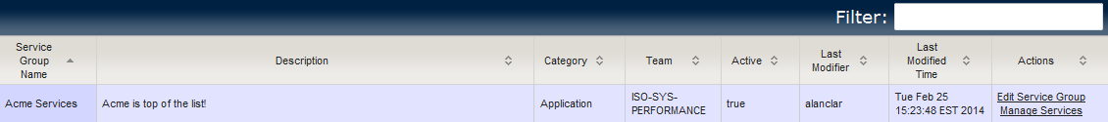

**Modifying a Service Group**

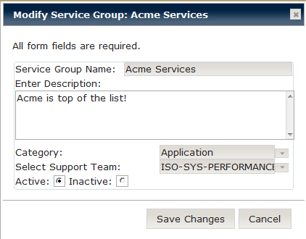

*Image 15*

1. Click on the **Edit Service Group** link to display the **Modify Service Group** form.
2. The fields are the same as for the Create Service Group form with one addition; buttons to change the Service Group to either Active or Inactive status.
3. When the changes are complete, click on Save Changes.

## Managing Services

In the **Manage Service Group** view, each line contains a Manage Services link used to view, create, and edit a Service for a Service Group.



When the Manage Services link is clicked, the information for the Services belonging to that Service Group is displayed.

The Management Console provides a New Service button used to add a new service (a), an Edit Service link to modify a service (b) and breadcrumbs (c) for navigating back to the Manage Service Groups view.

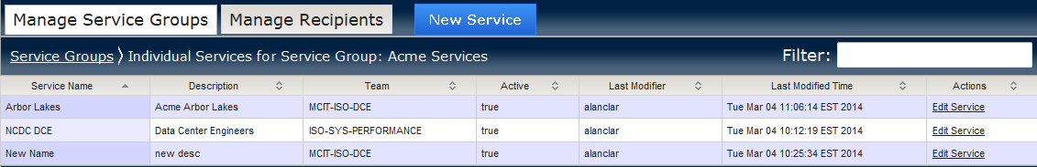

b.

c.

a. a.

.

## Creating a New Service

**Adding a Service**

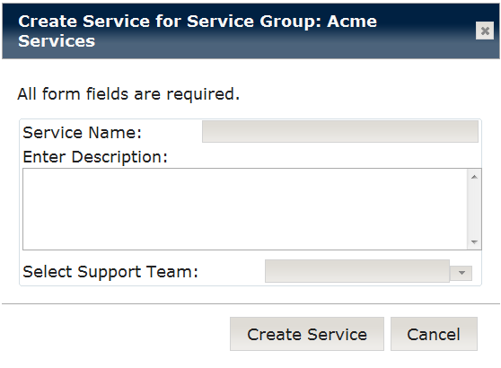

*Image 16*

1. Click on the **New Service** button to display the **Create Service** form. All fields require data.
2. The first two fields are text fields for the Service Name, and a Service Description.
3. The last field is a drop-down menu. Select one item for the Support Team (Remedy Group). **Note:** The Support Team you select was added as a Recipient in the Manage Recipients tab.
4. After the form is complete, click on Create Service.

## Modifying a Service

From the Manage Service Groups view, the **Manage Services** link is clicked on to display the Edit Service link. This link is used to edit the description of a Service and to add recipients to the assign recipients list (Recipients Assigned) of a specific Service.



**Modifying a Service**

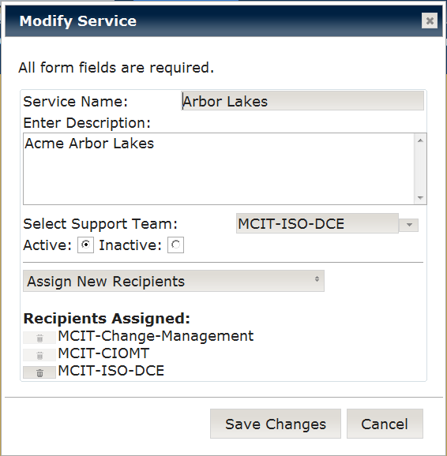

*Image 17*

1. Click on the **Edit Service** link to display the **Modify Service** form.

a.

1. There are four sections to this form.

b.

**a.** Is used to edit the information that was entered on the Create Service form.

c.

d.

**b.** The radio buttons are for making a Service inactive or active.

**c.** Is to add a group to the email recipients list that receives an email when the status of an event changes.

**d.** This is the current recipient notification list for this Service. MCIT-Change-Management and MCIT-CIOMT are automatically added to all recipient lists when the Service is created and cannot be removed.

1. To delete a group from the recipient list, click on the garbage can next to it. This displays a popup window. Click the Delete button to permanently remove this email recipient group.



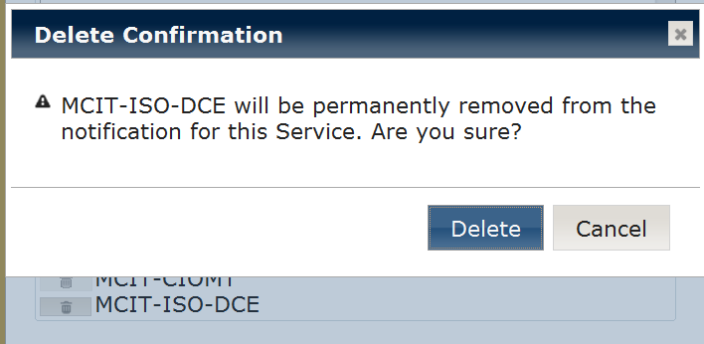

1. To save all changes, click the Save Changes button.

**All new Service Groups and Services that you added are now available in the Events Console**

**Best Practices**

1. **Column Sorting:**

To sort by a specific column, click on the column heading. Each time you click on the column it changes from: Ascending, to Descending, to Unsorted.

To sort by multiple columns, hold down the shift key and click on the columns in the order desired.

1. **Creating Events:**

When creating an Event Title, use a reasonably short description that captures the essence of the occurrence (normally the title will not change over the life of the Event). The other Event fields can be used to detail other aspects of the Event. Here is an example Event:

**Event Title:**

High CPU utilization impacting nightly cycle

**Event Status:**

CPU utilization is reaching 100% during the nighly backup window which is causing the nightly cycle to run extra long. Problem started when we upgraded the OS to AIX 6.2 and TSM to v6

**Impact:**

The nightly cycle is not able to complete in the time allowed, causing some servers to skip their nightly backup cycle

**Current Action/Next Steps:**

1. Open a problem ticket with IBM to see if this is a known problem

1. **Service Groups, Services and Categories:**

When creating a Service Group, keep in mind that each service group will be associated with a single Category (Application, Infrastructure, or Facilities). If you need to add Services that fall into more than one category, you will need to create a separate Service Group for each category.

1. **Service Groups, Services and Support Teams:**

When creating a Service Group or Service, keep in mind that the Support Team that you assign to the Service Group or Service comes from the current list of Recipients. Therefore the Support Teams that you will need must first exist, or be created using the Manage Recipients tab, before creating Service Groups or Services.

Glossary

**Status**  
Red, Yellow or Green indicates the status of the Event with Red being the highest and Green indicating closed/resolved.

**Team**  
The Remedy Group associated with the Service Group or Service.

**Event Title**  
A succinct description of the operational status Event. The other descriptive fields: Event Status, Impact, and Current Actions/Next Steps should be used to change the event information over time. as updates to the Event occur.

**Open**The Date and Time that the Event was created (declared).

**Closed**The Date and Time that the Event was closed (resolved).

**Duration**The duration of the Event. **For Closed Events** this will be the time between Event Creation and Event Close. **For Active Events** this will be the time from Event Creation to the present time.

**Updater**The Uniqname of the last person to update the Event.

**Last Update**This is the last Date and Time the Event was updated.

**Views/ Actions**Links that provides ways to view data or perform a specific action.