## FULL STACK ENGINEERING

Project Report

Semester-VI (Batch-2022)

**Co-Founder AI.**

**Supervised By: Submitted By:**

Mr. Rahul Gurpreet Kaur (2210991597).

Arsh Thakur (2210991362).Jatin Kumar (2210991712).

Sahil Singh Ranout (2210992214).

**Department of Computer Science and Engineering**

## Chitkara University Institute of Engineering & Technology,

## Chitkara University, Punjab

**Abstract**

Cofounder AI is an advanced AI-powered platform designed to streamline **content creation, business automation, and data-driven decision-making**. It leverages **Next.js for frontend, Node.js with Express.js for backend, and MongoDB for scalable data management**, ensuring a seamless and high-performance user experience.

The platform integrates **AI-driven automation, real-time analytics, and intelligent recommendations** to enhance productivity across various industries. By enabling **efficient content generation, automated workflows, and smart business insights**, Cofounder AI helps organizations **reduce manual effort, optimize operations, and improve scalability**.

With a **secure, scalable, and AI-native infrastructure**, Cofounder AI is revolutionizing how businesses leverage artificial intelligence, making innovation accessible and impactful.

**Table of Contents**  
**1. Introduction**

* 1. Background
  2. Objectives
  3. Significance

**2. Problem Definition and Requirements**:

2.1. Problem Statement

2.2. Software Requirements

2.3. Hardware Requirements

2.4 Data Sets

**3. Proposed Design/Methodology** :

3.1. System Architecture

3.2 Core features and Functionalities

3.3 Technology Stack

3.4 Development Methodology

3.5 Security Measure

**4. Results**:

4.1. Code Snippets

4.2 Project Snippets

**5. References**:

**1. Introduction**

**1.1 Background**

In today's fast-paced digital world, businesses and individuals struggle with **efficient content creation, data management, and automation**. Traditional methods are **time-consuming, costly, and lack scalability**, making it difficult to meet growing demands.

With advancements in **Artificial Intelligence (AI) and automation**, there is a need for a **smart, efficient, and scalable solution** that can **streamline workflows, generate content, and provide real-time business insights**.

**Cofounder AI** was developed to address these challenges by integrating **AI-driven automation, real-time analytics, and intelligent decision-making**. Built with a modern **tech stack (Next.js, Node.js, Express.js, MongoDB)**, it offers businesses an **intuitive, fast, and scalable solution** to enhance productivity and innovation.

**1.2 Objectives**

1. **Automate Content Creation** – Reduce manual effort by leveraging AI for fast and high-quality content generation.
2. **Enhance Business Intelligence** – Provide real-time AI-driven insights to improve decision-making.
3. **Improve Scalability** – Ensure seamless handling of large datasets and growing user demands.
4. **Streamline Workflow Automation** – Optimize operations by integrating AI-powered automation tools.
5. **Simplify Data Analysis** – Use AI to extract meaningful insights from complex datasets efficiently.
6. **Ensure Secure & Efficient AI Integration** – Implement **Next.js, Node.js, MongoDB** for robust, scalable, and secure execution.
7. **Democratize AI for Businesses** – Make AI technology accessible to startups and enterprises for enhanced innovation.

Cofounder AI aims to **revolutionize automation, content generation, and business intelligence** through a smart, AI-driven approach.

**1.3 Significance**

1. **Enhancing Efficiency** – Automates repetitive tasks like content creation and data analysis, reducing manual effort and increasing productivity.
2. **Scalability & Adaptability** – Handles large datasets and complex operations seamlessly, making it suitable for businesses of all sizes.
3. **AI-Driven Decision Making** – Provides real-time insights and analytics, helping businesses make smarter, data-backed decisions.
4. **Cost-Effective Solution** – Reduces operational costs by streamlining workflows and eliminating the need for extensive human intervention.
5. **Seamless Integration** – Built with **Next.js, Node.js, and MongoDB**, ensuring a robust, flexible, and future-proof architecture.
6. **Empowering Businesses & Creators** – Democratizes AI by making advanced automation tools accessible to startups, enterprises, and individual creators.
7. **Innovation & Competitive Edge** – Helps organizations stay ahead in the rapidly evolving digital landscape by leveraging cutting-edge AI technologies.

Cofounder AI is **redefining automation, content generation, and business intelligence**, making AI-driven innovation more accessible and impactful.

**2. Problem Definition and Requirements**

**2.1 Problem Statement**

In today's digital landscape, businesses face challenges in **efficient content creation, workflow automation, and data-driven decision-making**. Traditional methods are **time-consuming, resource-intensive, and lack scalability**, leading to inefficiencies in operations and business intelligence.

With the increasing demand for **AI-driven solutions**, there is a need for a **smart, automated platform** that can **generate content, analyze data, and optimize workflows** without extensive human intervention. Additionally, many small and mid-sized businesses struggle with **integrating AI into their processes due to technical complexity and high costs**.

**Cofounder AI** addresses these challenges by providing an **AI-powered, scalable, and cost-effective solution** that enhances **content automation, real-time insights, and intelligent decision-making**. Built with **Next.js, Node.js, Express.js, and MongoDB**, it offers a **seamless, high-performance, and user-friendly** experience, making AI adoption easier and more accessible.

**2.2 Software Requirements**

**1. Frontend Development**

* **Framework:** Next.js (for SSR, SEO, and performance optimization)
* **Languages:** JavaScript, TypeScript (optional for scalability)
* **Styling:** Tailwind CSS / Styled Components

**2. Backend Development**

* **Runtime Environment:** Node.js
* **Framework:** Express.js (for handling API requests)
* **Authentication:** Firebase/Auth0 (for user authentication & security)

**3. Database Management**

* **Database:** MongoDB (NoSQL, scalable data storage)
* **ORM/ODM:** Mongoose (for MongoDB object modeling)

**4. AI & Automation**

* **AI Models:** OpenAI API / Custom NLP models (for content generation & insights)
* **Machine Learning Frameworks:** TensorFlow / PyTorch (if custom AI models are implemented)

**5. Deployment & Hosting**

* **Frontend Hosting:** Vercel (optimized for Next.js apps)
* **Backend Hosting:** AWS / DigitalOcean / Render
* **Database Hosting:** MongoDB Atlas (for cloud-based scalable storage)

**6. DevOps & Version Control**

* **Version Control:** GitHub (for collaborative development)
* **CI/CD:** GitHub Actions / Jenkins (for automated deployment)
* **Containerization (Optional):** Docker (for scalability & microservices)

These **software requirements ensure a scalable, high-performance, and AI-powered** execution of Cofounder AI.

* 1. **Hardware Requirements**

**1. Development System (Local Machine Requirements)**

* **Processor:** Minimum **Intel Core i5 / AMD Ryzen 5** (Recommended: i7/Ryzen 7 or higher)
* **RAM:** **8GB** (Recommended: 16GB+ for smooth development)
* **Storage:** **256GB SSD** (Recommended: 512GB+ SSD for faster read/write speeds)
* **GPU (Optional for AI Development):** **NVIDIA GTX 1650 / RTX 3060+** (For ML model training and AI computations)
* **Operating System:** Windows 10/11, macOS, or Linux (Ubuntu recommended for backend development)

**2. Server Requirements (For Hosting & AI Processing)**

* **Processor:** Minimum **Quad-Core CPU** (Recommended: Intel Xeon / AMD EPYC)
* **RAM:** **16GB** (Recommended: 32GB+ for AI processing & multiple requests)
* **Storage:** **500GB SSD** (Recommended: NVMe SSD for high-speed data handling)
* **GPU (For AI & ML Tasks):** **NVIDIA A100 / RTX 3090 / Tesla V100** (For AI-driven content generation & processing)
* **Cloud Infrastructure:** AWS EC2, Google Cloud, or DigitalOcean (for scalable deployment)

**3. Network & Connectivity**

* **Internet Speed:** Minimum **50 Mbps** (Recommended: 100+ Mbps for smooth API calls & data transfer)
* **Cloud Database Support:** MongoDB Atlas, Firebase, or PostgreSQL for remote access

These hardware specifications ensure **smooth development, deployment, and AI-powered execution** of Cofounder AI.

**2.4 Data Sets**

Cofounder AI relies on various datasets for **training AI models, content generation, and business analytics**. The following datasets are essential for different aspects of the platform:

**1. NLP & Content Generation**

* **Common Crawl** – Large-scale web data for text-based AI training.
* **OpenAI GPT Datasets** – Pre-trained language models for AI-driven content generation.
* **Wikipedia Dump** – Structured and factual text data for AI training.

**2. Business Intelligence & Analytics**

* **Google Trends Data** – Analyzing search trends for market insights.
* **Kaggle Business Datasets** – Pre-collected data on sales, customer behavior, and business intelligence.
* **Open Government Data** – Economic and business reports for AI-driven decision-making.

**3. AI & Machine Learning Model Training**

* **Hugging Face Datasets** – Pre-trained AI models for NLP, automation, and AI-powered recommendations.
* **TensorFlow Hub Datasets** – AI-ready datasets for machine learning and deep learning tasks.
* **Financial & Market Data APIs** – Real-time stock and financial data for predictive analytics.

**4. User Data (Post-Deployment)**

* **User Behavior Logs** – Data on user interactions to refine AI models.
* **Customer Feedback Data** – Used for improving AI-generated recommendations.
* **Email & Chat Logs (If Integrated)** – To enhance AI-driven automation and messaging capabilities.

By leveraging these datasets, **Cofounder AI ensures accurate, scalable, and AI-driven automation**, improving efficiency and decision-making.

**3. Proposed Design / Methodology**

**3.1 System Architecture**

Cofounder AI follows a **modular, scalable, and AI-driven architecture** to ensure **efficient processing, automation, and seamless integration**.

**1. Client-Side (Frontend - Next.js)**

🔹 **User Interface (UI):** Built with **Next.js** for fast rendering and SEO optimization.  
🔹 **API Integration:** Communicates with the backend via **RESTful APIs** or **GraphQL**.  
🔹 **Authentication & Authorization:** Handled using **Firebase/Auth0** for secure user access.

**2. Server-Side (Backend - Node.js & Express.js)**

🔹 **API Layer:** Express.js handles **user requests, business logic, and AI processing**.  
🔹 **AI Processing Module:** Uses **OpenAI API / Custom NLP models** for automation and content generation.  
🔹 **Authentication & Security:** Implements **JWT/OAuth** for secure access control.

**3. Database Layer (MongoDB)**

🔹 **User Data Management:** Stores **user profiles, preferences, and AI-generated content**.  
🔹 **AI Model Data Storage:** Saves **ML-generated insights, logs, and historical data**.  
🔹 **Fast Query Execution:** NoSQL structure ensures **high-speed data retrieval and scalability**.

**4. AI & Automation Layer**

🔹 **Natural Language Processing (NLP):** AI models analyze and generate text-based content.  
🔹 **Machine Learning (ML):** AI improves through **user feedback and data training**.  
🔹 **Recommendation Engine:** Provides **personalized content, insights, and automation suggestions**.

**5. Deployment & Hosting**

🔹 **Frontend Hosting:** Vercel (optimized for Next.js apps).  
🔹 **Backend Hosting:** AWS / DigitalOcean / Render for scalable performance.  
🔹 **Database Hosting:** MongoDB Atlas for **secure cloud storage**.

**6. Monitoring & Optimization**

🔹 **Performance Tracking:** Integrated with **Google Analytics, New Relic, or Datadog**.  
🔹 **Logging & Error Handling:** Uses **Winston & Morgan** for backend monitoring.  
🔹 **Continuous Deployment (CI/CD):** GitHub Actions for automated updates.

This architecture ensures **scalability, efficiency, and AI-driven automation**, making Cofounder AI a **powerful and future-ready platform**.

**3.2 Core Features and Functionalities**

**1. AI-Powered Content Generation**

**🔹 Generates high-quality text, emails, and marketing content using AI.  
🔹 Supports NLP-based content recommendations and auto-suggestions.**

**2. Business Intelligence & Analytics**

**🔹 Provides AI-driven insights for data analysis and decision-making.  
🔹 Real-time analytics dashboard for tracking performance and trends.**

**3. Workflow Automation**

**🔹 Automates repetitive tasks like email responses, content scheduling, and data processing.  
🔹 Integrates with third-party tools (Zapier, APIs) for seamless automation.**

**4. AI Chat & Email Assistant**

**🔹 AI-driven chatbot for real-time support and business communication.  
🔹 Smart email drafting and automated responses based on user input.**

**5. Secure Authentication & User Management**

**🔹 Supports OAuth, JWT, Firebase/Auth0 for secure login.  
🔹 Role-based access control for different user levels.**

**6. Customizable AI Recommendations**

**🔹 Personalized AI suggestions for content, business strategies, and automation.  
🔹 Adapts to user behavior for more relevant recommendations.**

**7. Scalable & Cloud-Based Architecture**

**🔹 Built with Next.js, Node.js, MongoDB for high performance.  
🔹 Hosted on Vercel (frontend) & AWS/DigitalOcean (backend) for scalability.**

**8. API Integration & Extensibility**

**🔹 RESTful & GraphQL APIs for seamless third-party integrations.  
🔹 Easily extendable for future AI enhancements and additional features.**

These features make Cofounder AI a powerful, intelligent, and scalable automation platform for businesses and individuals.

**3. 3 Technology Stack**

**1. Frontend**

**🔹 Framework: Next.js (Server-side rendering, SEO optimization, fast UI rendering)  
🔹 Languages: JavaScript, TypeScript (for scalability and maintainability)  
🔹 Styling: Tailwind CSS / Styled Components (for responsive UI)**

**2. Backend**

**🔹 Runtime Environment: Node.js (Event-driven, non-blocking architecture)  
🔹 Framework: Express.js (Lightweight, efficient API handling)  
🔹 Authentication: Firebase/Auth0 (Secure user authentication & authorization)**

**3. Database**

**🔹 Primary Database: MongoDB (NoSQL, scalable & flexible data storage)  
🔹 ORM: Mongoose (Schema modeling & database interaction)**

**4. AI & Machine Learning**

**🔹 NLP & AI Models: OpenAI API / Custom AI models (For content generation & automation)  
🔹 Machine Learning Frameworks: TensorFlow / PyTorch (For AI-based recommendations & analytics)**

**5. Deployment & Hosting**

**🔹 Frontend Hosting: Vercel (Optimized for Next.js applications)  
🔹 Backend Hosting: AWS / DigitalOcean / Render (Scalable backend deployment)  
🔹 Database Hosting: MongoDB Atlas (Cloud-based, managed database service)**

**6. DevOps & Version Control**

**🔹 Version Control: GitHub (Collaborative development & code management)  
🔹 CI/CD: GitHub Actions / Jenkins (Automated deployment & updates)  
🔹 Containerization (Optional): Docker (For scalability & microservices architecture)**

**This modern, scalable, and AI-driven tech stack ensures high performance, security, and efficiency for Cofounder AI.**

**3.4 Development Methodology**

Cofounder AI follows the **Agile Development Methodology** to ensure **flexibility, continuous improvement, and efficient project execution**.

**1. Agile & Scrum Approach**

🔹 **Sprint-Based Development:** Features are broken down into small, manageable sprints (1-2 weeks).  
🔹 **Daily Standups:** Regular team meetings to track progress and resolve blockers.  
🔹 **Iterative Development:** Continuous refinement and enhancement of features based on feedback.

**2. Phases of Development**

**1. Planning & Requirement Gathering**

* Identify key features, target users, and tech stack (**Next.js, Node.js, MongoDB, AI models**).
* Define project milestones and sprint timelines.

**2. System Design & Architecture**

* Develop a **modular, scalable architecture** for frontend, backend, and AI components.
* Design API structures, database schemas, and cloud deployment strategy.

**3. Development & Implementation**

* **Frontend:** Build UI components using **Next.js & Tailwind CSS**.
* **Backend:** Develop REST APIs with **Node.js & Express.js**.
* **AI Integration:** Implement **AI-powered automation & analytics**.

**4. Testing & Quality Assurance**

* **Unit Testing:** Test individual components and functions.
* **Integration Testing:** Ensure seamless communication between frontend, backend, and AI modules.
* **Load & Performance Testing:** Optimize for scalability and speed.

**5. Deployment & Monitoring**

* Deploy frontend on **Vercel** and backend on **AWS/DigitalOcean**.
* Implement **CI/CD pipelines** for automated updates.
* Use **monitoring tools (Google Analytics, New Relic)** for performance tracking.

**6. Continuous Improvement & Updates**

* Collect user feedback and analyze performance metrics.
* Optimize AI models and enhance features iteratively.
* Roll out regular updates with new enhancements.

This **Agile-based approach** ensures **efficient development, rapid iterations, and continuous enhancement** of Cofounder AI

**3.5 Security Measures**

**Cofounder AI implements robust security measures to ensure data protection, user privacy, and secure AI-driven operations.**

**1. Authentication & Access Control**

**🔹 OAuth 2.0 & JWT – Secure user authentication with role-based access control.  
🔹 Multi-Factor Authentication (MFA) – Adds an extra layer of login security.  
🔹 Firebase/Auth0 Integration – Secure identity management and user verification.**

**2. Data Security & Encryption**

**🔹 End-to-End Encryption (E2EE) – Encrypts sensitive user data during transmission.  
🔹 AES-256 & SHA-256 Encryption – Ensures secure data storage and hashing.  
🔹 SSL/TLS Certificates – Encrypts all communication between clients and servers.**

**3. Secure API & Backend Protection**

**🔹 Rate Limiting & Throttling – Prevents DDoS attacks and excessive API usage.  
🔹 Input Validation & Sanitization – Prevents SQL injection and XSS attacks.  
🔹 CSRF & CORS Protection – Ensures safe cross-origin data requests.**

**4. Database & Infrastructure Security**

**🔹 MongoDB Atlas Security Features – Automated backups, role-based access, and secure cloud storage.  
🔹 Regular Security Audits – Routine vulnerability assessments and penetration testing.  
🔹 Logging & Monitoring – Uses Winston & Morgan for real-time security tracking.**

**5. Compliance & Data Privacy**

**🔹 GDPR & CCPA Compliance – Adheres to global data privacy regulations.  
🔹 User Data Anonymization – Protects sensitive information from unauthorized access.  
🔹 Secure Data Retention & Deletion Policies – Ensures responsible data management.**

**These security measures ensure high-level protection, data integrity, and compliance, making Cofounder AI a safe and reliable AI-powered platform.**

**4. Result**

**4.1 Code snippets:**

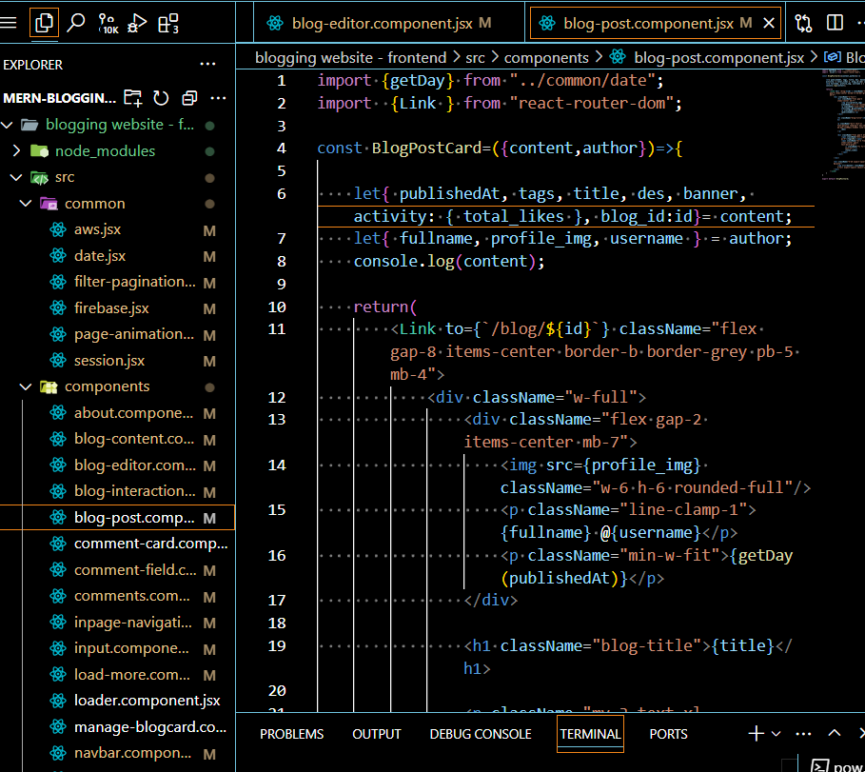

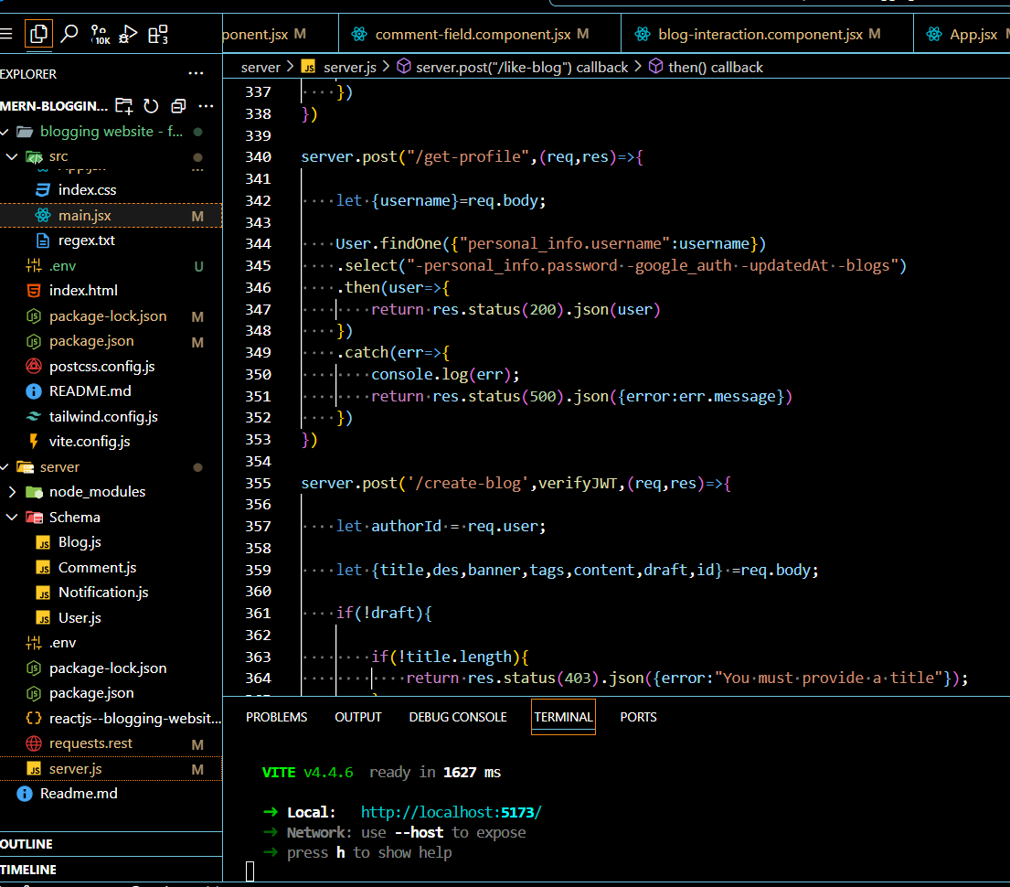

**4.2 Project Snippets:**

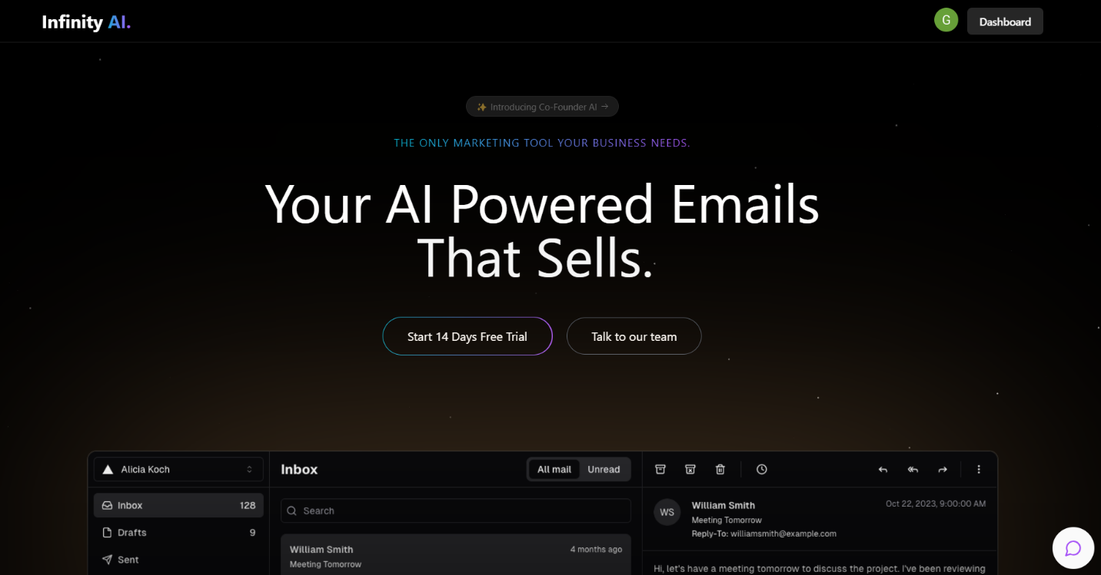

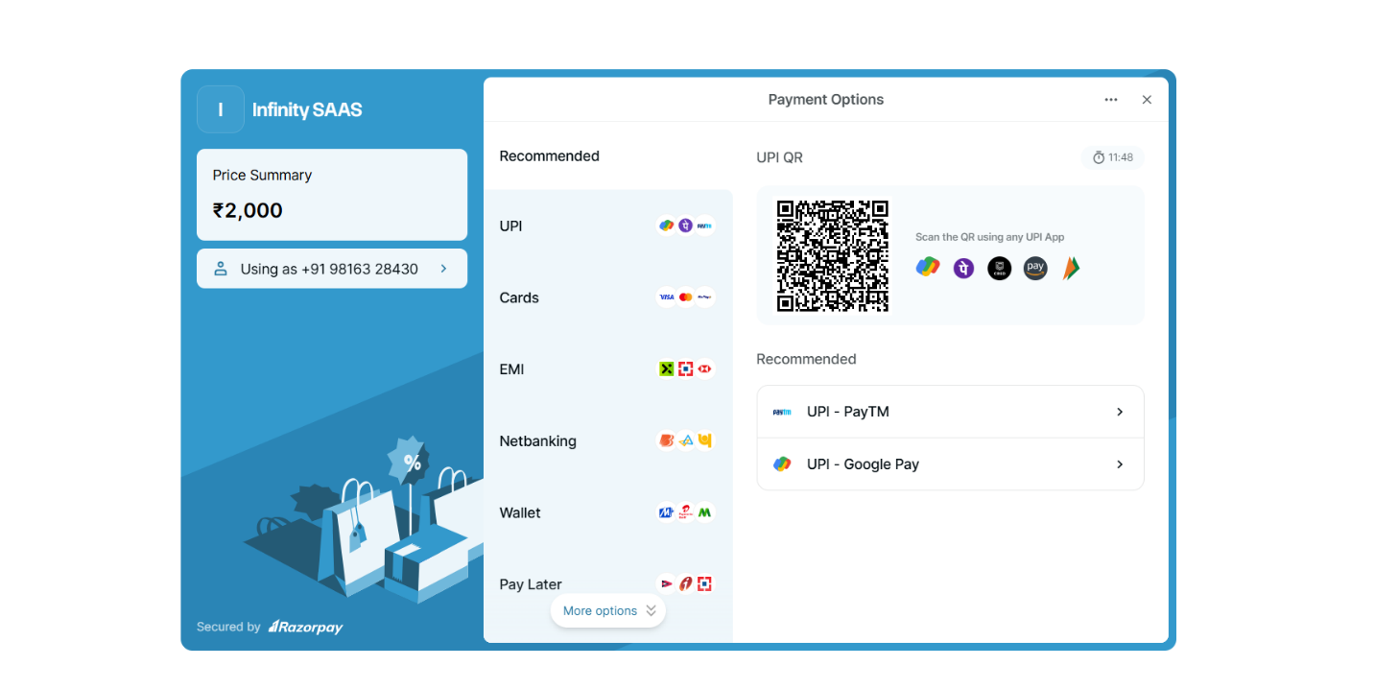



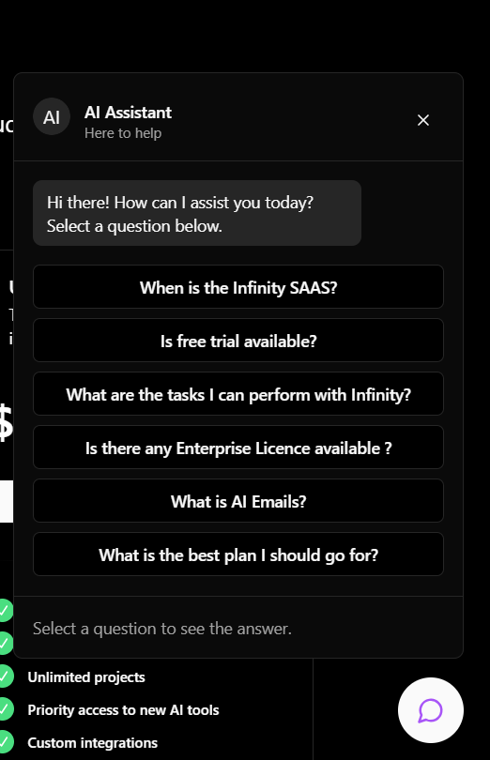

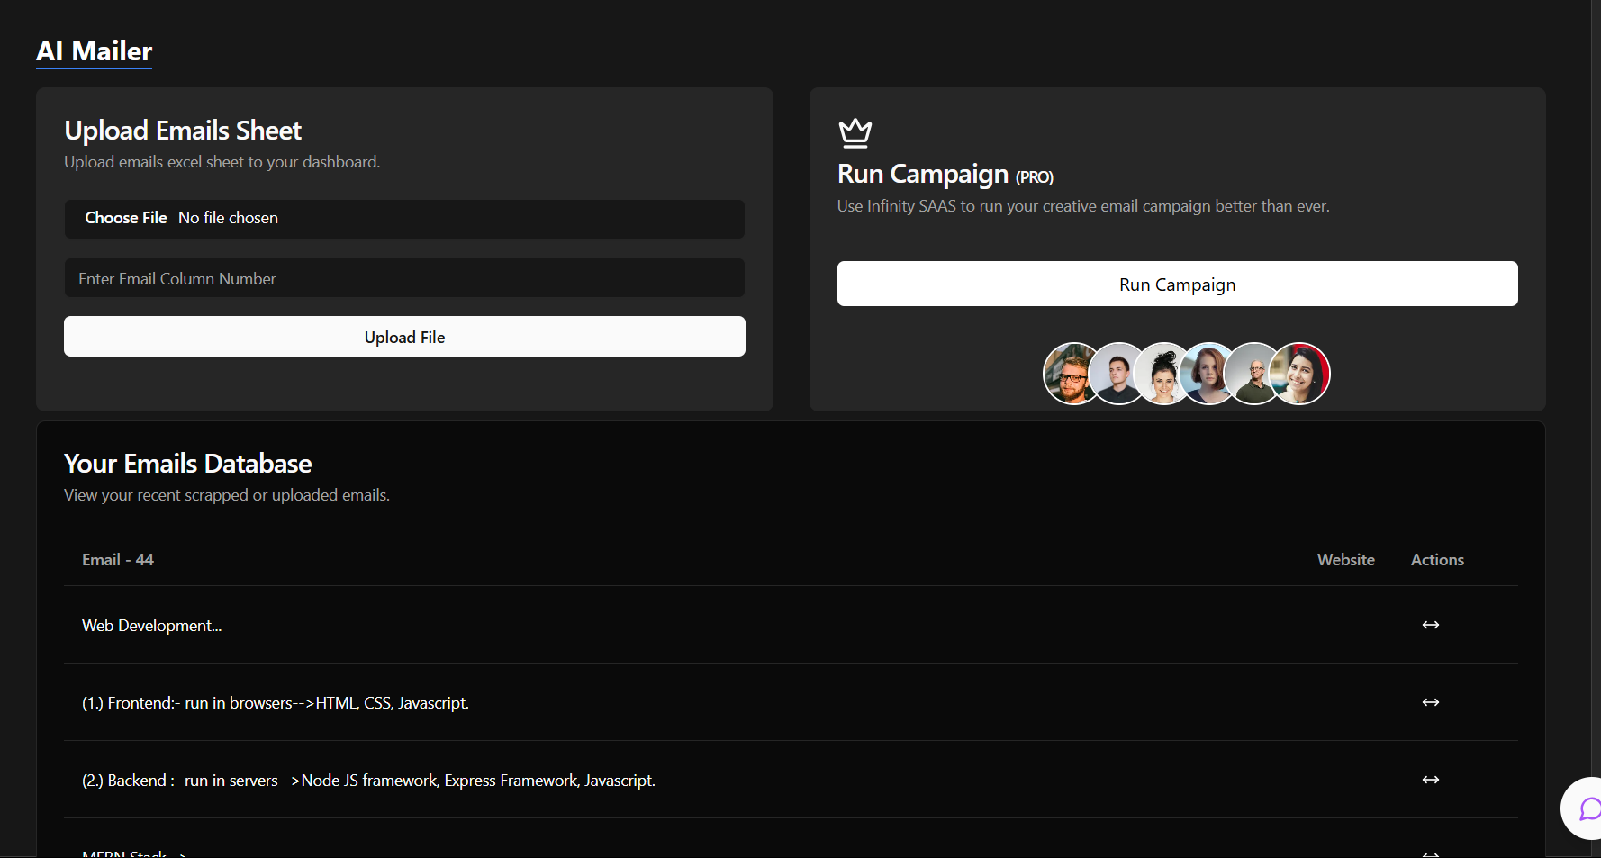

**5. References:**

* “Run JavaScript everywhere,” Nodejs.org. [Online]. Available: https://nodejs.org/en. [Accessed: 18-Sep-2024].
* “React,” React.dev. [Online]. Available: https://react.dev/. [Accessed: 18-Sep- 2024].
* “Express - Node.js web application framework,” Expressjs.com. [Online]. Available: https://expressjs.com/. [Accessed: 18-Sep-2024].
* “Documentation - Tailwind CSS,” Tailwindcss.com. [Online]. Available: https://v2.tailwindcss.com/docs. [Accessed: 18-Sep-2024].
* “Github Docs,” github.com Available: https://docs.github.com/en