CAPSTONE_RESULTS_W_Wardzinski

Wes Wardzinski

March 16, 2017

## Code and Results for Loading and Processing Ottawa temperatures in 20th Century

#### temp_hist_all <- read.csv(file="C:/STUDY/RYERSON_BIG_DATA/CAPSTONE/eng-monthly-011889-122006.csv", header=TRUE, sep=",")  
temp_hist_all <- read.csv(file="C:/INSTALLS/R/CAPSTONE/eng-monthly-011889-122006.csv", header=TRUE, sep=",")  
  
#### head (temp_hist_all)  
temp_hist <- temp_hist_all[,2:8]  
colnames(temp_hist) <- c("Year","Month","MaxTemp","MinTemp","Avg","MaxExt","MinExt")  
head(temp_hist)

## Year Month MaxTemp MinTemp Avg MaxExt MinExt  
## 1 1890 1 -4.2 -15.5 -9.9 8.9 -28.9  
## 2 1890 2 -3.7 -13.9 -8.8 7.2 -24.4  
## 3 1890 3 -0.3 -9.3 -4.8 6.1 -23.3  
## 4 1890 4 9.9 -1.2 4.4 20.0 -10.6  
## 5 1890 5 16.3 4.8 10.6 25.0 -3.9  
## 6 1890 6 24.2 12.3 18.3 32.8 3.9

hist(temp_hist$Avg, main="Histogram of Average Monthly temperatures", xlab = "Avg Temp in Celsius")

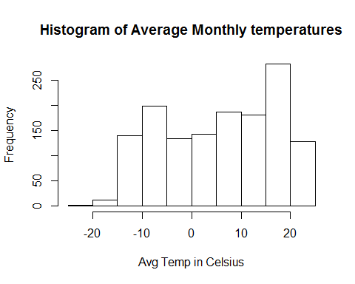

## Short function to show Month's Average temperatures for the decade  
AvgMM10YY <- function (mm,decade) {   
 + temp_hist$Avg[which(temp_hist$Month == mm & temp_hist$Year%/%10 == decade)] }  
AvgMM10YY(5,189)

## [1] 10.6 11.8 11.6 12.4 13.1 14.5 15.2 12.6 14.2 14.2

## Let's see oveall average monthly temperatures  
boxplot(temp_hist$Avg ~ temp_hist$Month, main = "Average Monthly temperatures in 1890-2006", xlab="Months 1=January... 12=December", ylab="Avg Temp in Celsius")

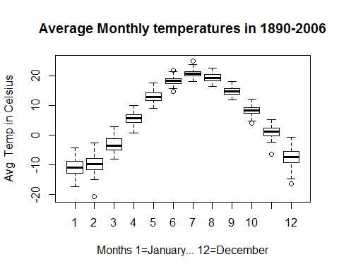

## As we see the winter months have more fluctuations  
attach(temp_hist)  
plot(Month,Avg, main = "Average Monthly temperatures in 1890-2006", xlab = "Month", ylab = "Avg temp in Celsius")

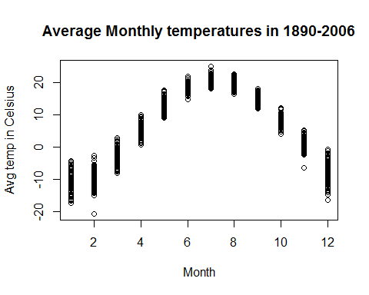

## I like boxplot better :)

## Continue Fun Plots

## Let's take begining of the Century. May temperatures were going down  
x <- c(1910:1919)   
y <- AvgMM10YY(5,191)  
plot(x,y, main="May temperatures in 1910-1919", xlab="Year", ylab = "Avg Temp in Celsius")  
cord <- lm(y~x)  
abline(cord)

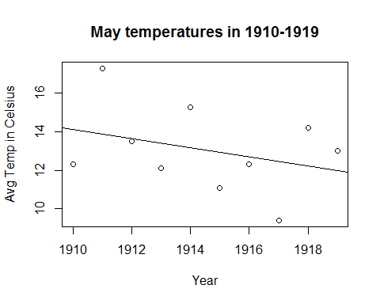

cord

##   
## Call:  
## lm(formula = y ~ x)  
##   
## Coefficients:  
## (Intercept) x   
## 471.3697 -0.2394

####  
#### Let's take end of the Century. May temperatures were going up  
x <- c(1980:1989)   
y <- AvgMM10YY(5,198)  
plot(x,y, main="May temperatures in 1980-1989")  
cord <- lm(y~x)  
abline(cord)

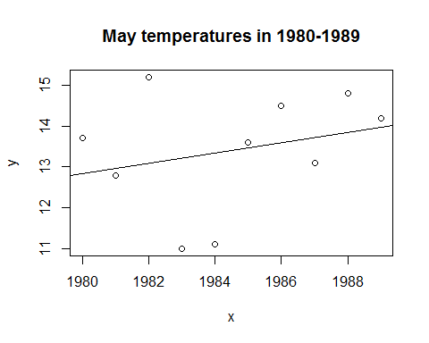

cord

##   
## Call:  
## lm(formula = y ~ x)  
##   
## Coefficients:  
## (Intercept) x   
## -239.1727 0.1273

## Let's take larger period of time.  
temp_hist5 <- subset(temp_hist, Month==5 & Year <= 1970)  
plot(temp_hist5$Year, temp_hist5$Avg, main = "May Temperatures 1890-1970", xlab = "Year", ylab = "Avg temp in Celsius")  
lm (temp_hist5$Avg ~ temp_hist5$Year)

##   
## Call:  
## lm(formula = temp_hist5$Avg ~ temp_hist5$Year)  
##   
## Coefficients:  
## (Intercept) temp_hist5$Year   
## 32.41351 -0.01026

abline( lm (temp_hist5$Avg ~ temp_hist5$Year) )

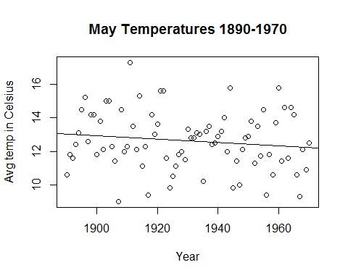

## Now Years after 1970  
temp_hist5 <- subset(temp_hist, Month==5 & Year > 1970 & Year < 2001)  
plot(temp_hist5$Year, temp_hist5$Avg, main = "May Temperatures 1971-2000", xlab = "Year", ylab = "Avg temp in Celsius")  
lm (temp_hist5$Avg ~ temp_hist5$Year)

##   
## Call:  
## lm(formula = temp_hist5$Avg ~ temp_hist5$Year)  
##   
## Coefficients:  
## (Intercept) temp_hist5$Year   
## -36.17022 0.02505

abline( lm (temp_hist5$Avg ~ temp_hist5$Year) )

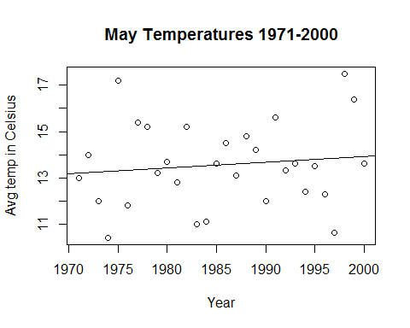

##  
# Let's do the same with Month of December:  
##  
temp_hist5 <- subset(temp_hist, Month==12 & Year <= 1970)  
plot(temp_hist5$Year, temp_hist5$Avg, main = "December Temperatures 1890-1970", xlab = "Year", ylab = "Avg temp in Celsius")  
lm (temp_hist5$Avg ~ temp_hist5$Year)

##   
## Call:  
## lm(formula = temp_hist5$Avg ~ temp_hist5$Year)  
##   
## Coefficients:  
## (Intercept) temp_hist5$Year   
## -29.70510 0.01127

abline( lm (temp_hist5$Avg ~ temp_hist5$Year) )

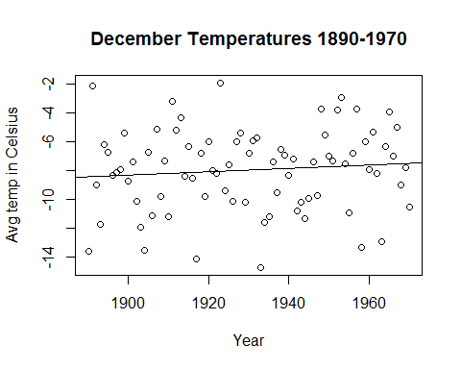

## Now Years after 1970  
temp_hist5 <- subset(temp_hist, Month==12 & Year > 1970 & Year < 2001)  
plot(temp_hist5$Year, temp_hist5$Avg, main = "December Temperatures 1971-2000", xlab = "Year", ylab = "Avg temp in Celsius")  
lm (temp_hist5$Avg ~ temp_hist5$Year)

##   
## Call:  
## lm(formula = temp_hist5$Avg ~ temp_hist5$Year)  
##   
## Coefficients:  
## (Intercept) temp_hist5$Year   
## -156.10235 0.07528

abline( lm (temp_hist5$Avg ~ temp_hist5$Year) )

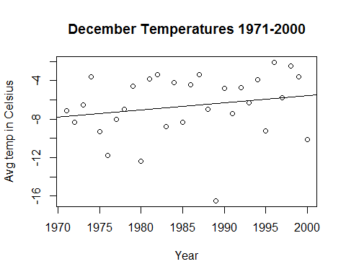

So, the presented results show us that the temperatures, were steady up to 1970. After that we noticed slight increase in temperatures ( 0.7 degree per decade)