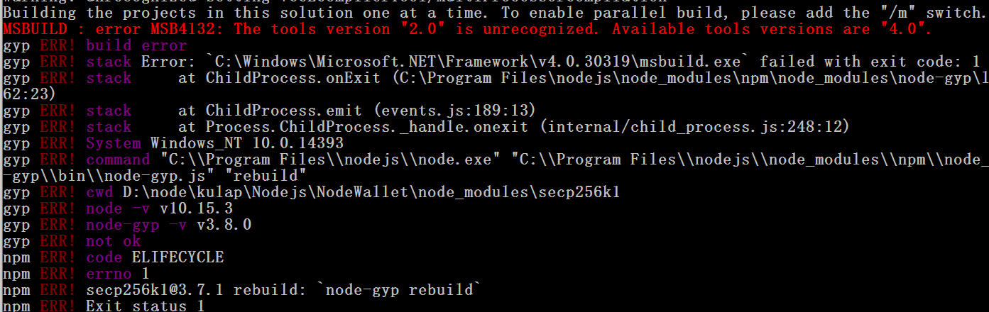

npm install --global --production windows-build-tools

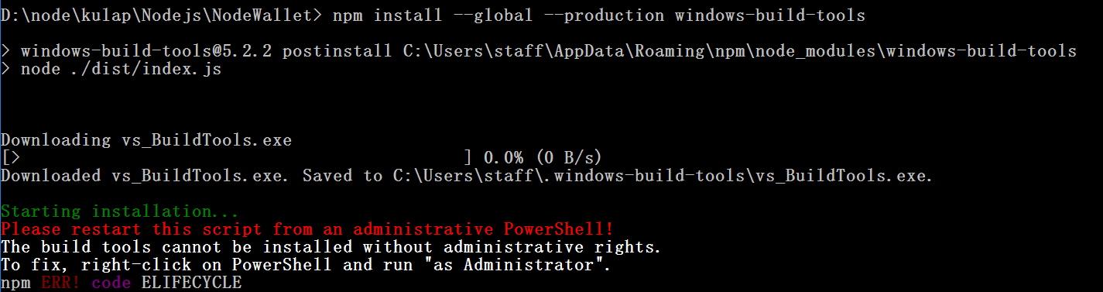

(Must be run above command with Administrator right)

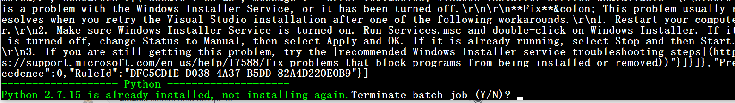

Must uninstall Python 2.7.15 and run it again

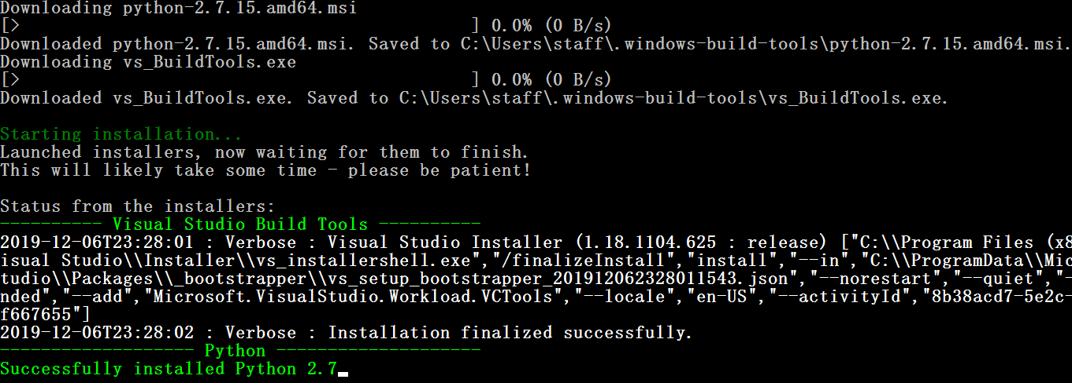

npm i (again)

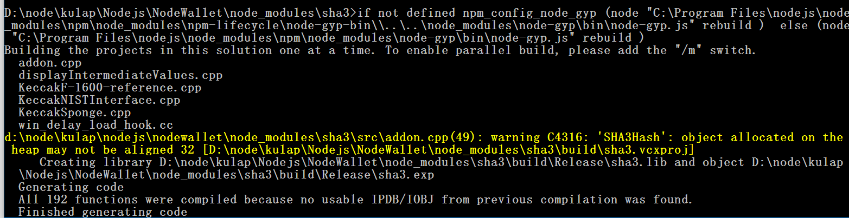

Done…

Summary: uninstall python (if exist) and run at Administrator right by:

npm install --global --production windows-build-tools

Reference:

<https://github.com/freearhey/web-learn/issues/2>

Mac OSX

npm -v. (v 6.10.1)

rm -rf node_modules  
npm install -g npm@latest  
npm i core-util-is 🡸 the main solution

**Ref:** <https://github.com/nodejs/help/issues/1846>