1. Install the MATLAB Compiler Runtime (MCR).
   1. Go to <https://www.mathworks.com/products/compiler/matlab-runtime.html>.
   2. The webpage should look something like below.
   3. Download the Windows 64-bit version in the row R2018b (9.5), as highlighted below.
   4. Follow the included instructions.

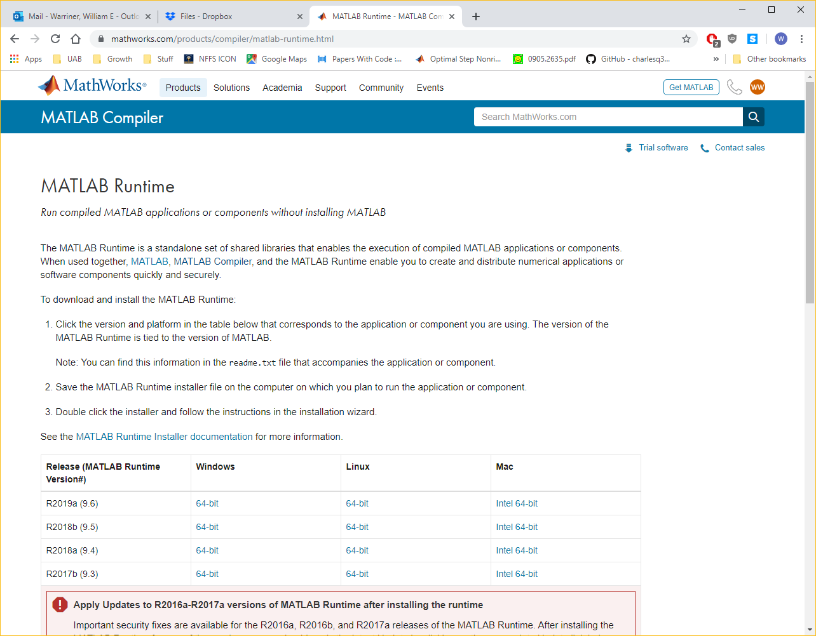

1. Put the contents of the zip file in any preferred location on your system.
2. Start the “CostAdvisorPlus.exe” application.
   1. Note that startup may take some time (up to several minutes for the first run).
   2. Slow startup is because of the MCR, and unfortunately we can’t do much about it at this stage, sorry!
3. Begin using the program.
   1. The screen below is what you should see after the program finishes loading.

|  |
| --- |
|  |

* 1. Press the “Process file…” button, highlighted above, to open a dialog box to locate an STL file on your system. You should see a dialog window that looks like below.

|  |
| --- |
|  |

* 1. Select a file on your system and press open. The main window should look like below. Note the file is “Processing…” This may take a few minutes, depending on the settings and your machine.

|  |
| --- |
|  |

* 1. On completion, the main window should look like below. Note the information lamp and message have changed to reflect completion. Also the “Model” and “Cost” panels in the middle and bottom of the window have updated.

|  |
| --- |
|  |

1. At any point before or after processing a file, you can change the “Order” information in the top-left panel, and the “Cost” panel will update with revised information.
2. Press the “Export results…” button at the bottom of the window to open a Save dialog to choose a location to save a summary file to. The summary file is a text file containing the analyzed feature information, the order information, the settings, and the cost information. Please send me these files as you perform analyses on 3D STL files! Thanks!