MINISTRY OF EDUCATION AND SCIENCE OF UKRAINE
NATIONAL TECHNICAL UNIVERSITY
“KHARKIV POLYTECHNIC INSTITUTE”
DEPARTMENT OF SOFTWARE ENGINEERING AND MANAGEMENT
INFORMATION TECHNOLOGIES”
Report of laboratory work №1
Discipline «Software Engineering»

Executed by: Student of group KN-226e
Sokurenko D.O.
Checked by: Associate professor
Melnyk K.V.

Kharkiv
2026
Theme: Creating Activity Diagrams and Use Case Diagrams using appropriate software
Work objective: to learn how to create UML Activity Diagrams and Use Case Diagrams using appropriate software
Task:
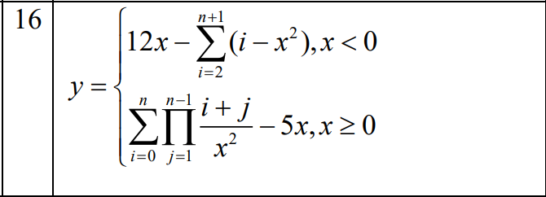

Progress of work:
1. UML Activity Diagram

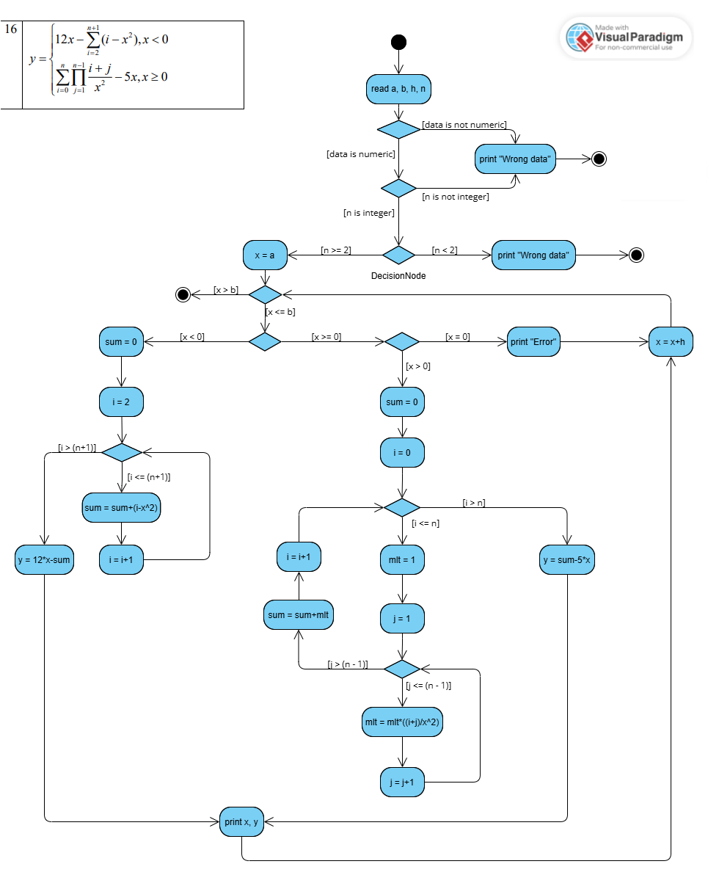
Explanation of the Diagram:
1. 1) The program reads the parameters a (start of range), b (end of range), h (step value), and n (upper loop boundary tier).
2) A Decision Node performs the initial data format validation by checking if [data is numeric]. If the user inputs text, special characters, or invalid commas, the algorithm follows the [data is not numeric] branch, outputs "Wrong data", and terminates the execution.
3) If the data format is verified, a second nested Decision Node checks the type constraint of parameter n. If [n is not integer], the system routes to the same "Wrong data" block to reject float values. If [n is integer], the execution moves to the next boundary node to verify if [n >= 2]. If [n < 2], it outputs "Wrong data" and safely exits.
4) If [n >= 2], the initialization phase successfully begins: the variable x is initialized to the starting value a. The main loop checks the boundary condition [x <= b] before entering the iteration.
2. The algorithm evaluates the current value of x through two primary branches:
2.1. Left branch [x < 0] computes a single sum function (∑).
- The accumulation variable sum is assigned the value 0, and the loop iterator i is initialized to 2. The loop executes as long as [i <= (n+1)].
- Inside the loop, the operation sum = sum+(i-x^2) (the core of the summation formula) is performed, followed by the increment i = i+1 (increases the counter by 1 to move to the next iteration).
- To terminate the loop, the condition [i > (n+1)] must be met, after which the final value is calculated using the formula y = 12*x-sum.
2.2. Right branch [x >= 0] splits into two directions: [x = 0] and [x > 0].
- The program checks whether [x = 0]. If so, it immediately outputs the message "Error" (due to the risk of division by zero in the alternative formula) and proceeds directly to the incremental step x = x+h. This allows the program to safely evaluate all subsequent points in the range without interruption.
- If [x > 0], the program calculates a complex nested function of the sum of products (∑∏). The global sum accumulator is reset to 0, and the outer loop iterator i is initialized to 0.
- If [i <= n], the outer loop initializes the local product accumulator mlt to 1 and the inner iterator j to 1.
- The inner loop, which runs while [j <= (n-1)], iteratively calculates the product using the formula mlt = mlt*((i+j)/x^2) and increments j by 1.
- When [j > (n-1)], the inner product-calculation loop terminates, the resulting value is added to the sum (sum = sum + mlt), i is incremented by 1, and the process returns to the start of the loop.
- When [i > n], the outer loop terminates, and the final expression is calculated: y = sum-5*x.
3. For any valid calculable branch (x < 0 or x > 0), the final synchronized block executes print x, y. Following this, the argument is incremented by the step value x = = x+h, and the flow returns to the main range validation. The entire function evaluation loop terminates once the condition [x > b] is met.

2. Use Case Diagram

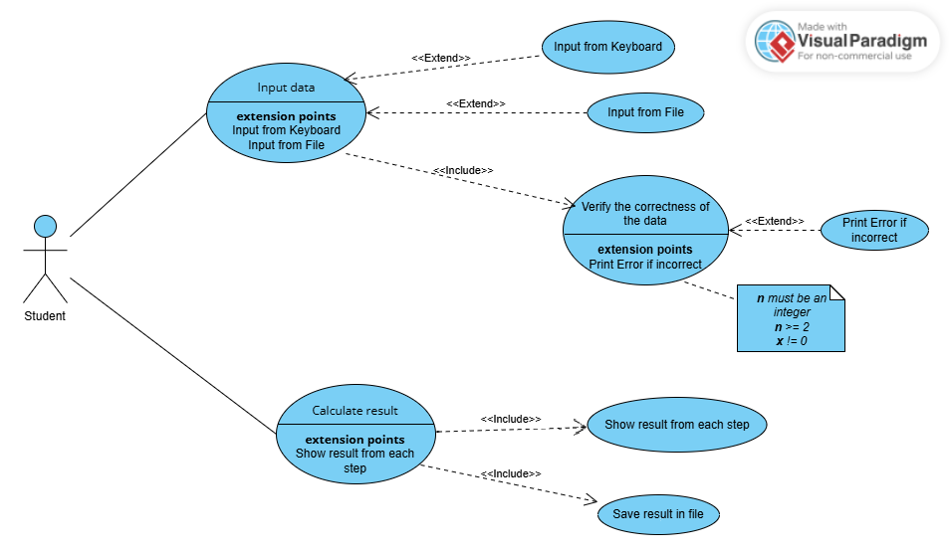

Explanation of the Diagram:
The diagram includes such elements as:
- Student — the primary user interacting with the system (entering data).
- Input data — allows the student to enter the necessary variables (a, b, h, n) into the system. Two optional extension points are provided: Input from Keyboard — activated if the user enters parameters manually; Input from File — activated if parameters are imported directly from an external data file. Verify the correctness of data (included use case) — ensures compliance with structural constraints monitored by a system-bound note (constraints checked: n is an integer, n ≥ 2, x ≠ 0). The extension point is provided: if any constraint is violated, the system displays an Error message.
- Calculate result — initiates the main execution loop, which processes the ranges defined by the input variables step-by-step. There are two included use cases provided. The Show result from each step option enables the dynamic output of coordinates (print x, y) to the log after each increment step, without buffering data until the process completes. Save result in file is included step integrated into the calculation process that writes the complete generated set of coordinates to a permanent output log file.

Conclusions: during execution of this laboratory training I got skills and knowledge in developing system algorithms using UML Activity Diagrams and modeling system behavior via Use Case Diagrams. I described the step-by-step logic of the computation cycle, incorporated validation mechanisms to prevent mathematical errors during program execution, and illustrated the functional interaction between data processing components, including subsystems for automatic file generation.

