MINISTRY OF EDUCATION AND SCIENCE OF UKRAINE
NATIONAL TECHNICAL UNIVERSITY
“KHARKIV POLYTECHNIC INSTITUTE”
DEPARTMENT OF SOFTWARE ENGINEERING AND MANAGEMENT
INFORMATION TECHNOLOGIES”
Report of laboratory work №2
Discipline «Software Engineering»

Executed by: Student of group KN-226e
Sokurenko D.O.
Checked by: Associate professor
Melnyk K.V.

Kharkiv
2026
Theme: Learning basic principles of C++
Work objective: to create a console application in Visual Studio using a UML Activity Diagram and a Use Case Diagram to develop a wireframe for this program.
Task:
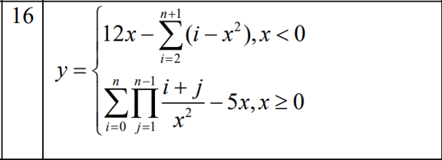
Figure 1. The application has to calculate the values by the following formula for the range with a predefined step

Progress of work:

- Wireframe for the program
Below is a full wireframe template of the program:

=====================================
[Screen 0 - welcome & entry overview layer]
=====================================

|====================================|
| FUNCTION TABULATOR |
|====================================|

Welcome to the enhanced function tabulation application!
This software computes an advanced math algorithm with deep nested loops.

--- IMPORTANT USER INSTRUCTIONS & FILE FORMAT RULES ---

1. Inputs via keyboard are real-time bulletproof validated (prevents crashes).
2. 'b' must be >= 'a'. Step 'h' must be > 0. Argument limit 'n' must be an integer and >= 2.
3. Avoid inputs that contain x = 0 to bypass division-by-zero errors.
4. At any input stage, type 'q' to cancel and return to Main Menu. Type any letter in other cases to return.
5. IF USING FILE INPUT:
- File must be located directly inside the project directory.
- It must contain exactly 4 pure numbers each on a new line.
- Ensure no extra letters, commas, or empty trailing rows exist.

Press Enter to load the application Main Menu...
=====================================
[Screen 1 – main menu]
=====================================
=====================================
Main Menu
=====================================
1. Input data
2. Calculate result
3. Exit

Select option: [ ]

=====================================
[Screen 2 - input methods]
=====================================
Choose input method:
1. Input from Keyboard
2. Input from File

Select: [ ]

=====================================
[Screen 3 - keyboard input with compact borders]
=====================================

---------- Keyboard Input -----------
|===================================|
Enter 'a': [0]
|===================================|
Enter 'b': [9]
|===================================|
Enter 'h': [8]
|===================================|
Enter 'n': [3]
|===================================|

Data entered and verified successfully

=====================================
[Screen 4 - displaying results with separator blocks]
=====================================
------------- Results ---------------

x = 0, y = Error (division by zero)
x = 8, y = 64864800
Results automatically saved to 'results.txt'

=====================================
[Screen 5 – exit program layer]
=====================================
=====================================
Main Menu
=====================================
1. Input data
2. Calculate result
3. Exit

Select option: 3

Exiting program. Goodbye!
=====================================

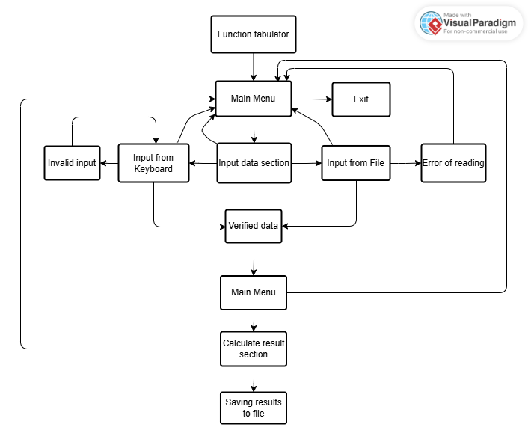
Figure 2. Program operation flowchart

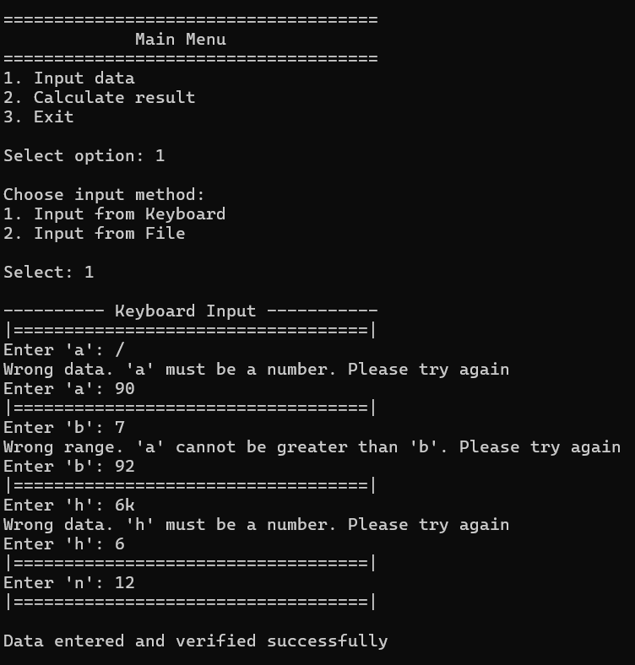


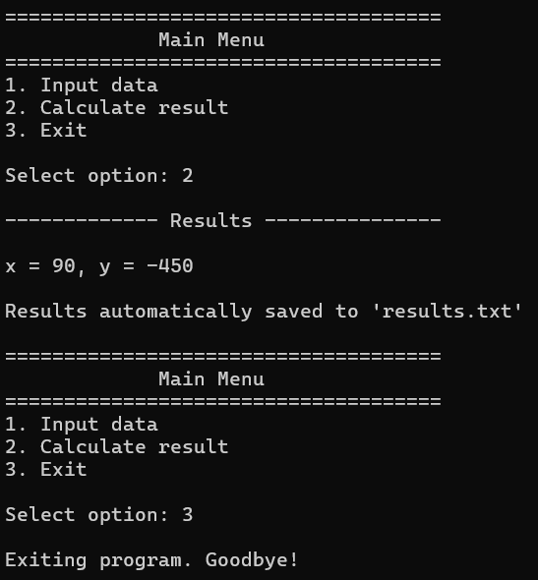

Figure 3. An example of using a wireframe (without Entry screen)
while the program is running
2. Code of the program
The full program code is presented below:

#include <iostream>
#include <cmath>
#include <limits>
#include <fstream>
#include <Windows.h>
#include <string>
#include <sstream>

using namespace std;

// Глобальні змінні для збереження параметрів програми та стану валідації
double a, b, h, n_raw;
int n;
bool data_is_loaded = false;

// Очищення консольного буфера пам'яті у разі помилкового введення (наприклад, літер)
void clear_input() {
cin.clear();
cin.ignore((numeric_limits<streamsize>::max)(), '\n');
}

// Повна перевірка коректності всіх даних (використовується переважно для файлів)
bool verify_all_data() {
if (a > b) {
cout << "Wrong range. 'a' cannot be greater than 'b'\n";
return false;
}
if (h <= 0) {
cout << "Wrong data. 'h' must be greater than 0 to avoid infinite loop. Please try again\n";
return false;
}
if (n_raw > 10000) {
cout << "Wrong data. The number is too large to process. Max 'n' is 10000\n";
return false;
}
if (n_raw != floor(n_raw) || n_raw < 2) {
cout << "Wrong data. 'n' must be an integer greater than or equal to 2\n";
return false;
}
return true;
}

// Допоміжна функція для зчитування рядка та перевірки на клавішу 'q'
bool read_and_check(const string& prompt, double& target, const string& error_msg, bool check_range = false) {
string input_str;
while (true) {
cout << prompt;
if (!(cin >> input_str)) {
clear_input();
continue;
}
// Перевірка, чи користувач хоче скасувати введення та повернутися в меню
if (input_str == "q" || input_str == "Q") {
cout << "\nInput cancelled. Returning to Main Menu...\n";
return false;
}
// Спроба конвертувати рядок у число та перевірка на відсутність зайвих літер
stringstream ss(input_str);
double temp_val;
if (ss >> temp_val && ss.eof()) {
if (check_range && a > temp_val) {
cout << "Wrong range. 'a' cannot be greater than 'b'. Please try again\n";
continue;
}
target = temp_val;
return true;
}
cout << error_msg;
}
}

// Покрокове введення параметрів з клавіатури з миттєвою валідацією та підтримкою 'q'
void input_from_keyboard() {
cout << "\n---------- Keyboard Input -----------";
cout << "\n(Type 'q' at any step to cancel and return to Main Menu)\n";

// Введення та перевірка змінної 'a'
cout << "\n|===================================|\n";
if (!read_and_check("Enter 'a': ", a, "Wrong data. 'a' must be a number. Please try again\n")) return;

// Введення та перевірка змінної 'b' із перевіркою коректності діапазону (a <= b)
cout << "|===================================|\n";
if (!read_and_check("Enter 'b' (must be greater than or equal to 'a'): ", b, "Wrong data. 'b' must be a number. Please try again\n", true)) return;

// Введення та перевірка кроку 'h' (має бути строго більшим за 0)
cout << "|===================================|\n";
while (true) {
if (!read_and_check("Enter 'h': ", h, "Wrong data. 'h' must be a number. Please try again\n")) return;
if (h > 0) break;
cout << "Wrong data. Step 'h' must be greater than 0 to avoid infinite loop. Try again\n";
}

// Введення та перевірка обмежень для n (ціле число, від 2 до 10000)
cout << "|===================================|\n";
while (true) {
if (!read_and_check("Enter 'n' (must be greater than or equal to 2): ", n_raw, "Wrong data. 'n' must be a number. Please try again\n")) return;
if (n_raw > 10000) {
cout << "The number is too large to process. Max 'n' is 10000. Please try again\n";
continue;
}
if (n_raw == floor(n_raw) && n_raw >= 2) {
n = static_cast<int>(n_raw);
break;
}
cout << "Wrong data. 'n' must be an integer greater than or equal to 2. Please try again\n";
}
cout << "|===================================|\n";
cout << "\nData entered and verified successfully\n";
data_is_loaded = true; // Активуємо дозвіл на проведення обчислень
}

// Завантаження параметрів програми з текстового файлу
void input_from_file() {
string filename;
cout << "\nEnter input filename (e.g., input.txt): ";
cin >> filename;
ifstream infile(filename);
if (!infile) {
cout << "\nError: Cannot open file. Make sure this file is in the project folder\n";
return;
}
// Зчитування 4 чисел поспіль та перевірка на коректність структури файлу
if (!(infile >> a) || !(infile >> b) || !(infile >> h) || !(infile >> n_raw)) {
cout << "\nError: Invalid data format inside the file. Make sure it contains 4 pure numbers, each on a separate line\n";
infile.close();
return;
}
cout << "\nRead from file: a=" << a << ", b=" << b << ", h=" << h << ", n=" << n_raw << endl;
// Перевірка логічних обмежень для отриманих із файлу даних
if (verify_all_data()) {
cout << "Data loaded from file and verified successfully\n";
n = static_cast<int>(n_raw);
data_is_loaded = true;
}
else {
cout << "File data verification failed\n";
}
infile.close();
}

// Основний блок обчислень функції та автоматичного збереження результатів
void calculate_and_save_result() {
// Запобіжник: забороняє розрахунок, якщо дані ще жодним способом не введені
if (!data_is_loaded) {
cout << "Error: you must input the data first (Option 1)\n";
return;
}
ofstream outfile("results.txt");
if (!outfile) {
cout << "Warning: Cannot create results.txt for saving\n";
}
cout << "\n------------- Results ---------------\n\n";
if (outfile.is_open()) {
outfile << "------------- Results ---------------\n\n";
}
// Головний цикл табуляції аргументу x від початкової точки a до кінцевої b з кроком h
for (double x = a; x <= b; x += h) {
// Перевірка критичної математичної умови x != 0 безпосередньо в момент розрахунку
if (x == 0) {
cout << "x = 0, y = Error (division by zero)" << endl;
if (outfile.is_open()) outfile << "x = 0, y = Error (division by zero)\n";
continue; // Пропускаємо крок обчислення формули та переходимо до наступного x
}
double y;
// Гілка алгоритму для від'ємних значень аргументу x
if (x < 0) {
double sum_val = 0;
for (int i = 2; i <= (n + 1); ++i) {
sum_val += (i - x * x);
}
y = 12 * x - sum_val;
}
// Гілка алгоритму для додатних значень аргументу x із вкладеними циклами суми добутків
else {
double sum_val = 0;
double x_squared = x * x;
for (int i = 0; i <= n; ++i) {
double mlt = 1;
for (int j = 1; j <= (n - 1); ++j) {
mlt *= (static_cast<double>(i + j) / x_squared);
// Захист процесора: якщо проміжне число переповнилось (inf) або зникло (0.0), зупиняємо внутрішній цикл
if (mlt == 0.0 || isinf(mlt)) {
break;
}
}
sum_val += mlt;
}
y = sum_val - 5 * x;
}
// Обробка результатів та перевірка кінцевої відповіді y на нескінченність (Infinity)
if (isinf(y)) {
cout << "x = " << x << ", y = [Result is too large (Infinity)]" << endl;
if (outfile.is_open()) outfile << "x = " << x << ", y = [Result is too large (Infinity)]\n";
}
else {
cout << "x = " << x << ", y = " << y << endl;
if (outfile.is_open()) outfile << "x = " << x << ", y = " << y << "\n";
}
}
if (outfile.is_open()) {
cout << "\nResults automatically saved to 'results.txt'\n";
outfile.close();
}
}

// Точка входу в програму. Керує початковим екраном та життєвим циклом меню
int main() {
// Встановлюємо Юнікод (UTF-8) для коректного виведення знака ≥
SetConsoleCP(65001);
SetConsoleOutputCP(65001);
int choice;
cout << "|====================================|\n";
cout << "| FUNCTION TABULATOR |\n";
cout << "|====================================|\n\n";
cout << "Welcome to the enhanced function tabulation application!\n";
cout << "This software computes an advanced math algorithm with deep nested loops.\n\n";
cout << "--- IMPORTANT USER INSTRUCTIONS & FILE FORMAT RULES ---\n\n";
cout << "1. Inputs via keyboard are real-time bulletproof validated (prevents crashes).\n";
cout << "2. 'b' must be ≥ 'a'. Step 'h' must be > 0. Argument limit 'n' must be an integer and ≥ 2.\n";
cout << "3. Avoid inputs that contain x = 0 to bypass division-by-zero errors.\n";
cout << "4. At any input stage, type 'q' to cancel and return to Main Menu. Type any letter in other cases to return.\n";
cout << "5. IF USING FILE INPUT:\n";
cout << " - File must be located directly inside the project directory.\n";
cout << " - It must contain exactly 4 pure numbers each on a new line.\n";
cout << " - Ensure no extra letters, commas, or empty trailing rows exist.\n\n";
cout << "Press Enter to load the application Main Menu...";
cin.get();

// Головний нескінченний цикл текстового меню програми
while (true) {
cout << "\n=====================================\n";
cout << " Main Menu \n";
cout << "=====================================\n";
cout << "1. Input data\n";
cout << "2. Calculate result\n";
cout << "3. Exit\n";
cout << "\nSelect option: ";
// Перевірка на помилку вибору пункту меню
if (!(cin >> choice)) {
cout << "Invalid menu option. Please try again\n";
clear_input();
continue;
}

// Обробка обраних користувачем сценаріїв
if (choice == 1) {
int input_choice;
cout << "\nChoose input method:\n1. Input from Keyboard\n2. Input from File\n\nSelect: ";
if (cin >> input_choice) {
if (input_choice == 1) input_from_keyboard();
else if (input_choice == 2) input_from_file();
else {
cout << "Invalid input choice. Returning to Main Menu...\n";
}
}
else {
cout << "Invalid input choice. Returning to Main Menu...\n";
clear_input(); // Очищення буфера, щоб уникнути зациклення через літери
}
}
else if (choice == 2) {
calculate_and_save_result();
}
else if (choice == 3) {
cout << "\nExiting program. Goodbye!\n";
break; // Перериваємо нескінченний цикл роботи програми для коректного виходу
}
else {
cout << "Wrong option. Please select 1, 2 or 3\n";
}
}
return 0;
}

4. Core execution scenarios (examples)

- Standard input streams
Parameters applied: a = 0, b = 9, h = 8, n = 3
Input values are accepted sequentially. The application catches boundaries accurately and proceeds to evaluation blocks. x = 0 successfully triggers the internal computational safe fallback condition.
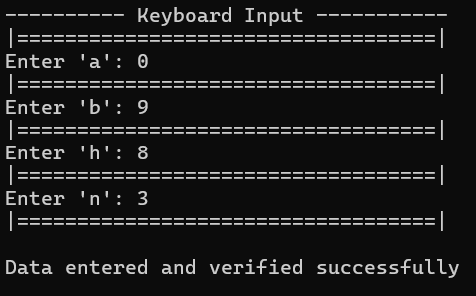

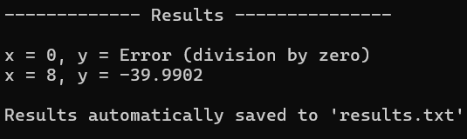

Figure 4, 5. An example of standard input stream work

2) Data corruption defense structure (UX validation)
Parameters applied: h = 9k
The conditional check cin.peek() triggers. The stream buffer captures the invalid alphabetic data stream, fires custom warning structures without advancing layers, and isolates user control on repeating the h variable request.

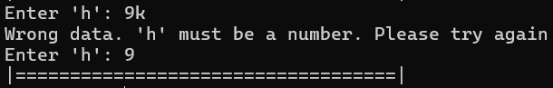

Figure 6. An example of Data corruption defense structure work

3) Loop limit boundary constraint validation
Parameters applied: n = 1
The conditional checks validate the `n_raw` parameter against the allowed closed interval [2; 10000] (10000 to prevent a huge number of operations). If the value falls below the minimum requirement or exceeds the processing safety limit, the execution loop refuses the data state, triggers a specific boundary error prompt, and prompts the user for re-entry without moving forward.

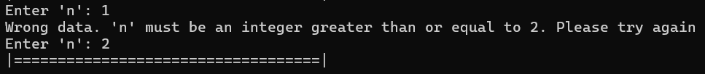
Figure 7. An example of Loop limit boundary constraint validation work

4) Extreme calculation underflow/overflow protection
Parameters applied: Extreme structural stress loop n = 9999 with arguments evaluated over zero boundary parameters.
Math evaluation bounds stay operational due to isinf(mlt) || mlt == 0.0 loop control filters. The system calculates outcomes instantly instead of freezing, map-reducing extreme calculations straight into informative error flags.

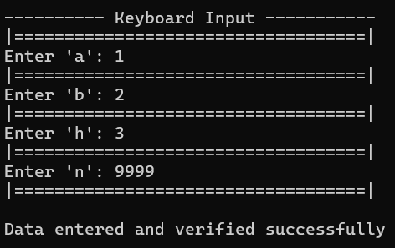

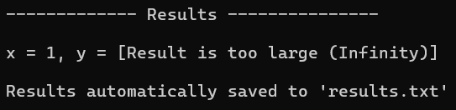

Figure 8, 9. An example of Extreme calculation underflow/overflow protection work

5) Missing file reference management
Parameters applied: Non-existent text reference named file used inside option 2 interface flow.
The system fails validation when using !infile. The program safely halts the computation, logs an Error message with appropriate advice, and correctly returns the user to the Main Menu.
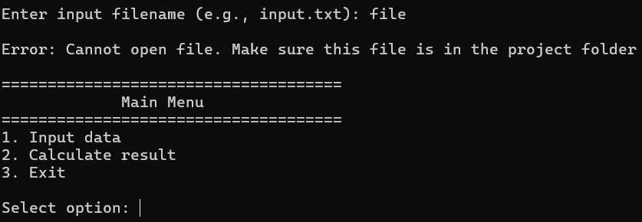
Figure 10. An example of Missing file reference management work

Conclusions: during execution of this laboratory training we got skills and knowledge about designing user-friendly console interfaces, coding and implementing multi-stage input data validation in C++, and handling file input/output streams securely. We described the complete structural logic of the application by mapping out detailed user flows, developing comprehensive interface wireframes, and managing critical algorithmic edges such as division by zero and extreme values overflow. As a result, we developed a highly robust, fault-tolerant software solution that prevents execution crashes and delivers a seamless, optimized user experience.

