Page 3

空格

大小写

符号

F：what repair or renovation have been carried out on the staircase.（时态不确定）

Page4

G:没想好怎么改

Changes那一大段改为

对楼梯来说，使用的材料体积较小，材料的力学性质的改变可以被忽略。同时，计算时忽略变化极其微小的力学参数，有利于建模。

As for stairs, the materials used have relatively small volumes and the changes in their mechanical properties can be disregarded. Meanwhile, when conducting calculations, ignoring extremely minor mechanical parameters is beneficial for simplifying the research process and improve the scientific and operability of the model.

4改为

没想好

5模型名字

Step Load Interaction Model (SLIM)，我以为这个就是人脚模型（挠头.jpg）

Page5

Dertah 改为CE

这个公式删掉，CE为直接测量得到的凹陷深度

L\w\H 都要换，后面用过了（建议LEN，WID、HIG）

Page6

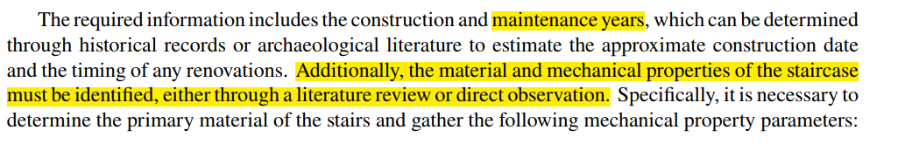

The required information includes the construction period given by the archaeological team and the rough judgment on the types of materials made at the time of the inspection. Meanwhile, based on the rough judgment of the materials, query the data table and obtain the material mechanical parameters as shown in Table 1.

Page7

字符

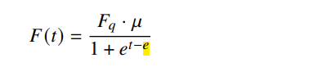

t-e中的e换成希腊字符，说明是时间调节因子

page 8

左手系

X轴换成Y The outer edge of the staircase coincides with the Y-axis.

Y换成Z

B的解释：每一次法向载荷造成的凹陷对应周长（需要个图）

公式了L改成L1

Page 14

D小写