Page3

A：The consistency between the wear patterns simulated by the model optimization and the actual wear patters of the staircase

Page4

G

模型中使用的材料力学参数与从考古学家相信的材料来源中实验获得的力学参数的一致性

The consistency between the material mechanical parameters used in the model and those obtained experimentally from the sources believed by archaeologists as the material origins

F

And

假设4改为

这项研究针对的是经过长期使用的石质或木质楼梯,要求楼梯踏面的宽度大于美国人的平均脚长。

This study focuses on stone or wooden staircases that have been in use for a long time. It requires that the width of the stair treads be greater than the average foot length of Americans.

Page13

问题E（问题D的回答还没写）

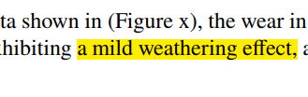

A Micro-weathering effect

Page14

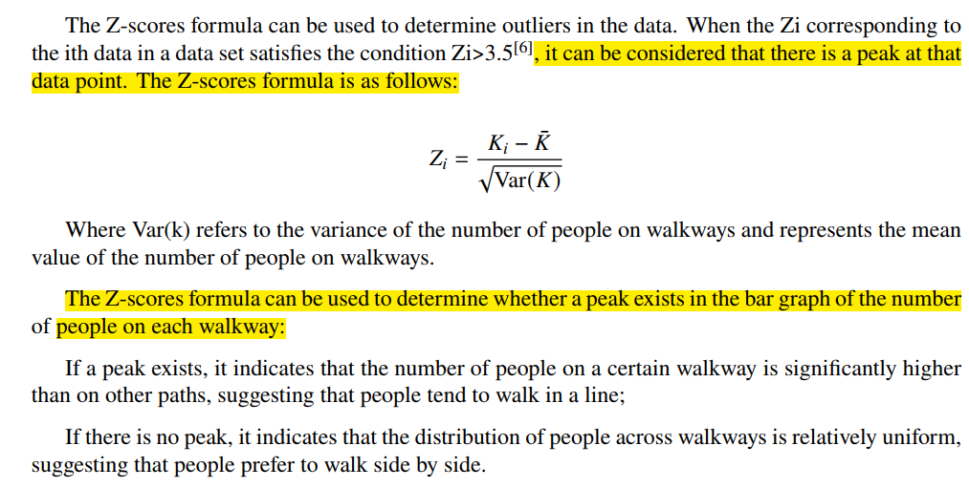

, it can be considered that this data point is a peak（后半句没问题）

第二大段荧光笔的删掉——内容重复

Page16

R（）指秩次和sum of ranks

这里，R（）指秩次和运算

**Here, R represents the calculation of the sum of ranks.**

花花、黑点、菱形可以统一不（有一点点乱）

全局变量表 h： 对应点到下方踏面的距离The distance from the corresponding point to the lower tread

目录只能占据一页（引用最好也只占一页）

8. Conclusion of Basic Predictions

9 Guidance Based on Stairwell Usage

补全步坑模型（李锦的文档）

8.2回答问题B

If Kupstairs>Kdownstairs 倾向于向上

If Kupstairs<Kdownstairs 倾向于向下