To describe the wear behavior of stairs more accurately, a mathematical model based on beam bending theory (楼梯弯曲理论)was developed to predict the wear under different conditions through the relationship between deflection and loading.

**Variable description**

· Wr: Deflection, the depth of deformation under external forces, measured in meters (m).

· ν: Poisson's ratio

· k: Shear correction factor

· q: Uniformly distributed load, measured in newtons per meter (N/m).

· E: Elastic modulus, measured in pascals (Pa).

· I: Moment of inertia of the stair cross-section, in meters to the fourth power (m4^44).

· A: Cross-sectional area of the stair, measured in square meters (m2^22).

· G: Gravitational acceleration, with a value of 9.98 meters per second squared (m/s2^22).

· X: Horizontal coordinate of the force application point, measured in meters (m).

· L: Total length of the beam, measured in meters (m).

**Coordinate axis description**

The coordinate axis of the stair adopts the right-handed rectangular coordinate system, where the X-axis is along the horizontal direction of the stair, indicating the horizontal coordinates of the force position, and the Y-axis is along the vertical direction of the stair, indicating the change of deformation and deflection, and the origin of the coordinate system is located at the bottom of the stair, as illustrated in the figure n.

**model building**

Firstly, we simplify the staircase to a model of a beam fixed at both ends (both ends are fixed by supports, one of which is supported with pulleys to allow sliding in the axial direction)[3,4]. Based on this assumption, the deflection equation for this model is expressed as:

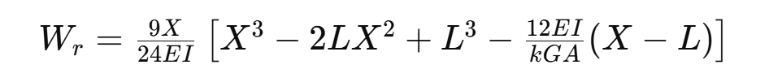

From the above equation, We established the functional relationship between the deflection Wr and the horizontal coordinate of the force application point X and plotted the corresponding figure n. The figure shows that the deflection reaches its maximum value near X=Xmax.

(图)

We further abstracted the overall bending deformation of the beam as a concave region centered at Xmax, corresponding to the maximum deflection Wr. It is assumed that the cross-sectional profile of this region conforms to the shape of a catenary (while ignoring the deformation and concavity at other positions). The wear width of the catenary-shaped region is calculated using the following equation:



Through calculation, the wear width L1 caused by each applied load is determined to be 0.1±0.01. For the sake of simplification in subsequent calculations, L1 is treated as a constant value of 0.1.