参考文献

@article{SJDJ13012100021589,

author = { Hessert Mary and Vyas Mitul and Leach Jason and Hu Kun and Lipsitz Lewis and Novak Vera},

title = {Foot pressure distribution during walking in young and old adults},

journal = {BMC Geriatrics},

volume = {5},

number = {1},

pages = {8},

year = {2005},

issn = {1471-2318},

}

@article{CHO2021110446,

title = {The difference of in-shoe plantar pressure between level walking and stair walking in healthy males},

journal = {Journal of Biomechanics},

volume = {122},

pages = {110446},

year = {2021},

issn = {0021-9290},

doi = {https://doi.org/10.1016/j.jbiomech.2021.110446},

url = {https://www.sciencedirect.com/science/article/pii/S0021929021002268},

author = {Yun Jae Cho and Choongho Lee and Jae Hee Lee and Min Gyu Kyung and Kyung Hwan Lee and Dong Yeon Lee},

keywords = {Stair walking, Plantar pressure, Pedar-X system, Peak pressure, Pressure time integral},

abstract = {Stair walking is more demanding locomotion than level walking and can aggravate discomfort of the foot. The purpose of this study is to analyze plantar pressure distribution and pressure patterns during gait cycle at stair walking compared to level walking. Thirty-five healthy males with 23.4 ± 2 years old were included in this study after examining normality. They performed level walking, stair ascending, and descending in same type of shoes. Measurements of in-shoe plantar pressure including peak pressure, pressure-time integral were done by Pedar-X system, masked 7 regions. Also, pressures in each region throughout the gait cycle were analyzed from each type of walking. Statistical analysis was performed using repeated measure one way analysis of variance. Peak pressure in all regions except for the midfoot was higher during level walking than stair walking. Pressure-time integral in the forefoot, midfoot during stair ascending, and the forefoot during stair descending was higher than level walking. In gait cycle, first peak was produced in the heel and the second peak was produced in the hallux during level walking, whereas during stair ascent, the heel and midfoot were in first peak, and the second peak was in the hallux. During stair descent, the first peak were in the forefoot and the midfoot, and the second peak was in the forefoot. In healthy young male adults, forefoot and midfoot are significant regions in the way that they have higher pressure burdens than other foot regions during stair walking.}

}

下面的过程仅示意图片非导出图

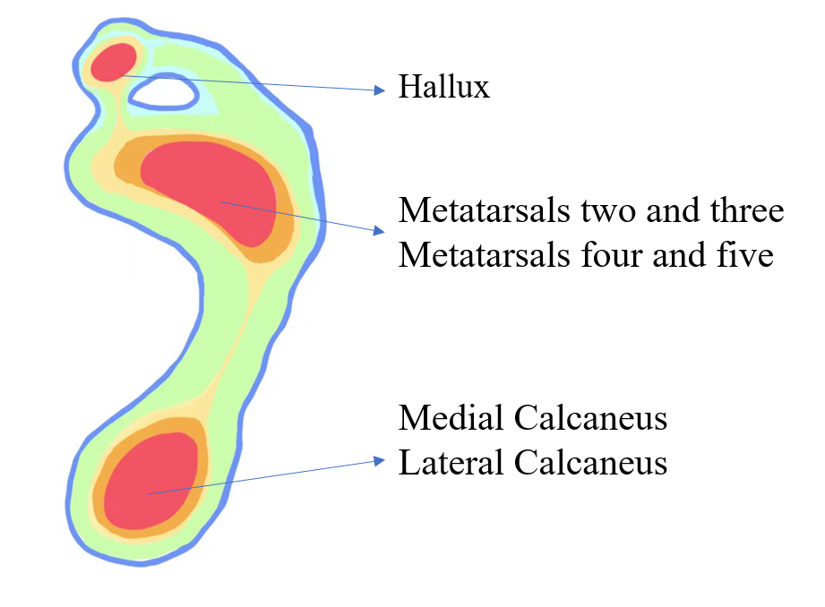

综合上述参考文献得出的上下楼梯脚所受压力的红外分布图

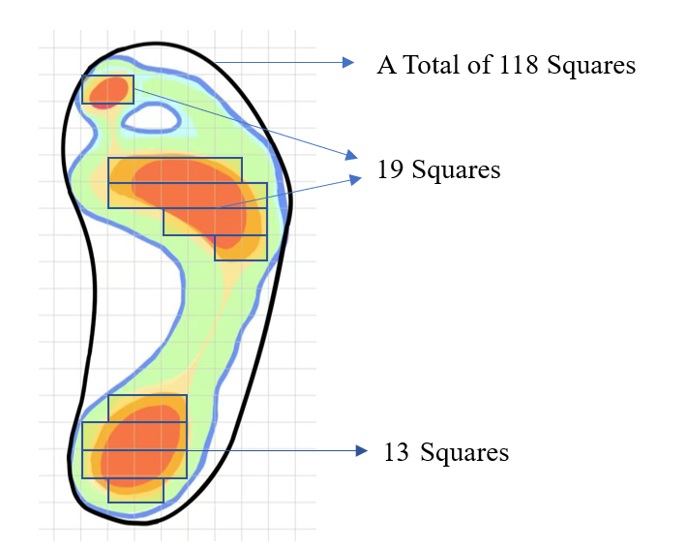

网格法得到的主要受力面积和总面积的关系

美国公民平均脚面积取245平方厘米

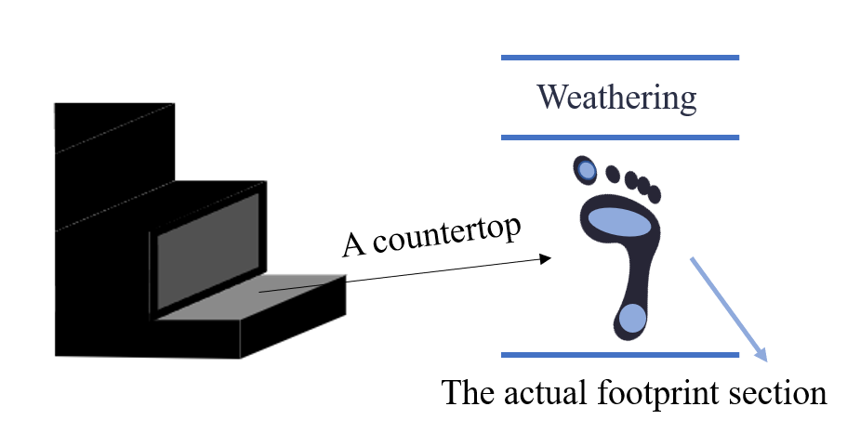

一个台面分为实际踩踏部分，和仅受分化部分