【3】Journal | [J] [Materials Testing.](https://webvpn.xjtu.edu.cn/https/77726476706e69737468656265737421e3f449932b317a1e7d0682a5d65b2621/journal/index/SBQK002553000044) Volume 12 , Issue 11 . 1970. PP 377-380

[10.1515/MT-1970-121103](https://webvpn.xjtu.edu.cn/http/77726476706e69737468656265737421f4ef0f982839265f6c0f/10.1515/MT-1970-121103)

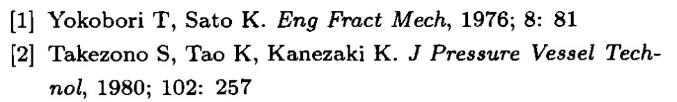

* 【4】@article{ SJESF46245B4D88236414B6977C781CEC048,  
  author = { Y Nakai and  C Hiwa },  
  title = {Effects of loading frequency and environment on delamination fatigue crack growth of CFRP},  
  journal = {International Journal of Fatigue},  
  volume = {24},  
  number = {2},  
  pages = {161-170},  
  year = {2002},  
  issn = {0142-1123},  
  }
* 【5】@article{ SJESAC88A958454EEE1CD4ED092FB8A0E8F8,  
  author = { Rongchang Zeng and  Enhou Han and  Wei Ke },  
  title = {A critical discussion on influence of loading frequency on fatigue crack propagation behavior for extruded Mg–Al–Zn alloys},  
  journal = {International Journal of Fatigue},  
  volume = {36},  
  number = {1},  
  pages = {40-46},  
  year = {2011},  
  issn = {0142-1123},  
  }

其他材料