A Programmer’s Guide to Cell Biology: A Travelogue from a Stranger in a Strange Land
William W. Cohen, Center for Automated Learning and Discovery, Carnegie Mellon University, Pittsburgh PA

Introduction
For the past few months, I have been spending most of my time learning about biology. This is a major departure for me, as for the previous 25 years, I’ve spent most of my time learning about programming, computer science, text processing, artificial intelligence, and machine learning. Surprisingly, many of my long-time colleagues are doing something similar (albeit usually less intensively than I am). This document is written mainly for them—the many folks that are coming into biology from the perspective of computer science, especially from the areas of information retrieval and/or machine learning—and secondarily for me, so that I can organize and retain more of what I’ve learned.
I find it helpful to think of “biology” in three parts. One part of biology is information about biological systems (for instance, how yeast cells metabolize sugar). This is the focus of most introductory biological textbooks and overviews, and is the essence of what biologists actually study—what biologists are trying to determine from their experiments. However, it is not always what biologists spend most of their time talking about. If you pick up a typical biology paper, the conclusions are typically quite compact: often all the new information about biological systems in a paper appears in the title, and almost always it can be squeezed into the abstract. The bulk of the paper is about experimental mechanisms and how they were used—this, I consider to be the second part of “biology”. The third part of “biology” is the language and nomenclature used, which is rich, detailed, and highly impenetrable to mere laymen. To read and understand current literature in biology, it is necessary to have some background each of these three parts: core biology, experimental procedures, and the vocabulary.
I like to think of the last few months as something like a field trip to a new and exotic land. The inhabitants speak a strange and often incomprehensible language (the nomenclature of biology) and have equally strange and new customs and practices (the experimental mechanisms used to explore biology). To further confuse things, the land is filled with many tribes, each with its own dialect, leaders, and scientific meetings. But all the tribes share a single religion, with a single dogma—and all their customs, terms and rituals are organized around this religion. The highest goal of their religion is discover truth about living things—as much truth as possible, in as much detail as possible. This truth is “core” biology—information about living things. Knowing this “truth” is important, of course, but merely knowing the “truth” is not enough to understand a community of biologist, just as reading the Torah is not enough to understand a community of Jews.
In this document, I will provide a short introduction to “core” cell biology, mainly to introduce the most common terms and ideas. (For a more comprehensive background, there are many excellent textbooks, written by people far more qualified, some of which are mentioned in the final section of this paper). I will then move on to discuss the most widely-used experimental procedures in biology. In doing so, I will focus on what I perceive to be the high-level principles behind experimental procedures and mechanisms, and relate them to concepts well-understood in computer science whenever possible. Comments on nomenclature and background points will be made in side boxes.

How Cells Work

Prokaryotes: the simplest living things
One of the most fundamental distinctions between organisms is between prokaryotes and eukaryotes. Eukaryotes include all vertebrates (like humans) as well as many single-celled organisms, like yeast. The simpler prokaryotes are a class of organisms that include bacteria and cyanobacteria (blue-green algae). The best-studied prokaryote is escherichia coli, or e.coli to its friends, a bacterium normally found in the human intestine. Like more complex organisms, the life processes of e. coli are governed by the “central dogma” of biology: DNA acts as the long-term information storage; proteins are constructed using DNA as a template; and to construct a particular protein, a corresponding section of DNA called a gene is transcribed to a molecule called a messenger RNA and then translated into a protein by a giant molecular complex called a ribosome. After the protein is constructed, the gene is said to be expressed. To take a computer science analogy, DNA is a stored program, which is “executed” by translation to RNA and expression as a protein.

DNA molecules are sequences of four different components, called nucleic acids. Proteins are sequences of twenty different amino acids. Translation maps triplets of nucleic acids called codons to single proteins: famously, the same triplet-to-protein mapping is used by all living organisms.
This same process of DNA-to-mRNA-to-protein is carried out by all living things, with some variations. One variation, which occurs again in all organisms, is that some RNA molecules are used directly by the cell, rather than being used only indirectly, to make proteins. (For instance, key parts of ribosomes are made of ribosomal RNA, and mRNA translation also involves special molecules called transfer RNAs. A second variation is that in the more complex eukaryotic organisms, mRNA is processed, before translation, by splicing out certain subsequences called introns.) Surprisingly, the process of DNA-to-RNA-to-proteins is similar across all living organisms, not only in outline, but also in many details: scores of the genes that code for essential steps of the “central dogma processes” are recognizably the same in every living organism.

Messenger RNA, ribosomal RNA, and transfer RNA are abbreviated as mRNA, rRNA, and tRNA, respectively. Another type of RNA, small nuclear RNA (snRNA), plays a role in splicing. A gene product is a generic term for a molecule (RNA or protein) that is coded for by a gene.

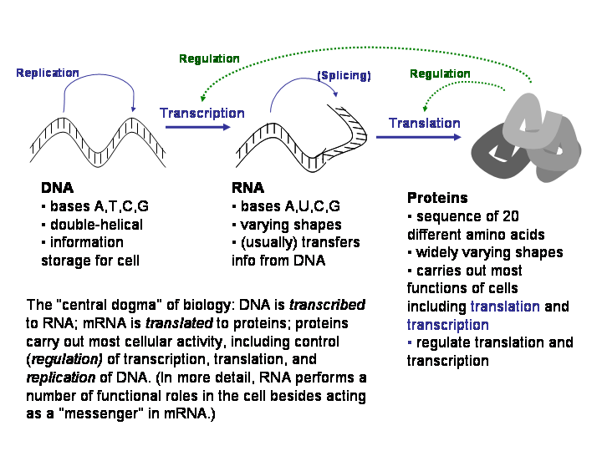
Figure 1. The central dogma of biology
Prokaryotes are extremely diverse—they live in environments ranging from hot springs to ice-fields to deep-sea vents, and exploit energy sources ranging from light, to almost any organic material, to elemental sulphur. However, prokaryotes are all structurally quite simple: to a first approximation, they are simply a bag of proteins. More specifically, a prokaryotic organism will consist of a single loop of DNA; an outer plasma membrane and (usually) a cell wall; and a complex mix of chemicals that the membrane encloses, many of which are proteins. Proteins are also embedded in the membrane itself.

Organisms that harvest light for enegy are phototropic; those that harvest inorganic materials for energy are lithotropic.

Membranes are composed of two back-to-back layers of fatty molecules called lipids, hence biological membranes are often called bilipid membranes.
A protein is a linear sequence of twenty different building blocks called amino acids. Different amino-acid sequences will fold up into different shapes, and can have very different chemical properties. The individual amino acids in a protein are connected with covalent bonds, which hold them together very tightly. However, when two proteins interact, they generally interact via a number of weaker inter-molecular forces; the same is true when a protein interacts with a molecule of DNA.

A covalent bond between two atoms means that the atoms share a pair of electrons. Weaker, inter-molecular forces include ionic bonds (between oppositely-charged atoms), and hydrogen bonds (in which a hydrogen atom is shared).
One attractive force that is often important between proteins is the van der Waals force, a weak, short range electrostatic attraction between atoms. Although the attraction between individual atoms is weak, van der Waals forces can strongly attract large molecules that fit very tightly together. Another strong “attractive force” is hydrophobicity: two surfaces that are hydrophobic, or repelled by water, will tend to stick together in a watery solution, especially if they fit together tightly enough to exclude water molecules. Proteins, like the amino acids from which they are formed, vary greatly in the degree to which they are attracted to or repelled by water.
The importance of all this is that the interactions between proteins in a cell are often highly specific: a protein P may interact with only a small number of other proteins Q1,...,Qk—proteins to which some part of P “fits tightly”. The chemistry of a cell is largely driven by these sorts of protein-protein interactions. Proteins also may interact strongly with certain very specific patterns of DNA (for instance, a protein might bind only to DNA containing the sequence “TATA”) or with certain chemicals: many of the proteins in the plasma membrane of a bacteria, for instance, are receptor proteins that sense chemicals found in the environment.

A bacteriophage, or phage, is a virus that infects a bacterium.

Even simpler “living” things: viruses and plasmids
There are constructs simpler than prokaryotes that are lifelike, but not considered alive. Viruses contain information in nucleic acids (DNA or RNA), but do not have the complete machinery needed to replicate themselves: instead they infect some other organism, and use its machinery to reproduce. A typical virus is the lambda phage, which consists of a protein coat that encloses a strand of DNA. The protein coat has the property that when it encounters a plasma membrane, it will bind to the membrane, and insert the DNA strand into the cell. This DNA strand has ends that attract each other, so it will soon form a loop—a loop similar to, but smaller than, the DNA loop that contains the genes in the host cell.
Even though this DNA loop is not in the expected place for DNA—that is, it is not part of the chromosomes of the cell—the machinery for transcription and translation that naturally exists inside the cell will recognize the viral DNA, and produce any proteins that are coded by it. The DNA from the lambda phage produces a protein called lambda integrase, which has the effect of splicing the viral lambda DNA into the host’s DNA. The cell is now a carrier of the lambda virus, and all its descendents will inherit the new viral DNA as well as the original host DNA. Eventually, some external event will make the virus become active: using the host’s translation and replication machinery, it will splice its DNA out of the host’s, create the materials (DNA and coat proteins) for many new viruses, assemble them, and finally dissolve the cell’s plasma membrane, releasing new lambda phage viruses to the unsuspecting outside world.
If DNA is the source code for a cell, then lambda phage produces a sort of self-modifying program: not only is the central-dogma machinery of the cell appropriated to make new viruses, but the DNA that defines the cell itself is changed. This sort of self-modifying code is actually quite common, especially in eukaryotes, and the basic unit of such a change is called a transposon. There are a many types of transposons—sections of DNA that use lambda-phage-like methods move or copy themselves around the genome—and a large fraction of the human DNA consists of mutated, broken copies of transposons.
A much simpler construct is a plasmid, which is simply a loop of double-stranded DNA, much like the DNA inserted by a virus. Biologists have determined that there is nothing special about viral DNA that encourages the cell to use it: in particular, the machinery for DNA replication that naturally exists inside the cell will recognize a plasmid and duplicate it as well, as long as it contains, somewhere on the loop, a specific sequence of nucleic acids called the origin of replication. Furthermore, the plasmid’s DNA will also be transcribed to RNA and expressed, as long as it contains the proper promoters—the DNA sequences that are recognized by the machinery which initiates transcription. In short, the DNA “program” in a plasmid will be “executed” by a cell, and the plasmid will be copied and inherited by children of a cell—just like the normal host DNA.
Plasmids are found naturally—they are especially common in prokaryotes. Like viruses, plasmids also occasionally migrate from cell to cell, allowing genetic material to pass from one bacterium to another. This is one way in which resistance to antibiotics can be propagated from one species of bacteria to another, for instance. There are also other plasmid-like structures that replicate in cells, but do not migrate from cell to cell easily—for instance, some yeast cells contain a loop of RNA that apparently encodes just the proteins needed for it to replicate.

All complex living things are eukaryotes
The class of eukaryotes includes all multi-celled organisms, as well as many single-celled organisms, like amoebas, paramecia, and yeast. Every plant or animal that you have ever seen without a microscope is a eukaryote. Surprisingly, in spite of their diversity, eukaryotes are quite similar at the biochemical level—there are more biochemical similarities between different eukaryotes than between different prokaryotes, for example.
Eukaryotes are much larger and more complex than prokaryotes. The well-studied e.coli, for instance, is about 2μm long, but a typical mammalian cell is 10-30 μm long, roughly 10-20 times the length of e.coli; this is about the same size ratio as an average-size man to a 60-foot sperm whale, or a hamster to a human. The figure below indicates the relative scale of some of the objects we have discussed so far.
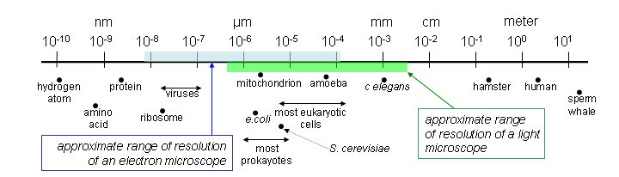
Figure 2. Relative size of various biological objects
Unlike prokayotes, eukaryotes have a complex internal organization, with many smaller subcompartments called organelles. For instance, the DNA is held in an internal nucleus, specialized compartments called mitochondria generate energy, the endoplasmic reticulum synthesizes most proteins, and long protein complexes called microtubules and microfilaments give shape and structure to the cell. The figure below illustrates some of the main components of a eukaryotic cell.
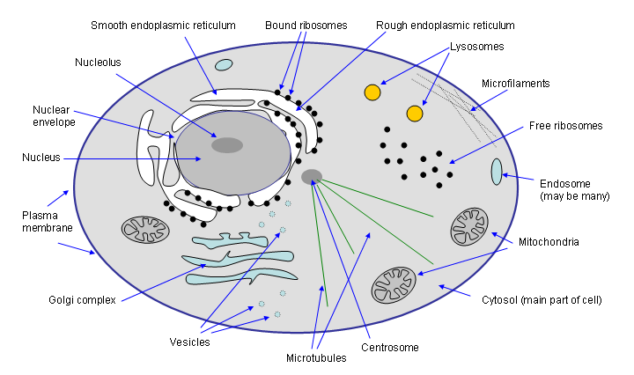
Figure 3 Internal organization of a eukaryotic cell
Eukaryotes also use a more intricate scheme for storing their DNA “program”. In prokaryotes, DNA is stored in what is essentially a single long loop. In eukaryotes, DNA is stored in complexes called chromosomes, wrapped around protein complexes called nucleosomes. The wrapping scheme that is used makes it possible to store DNA extremely compactly: for instance, the DNA for a human chromosome would be 1.5cm long, but the chromosome itself is only about 2μm long—four orders of magnitude shorter. Perhaps because of this ability to compact DNA, eukaryotes tend to have much larger genomes than prokaryotes.
In addition to containing much more DNA than prokaryotes, eukaryotes also postprocess mRNA by a process called splicing. In splicing, some subsections of mRNA are removed before it is exported from the nucleus. Importantly, there can be multiple ways to splice the mRNA for a gene, so a single gene can produce many different proteins. This further increases the diversity of eukaryotes. Eukaryotes also have an additional set of mechanisms for regulating the expression of genes, because depending on its position relative to the nucleosomes, the DNA of a gene may or may not be accessible to the cell’s transcription machinery.
It is believed that some of the organelles inside eukaryotes evolved from smaller, independent organisms that began living inside the early proto-eukaryotes in a symbiotic relationship. For instance, mitochondria might have once been free-living bacteria. One strong piece of evidence for this theory is that mitochondria (and also chloroplasts, an organelle found in plants) have their own vestigial DNA, which uses a different scheme for translating DNA triplets into amino acids than the scheme used by any modern organism.

This theory of development is called endosymbiosis. A variety of modern one-celled organisms are known which appear to incorporate some sort of blue-green algae in a larger organisms. Some endosymbionts even contain a vestigial nucleus.
At the molecular level, multi-celled eukaryotes are in many ways very similar to single-celled ones. The various cells that make up a multi-celled organism will share the same DNA, but are differentiated, meaning that they express a different set of genes: for instance, a kidney cell will express a different set of genes than a muscle cell. Cells in a multi-cellular organism also communicate, using a complex set of chemicals (mostly proteins) that are exchanged as signals, and received by receptor sites on the plasma membrane.

Understanding the complexity of living things
Although the basic mechanisms that underlie cellular biology are surprisingly few, there are many instances and many variations on these mechanisms, leading to an ocean of detail concerning (for instance) how the process of microtubule attachment to a centrosome differs across different species. Cellular-level systems, because they are so small, are also difficult to observe directly, which means that obtaining this detail is a long and arduous process, often involving tying together many pieces of indirect evidence. Most importantly, cellular biology is hard to understand because living things are extremely complex—in several different respects.
One source of complexity is the sheer number of objects that exist in a cell. At the molecular level of detail, there are thousands of different proteins in even simple one-celled organisms. These individual proteins can be themselves be quite large and intricate, and assemblies of multiple proteins (appropriately called protein complexes) can be extremely intricate. One notable example for bacteria is the “molecular motor” which spins the flagellum—an assembly of about dozens of copies of some twenty proteins which functions as a highly efficient rotary motor. This motor is atypical in some ways—most protein complexes are less well-understood, and do not resemble familiar mechanical devices like turbines—but it is far from unrivaled in its size or number of protein components—ribosomes, for instance, are much larger. Unraveling this type of complexity is part of the discipline of biochemistry.

A flagellum is a whip-like appendage that certain bacteria have. It functions as a sort of propeller to help them move. An e.coli flagella rotates at 100Hz, allowing the e.coli to cover 35 times its own diameter in a second.
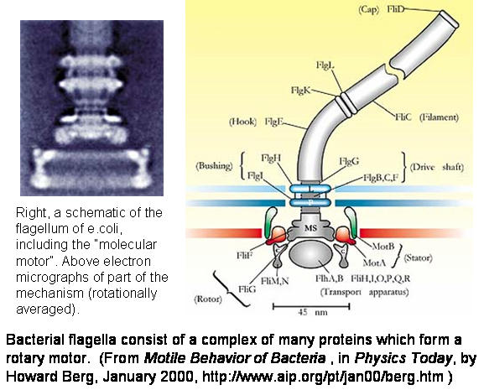
Figure 4. The baecterial flaggelum, a very complex protein complex found in apparently simple organisms.

A second type of complexity associated with living things is the complex ways in which proteins interact with each other, with the environment, and with the “central dogma” processes that lead to the production of other proteins. A simplified illustration of one of the best-studied such processes is shown in Figure 5, below, which illustrates how e.coli “turns on” the genes that are necessary to import lactose when its preferred nutrient, glucose is not present. This sort of “interaction complexity” is also very far from being deciphered, let alone understood. Like the molecular motor that drives the flagellum, the chemical interactions in a cell have been optimized over billions of years of evolution, and like any highly-optimized process, they are extremely difficult to comprehend.
Networks of chemical interactions like the one shown in Figure 5 are also complex in a different respect: not only is there a complex network that defines the qualitative interactions take place, the individual interactions can be quantitatively complex. To take an example, increases in glucose might increase the quantity of cAMP linearly—but often there will be complex non-linear relationships between the parts of a biological chemical pathway.
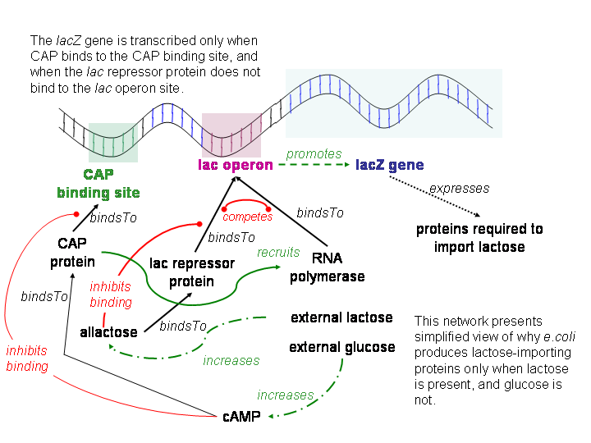
Figure 5. An illustration of how e. coli responds to the nutrients in its environment.

The reason for this is that most biological reactions are mediated by enzymes—proteins that encourage a chemical change, without participating in that change. The figure below gives a “cartoon” illustrating how an enzyme might encourage or catalyze a simple change, in which molecule S is modified to form a new molecule P. It is also common for enzymes to catalyze reactions in which two molecules S and T combine to form a new product.
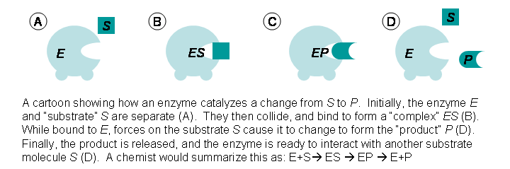
Figure 6.A "cartoon" showing how enzymes work.
Unlike naturally-occuring or man-made catalysts, enzymes can accelerate the rate of a chemical reaction by up to three orders of magnitude, so it is not a bad approximation to assume that a change (like S → P above) can only occur when an enzyme E is present. This means that if you assume a fixed amount on enzyme E and plot the rate of the chemical reaction (let’s call this “velocity”, V) against the amount of the substrate S (and like chemists, let’s write the amount of S as [S]), the result will be the curve shown below. Velocity V will increase until the enzyme molecules are all being used at maximum speed, and then flatten out, as shown in Figure 7, below.
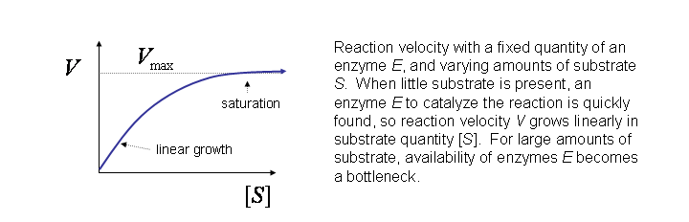
Figure 7. Saturation kinetics for enzymes.
This model is due to Michaelis and Morley and called “saturation kinetics”. In fact, the shape of the curve shown is quite easy to derive from basic probability and a few additional assumptions—the ambitious reader can look at the mathematics in Figure 8 to see this.
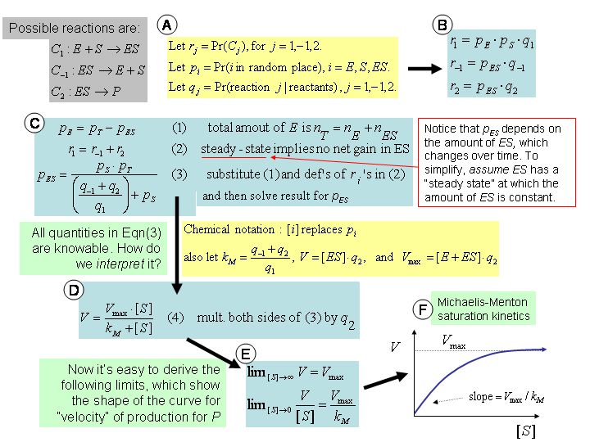
Figure 8. Derivation of Michaelis-Morley saturation kinetics.
Enzymes with slightly more complicated structures can lead to much more complicated velocity-concentration curves. A typical example would be an enzyme with two parts, each of which has an active site (a location at which the substrate S can bind), and each of which has two possible conformations or shapes. One conformation is a fast-binding shape, which has a high maximum velocity V_{maxFast}, and the other is a slower-binding shape with maximum velocity V_{maxSlow.} The right-hand side of Figure 9 shows a simple state diagram, in which (a) both parts of the enzyme change conformation at the same time, (b) shifts from the slow to fast conformation happen more frequently when the enzyme is binding the substrate, and (c) shifts from fast to slow tend to happen when the enzyme is “empty”, i.e., not binding any substrate molecule. In this case, as substrate concentration increases, the enzymes in a solution will gradually shift conformation, from slow-binding to fast-binding states, and the actual velocity-concentration plot will gradually shift from one saturation curve to another, producing a sigmoid (i.e., S-shaped) curve—shown on the left-hand side of Figure 9. A sigmoid is a smooth approximation of a step-function, which means that enzymes can act to switch activities on quite quickly.

A molecule that is composes of two identical subunits is a dimer; three identical subunits compose a trimer; and N identical subunits compose a polymer. An enzyme in which binding sites to not behave independently is an allosteric enzyme; in the example here, the enzyme exhibits cooperative binding.
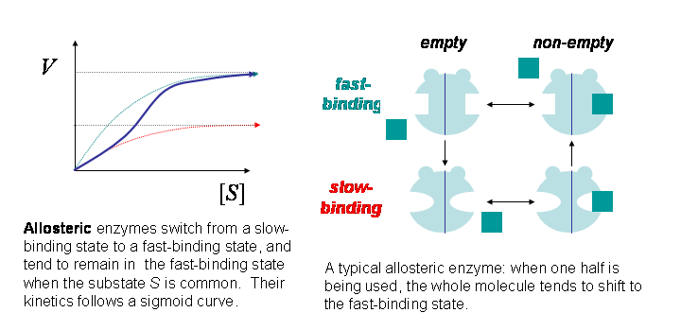
Figure 9. An allosteric enzyme with a sigmoidal concentration-velocity curve.
Sigmoid curves and network structures are also familiar in computer science, and especially in machine learning: they are commonly used to define neural networks. A neural network is simply a directed graph in which the “activation level” of each node is a sigmoid function of the sum of the activation levels of all its input (i.e., parent) nodes. It is well-known that neural networks are very expressive computationally: for instance, finite-depth neural networks can compute any continuous function, and also any Boolean function. Although I am not familiar with any formal results showing this, it seems quite likely that protein-protein interaction networks governed by enzymatic reactions are also computationally expressive—most likely Turing-complete, in the case of feedback loops. This is another source of complexity in the study of living things.

Energy and Biochemical Pathways
Enzymes are important in another way. Running the machinery of the cell requires energy. Most of this energy is stored by pushing certain molecules into a high-energy state. The most common of these “fuel” molecules is adenosine, which can be fund in two forms in the cell: adenosine triphosphate (ATP), the higher-energy form, and adenosine diphosphate (ADP), the lower-energy form. Enzymes are the means by which this energy is harnessed. Usually this is done by coupling some reaction P→Q that requires energy with a reaction like ATP→ADP, which releases energy. If you visualize the potential energy in a molecule as vertical position, you might think of this sort of enzyme as a sort of see-saw, in which one molecule’s energy is increased, and another’s is decreased, as in the figure below.
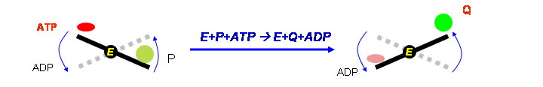
Figure 10. A coupled reaction.
Cellular operations that require or produce energy will often use a enzymatic pathway—a sequence of enzyme-catalyzed reactions, in which the output of one step becomes the input of the next. One well-known example of such a pathway is the TCA cycle, which is part of the machinery by which oxygen and sugar is converted into energy and carbon dioxide. A small part of this pathway is shown below in Figure 11.
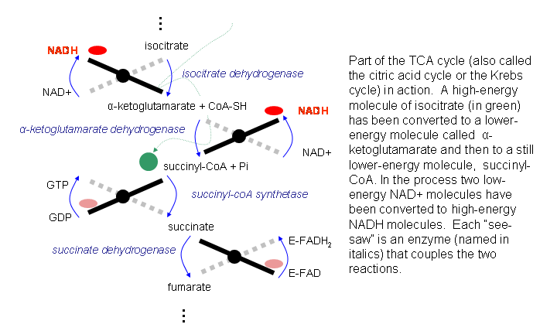
Figure 11. Part of an energy-producing pathway.
Since each intermediate chemical in the pathway (e.g., fumerate, succinate, etc) is different, each enzyme is also different: thus a pathway that either consumes or produces large amounts of energy will often involve many different enzymes, again contributing to complexity.

Modularity and Locality in Biology
Our understanding of macroscopic physical systems is guided by some simple principles—principles so universally applicable that we seldom think about them. One is the principle that most effects are local. This means that a good start to understanding how something works is to take it apart and see what touches what. Once we see that the ankle bone connects to the shin bone, we understand that those two components are likely to interact somehow.
This sort of common-sense approach to understanding systems fails for computer programs, where anything can affect anything. As a consequence, computer scientists are forced to construct elaborate schemes to limit the interactions of software components—in Java, for instance, private variables and methods, packages, and interfaces are all mechanisms for giving software constructs their own flavor of “locality”. Programs that do not observe these principles are notoriously difficult to maintain, debug, and understand.
Like unconstrained software, the machinery of the cell also lacks “locality”. A bacterium, for instance, is a complex machine, with thousands of types of parts (the types of gene products) and millions of instances of these parts. Although some of these parts form large structures (like the flagella), most of them are simply suspended in the fluid inside the cell. Components of the cellular machinery find each other, interact, and then separate, often without preference for a particular location.
This sort of non-local interaction is possible only for very small objects, and at very small scales. In a bacterium, proteins move about by diffusion, or random movement. In general, molecules around room temperature move very fast: for instance, a molecule of air moves at around 1000 miles per hour. However, molecules move randomly, not systematically, which limits the ground that they cover. It is fairly easy to show that for objects moving by a random walk—specifically, objects that move a fixed distance in a random direction at each time step—the time it takes to cover a distance x with high probability varies as Dx², where D depends on distance per unit time. This is very different from the macroscopic world, where the time to cover distance x is linear in x.
The result of this is that diffusion is a very quick way of moving around for very short distances—say, the width of a bacterium—and a very slow way of moving around over larger distances—say, from the bar to the buffet table. This may be why very little internal structure is necessary for bacteria, or for the bacteria-sized organelles in eukaryotic cells: there is simply no need for it, since everything is already close enough to interact quickly with everything else.
Over objects as large as a typical eukaryotic cell, however, simple diffusion is not necessarily the most efficient way for molecules to find each other and interact. For instance, the enzymes used by cells digest sugar are all localized to the inner membrane of the mitochondria—they still move by diffusion, but in a limited, two-dimensional area. The various membranes and organelles in eukaryotic cells, therefore, do not only limit the way that proteins interact, by isolating some proteins from others—they also may improve the speed at which interactions within that enclosure take place, by limiting diffusion to a small area.

An organelle is a discrete component of a cell. Some but not all organelles are membrane-enclosed areas.
Besides diffusion, eukaryotes have a number of other mechanisms for transport: for instance, vesicles are small organelles that move materials from organelle to organelle; and within the cytoplasm, some proteins are hauled from place to place along microtubules, which are long fibers that run radially from the center of the cell to the periphery. Transport in eukaryotic cells leads to locality, and hence to some small degree of modularity, which can be used to help understand cellular processes. More generally, the subcellular location at which proteins are found is often an important indicator of function.
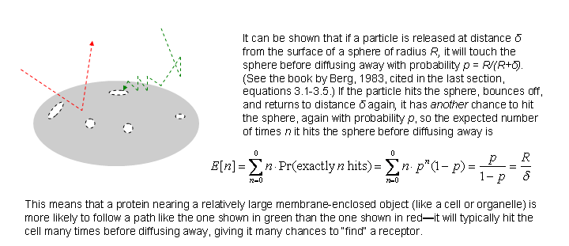
Figure 12. Behavior of particles moving by diffusion near an organelle.
Cellular-level biological systems are hard to understand in part because there is little meaningful notion of locality inside a bacterium, or within an organelle of a eukaryote. It should also be emphasized that, while membranes provide some notion locality inside a cell, membranes allow small molecules to diffuse through them, and biological membranes also have numerous mechanisms to allow (or actively encourage) certain larger molecules to pass through. Furthermore, because of properties similar to random-walk property of diffusion, molecules that come close to an organelle tend to remain close to it for a while, and brush against it many times—Figure 12 gives some intuitions as to why this is true.
The result of this is that if receptors for a protein p cover even a small fraction of the surface of an organelle, the organelle will be surprisingly efficient at recognizing p. As an example, if only 0.02% of a typical eukaryotic cell’s surface has a receptor for p, the cell will be about half as efficient as if the entire surface were coated with receptors for p. Cell-sized objects thus have a “high bandwidth”—they can recognize or absorb hundreds of different chemical signals, even if they are bounded by membranes.
To summarize, understanding even the “simplest” living organisms is far from simple. Analysis of how the different components of complex biological systems relate to one another is usually called systems biology.

Looking at Very Small Things

Limitations of optical microscopes
The best way to understand and model complex systems is to obtain detailed information about their behavior. Biologists have developed many ways to obtain information about the workings of a cell. Some of these methods are clever and intricate, and many methods collect indirect evidence of behavior. I will start by discussing the most natural of these methods—the microscope—because, as Yogi Berra is reputed to have said, “you can observe a lot by just watching”. For many purposes, the best way to study a cell is to look at it through a microscope.
Light microscopes have many advantages for biology. Relative to other sorts of radiation, light causes little harm to a cell—even highly focused laser light. Another advantage is that cells, which are largely water, are also largely transparent to light, which means that it is possible to look inside a living cell and watch it function. (The transparency of cells may come as a slight surprise to those that think of themselves as largely opaque. In fact, it is difficult to see through people only because they are many, many cells thick, and each layer of cell scatters a small amount of light.) Because of their transparency, cells are usually dyed in some way in order to be viewed in a microscope; this is more of an advantage than a chore, however, since there are many dyes that selectively color some parts of a cell but not others, thus emphasizing its structure.
One disadvantage of light is that objects that are too small simply cannot be resolved clearly with a light microscope. This limit is imposed by the wavelength of light. The wave nature of light implies that light waves interfere with each other, which distorts images: for instance, a point source of light will appear as a circle surround by a series of concentric circles. For some simple objects, one can precisely analyze the result of interference, and make precise claims about what can and what cannot be seen. Figure 13 summarizes one such result, which shows that wavelength λ of light and the aperture of a microscope—the width of the entry pupil—limits the amount of detail that can be distinguished for one class of simple objects. (The figure ignores the issue of refractive index, which is the ratio of speed of light in the medium containing the specimen to the speed of light in air. Also, the limit outlined in the figure can be improved by a factor of 2 by considering light that enters the specimen at an angle.) Visible light has a wavelength of around 0.5 micrometers (μm), and objects smaller than 2μm cannot be resolved even with the best light microscopes. This is adequate for resolving individual cells, and even the specialized organelles inside a cell, but not enough to visualize individual protein complexes or proteins.

The quantity n sin θ, where n is the refractive index of the medium being used, is called the numerical aperture of a microscope. Making the aperture wider improves resolution at the cost of depth of field.
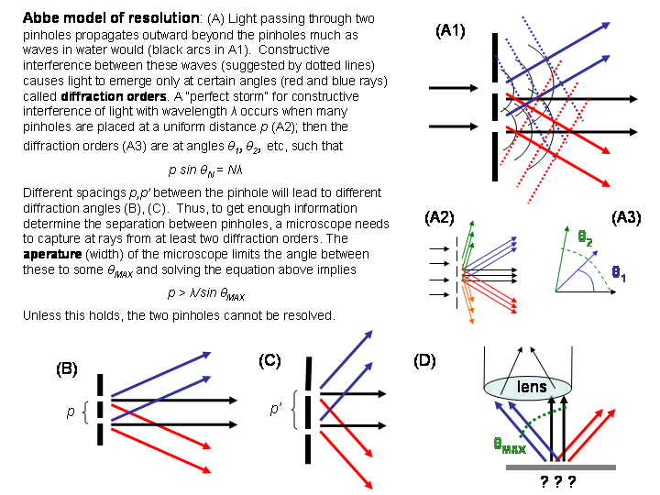
Figure 13. Abbe model of resolution.
A second disadvantage is that since cells are largely transparent, the signal obtained is fairly weak: put another way, the amount of light reflected by an object is not that much larger than the amount of light that is randomly scattered.

Special types of microscopes
One way to strengthen the signal is to use a technique called differential interference contrast (DIC). Although only a small amount is reflected by an unstained cell, the refractive index of the cell is usually different from the surrounding medium: that is, light moves more slowly as it passes through a cell. This slight difference can be detected by comparing the phase of a light-wave that has passed through a cell with the phase of a light-wave that has not. A DIC microscope works according to this principle. (See Figure 14 below).
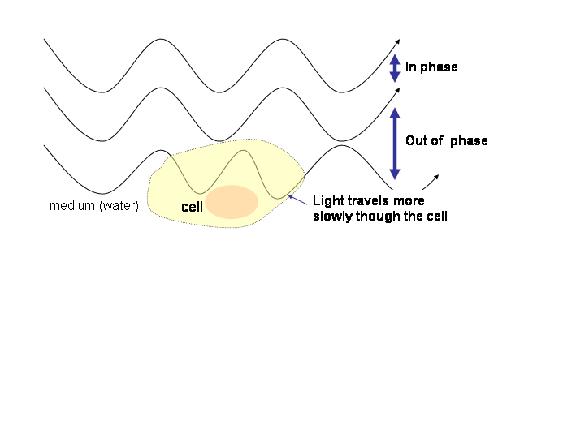
Figure 14. How a DIC microscope operates. Light travels more slowly inside a cell than in the surrounding medium, leading to a phase shift.

Another way to obtain better images is with a fluorescent dye. Fluorescent molecules are molecules that absorb light of one frequency f, and very shortly after, emit light of another frequency g. This happens because when the atom absorbs light, an electron orbiting the nucleus of some atom in the molecule is pushed into a higher orbital—an orbit which is highly unstable. This unstable orbit typically lasts for a nanosecond or so, and when the electron returns to the lower, stable orbital, a photon is emitted. Importantly, the wavelength of the emitted photon is different from the wavelength associated with the absorbed photon, so that it is possible to filter out the reflections from light which was intended to stimulate fluorescence, and detect very low levels of fluorescent light. In fact, it is possible to detect a very small number of fluorescent molecules (although one cannot form clear images of them).
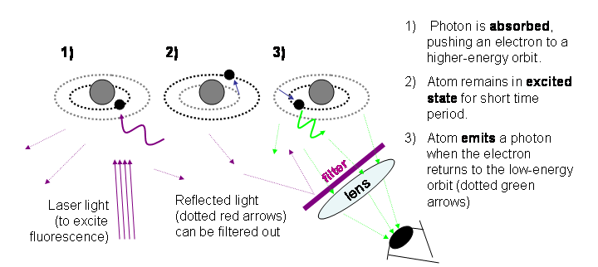
Figure 15. How fluorescence microscopes work.
Remarkably, it is now possible to create fluorescent dyes that are extremely specific—dyes that will bind themselves to only a few particular proteins in a cell—and use these dyes to visualize the behavior of specific proteins inside a cell. We will discuss two ways of doing this below, in the sections on antibodies and the section on fusion proteins. Figure 16, below, shows a set of cells that have been imaged with two fluorescent dyes (in the top two panels), and also with the DIC method (in the lower left). The two dyes were constructed so that they mark specific proteins: p100 in red, and ARF6 in green. The lower right panel has an overlay of the two dyes. From the images it is easy to see that neither protein is found in the nucleus, and that the green-dyed protein is more concentrated near the edges of the cell than the red-dyed protein.
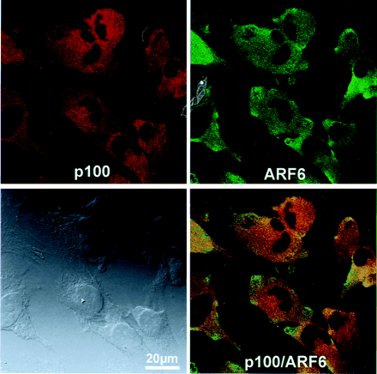
Figure 16. Cells imaged with DIC and fluorescent dyes (from Someya, Akimasa et al. (2001) Proc. Natl. Acad. Sci. USA 98, 2413-2418)
One important type of microscope for use with fluorescent dyes is the confocal microscope, in which aggressive filtering is used, so that not only is reflected light filtered out, but also only light emitted by very small part of the image is detected. A confocal microscope thus needs to scan progressively through a specimen. Good confocal microscopes can produce 3D images that include information from many different dyes. The confocal microscope was patented by Marvin Minsky in 1957, but only became practical years later, with the development of lasers.

Electron microscopes
Electron microscopes use higher-frequency wavelengths, which gives them improved resolution, relative to optical microscopes. Electron microscopes can in principle resolve objects 10,000 times smaller than optical microscopes—in practice, however, current electron microscopes improve resolution by “only” a factor of 100. This makes it possible to see very small objects indeed. Figure 17 shows electron microscope images of (A) human HeLa cells, with the magnified inset in (B); hamster CHO cells, with some mitochondria shown in (C), and stained actin filaments in (D).

Mitochondria are organelles that produce energy from glucose and oxygen. Actin is a protein that forms long filaments which help give a cell its shape.
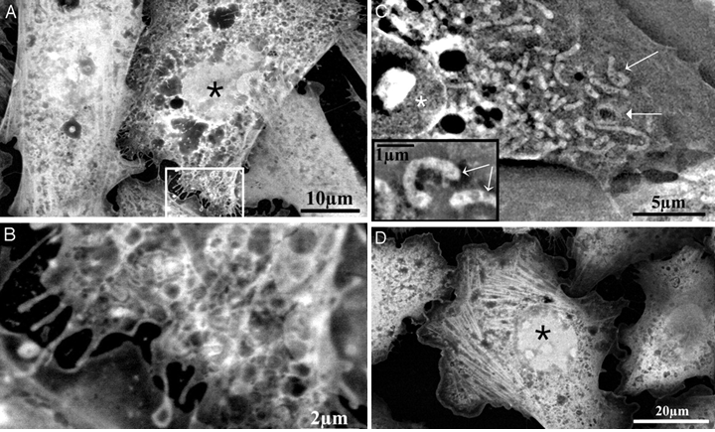
Figure 17. Electron microscope images, from Thiberge, Stephan et al. (2004) Proc. Natl. Acad. Sci. USA 101, 3346-3351
Electron microscopes have some disadvantages, however. They can only be used to view objects on the surface of a cell, not inside a cell, as is possible with optical microscopes. Also, while light microscopes can be used to view living cells, electron microscopy requires either freezing a cell, or staining it with a heavy metal like gold. Both of these procedures (to put it moderately) tend to cause damage, so preserving a specimen in something like its native state is often a major challenge for electron microscopy. Work on using electron microscopes in close-to-normal conditions is an active area of work, however (the paper from which Figure 17 was taken being a recent example of this).

Manipulation of the Very Small

Taking Small Things Apart.

A well-worn cliché is that cells are machines, the components of which are molecules. This leads to an important point: in general, molecules are too small to be seen or manipulated directly. How can one study a machine if you can’t look at or manipulate most its components? To take a computer science analogy to this problem, imagine trying to reverse engineer a PC from a hundred yards away, with your only tools for manipulation being a collection of bulldozers and excavators and such that you direct by remote control. What sort of things could you do, and what sort of things would you learn? Imagine for a moment a scientific field where a typical paper reads like this:
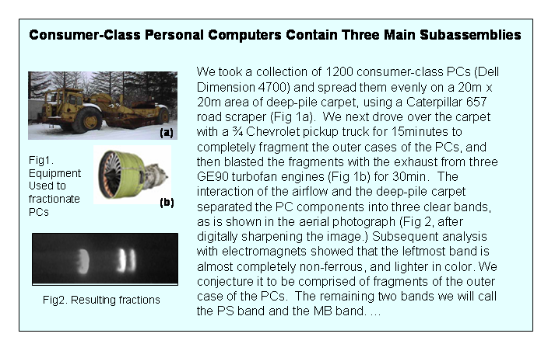
Figure 18. An article on reverse engineering PC, written by giants.
The study of the very small is analogous to this situation. In my facetious example, we’d like to simply take the darn PC apart, but that’s impossible to do with such crude tools; similarly, in biology, we don’t have tools sufficiently delicate to disassemble cells directly, component by component. On the other hand, the crude PC “disassembly” of the example is far from useless: the authors might have successfully determined that PCs are, to a first approximation, made of an outer casing, a power supply, and a motherboard.
The general technique used in the example to separate PC components is to apply a force in one direction (air pressure from the jet) to a mixture. Elements of the mixture then get separated depending on the degree to which they respond to the force, and/or stick to the surface (the shag carpet) that they are placed on. This idea is used over and over again in biology. Here are some examples:

Splitting a mixture into component elements is called fractionation (if you’re thinking about the input to the splitter) or purification (if you’re using fractionation to collect one particular mixture element, and you’re thinking about the output.).
- To separate different parts of a cell, cells may be broken up (by ultrasound, a blender, or some other means). The resulting whole cell extract is then placed in some appropriate medium and centrifuged—i.e., subjected to the force of gravity—to separate out the components (e.g., the nuclei, the mitochondria, etc) by their size and weight. As in the PC example, one starts with thousands of individual cells—perhaps a colony of identical clones. Modern variants of this technique, such as velocity sedimentation and equilibrium sedimentation, are capable of separating out individual molecules that are only slightly different in mass, by using gravities of up to 500,000g.
- Most of the interesting chemicals in a cell are proteins. To separate out the different components of a mixture of proteins, column chromatography is often used. In this technique the mixture is poured through a solid but porous column called a matrix. Proteins that stick to (interact with) the matrix will flow through the matrix slowly. By separating the fluids by the time that they take to emerge from the column, and choosing the appropriate matrix, proteins can be separated by size, electric charge, or hydrophobicity (i.e., affinity to water). The first types of column chromatography equipment took hours to perform this separation, but newer chromatography systems use tiny beads to form the matrix, and use high pressure to blast a mixture through a column in minutes.
- Sometimes a matrix is placed on a flat surface, rather than a vertical column, and an electric force is used to move the components around, instead of a gravitational force. This technique is called electrophoresis and the matrix is called a gel. One very common gel method, especially for mixtures containing proteins, is SDS-PAGE, which is short for sodium dodecyl sulfate (SDS) polyacrylamide-gel electrophoresis. SDS is a detergent, which is mixed with the protein solution before adding it to the gel: it acts to unfold the proteins from their natural shapes into simple linear chains. The unfolded proteins migrate through the gel at a rate determined only by their sizes (not their tertiary structures). A typical application of SDS-PAGE uses a single gel to compare several mixtures, each of which is placed in a different lane of the gel. An example of this is shown in Figure 19, below.

Proteins are linear sequences of molecules called amino acids. In a cell, this sequence will fold up into a complex shape, called the tertiary structure of the protein. The individual amino acids that make up proteins are sometimes called residues.
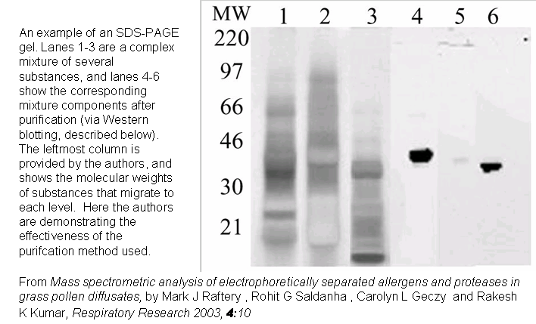
Figure 19. SDS-PAGE used to separate components of a mixture.
- A variant of SDS-page is 2-D gel electrophoresis. First, proteins are separated according to electric charge (using a special buffer in which pH varies from top-to-bottom) so that they spread out vertically in a narrow column. Then SDS is added to unfold the proteins; the original narrow columnar gel in placed on the left-hand-side of a wide SDS gel; and electrophoresis is used to spread the proteins out left-to-right according to size. Each protein will thus be mapped to a unique spot in two dimensions—unless of course there are two or more proteins with the same charge and size. A 2D gel can be used to separate 1000 different proteins, or in the hands of a master, even 10,000 proteins.

The technique for separating by charge used in 2D gels is called isoelectric focusing; it causes proteins to migrate to their isoelectric point (i.e., the point at which the protein has no net charge.)
MethodWhat is Typically Sorted(Numeric) Property Sorted Bycentrifugationwhole cell extractweightcolumn chromatographymixture of proteinssize, weight, charge, or hydrophobicitygel electrophoresismixture of proteinssize (folded) or electric chargeSDS-PAGEmixture of de-natured proteinssize (after denaturing)2-D gelmixture of proteinssize in one dimension, then electric charge in the second dimensionTable 1. Different ways of sorting mixtures

In all of the cases above, the “matrix” (i.e., the material through which objects move) interacts with the mixture elements in a simple and fairly uniform way. For instance, in SDS-PAGE, the interaction between a protein and the gel can be described by one numerical parameter (i.e., protein size). Another application of separation-by-force is when the “matrix” has been designed to interact tightly with some elements, and not with others. An example is affinity chromatography, a variant of column chromatography in which one particular item in the mixture binds very tightly to the matrix, and other items do not interact at all. For instance: the beads of the matrix might be constructed so that they contain a particular strand of DNA, to which some unknown protein X in a mixture is suspected to bind. To isolate X, one simply pours in the mixture, and waits for all the other mixture elements to wash out. Finally one pours in some appropriate solvent that will break the bond to the mixture to obtain X.
To summarize, the types of fractionation that we’ve seen so far are the biologist’s version of a common computer science operation: they sort mixture components according to a numeric function. Centrifugation sorts components by weight; gels sort components by size or charge. Affinity chromatography is a new type of operation, which extracts mixture components according to a “user-defined predicate”—it selects elements that pass a certain experiment-specific test.

Biologists often use the term selection for a “user predicate that can be applied quickly, in parallel. For instance, one can select for antibiotic-resistant bacteria by treating a group of them with the antibiotic. A test that requires manual effort for each item is usually called a screen. To a first approximation, a screen is an O(n) operation, and a selection is an O(1) operation.
As another example of “user predicates” in biology, consider a situation in which we have a mixture M of many proteins, and a particular protein X that we know binds to some of the proteins in M. How could we determine which ones? Let us assume for a moment that we have some way of easily detecting X—for instance, we’ve done something clever so that X is radioactive, or perhaps it’s been labeled to that it glows bright green. One possibility would be to construct a 2D gel M, and then use a sheet of slightly absorbent paper to blot up the proteins in the gel, while preserving their relative positions. We now have a 2D arrangement of proteins which are fixed in position on the blotter. We then smear X evenly over the paper, and then carefully wash it off. Every location on the paper to which X sticks corresponds to a protein in M with which X interacts.
This technique is called a Western blot. Performing the analogous operations starting with a (one-dimensional) gel containing RNA molecules in order to determine which RNAs hybridize to some DNA molecule X is called a Northern blot. Performing a Northern blot with DNA instead of RNA .is called a Southern blot. (Historically, Southern blots came first—they were invented by a biologist named Ed Southern in 1975.) The grandchild of the Northern blot is the infamous gene chip (and/or the closely related microarray), which I will talk about next.
In might be that two cells with the same DNA might build different sets of proteins—that is, they may have different proteomes. In single-celled organisms, a proteomic difference might be due to a response to different environments—for instance, different nutrients, or different temperatures. In a multi-celled organism, cells from different tissues express different sets of proteins. Studying such differences in genetic expression is a frequent goal in experimental biology.
Since proteins are always encoded by mRNA before they are built, one way detect differences in the proteomes of two cells is to compare their sets of mRNAs. In fact, this is actually a very convenient way to measure differences, because nearly all mRNAs have “polyA tails”—that is, the end of an mRNA is a long sequence of repetitions of the nucleic acid adenine, which is abbreviated “A”. The acid complementary to adenine is thymine, abbreviated “T”, and hence most mRNA will easily hybridize to a long sequence of thymines. This means that one can use affinity chromatography to purify mRNA from a whole cell extract.
A microarray has thousands of tiny wells, each of which contains DNA for a different gene. Thanks to the magic of gene sequencing, VLSI-scale engineering, and robotics, a microarray that holds DNA for every one of the thousands of genes in yeast can be made and mass-produced fairly inexpensively—and is about the size of a microscope slide. A common use for microarrays is to take two mRNA samples from two cells (or more realistically, two colonies of similar cells) which one would like to compare, and using the “magic” of fluorescence tagging, dye the mRNAs in these samples red and green, respectively. Both samples are then spread across the microarray and allowed to hybridize to their corresponding genes—the positions of which are known on the microarray. Finally image processing is used to look at the color of each tiny well.

Both DNA and RNA can be either single-stranded, or double-stranded. In double stranded DNA/RNA, each strand is complementary to the other. In the right conditions and at the right temperature, two single strands that are complementary can spontaneously form a double-stranded molecule; this process is called hybridization or base-pairing. Hybrid strands can be DNA-DNA or DNA-RNA.
Let’s call the cells and associated samples A and B. For genes being expressed in both A and B at about the same rate, the corresponding microarray well will be yellow. Genes expressed in neither A nor B will have black wells. Genes expressed by A and not B will show as green, and genes expressed by B and not A will be red. Intensity of a color indicates the level of expression—that is, the number of mRNA molecules being transcribed.
A gene chip has a similar function, but different construction. The “wells” in gene chips contain shorter sequences of DNA—up to about 25 base pairs long—that are synthesized (or should we say fabricated?) right on the chip. Often the sequences are chosen so that there is a known, unambiguous mapping between these sequences and genes from some sequenced genome; in this case, gene chips can be used in the same manner as a microarray.
Gene chips and microarrays are new technology, but not a new technique: they are essentially just high-resolution versions of Northern and Southern blots. There is also a high-resolution analog of the Western blot, called a proteome chip in which many proteins are attached to a single chip—perhaps a transcription of every yeast gene—and which can be manufactured reliably. The proteome chip is a more recent arrival to the biologist’s toolkit, but its impact may be ultimately comparable to that of microarrays and gene chips.
Method | What is Selected | (Boolean) Property Selected For
affinity chromatography | mixture, e.g. of proteins | Does a mixture component bind to a user-selected substance?
Western blot or protein chip | mixture of proteins | Does a protein bind to one of a set of user-selected proteins fixed on a blotter?
Northern blot, micro-array, or gene chip | mixture of RNAs | Does a RNA hybridize to one of a set of user-selected DNAs fixed on a blotter?
Southern blot, micro-array, or gene chip | mixture of DNAs | Does a DNA hybridize to one of a set of user-selected DNAs fixed on a blotter?
Table 1. Methods for selecting components of mixture that satisfy some property.

Parallelism, Automation, and Re-use in Biology.

At this point, let me take a break from the catalog of technical tricks, and make a few general observations about what we’ve seen so far.
We’ve seen that one occupation of biologists is developing ingenuous ways to disassemble cellular-sized components. One great advantage of these techniques, which I have not emphasized so far, is that it is often easy to apply them in parallel, to many mixtures at once. As a computer scientist, I have been struck by the widespread use of parallel processing in biological experimentation.
In particular, all of the “blot-like” methods discussed above—Northern, Southern, and Western blots, microarrays, and gene and protein chips—are naturally parallel. Consider a Western blot, which tests a protein X for interactions with the proteins on a blot: the experiment remains the same, whether the blot contains 100 proteins, 1000 proteins, or 10,000 proteins. If you like, the 2D gel functions as a 2D array of tiny little columns, just like those used in affinity chromatography—columns which can be easily used in parallel. More intriguingly, it is as easy to test a mixture of 1000 proteins X₁, …, X₁₀₀₀ against this “array of columns” as it is to test a single protein X! It is exactly this sort of parallelism that is exploited in a typical microarray experiment, in which every mRNA in mixture is tested for compatibility with every gene in a genome. (As an aside, this sort of parallel processing is also largely the reason that biologists are currently awash in experimental data; so much that they are eager to get help interpreting it from long-haired former AI hackers like me.)
Gene chips and microarrays have another important property, which again makes biologists immensely more productive than they were a generation ago. In programming, the single biggest gain in productivity comes from software re-use, and like a good software package, gene chips allow a sort of re-use. By this, I do not mean that an individual chip can be re-used—they can’t. However, gene chips can be manufactured repeatedly at moderate cost, and hence the effort of designing and engineering them—the vast bulk of the total cost—can be amortized (“reused”, if you like) over many related experiments. This is an important development, as doing a Western blot (or similar biological experimental procedures) requires technical expertise, practice, and some natural dexterity to accomplish successfully. This sort of human skill cannot be duplicated without expensive and painful processes (like postsecondary education). However, once one has overcome the large fixed cost of automating the procedure, the automated process can be duplicated— often at a surprisingly low cost.
Gene chips are just part of a trend—throughout biology, many experimental procedures are being automated, or partially automated. Liquid-handling robots can now carry out many routine experiments. In addition to the savings associated with automation, these robots are themselves parallel, in that they can dispense 8, 96, or even 384 fluids at once into in arrays of wells. This allows many operations to be performed at once.
Finally, although replicability of experiments is still important, many biological experiments not only produce replicable descriptions of the experimental procedure; increasingly, the biologists exchange results that others can build on directly, without having to first replicate the experiment that led to the result. These results are, in fact, re-usable resources, and many recent research projects are explicitly designed to construct such re-usable resources, rather than to address specific biological questions. In such projects, a lab will systematically perform all conceivable experiments of a particular type, and then make the results available as a service. An example of this sort of project might be the Yeast GFP Fusion Localization Database, which, among other things, provides researchers with a GFP-tagged variant of (almost) every protein expressed in yeast cells. Systematically repeating all possible variations of an experiment of this sort, and making the results available to other labs (in this case, as a series of GFP-tagged strains of yeast that can be purchased) means that subsequent researchers need never repeat this sort of experiment.
One could view this economically, as a move toward a “horizontal economy”, in which each lab specializes so as to do a few things well. I prefer to view this from a programming prospective, and think of resources (like GFP-tagged yeast) as a sort of “subroutine package” for biological experiments. In programming, one might save time by using some other hacker’s machine-learning software package; in biology, one might save time by using some other biologists’ library of genetically engineered yeast.

Classifying Small Things by Taking Them Apart

Let us now return to our discussion of experimental methods in biology. From the perspective of computer science, one way to describe the experiments discussed above is as various implementations of two basic operations:
- Given an object X, take that object apart into components W₁…W_{n}, and then sort the components according to some numeric property F(W_{i}).
- Given an object X, take that object apart into components W₁…W_{n}, and then extract all components that satisfy some Boolean property P(W_{i}).

Here X is usually a known object with unknown structure. One example of this generic task is centrifuging a whole cell extract to separate out the various components of the cell by weight. Another example is running a purified mixture of a cells mRNA over a gene chip to separate out individual mRNAs by their ability to hybridize to genes.
Another important class of tasks is the following:
- Given an unknown object X and a set of known objects Y₁,…,Y_{n}, determine the Y_{i} that X is most similar to.

A good example of this sort of task is identifying a particular protein. Here X is the protein and the Y_{i} ‘s are all possible proteins that could be expressed by the organisms from which X was isolated—e.g., if X was taken from a yeast cell, then the Y_{i} ‘s might be the entire yeast proteome. Finding the most similar Y is a way of identifying X.
In information retrieval, a simple and commonly used way of measuring the similarity of two documents X and Y is to convert them to “bags of words”, or counts of the number of times each word appears. More precisely, X will be represented as a function h_{X}(w), where w is a word and h_{X}(w) is the number of times w occurs in X. Well-known measures for the similarity of two functions can then be used to measure the similarity of h_{X} and h_{Y}—variations on an inner product being the most common. In short, a “bag of words” representation encodes a linear string X (the document) as a histogram of substrings of a particular sort (namely, words), and then uses histogram-based similarity metrics for comparison.
The same idea can be used to compare two proteins. First it is necessary to convert the protein, which is a single long sequence of amino acids, to a bag of “words”. The usual way of doing this is to use some chemical that breaks up the amino acid sequence in a consistent, predictable way: for example, cyanogen bromide will break proteins after each methionine residue. Separating and sorting the fragments of the protein, using a gel or chromatography, will produce a specific pattern called a peptide map. Assuming that the “sorting” is done according to some function f(z), where z is a fragment, one could formally represent the peptide map for protein P as a function h_{P}(n), in which h_{P}(n) is the number of fragments z in P such that f(z)=n. The peptide map is a “fingerprint” for the protein, and can be used to identify it from a list of candidates that have been previously “fingerprinted” by the same procedure.
The technique most widely used for the separation of protein fragments is mass spectrometry. The mass spectrometer sorts the fragments by their charge-to-weight ratio, and then counts the number of fragments of each size. The resulting histogram is called a mass spectrum. One advantage of mass spectrometry is that it can be used on extremely small amounts of a protein.
Another example of “classification by separation” is DNA fingerprinting. As with proteins, one begins by cutting the DNA into fragments using a chemical that cuts in a predictable way: for DNA, the chemicals that are used are called restriction endonucleases (which will be discussed more below). Since DNA sequences differ slightly from individual to individual, the “bag of fragments” representation of two DNA sequences are likely to be different. Such a difference is called a restriction fragment length polymorphism (or RFLP). Similarity between DNA sequences based on RFLP is useful for several forensic purposes, such as testing parentage and identifying criminals. Fundamentally, RFLPs are no different from the other histogram-based similarity measures discussed above.
In DNA fingerprinting, usually only a subset of the fragments are considered. One particular approach is to look only at fragments that contain certain minisatellites. Minisatellites are portions of DNA that occur in repeating sections: more specifically, each minisatellite contains many repeating subparts, and the sections also appear multiple times in the genome. Often the number of repeats per section varies from person to person, as does the number and position of repeating sections. It is easy to find minisatellite-containing restriction fragments using hybridization, and the variations in repetition (and hence size) make the histograms of minisatellites-containing fragment lengths quite distinctive. These properties make them well-suited to DNA fingerprinting.

Reprogramming Cells

Our Colleagues, the Microorganisms
There is another whole family of approaches to studying very small objects: rather than attempting to study molecular-level processes with the (comparatively) huge and clumsy machinery that we humans can design, let us look for useful molecular-level tools we can find in nature. In particular, living cells are full of useful molecular-level machinery—what can we, as biologists, do with this existing machinery?
As it turns out, a huge amount of biological experimentation is based on either using “machines” that have been extracted from living cells, or by cleverly tricking living organisms to do some work for us. In this section we will discuss how some of this machinery is used.

Restriction Enzymes and Restriction-Methylase Systems
In nature viruses invade a cell by inserting a fragment of foreign DNA. One defense mechanism against viruses is a restriction-methylase system (R-M system). The first part of such a system is that DNA native to the cell is “marked” after it is produced. (Usually the marker is a methyl group attached to some of the nucleic acids of the DNA, and thus the protein which adds this marker is called a methylase.) The second part of the system is that unmarked DNA—i.e., DNA that has not been “modified”—is attacked by a complex molecule called a restriction endonuclease (RE), which cuts the DNA at certain specific sequences of nucleotides. For example, the RE named EcoRI “recognizes” the sequence “GAATTC”, and cuts after the “G”; the RE named HaeIII cuts the sequence “GGCC” between the G’s and C’s; the RE named HindII cuts any sequence matching the regular expression “GT[TC][AG]AC” after the third nucleotide.

A nuclease cuts nucleic acids, like DNA or RNA. Those that cut at the ends of a molecule are called exonucleases and those that cut in the middle are called endonucleases. Restriction endonucleases are named according to certain rules. The first three letters come from the organism from which the RE was obtained; an optional fourth letter identifies the “strain” of the organism; and the remainder is a Roman numeral. Thus, HindII (pronounces “hin dee two”) is the first RE isolated from strain R_{d} of Haemophilus influenzae.
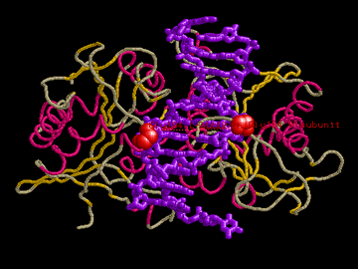
It’s important to realize just how sophisticated the machinery in a RE is. In spite of the fact that the action of a RE is easy to describe, the process involved in performing this action is quite complex. To the left is an image of an RE called BamHI, in position and ready to cut a DNA strand (shown in purple). It is remarkable enough that the RE binds very specifically to a particular pattern of DNA (in this case, the pattern “GGATCC”), but on top of this, BamHI is a machine with moving parts—once it has acquired its target, it changes shape, as a prelude to cutting the DNA. The whole cleavage process requires no external energy (e.g, in the form of ATP) to accomplish. In spite of years of study of natural REs, biochemists do not yet understand, for instance, how to modify REs of this type so that they bind to different DNA sequences.
Figure 20. Structure of the BamHI restriction endonuclease, binding to a strand of DNA..
Fortunately, we don’t need to completely understand the mechanism of an RE to use one. Just as one can use a complicated software module as a “black box” in programming, one can exploit an RE quite effectively, as long as we understand its “interface”—that is, what the RE does. We’ve already seen one common use of REs—they are used to create the RFLPs that are the basis of DNA fingerprinting. Another very important use is construct new DNA molecules by “cutting and pasting” together strands of existing DNA.

Constructing Recombinant DNA with REs and DNA Ligase
It is clear how to cut DNA with an RE. But how does one “paste together” two slices of DNA that have been cut?
The answer to this depends in part on how the DNA has been cut. Recall that the RE EcoRI “recognizes” the sequence “GAATTC”, and cuts after the “G”. Recall also that complementary base pairs in DNA are A-T, for adenine and thymine, and G-C, for guanine and cytosine. The sequence “GAATTC” has an interesting property: if you reverse it, the resulting string “CTTAAG” is complementary. Let’s look at an example of a double-stranded DNA sequence containing the subsequence “GAATTC” and see how it gets cut by EcoRI:
GATTACA | G | AATT | C | CATATTAC
CTAATGT | C | TTAA | G | GTATAATG
Table 2. Small fragment of double-stranded DNA before being cut by EcoRI
Here the grey area shows one fragment after the cut, and the white area shows the other. Notice that the resulting DNA fragments will be mostly double-stranded, but with single-stranded bits hanging off the end. The single stranded bits that stick out (AATT in the upper strand, and TTAA in the lower strand) are called sticky ends. Just as ordinary single-stranded DNA strands hybridize together, the sticky ends of DNA fragments cut with EcoRI will hybridize together. So, fragments of DNA cut by EcoRI can re-assemble themselves.
However, this re-assembly process is not perfect, as fragments can re-assemble in a different order. Consider a longer DNA molecule, with three EcoRI sites:
GATTACA | G | AATT | C | ATTACCAT | G | AATT | C | CATATTAC
CTAATGT | C | TTAA | G | TAATGGTA | C | TTAA | G | GTATAATG
Table 3. A longer DNA fragment, showing how it is cut by an RE.
If there are two or more possible cutpoints, then cutting a large population of DNA molecules with EcoRI and allowing the resulting fragments to re-assemble will not be a null operation. Instead, since the fragments re-assemble randomly, the result will be all possible re-assemblies of the fragments. For the DNA above, this would include a molecule in which the middle section has been cleanly removed, producing the DNA molecule of Table 1.
(I have glossed over an important point here, which is that the re-assembled molecules are not structurally identical to normal double-stranded DNA. In normal DNA, the nucleotides in each strand are linked together by a strong type of molecular bond called a covalent bond, and the two strands are held together by weaker forces. When a RE cleaves DNA, the covalent bonds are broken, and they are not repaired if the DNA is re-assembled by hybridizing sticky ends together. However, the covalent bonds can be repaired by another naturally-occurring enzyme called DNA ligase.)

An enzyme is a protein that acts as a catalyst: that is, a protein that facilitates a chemical reaction, but is itself unchanged by that reaction. Most enzymes have verb-like names that end in “-ase”. A ligand is a molecule that binds to specific place on another molecule, and joining two molecules together is also called ligating them together.
An important application of this sort of DNA cutting-and-pasting is to take two strands of DNA of the form xSy and wSz, where S is the sequence recognized by EcoRI (or any other RE that leaves “sticky ends”) and w, x, y, and z are all different DNA sequences. Cleaving with the RE and then allowing the fragments to re-assemble will give the brand-new DNA sequences xSz and wSy. These sequences are recombinant DNA, and they have many uses.

Inserting Foreign DNA into a Cell
If DNA is the “programming language” for cellular behavior, then recombinant DNA molecules are new programs. An exciting question is: can one execute these new programs? Can one execute a synthesized DNA program in a living cell, and change its behavior? In short, can one “hack into” a cell?
Amazingly, this trick is not only possible, but a common procedure in experimental biology. In fact, there are several ways to insert “foreign” DNA into a cell. The most direct approach is to take advantage of plasmids. Plasmids are common naturally in bacteria and less common in eukaryotic cells. Eukaryotic cells can be encouraged accept plasmids in certain unnatural conditions: for instance, by mixing plasmids with cells in a salty solution, which makes cellular membranes somewhat leaky.
Thus, one way to “hack into” a cell is to use REs to create a new recombinant “program” and store it on a circular strand of DNA which contains an origin of replication—a plasmid—and then insert the plasmid into a cell. Since plasmids may or may not be accepted by a cell, a little extra work is necessary to determine which cells actually contain one. One approach is to start with a plasmid that when “unrolled” has the form xyz, where xy is a gene that contains the RE site S between x and y, and also confers resistance to antibiotic A, and z is a gene that confers resistance to antibiotic B. Suppose you cleave this DNA and mix it with some DNA string w which was also cut from between two S sites: you will get plasmids of the form xw^{K}yz, where K could be zero (i.e., the original plasmid) or greater than zero (i.e., a plasmid containing your new gene). Notice that if K>0 then the gene xy is interrupted; in this case it will no longer function properly. Thus randomly inserting this population of plasmids into cells will produce cells of three types: (1) cells that absorbed no plasmids, which will not be resistant to either A or B; (2) cells that absorbed a non-recombinant plasmid xyz, which will be resistant to both A and B; and (3) cells that absorbed a recombinant plasmid xwyz, xwwyz, etc, which will be resistant to B but not A. (Notice that all cells of type (3) will have similar behavior, since they contain equivalent sets of genes.)

The mechanism used to insert foreign DNA into a cell (in this case, the plasmid) is called a vector. Plasmids were one of the first vectors that were used, but can only hold relatively short strands of DNA—say, 8000-20,000 base-pairs long. Phages—viruses that infect single-celled organisms—are also used as vectors. Phages can hold more DNA, and have evolved their own efficient mechanisms for inserting foreign DNA. Phages typically consist of nucleic acid (RNA or DNA) and a protein coat, and many of them self-assemble in vitro; thus it is only slightly more difficult to construct a phage containing recombinant DNA than a plasmid.
So, how can one select out cells that are resistant to B and sensitive to A? Resistance to B is easy to check: one can simply add B to the medium on which cell colonies are growing, and those that survive will be B-resistant. Checking for sensitivity to A is somewhat more complex. You first take a single petri dish D1 that contains many cell colonies, and copy the colonies, in parallel: one way to do this is to touch a blotter to the surface of the dish, and then move the blotter to a new dish. After some cell growth, the result is a copy D2 of the colonies in D1, where all colonies have the same relative position in D1 and D2. You then treat D2 with A and see which colonies die off: these are sensitive to A. Finally you go back to the original disk D1 and pick out the colonies that were the sources of the A-sensitive colonies in D2.

Cells that are not resistant to a drug are said to be sensitive to it. The technique described here for copying a group of cell colonies is called replica plating.
It is common practice to use selectable markers (like resistance or sensitivity to antibiotics) to confirm that foreign DNA has been accepted in a cell. Most plasmids used as vectors now are engineered ones, containing many RE sites and many easily-selectable genes.

Genomic DNA libraries
Like most of the operations we’ve discussed, insertion of foreign DNA can be performed in a massively parallel way: for instance, one can use REs to create a large pool of plasmids representing different programs and then insert this pool, randomly, into a large number of cells. By controlling the relative amount of plasmid material and cells, one can ensure that with high probability, each cell will contain at most one plasmid, and by using selectable markers, one can select for cells that contain at least one plasmid.
One application of this method is to take an entire organism’s genome—for instance, the complete DNA of a fruit fly—and, using REs, mechanical methods, or some mix of the two, break the DNA into approximately gene-sized pieces. This random collection of gene-sized pieces can then be randomly inserted into cells, which are then grown in colonies such that each colony contains one foreign gene. The collection of colonies is called a genomic DNA library. It is useful for many purposes—among them, finding the DNA code that gave rise to a particular mRNA molecule. (These can be quite different in eukaryotes, in which mRNA is spliced before it is translated.) Some the colonies can replicate, of course, it is never necessary to “return” anything to this library—one can withdraw a copy of every gene, and the entire library will still be available for the next researcher.

Creating novel proteins: tagging and phage display
Another way that biologists “hack” organisms is to modify the genome so that new, unnatural proteins are produced. For instance, hormones such as human insulin or human growth hormone can be synthesized by inserting the appropriate plasmid into some organism—usually a bacterium, a yeast cell, or a cultured mammalian cell. Since producing large quantities of a foreign protein is usually harmful, the typical approach is to insert a gene which can be easily regulated—that is, which has a promoter which is active only under certain easily-controlled conditions, such as when the temperature is high. Proteins are then synthesized by growing a large colony of the bacteria (or other expression vector) and then “turning on” protein synthesis by activating the promoter.

An organism used to produce proteins is called an expression vector.
Another use of recombinant DNA methods is to modify some protein of interest. This might be done to determine protein function in a very specific way—for instance, one might change the 432nd amino-acid residue of protein p to see if that residue is important to the function of p. It is also common to add an additional sequence of amino acids to the end of p in order to make p easier to recognize. For instance, there are certain short (8-12 amino acid) sequences that bind tightly to commercially available substances called antibodies (which are described further below). These antibodies can include (or can be combined with) fluorescent dyes, or tiny gold balls, enabling the protein to be seen in a fluorescence microscope or an electron microscope. Another use of antibodies is to isolate proteins, via affinity chromatography. Co-affinity purification is variant of this in which one isolates a protein p of interest, as well as whatever proteins q,r,s might be bound to p—thus identifying p’s potential binding partners.

The short sequence that “attracts” an antibody here is called an epitope, and the process described here is epitope tagging. Longer tagging sequences may contain multiple epitopes and/or special cleavage sites at which easily-available enzymes cut the sequence: these more complex epitope tags make it easier to purify the tagged protein. Two commonly used tag is the tandem affinity purification (TAP) tag, which allows extremely accurate purification by a series of two steps of affinity chromatography using very gentle chemicals, and glutathionine S-transferase (GST).
Another type of marker that is often added to proteins is the sequence for green fluorescent protein (GFP). As an aside, it should be noted that useful fluorescence is a rather rare property. The dye molecule must fluorescence easily—otherwise, the large amount of light required to excite the molecule will damage the cell. The dye also needs to emit light at a very different wavelength from the excitation light—otherwise, it will be impossible to filter out reflected emission-light “noise”. Finally, the dye should not photobleach easily. Photobleaching occurs when a fluorescent molecules undergoes a structural change as a result of being excited—a change that prevents later fluorescence. This is a random event, which can happen with any fluorescent molecule: however with good dyes, photobleaching happens with low probability, so the dye will work for a long time.
Interestingly, although none of the 20 amino acids found in nature are fluorescent, nature has still managed to develop a very good fluorescent protein molecule, called green fluorescent protein, or GFP to its friends. This protein is naturally found in a type of luminescent jellyfish. It is relatively small (238 amino acid residues) and very stable. The stability is due to its shape: the GFP protein folds into a narrow tube, which protects a small group of amino acids that, after protein folding is complete, spontaneously form new covalent bonds and thus become a fluorophore.

A fluorophore is a molecule that fluoresces easily. Many fluorophores contain a long series of adjacent bonds that can collectively either contain n or n+1 electrons—the tyrosine ring in GFP being an example of such a structure.
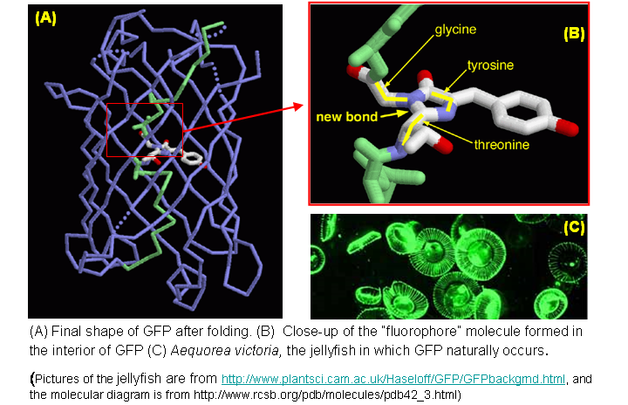
Figure 21. Structure of the GFP protein
Since the sequence for GFP is known, DNA hacking can be used to modify any protein p by appending the sequence for GFP. The modified protein almost always has the same sort of behavior as the original protein, but can be easily seen in a fluorescent microscope. Variants of GFP that fluoresce in other colors are also available.

The combination of a target protein with a sequence from another protein is called a fusion protein or a chimeric protein.
A final way in which fusion proteins are used is to modify a virus or phage so that the virus coat is combined with some protein p of interest—in other words, so the virus “displays” the protein p “on the outside”, where it can easily bind with free proteins q. One powerful application of this phage display technique is to create a large library of phages, each of which “displays” a different protein p, grow large quantities of these phases and then mix them together to see which bind to the protein q of interest. It is usually relatively easy to isolate the phages that bind to q, and importantly, each phage contains its own DNA. This means that one can easily determine the identity of the binding protein p by sequencing the phage DNA.

Yeast two-hybrid assays using fusion proteins
Recombinant fusion proteins can also be used to test to see if two proteins p and q bind to each other. The trick is to modify p and q by attaching tags that will make it obvious when and if p and q bind. This can be done using a yeast two-hybrid assay.
One natural setting in which protein-protein binding is apparent is when that binding causes some gene to be transcribed. An example is shown on the right-hand side of the figure below, where protein A recognizes the promoter for gene x, and then initiates the transcription of x by binding to a partner protein B. The natural scenario can be exploited by first modifying the DNA so that the promoter for x is paired with some gene y whose expression can be easily detected (for instance, y changes the cell’s color when it is expressed). The DNA is also modified so that proteins A and B will not be produced, but two fusion proteins A1p and B1q are produced. A1p combines p with the part of A that actually binds to the promoter site, but not the part of A that binds to B. B1q combines q with the part of B that initiates transcription, but not the part that binds to A. If p and q bind, then y will be transcribed and expressed, but otherwise it will not be. The process is shown on the left-hand side of the figure below.

A reporter gene is one that will behave differently under different circumstances in an experiment, and which can be easily detected when it is expressed.
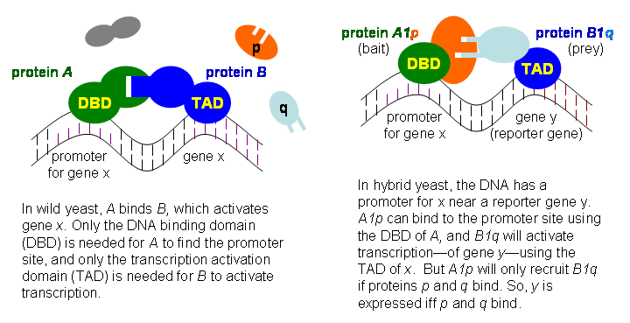
Figure 22. The yeast two-hybrid system
This process is usually carried out in yeast cells, and is called the yeast two-hybrid system. It lends itself to parallelism quite nicely: if there are many potential p’s and q’s, then it is possible to produce a population of yeast with alternative p’s, and a second population with alternative q’s, and then cross-breed the two populations. The children will each contain one of the p fusion genes, and one of the q fusion genes. The small numbers of child cells that contain a p and q which interact can be detected using the reporter gene.

Other Ways to Use Biology for Biological Experiments

Replicating DNA in a test tube
There are a number of reasons for wanting to insert foreign DNA into a cell, one of which is simply to amplify (increase) the quantity of foreign DNA by making use of a cell’s natural ability to grow and multiply. However, there is a more direct way to amplify DNA, by using of some of the cell’s DNA replication machinery in vitro. This technique is called polymerase chain reaction (PCR). To explain how it works, I will first review, at a high level, how DNA is duplicated (replicated) in a cell. (The mechanisms for this differ somewhat in prokaryotes and eukaryotes—here I will focus on prokaryotic replication.)

A molecule that contains a number of repeated units arranged linearly is a polymer. DNA, RNA, and proteins are all polymers.
DNA replication consists of two main stages: initiation, and polymerization. In initiation, special proteins bind to the origin of replication in a double-stranded DNA, and separate the two strands. An enzyme called RNA primerase then builds two RNA molecules, each of which is complementary to a few bases of the separated strands. These RNA “primers” that are created by the primerase serve as a sort of scaffold that supports the next phase of initiation, in which a complex of proteins called a replisome is formed.
The replisome carries out the next stage of polymerization, in which the bulk of the DNA is duplicated. (If DNA replication were an iterative program, the initiation phase would be the initialization, and polymerization would be the main loop.) This is a complicated process, because single-stranded DNA is asymmetric: the two ends of each nucleotide are called the 5’ and 3’ ends, and nucleotides are always linked up 5’ to 3’. In a double-stranded DNA, if the “top” strand is laid out with 5’ on the left and 3’ on the right (the usual orientation), then the “bottom” strand would have the 5’ on the right and the 3’ on the left, like so:

Figure 23 explains why the ends of DNA strands are called 3’ and 5’ (pronounced as “three prime” and “five prime”).
5’ | GATTACAGAATTCCATATTAC | 3’
3’ | CTAATGTCTTAAGGTATAATG | 5’
Table 4. Dual-stranded DNA, with 5' and 3' ends labeled.
In polymerization, the replisome moves in one direction (say, left-to-right)—which is quite a trick since the main work of duplicating the DNA is performed by three molecules of DNA polymerase III, an enzyme which repeatedly extends a partially duplicated DNA, but which only moves in the 5’ to 3’ direction. To handle this mismatch, duplication along one of the two strands is performed with a series of jumps and re-starts: along the so-called “lagging strand” DNA is duplicated for runs of 1000 nucleotides or so in the opposite direction of replisome movement. Additional machinery is needed to patch up the discontinuities in the “lagging strand”, to uncoil the DNA that is being replicated, and to “proofread” the generated DNA.
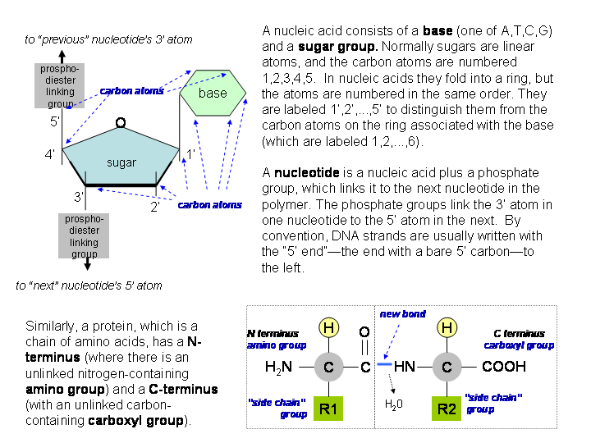
Figure 23. Structure and nomenclature for DNA and protein molecules

To take a physical analogy, the replisome is like a car motor, and the initiation phase is like a starter motor—and the origin of replication is like the car keys. However, there is a way of “hotwiring” the replication process. The trick is to first denature the DNA, i.e., separate the double-stranded DNA into two complementary single-stranded molecules, and then combine these single-stranded molecules with short single-stranded “primer” DNA molecules that are complementary to part of it. After the primer hybridizes to a single-stranded DNA molecule, the result is a partially replicated DNA molecule—the same as the DNA molecules that are extended by DNA polymerase. The process is shown below in Figure 24.
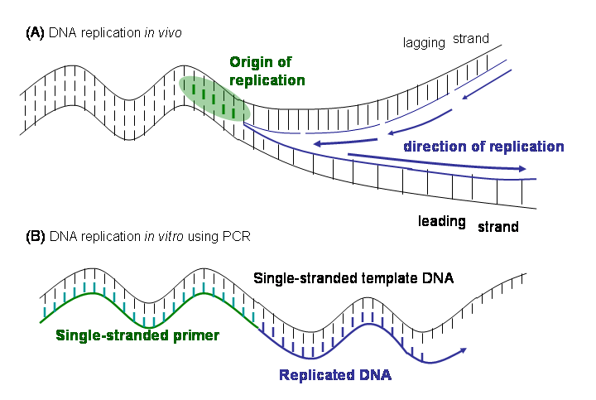
Figure 24.DNA duplication in nature and with PCR
The complete PCR process is performed by first mixing the DNA that needs to be amplified with DNA polymerase, and a relatively large quantity of primer molecules. (The primers, or any other short DNA sequence, can be synthesized relatively easily by chemical means.) One then (1) heats the mixture, which separates the two strands of the DNA; (2) cools it, allowing primers to hybridize to the separated single strands; and (3) waits for the DNA polymerase to replicate the remainder of each template-strand/primer pair. After this cycle, each single DNA strand has been turned into to a double-stranded version of itself—or to put it another way, the number of double-stranded DNA molecules has been doubled. One can then repeat steps 1,2,3 above again and again, doubling the amount of DNA in each cycle.
PCR is a very sensitive technique—it can be used to amplify even a single DNA molecule, which is very important for forensic purposes. The technique was made much more economical by the purification of DNA polymerase from “extremophile” bacteria that live in hot springs, as this flavor of polymerase is not damaged by the heat applied in each cycle.

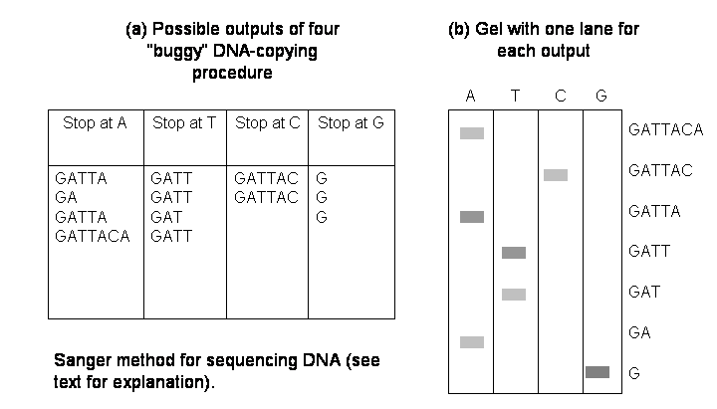
Figure 25 Procedure for sequencing DNA.

Sequencing DNA by Partial Replication and Sorting

One extremely important operation is determining the sequence of nucleic acid bases in a DNA molecule. Suppose that we can modify the DNA replication procedure described above so that it will occasionally stop at one of the four bases. (This can be done by adding to the PCR mixture above an appropriate quantity of a particular variant of the base called a dideoxynucleotide, which can be incorporated into a DNA being constructed, but halts replication after it has been incorporated.) In fact, suppose that we can construct four “buggy” DNA-copying procedures, each of which occasionally stops a different one of the four nucleotides A,T,C,G (adenine, thymine, cytosine, and guanine). With these operations we can now sequence a strand of DNA.
First, provide the DNA to each of the four “buggy” copying procedures, and collect the results, in four separate test tubes. If one makes enough copies, then one can be reasonably sure that one has all prefixes of the original DNA sequence, with prefixes that end in “A” in one test tube, prefixes that end in “T” in another, and so on. Performing this step on the string “GATTACA” might lead to the four populations of DNA shown in Figure 25.
Then, sort each population by size, using different columns of the same gel. Again, the result is shown on in the figure. The sequence can now be read off easily from the four columns. Notice that you start reading the sequence at the bottom—normally substances are introduced at the top, and lighter molecules travel further.
Notice that the length of DNA that can be sequenced is limited by the precision with which the molecules can be sorted by size. If only a 5% difference in size can be detected reliably, then only 20 bases can be sequenced at once; if a 0.001% difference in size can be detected, then 10,000 bases can be sequenced. In practice, only about 1000 bases can be sequenced at once. This means that computational methods for pasting together many short overlapping sequences are needed to find the sequence of an entire organism.
This is the first method used for sequencing DNA, and variants of it are still used today. The main difference is that in modern sequencing methods, all four “buggy copies” are carried out in the same mixture, with fluorescent labels being used added to the dideoxynucleotides to indicate the last base in a sequence. This makes it easier to automate the process of interpreting a sorted sequence of DNA fragments.

Other in vitro systems: translation and reverse transcription
A surprising number of complex biological activities can be performed in vitro. For example, the process of translating an mRNA into a protein can be carried out in a test tube: this is done by using (most of) a whole cell extract, which will contain a certain number of intact ribosomes. In vitro translation is a very useful way of finding what protein is generated by an mRNA: the trick is to add mRNA and radioactively-tagged amino acids to an in vitro translation system. The proteins built according to the template provided by the mRNA will be radioactive, which makes them relatively easy to isolate with a gel.
Another useful operation to perform on an isolated mRNA is reverse transcription—conversion from an RNA to the corresponding DNA molecule. Reverse transcription is not part of the normal cycle of a cell, but certain viruses use reverse transcription to infect a cell. Thus reverse transcription is performed by a naturally-occurring viral enzyme called reverse transcriptase.
DNA that has been formed from RNA by reverse transcription is called cDNA. One application of reverse transcriptase is to create another type of gene library, a cDNA library, by isolating (in parallel!) all the mRNA in a cell, and using reverse transcriptase to create the corresponding collection of cDNA. Unlike a genomic DNA library, in which every gene appears about once, a cDNA library will have many copies of genes that are expressed frequently, and no copies of genes that were not expressed in the organism from which the mRNA was drawn.

Exploiting the natural defenses of a cell: Antibodies
Mammals have immune systems that act as a defense against certain foreign substances. Our immune systems produce antibodies, complexes of proteins that bind very specifically to the foreign substance—that is, they bind to the foreign substance X, and to very few other things. Since antibodies bind so specifically, they are naturally useful in selecting out the substance X. A typical X might be some protein being studied.

An antibody is a protein complex that has been produced, by the immune system, so that it binds specifically to a particular antigen (foreign substance) X. The antibody might be called “antibody against X” or “anti-X”.
To construct antibodies to a particular antigen X, one injects a small amount of X into some animal, usually a mouse or rabbit, and waits for the immune system to do its work. One then extracts some blood from the animal and extracts the serum—the fluid obtained by separating out the liquid part of the blood. This serum will be rich in antibodies, some (but not all) of which are antibodies for X. Isolation of the particular antibody for X requires an additional purification step.
If a larger quantity of an antibody is required, one possible procedure is to extract some of the cells in the mouse (or rabbit) that produce the antibodies. These cells, which are called B-lymphocyte cells, cannot be easily grown in culture, but they can be crossed (by certain unnatural means) with easily-cultured cancerous B-lymphocyte cells to create a particular kind of hybrid cell called a hybridoma. One can then screen for hybridoma cells that produce the desired antibody for X, and then culture these cells.
One important application of antibodies is to construct highly specific fluorescent dyes—dyes that affect only the protein X. This is typically done in a modular way with two types of antibodies: Ab1, an antibody against X, and Ab2, a general-purpose fluorescently-tagged antibody against all rabbit antibodies. In the cell, Ab1 will bind to X, and Ab2 will bind to Ab1, thus tagging X.

Using antibodies to fluorescently label antigens is called immunofluorescence. The analogous use of antibodies to make antigens visible to an electron microscope is called immuno-EM.
A similar process is sometimes used for electron microscopy, except that Ab2 will include small amount of heavy metal—for instance, a small sphere of gold—instead of a fluorescent tag.

Exploiting the natural defenses of a cell: RNA interference
To determine what a particular gene does, it is often useful to remove the gene completely from the genome. Often this can be done with recombinant DNA methods. However, sometimes there is a simpler way to achieve the same effect: sometimes it is possible to “convince” an organism that a particular gene should not be expressed, by using a mechanism called post-transcriptional gene silencing (PTGS). PTGS can be used for many plants and animals—including fruit flies, nematodes, and several other widely-used model organisms. As the name suggests, genes are transcribed into mRNA, but the mRNA is “silenced” and never translated into proteins. The most common PTGS method is RNA interference, often abbreviated RNAi.

Since many biologically important phenomena are conserved across many species, biologists often choose to work with model organisms—organisms that are particularly convenient to experiment on.

Removing a single gene from an organism is usually called knocking out the gene. “Silencing” a gene is often called knocking down the gene.
To use RNAi to silence a gene, one constructs a double-stranded RNA molecule that is complementary to the mRNA for the gene—or perhaps, one that is complementary to only part of the gene. Double-stranded RNA is not normally found in the cell—mRNA, for instance, is single-stranded—and it is attacked by an enzyme called dicer that chops it up into segments 21-23 bases long, called siRNAs (for “small interfering RNA”). Each of these siRNAs becomes part of a protein complex called an RNA induced silencing complex (RISC). The RISC, using the siRNA as a guide, finds and degrades any matching mRNA, thus preventing its translation to protein. The incorporation of the siRNA into the RISC complex makes this mechanism very specific: mRNA that do not hybridize to the siRNA are left alone.
Gene silencing is not completely understood, but some of its uses in the cell are known—for instance, it is also used to regulate the expression of genes in some species. We also know that some viruses encode genetic material as double-stranded RNA, and RNAi thus acts as a defense against these viruses; in fact, this is probably how RNAi evolved. However, there is also a difficulty associated with the existence of RNA viruses: in mammals, long double-stranded RNA produce a strong anti-viral response. To use RNAi in mammals, it is necessary to introduce the siRNAs directly.

Where to go from here?
This document is aimed at computer scientists that are trying to acquire a “reading knowledge” of biology. For those that want to learn more about core biology, the gentlest introduction I know of is “The Cartoon Guide to Genetics”. The most comprehensive introduction is “Molecular Biology of the Cell, 4th Edition”, by Alberts et al, which also has the virtue of being freely available on-line at the National Library of Medicine (NLM). If you’re a non-biologist hoping to get along in biology, you could do worse than to read the former, and skim through the latter:
The Cartoon Guide to Genetics (1991) by Larry Gonick and Mark Wheelis. Published by HarperCollins.
Molecular Biology of the Cell (1994) by Bruce Alberts, Dennis Bray, Julian Lewis, Martin Raff, Keith Roberts, and James D. Watson. Published by Garland Publishing, a member of the Taylor & Francis Group. On-line at http://www.ncbi.nlm.nih.gov/entrez/query.fcgi?db=Books.
There is also plethora of on-line information. Aside from the several other textbooks available from NLM, one visually appealing online resource is the collection of Flash animations on http://johnkryk.com. There are also several hyperlinked textbooks, one of which is available from MIT at http://web.mit.edu/esgbio/www/. Dictionary.com is also a surprisingly good resource for finding technical definitions.
For persons interested in text-processing applied to scientific, biological text, some useful sites include these:
- BioNLP at http://www.ccs.neu.edu/home/futrelle/bionlp/
- BioLink at http://www.pdg.cnb.uam.es/BioLink
- BLIMP at http://blimp.cs.queensu.ca/.
There is also a good recent review article on NLP and biology, by Cohen (no relation) and Hunter. Another recent review article, coincidentally by yet another Cohen (Jacques Cohen, again, no relation!) surveys bioinformatics, rather than biology.
Natural Language Processing and Systems Biology, by K.Bretonnel Cohen and Lawrence Hunter. In Artificial Intelligence and Systems Biology, 2005, Springer Series on Computational Biology, Dubitzky W. and Azuaje F. (Eds.). This paper can also be found on-line at http://compbio.uchsc.edu/Hunter_lab/Cohen/Cohen.pdf.
Bioinformatics—An Introduction for Computer Scientists, by Jacques Cohen, in ACM Computing Surveys, 2004, vol 36, pp122-158.
In preparing this I used several additional textbooks and/or web sites as references:
Biochemistry (2002) by Mary K. Campbell, and Shawn O. Farrell. Published by Thomson-Brooks/Cole. A good introductory textbook on biochemistry.
Biological Sequence Analysis: Probabilistic models of proteins and nucleic acids (1998), by R. Durbin, S. Eddy, A. Krogh, and G. Mitchison. Published by Cambridge University Press. An excellent introduction to the many aspects of sequence modeling, including hidden Markov models, edit distances, multiple alignment, and phylogenetic trees, this text has uses beyond biology as well.
An Introduction to the Genetics and Molecular Biology of the Yeast Saccharomyces cerevisiae (1998), by Fred Sherman. http://dbb.urmc.rochester.edu/labs/sherman_f/yeast/. This web site is a detailed description of yeast, a popular model organism for genetics. It is a modified (presumably updated) version of : F. Sherman, Yeast genetics, In The Encyclopedia of Molecular Biology and Molecular Medicine, pp. 302-325, Vol. 6. Edited by R. A. Meyers, VCH Pub., Weinheim, Germany,1997.
Molecular Biology, Third Edition (2005) by Robert F. Weaver. Published by McGraw-Hill. Unlike Alberts et al, this book contains many in-depth discussions of the research, results, and reasoning processes behind our understanding of biology. It is a good resource for those wanting to obtain a “reading knowledge” of biology.
Random Walks in Biology (1983), by Howard Berg. Published by Princeton University Press. This is a short book with some very accessible discussions of diffusion in biological systems.
Transport Phenomena in Biological Systems (2004), by George Truskey, Fan Yuan, and David Katz. Published by Pearson Prentice Hall. An in-depth treatment of transport and diffusion.

Cell membranes are about the viscosity of butter, while the cytoplasm of a cell is about as viscous as water, so molecules move about 100 times as slowly when they are stuck in a membrane. However, diffusion in two dimensions is asymptotically more efficient than in three dimensions, so it is faster to diffuse along a membrane if the distance is large enough. Analysis of simple systems suggests that “cross-over point” at which membrane-bound diffusion is faster than simple diffusion is somewhere between the size of a bacterium and a mammalian cell.
For more information on proteome chips, see Global Analysis of Protein Activities Using Proteome Chips, by Zhu et al, Science 2001, Vol 293, pp 2101-2105.
http://yeastgfp.ucsf.edu/
From http://www.clunet.edu/BioDev/omm/bamh1/molmast.htm

