**RoadWatch – Planned Features**

This current release of RoadWatch is incomplete in a number of aspects. Future work would aim to address these missing features.

**Client-side validation**

Currently no validation is performed on the user input. Effectively the user could enter any text into the start and end point fields.

Although the user is informed of a problem. The error handling mechanism is crude and uninformative. A simple alert popup is display with a rather generic error message:

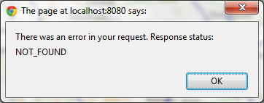

This needs to be corrected so that the user is either physically prevented from entering incorrectly formatted text or the user is alerted to any problem with their input when the try to submit a request to RoadWatch. The current situation

**Server-side validation**

Similar issue to client-side validation. Since the intention of the core RoadWatch API is that it is standalone it should be better protected from invalid requests.

**Server-side error reporting**

Currently Exceptions generated on the Server-side are not reported back to the client. At a minimum these should be logged rather than simply being pumped to std err. A better solution would be some combination of logging with a UI error reporting mechanism. Liferay’s or Spring MVC’s own support for this problem should be investigated.

**Style sheet improvements**

Currently there is a style sheet for RoadWatch however some of the style is also defined in-line within the HTML. There is a degree of redundancy in these styles. They should be moved into the stylesheet where they are more readily maintained and can be clearly named. This will also lead to cleaner more readable HTML