

SSMS Exploration Document

Inventory and Sales Management System

Avishay Aknin

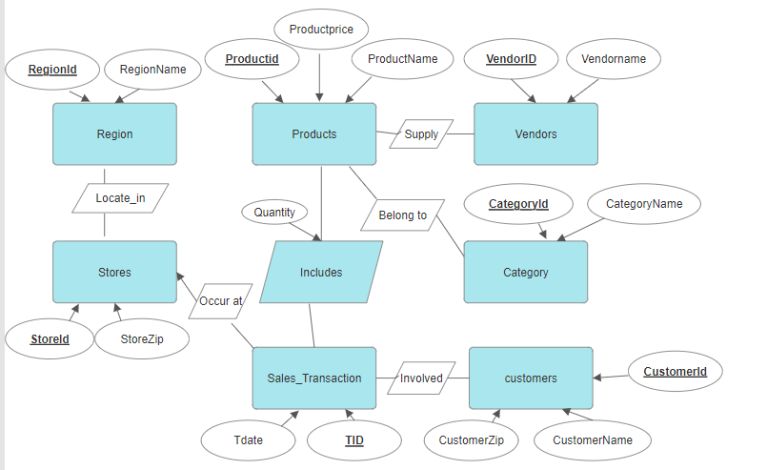**ERD Diagram**

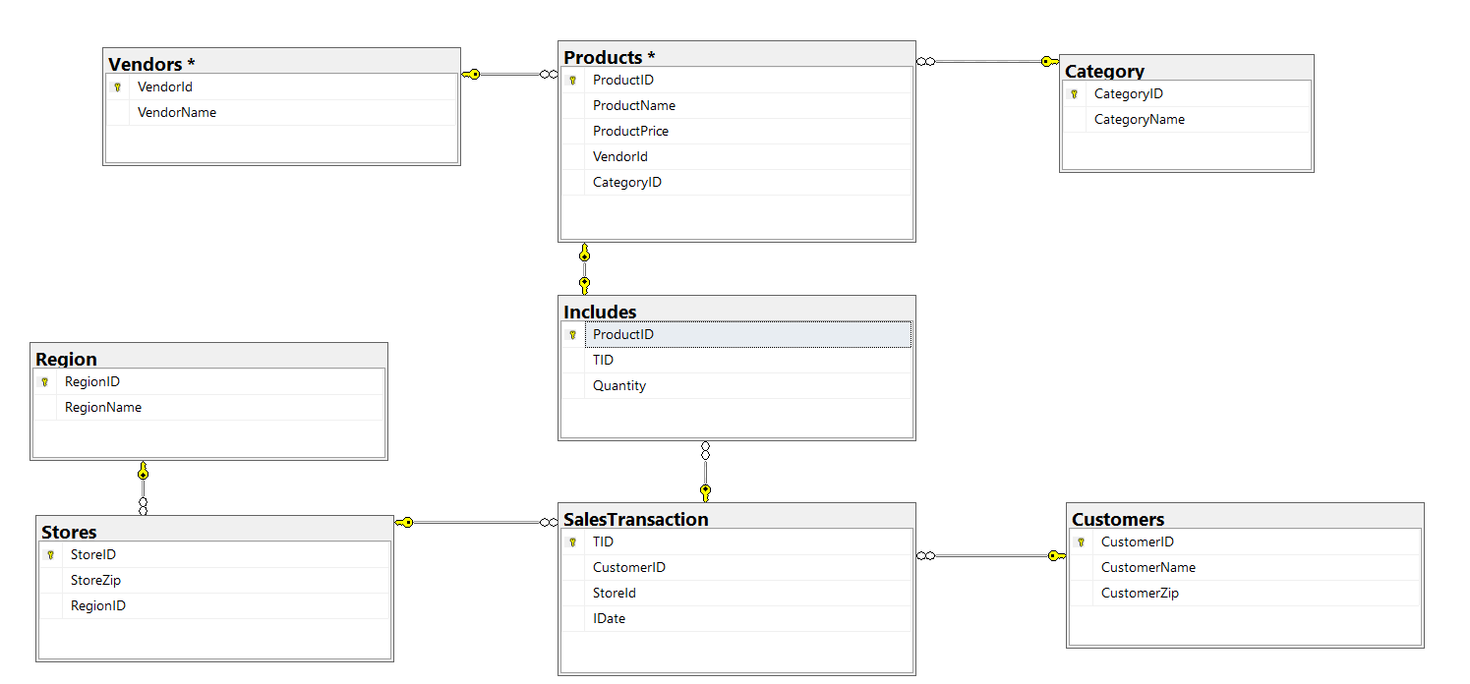**Database Diagram**

**Tables :**

**Category Table :**

Represents different categories for grouping items or products.

* **CategoryID**: Unique identifier for each category (Primary Key).
* **CategoryName**: Name of the category.

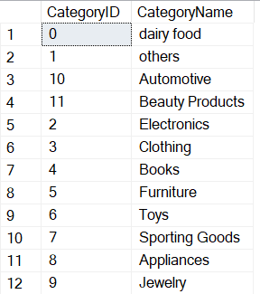

**Customers Table :**

**Stores information about individual customers.**

* **CustomerID:** Unique identifier for each customer (Primary Key).
* **CustomerName:** Name of the customer.
* **CustomerZip:** Zip code of the customer's location.

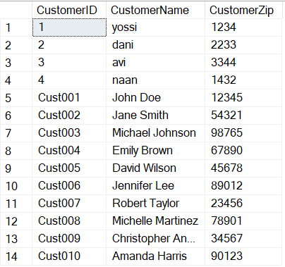

**Includes Table :**

**Serves as a junction table linking products and sales transactions tables, representing the quantity of each product included in a transaction.**

* **ProductID:** Identifier for the product included in the transaction.
* **TID:** Identifier for the sales transaction (Transaction ID).
* **Quantity:** Quantity of the product included in the transaction.

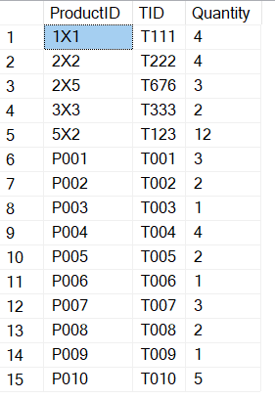

**Products Table :**

**Stores information about various products available for sale.**

* **ProductID:** Unique identifier for each product (Primary Key).
* **ProductName:** Name of the product.
* **ProductPrice**: Price of the product.
* **VendorID:** Identifier for the vendor supplying the product.
* **CategoryID:** Identifier for the category to which the product belongs.

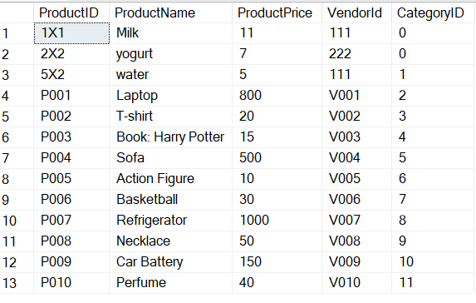

**Region Table :**

**Represents different regions or geographical areas.**

* **RegionID:** Unique identifier for each region (Primary Key).
* **RegionName**: Name of the region.

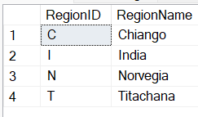

**SalesTransaction Table :**

**Records information about individual sales transactions**

* **TID:** Unique identifier for each transaction (Primary Key).
* **CustomerID:** Identifier for the customer involved in the transaction.
* **StoreID:** Identifier for the store where the transaction occurred.
* **TDate**: Date of the transaction**.**

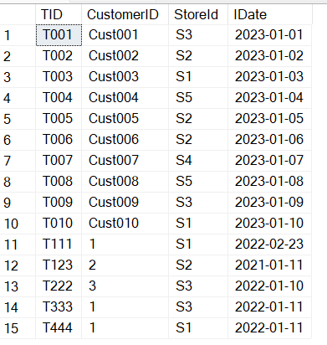

**Stores Table :**

**Stores details about different stores.**

* **StoreID:** Unique identifier for each store (Primary Key).
* **StoreZip**: Zip code of the store's location.
* **StoreRegion**: Identifier for the region to which the store belongs.

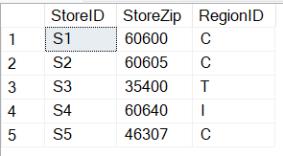

**Vendors Table :**

**Contains information about various vendors.**

* **VendorID:** Unique identifier for each vendor (Primary Key).
* **VendorName:** Name of the vendor.

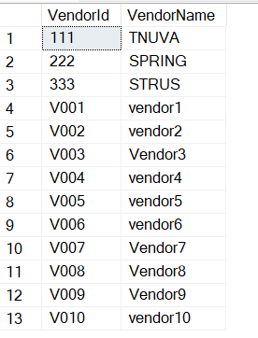

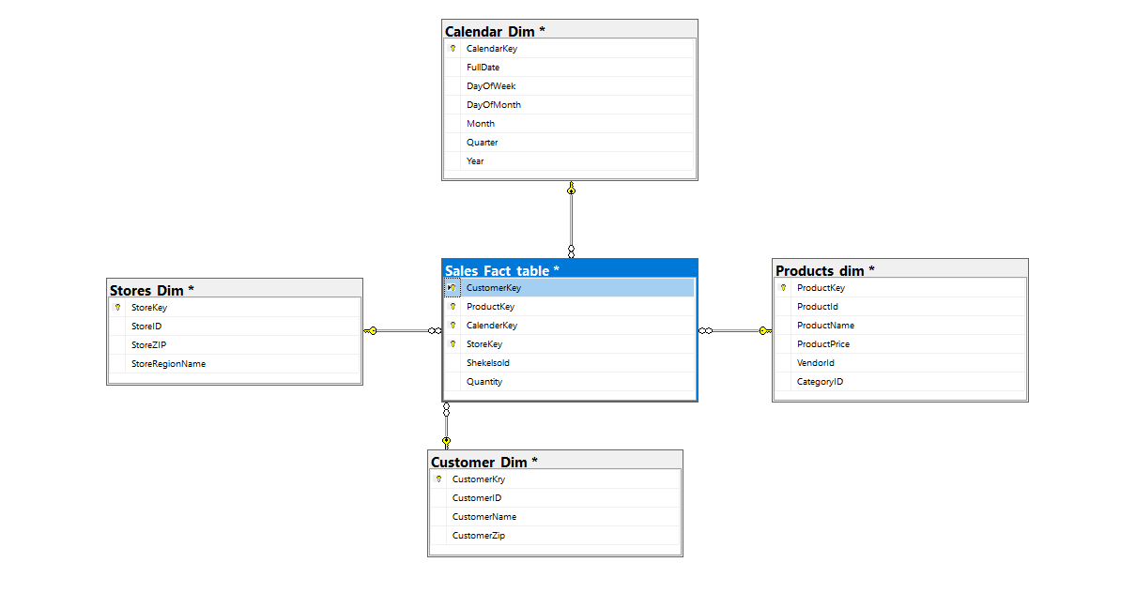**Data Ware House diagram**

**Views –**

**Calender_View:**

SELECT

DISTINCT IDate AS FullDate,

CONVERT(NVARCHAR, IDate) AS DayOfWeek,

MONTH(IDate) AS Month,

DAY(IDate) AS DayOfMonth,

DATEPART(QUARTER, IDate) AS Quarter,

YEAR(IDate) AS Year

FROM dbo.SalesTransaction

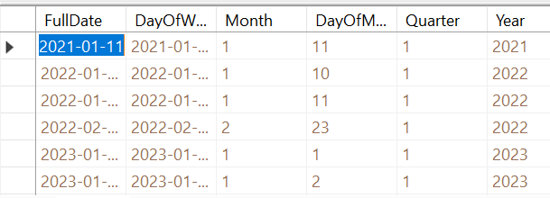

**Customer_view:**

SELECT

CustomerID, CustomerName, CustomerZip

FROM dbo.Customers

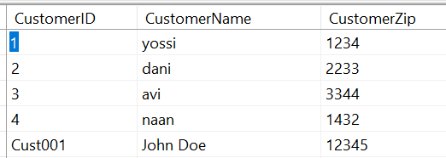

**Product_view:**

SELECT

dbo.Products.ProductName,

dbo.Products.ProductPrice,

dbo.Products.ProductID,

dbo.Category.CategoryID,

dbo.Vendors.VendorId

FROM dbo.Products INNER JOIN

dbo.Category ON dbo.Products.CategoryID = dbo.Category.CategoryID INNER JOIN

dbo.Vendors ON dbo.Products.VendorId = dbo.Vendors.VendorId

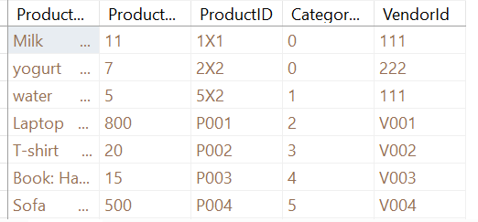

**Store_View:**

SELECT

CONVERT(NVARCHAR, dbo.Region.RegionName) AS RegionNames,

dbo.Stores.StoreZip,

dbo.Stores.StoreID

FROM

dbo.Region INNER JOIN

dbo.Stores ON dbo.Region.RegionID = dbo.Stores.RegionID

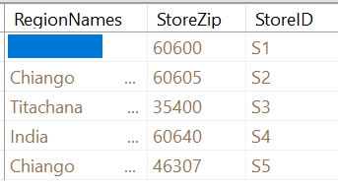

**Sales_view:**

SELECT

dbo.Includes.Quantity,

AvishayDB_DWH.dbo.Products_dim.ProductKey,

AvishayDB_DWH.dbo.Stores_Dim.StoreKey, AvishayDB_DWH.dbo.Calendar_dim.CalendarKey, AvishayDB_DWH.dbo.Customer_Dim.CustomerKey,

AvishayDB_DWH.dbo.Products_dim.ProductPrice * dbo.Includes.Quantity AS Shekelsold

FROM

dbo.Includes INNER JOIN

dbo.Products ON dbo.Includes.ProductID = dbo.Products.ProductID INNER JOIN

AvishayDB_DWH.dbo.Products_dim ON dbo.Includes.ProductID = AvishayDB_DWH.dbo.Products_dim.ProductId INNER JOIN

dbo.SalesTransaction ON dbo.Includes.TID = dbo.SalesTransaction.TID INNER JOIN

AvishayDB_DWH.dbo.Calendar_dim ON dbo.SalesTransaction.IDate = AvishayDB_DWH.dbo.Calendar_dim.FullDate INNER JOIN

AvishayDB_DWH.dbo.Customer_Dim ON dbo.SalesTransaction.CustomerID = AvishayDB_DWH.dbo.Customer_Dim.CustomerID INNER JOIN

AvishayDB_DWH.dbo.Stores_Dim ON dbo.SalesTransaction.StoreId = AvishayDB_DWH.dbo.Stores_Dim.StoreID

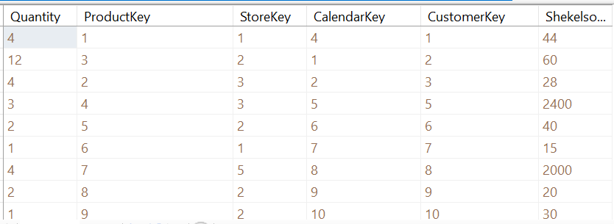

**Data Ware House Tables :**

**Calendar_dim Table :**

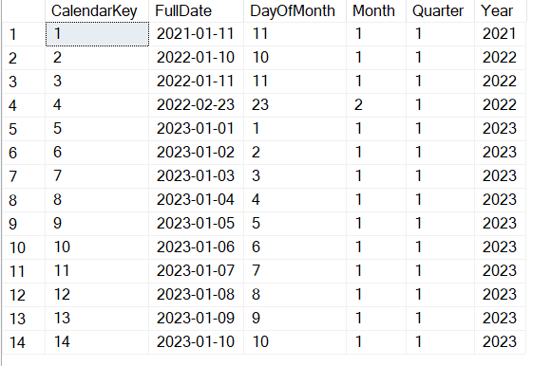

**Customer_Dim Table :**

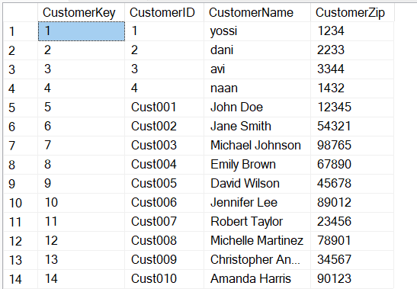

Products_dim table :

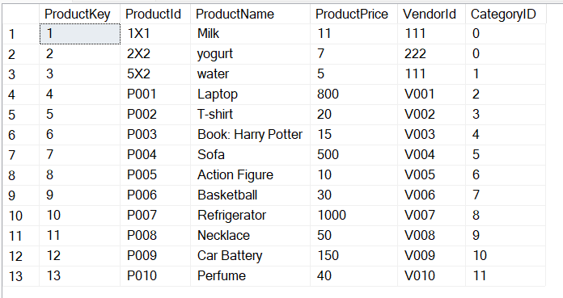

**Sales_Fact_table Table :**

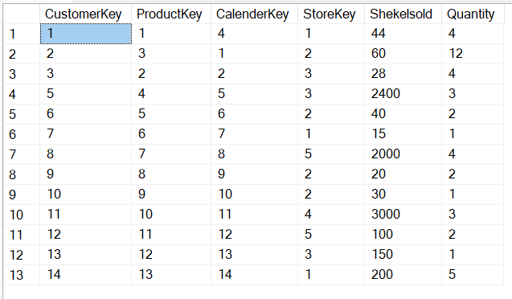

**Stores_Dim Table:**

