VoIP phone Technical Documentation

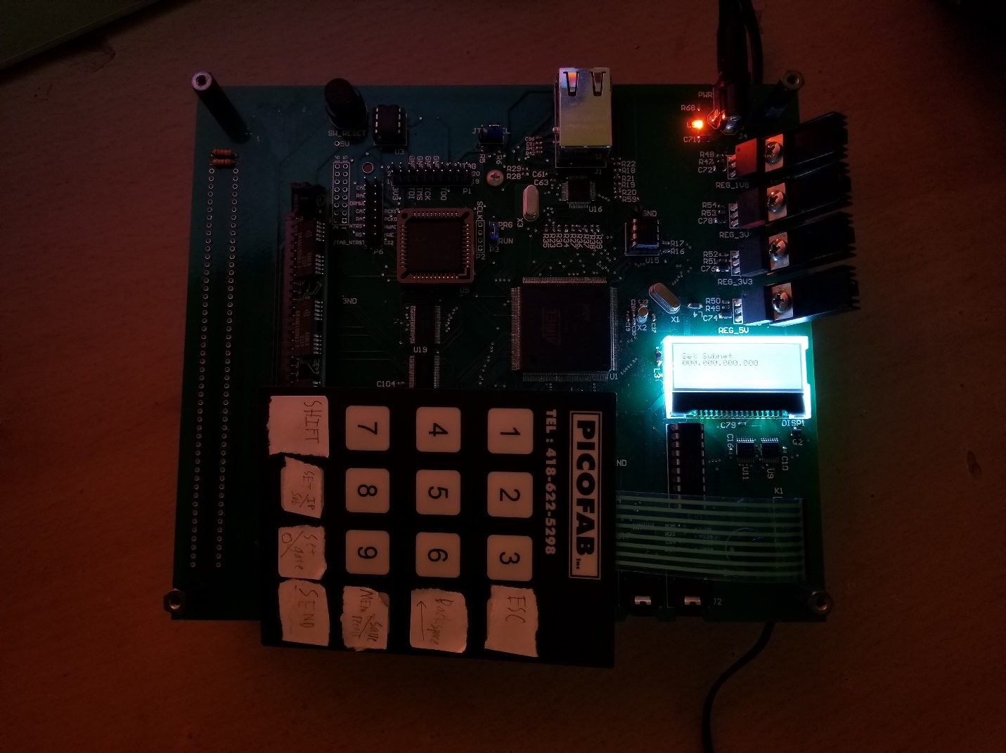

The EE52 VoIP phone is a phone that can communicate with other EE52 VoIP phones. The user controls the phone by using a 128x32 display and a 4x4 keypad. There is a headphone and microphone jack that a headset can be plugged into, and there is a button for putting the phone “on-the-hook” to hangup the call.

Will Werst

Contents

Overview 5

Block Diagram 5

Power Circuitry 6

Linear Regulators 6

CPU Support Circuitry 7

Clocks 7

Reset 7

JTAG 8

Memory 9

Memory Testing 10

EEPROM Bootloader 10

ROM 10

SRAM 10

DRAM 10

User Interface Components 11

Keypad 11

Display 12

Audio 13

Ethernet 14

Appendix A (ROM Timing)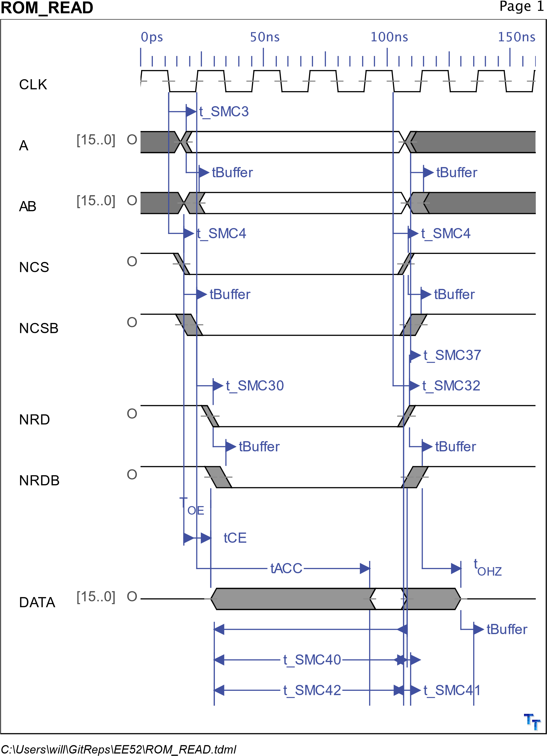 16

Appendix C (DRAM Timing) 32

Appendix D (DRAM Abel Code) 48

Appendix E (Software) 49

Appendix F (Printed Circuit Board) 50

Appendix G (Schematics) 51

# Overview

|  |  |
| --- | --- |
| Processor | Atmel AT91RM9200 |
| Input power | 8V-12V DC 5.5mm barrel jack |
| Display | 128x32 |
| Headphone Jack | 3.5mm mono audio jack |
| Microphone Jack | 3.5mm |
| Keypad | 4x4 button keypad |

## Block Diagram

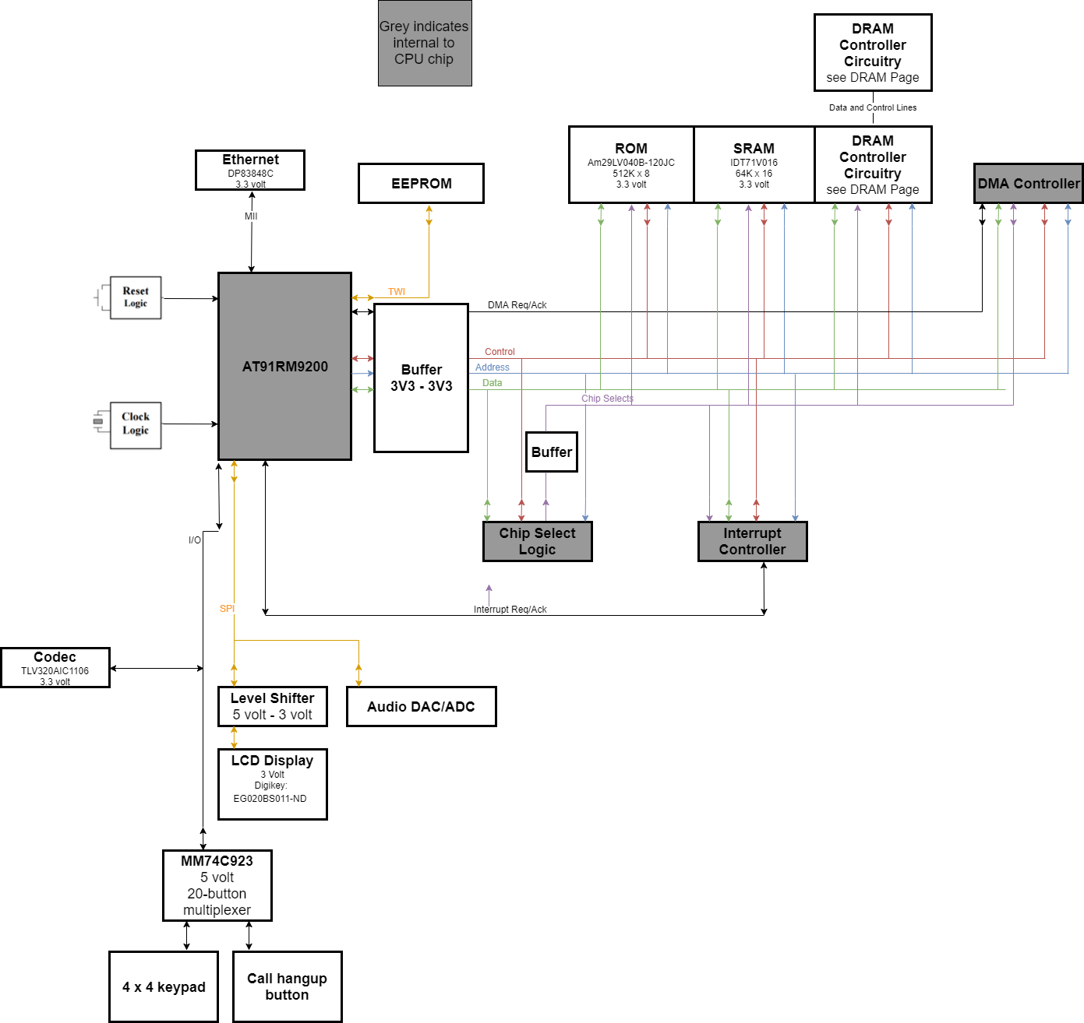

# Power Circuitry

The system takes ~8V-12V DC input. The upper bound is due to thermal dissipation constraints of the linear regulator heatsinks. There are four power rails on this board.

|  |  |
| --- | --- |
| Rail | Uses |
| 5V | Reset circuit, DRAM, CPLD |
| 3V3 | Audio, SRAM, ROM, CPU |
| 3V | Display |
| 1V8 | CPU Core logic |

## Linear Regulators

The system uses LM1086 linear regulators with heatsinks attached.

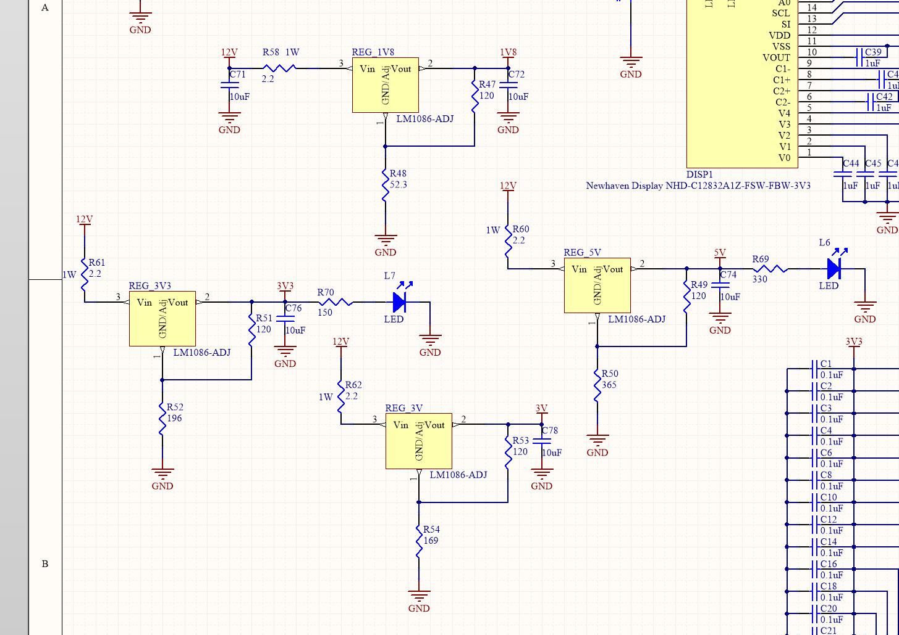

*Linear regulators*

# CPU Support Circuitry

## Clocks

The CPU uses a 32.768 kHz slow clock and a 20 MHz main clock crystal. The main clock is scaled using a PLL to 44 MHz.

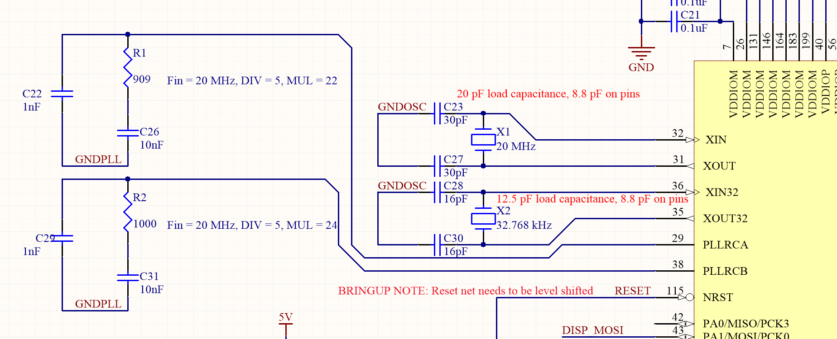

*Clocks and PLL circuits*

## Reset

The reset circuitry uses a MAX705 chip in the standard configuration. The 5-volt reset line output is scaled using a resistor divider for devices that need 3.3V input.

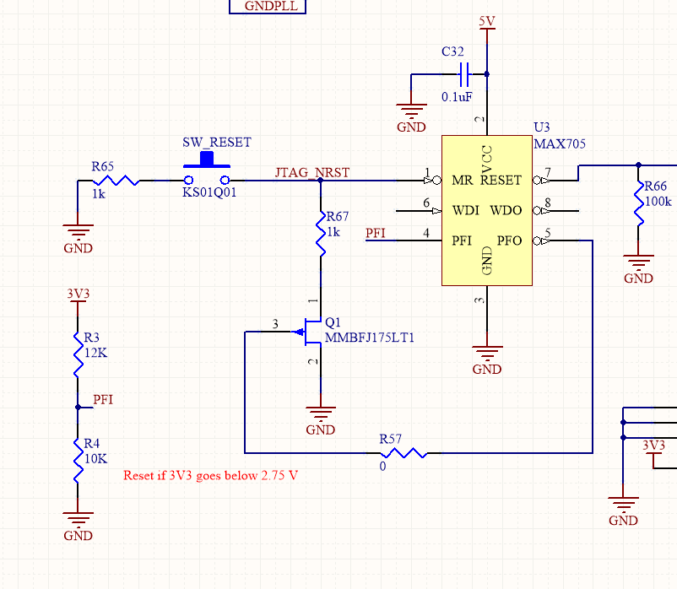

## JTAG

This board has a JTAG interface routed and populated for the purposes of debugging. It is a 20-pin legacy ARM IDC 0.1” pitch JTAG connector with the following pinout (see <http://infocenter.arm.com/help/topic/com.arm.doc.faqs/attached/13634/cortex_debug_connectors.pdf>):

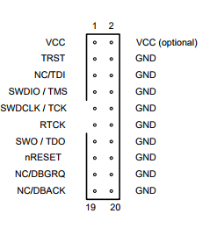

# Memory

All memory access is done through 74LVT16245 buffers.

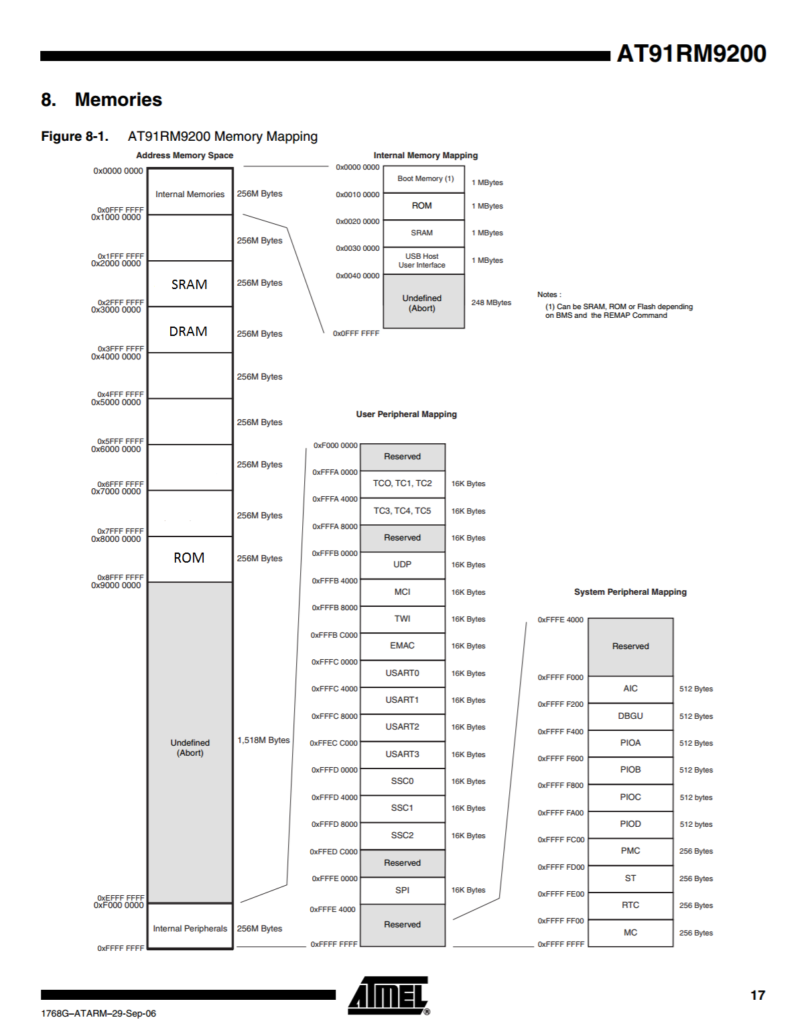

*Memory map*

## Memory Testing

When the system boots, all of the memory in the SRAM and DRAM is checked for errors before the code is copied from ROM to SRAM for program operation. This is done in the memtest.s file. The test works by writing a few sequences of numbers that do not repeat with any 2^n periodicity, and reading back the data and comparing it against the expected sequence. This test seems to do a good job at detecting rare memory integrity issues, but it does not test for DRAM refresh being fast enough to prevent DRAM bit rot.

## EEPROM Bootloader

The system uses a 24AA32 over TWI for the bootloader. This bootloader initializes the ARM CPU modes, checks for SRAM and DRAM integrity, and then copies ROM to SRAM. Future possible improvements could be to check a hash of the ROM values against a hash stored in ROM to verify ROM integrity.

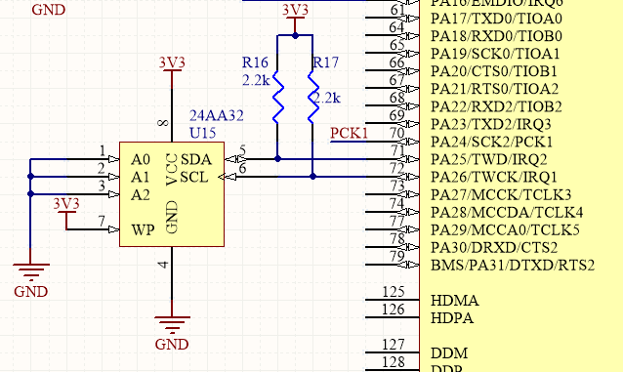

## ROM

This board uses a 29LV040 chip for ROM. This chip has an address bus width of 19 bits, and a data bus width of 8 bits. It is on chip select 7. See schematic in Appendix.

## SRAM

This board uses a IDT71V016 chip for SRAM. This chip has an address bus width of 16 bits, and a data bus width of 16 bits. It is on chip select 1. See schematic in Appendix.

## DRAM

This board uses a socket mount DRAM module. The DRAM controller is implemented in a CPLD. The address lines are multiplexed to the DRAM via U19 and U21, which are two buffers that can be toggle high-Z and enabled by the CPLD DRAM controller. The data lines are connected to the CPU data bus via a bidirectional buffer that is enabled when the DRAM chip select goes low. The directionality of the buffer is set by the NRD signal.

The DRAM has an effective address bus width of 20 bits, and a data bus width of 8 bits. The DRAM is on chip select 2. See Schematic in Appendix.

# User Interface Components

## Keypad

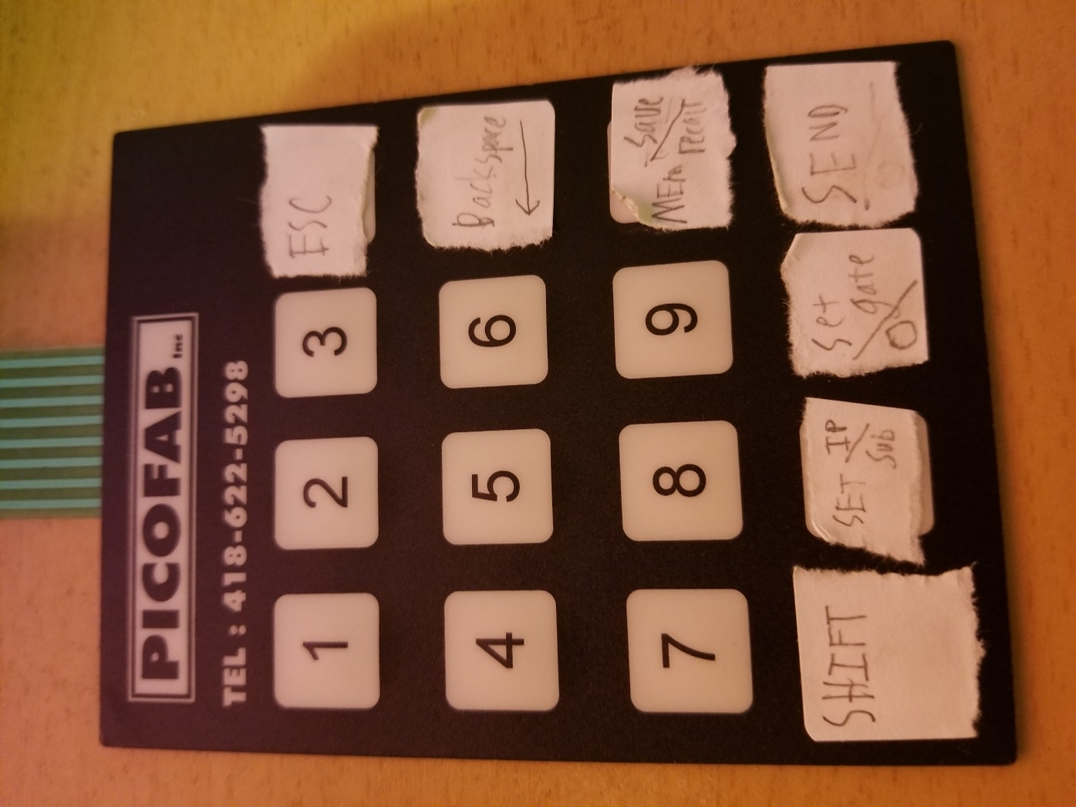

The keypad is used for user input into the device. It is a 4x4 keypad, and since more inputs are needed than are available, a shift key is used to toggle the function of a few keys. The keypad uses a MM74C923 chip for debouncing key presses. Also, on the test board, the hangup button was connected into the ROW1 channel of the chip, to simplify code. The design implemented in schematic works as well, but if the hangup button remains a button that is pressed when it is needed, rather than being a button that is always pressed when the phone is on the hook, then the hangup button can be connected to the debouncer chip. The debouncer chip can only debounce one key at a time, so if the hangup button is pressed while the user wants to press other buttons, the system would not respond to the new button presses, hence why the hangup button was kept separate in the schematic right now.

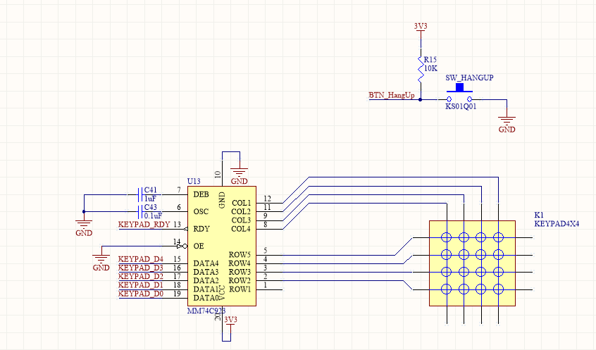

The above schematic shows the design as routed on the PCB. This design is fully functional, but on the test board, the hangup button was wired into row 1 of debouncer chip for code simplicity.

## Display

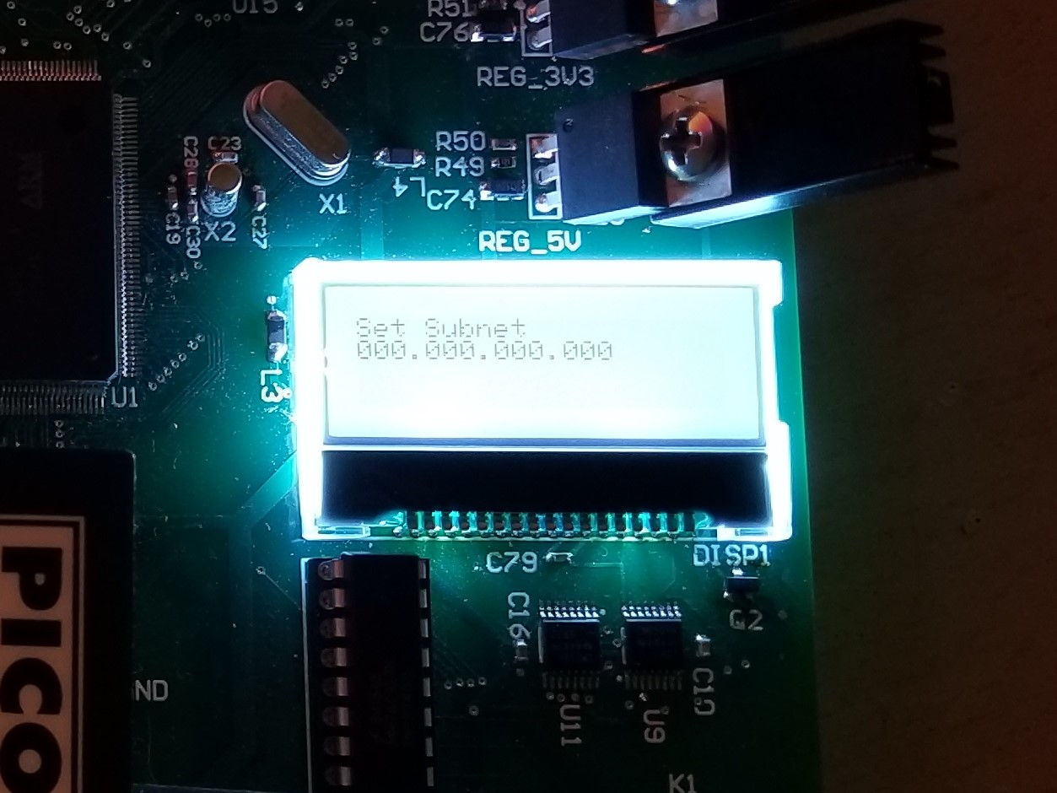

The display is a NHDC12832 128x32 display. In software, the display is divided into 4 rows. Only the top two rows are used.

The top row displays the current menu the system is in, or the status of the system if a call is in progress.

The 2nd row displays auxiliary information for a menu, such as the IP address being set, the subnet mask, or the memory location for recall.

Data is streamed to the display using SPI, with the data transfer to the SPI peripheral done using DMA.

The display uses 3 volt power, while the CPU uses 3.3 volt, so level shifters are used.

A backlight is available on the display, and is toggled via pin PA5 on the CPU.

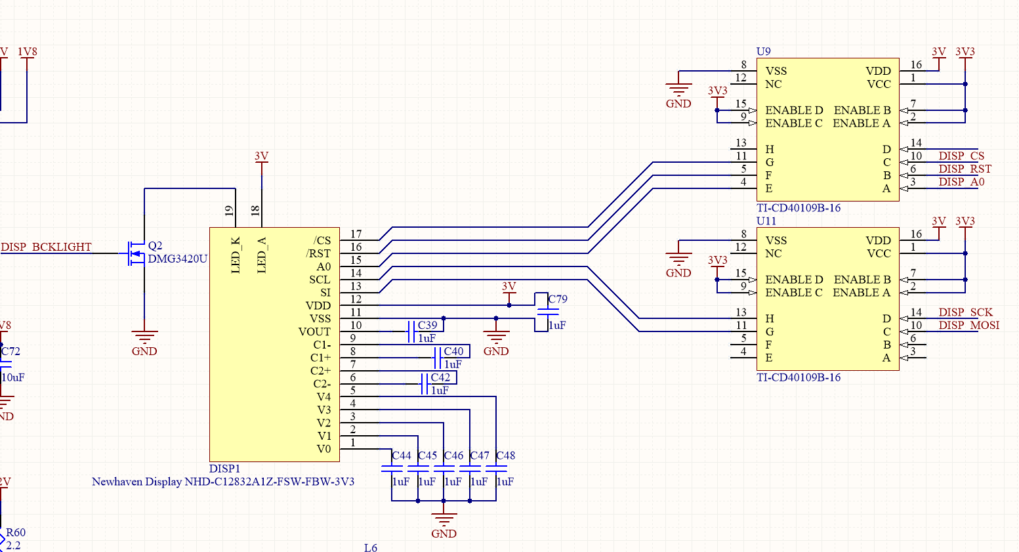

*Display and level shifters for display*

## Audio

The audio circuitry uses the TLV320AIC1106 chip. Depending on whether companding or linear serial stream is desired, R63 or R64 can be stuffed. Currently, the code base only supports linear mode, which corresponds to R64 being stuffed. Data is sent and received from the audio chip via a synchronous serial controller on the ARM chip and a DMA engine on the ARM chip.

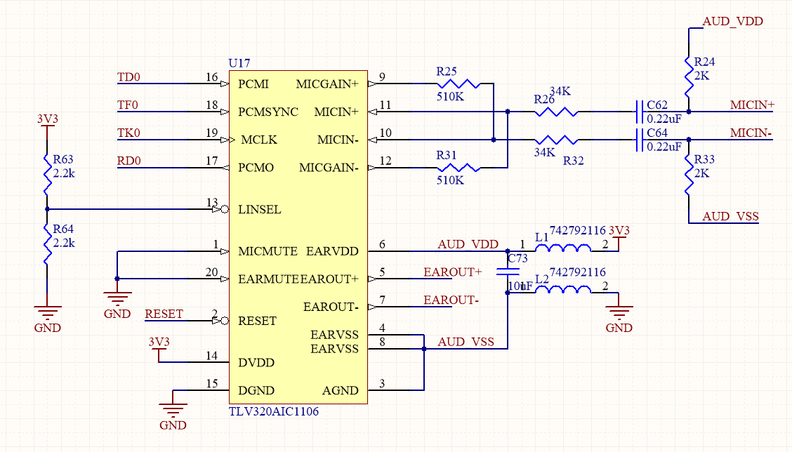

*Audio Circuitry*

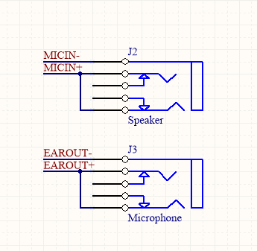

*Audio output*

## Ethernet

The ethernet circuitry in the schematic is untested, and may not work. It is designed to operate in either 10Base-T or 100Base-T, half or full duplex.

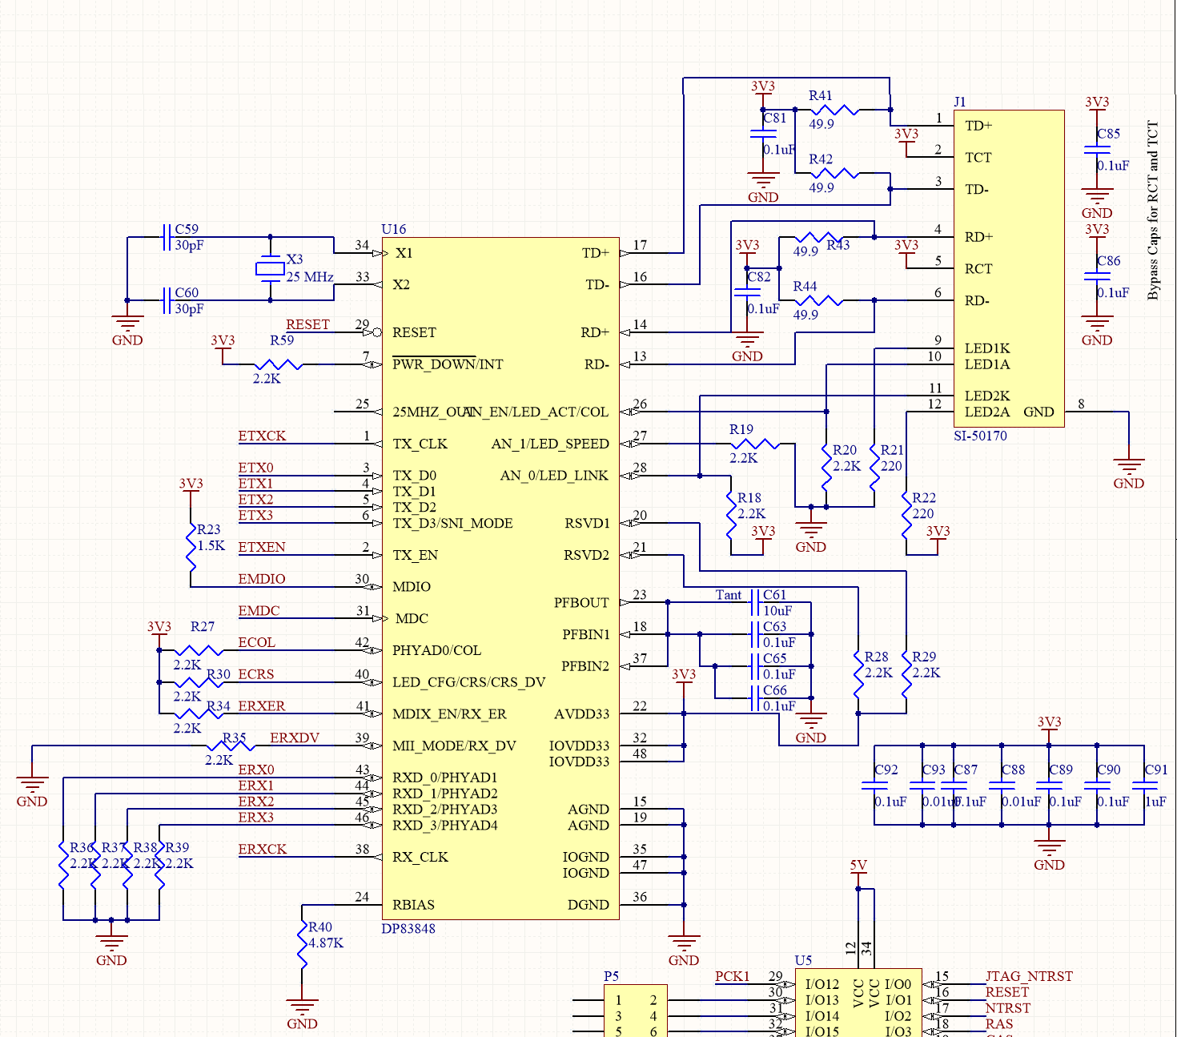

# Appendix A (ROM Timing)



DATAB

O

tBuffer

t_SMC43





|  |  |  |  |  |  |
| --- | --- | --- | --- | --- | --- |
| General Data |  |  |  |  |  |
| SYMBOL | DEFINITION | DESCRIPTION | MIN | MAX | NOTES |
| t_SMC3 | MCK Falling to  A1-A25 valid | to be defined | 4.9ns | 7.5ns |  |
| t_SMC4 | MCK Falling to | to be defined | 4.3ns | 6.5ns |  |
|  | Chip Select |  |  |  |  |
| tBuffer |  | to be defined | 1.3ns | 5.1ns |  |
| t_SMC1 |  | to be defined |  |  |  |
| t_SMC30 | MCK Rising to  NRD Active | to be defined | 4.7ns | 7.0ns |  |
| tACC | Address Access | defined by | 0ps | 70ns |  |
|  | time | memory |  |  |  |
| tCE | Chip Select  Access time | defined by  memory | 0ns | 70ns |  |
| T | Output enable | defined by | 0ns | 30ns |  |
| OE | access time | memory |  |  |  |
| t_SMC32 |  | to be defined | 4.5ns | 6.8ns |  |
| t_SMC40 | Data Setup time | to be defined | 7.5ns |  |  |
|  | before NRD |  |  |  |  |
| t_SMC4 | MCK falling to  CHip Select  Change | to be defined | 4.3ns | 6.5ns |  |
| t_SMC41 | Data Hold time | to be defined | -3.4ns |  |  |
|  | after NRD rising |  |  |  |  |
| t_SMC37 | NRD High to  A1-A25 change | to be defined | 0.3ns | 0.6ns |  |
| t | Output Enable | defined by | 0ns | 16ns |  |
| OHZ | High to Output in  High-Z | memory |  |  |  |
| t_SMC42 | Data Setup before NCS High | to be defined | 7.3ns |  |  |
| t_SMC43 | Data Hold after | to be defined | -3.2ns |  |  |
|  | NCS High |  |  |  |  |
| Notes:  Device: AM29LV040  Results:  1 wait states | |  |  |  |  |
|

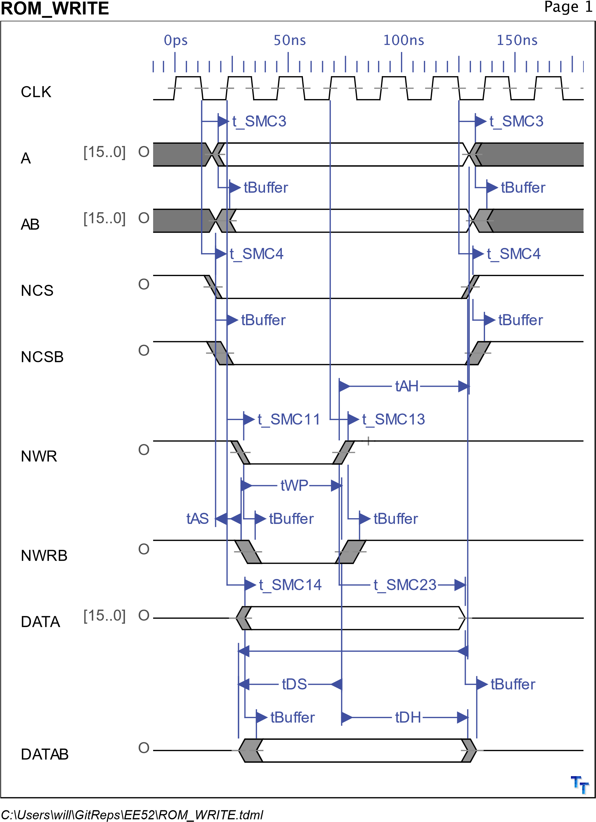



|  |  |  |  |  |  |
| --- | --- | --- | --- | --- | --- |
| General Data |  |  |  |  |  |
| SYMBOL | DEFINITION | DESCRIPTION | MIN | MAX | NOTES |
| t_SMC3 | MCK Falling to  A1-A25 valid | to be defined | 4.9ns | 7.5ns |  |
| tBuffer |  | to be defined | 1.3ns | 5.1ns |  |
| t_SMC14 | MCK Rising to  D0-D15 Valid | to be defined | 4.1ns | 7.9ns |  |
| t_SMC4 | MCK falling to | to be defined | 4.3ns | 6.5ns |  |
|  | CHip Select  Change |  |  |  |  |
| tAS | Address Setup to End of Write | to be defined | 0ns |  |  |
| tDS | Data Setup Time | to be defined | 35ns |  |  |
| tDH | Data Hold Time | to be defined | 0ns |  |  |
| tAH | Address Hold | to be defined | 45ns |  |  |
|  | from End of Write |  |  |  |  |
| tWP | Write Pulse | to be defined | 35ns |  |  |
| t_SMC11 | MCK Rising to | to be defined | 4.8ns | 7.2ns |  |
|  | NWR Active (with wait states) |  |  |  |  |
| t_SMC13 | MCK Rising to  NWR Inactive | to be defined | 4.1ns | 7.9ns |  |
| t_SMC23 | MCK Rising to | to be defined | 55.7ns |  |  |
|  | Data Out Invalid  (1 hold state) |  |  |  |  |
| t_SMC17 | NWR High to  A1-A25 Change | to be defined | 3.3ns |  |  |
| Notes:  Results:  0 setup   1. wait state (pulse length)   2.5 hold parameter | |  |  |  |  |
|

Appendix B (SRAM Timing)

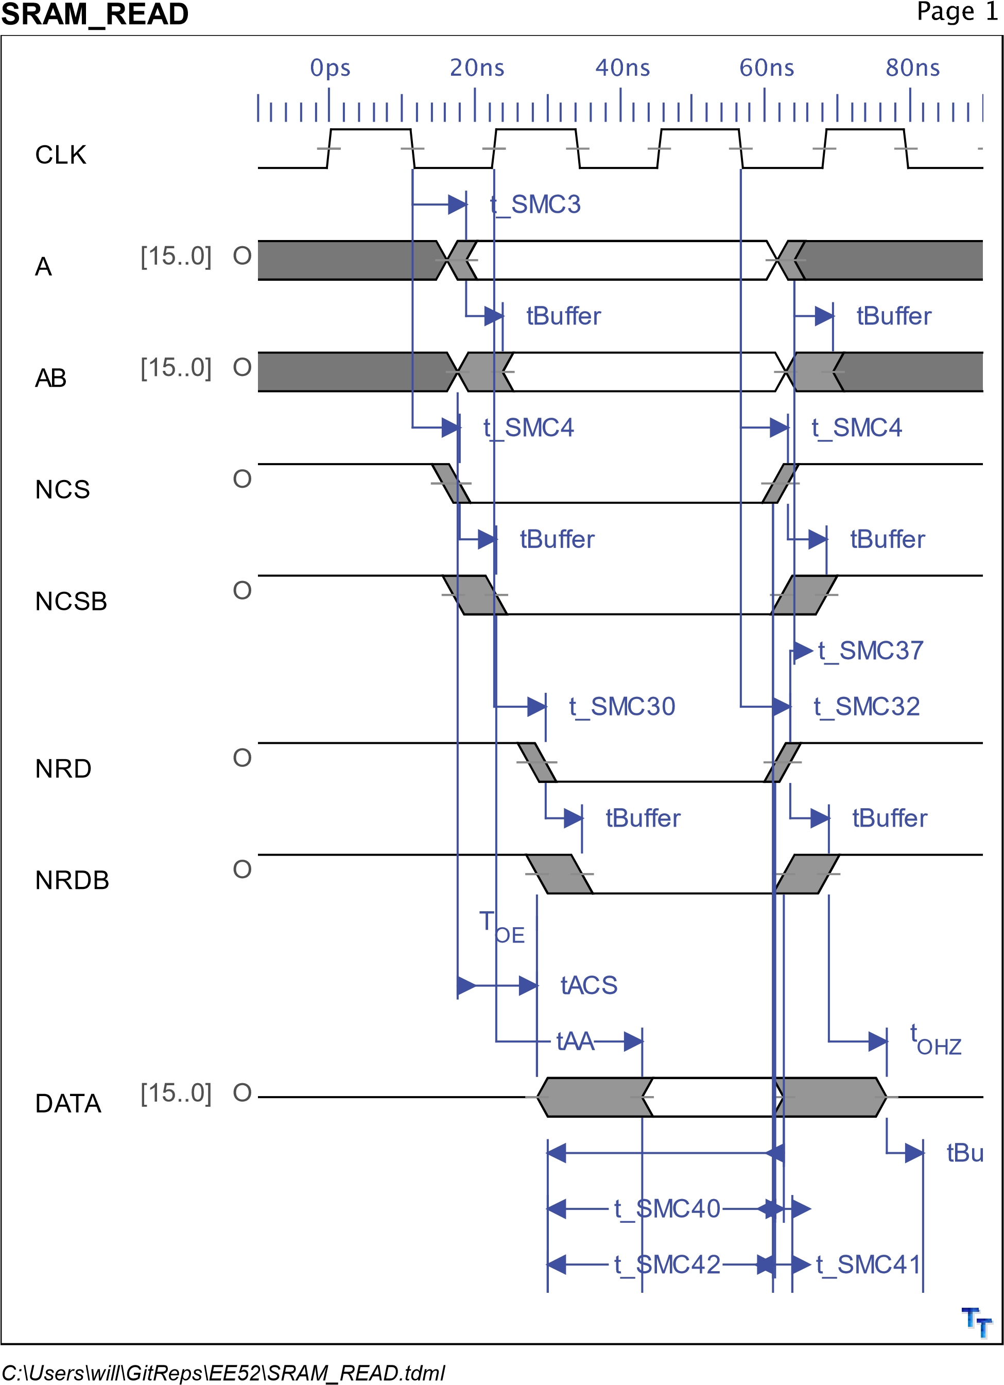

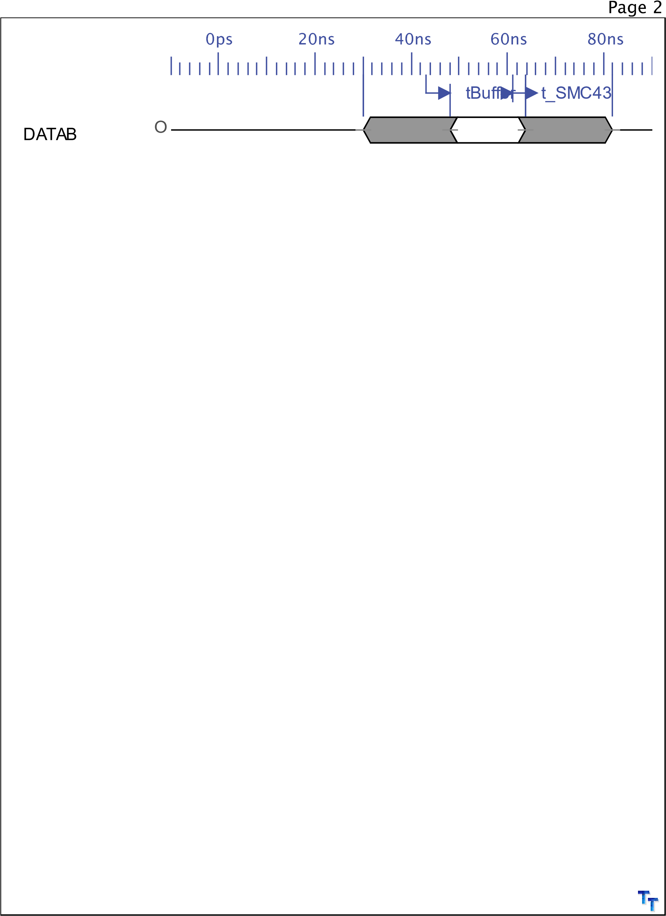



|  |  |  |  |  |  |
| --- | --- | --- | --- | --- | --- |
| General Data |  |  |  |  |  |
| SYMBOL | DEFINITION | DESCRIPTION | MIN | MAX | NOTES |
| t_SMC3 | MCK Falling to  A1-A25 valid | to be defined | 4.9ns | 7.5ns |  |
| t_SMC4 | MCK Falling to | to be defined | 4.3ns | 6.5ns |  |
|  | Chip Select |  |  |  |  |
| tBuffer |  | to be defined | 1.3ns | 5.1ns |  |
| t_SMC1 |  | to be defined |  |  |  |
| t_SMC30 | MCK Rising to  NRD Active | to be defined | 4.7ns | 7.0ns |  |
| tAA | Address Access | defined by | 0ps | 20ns |  |
|  | time | memory |  |  |  |
| tACS | Chip Select  Access time | defined by  memory | 0ns | 20ns |  |
| T | Output enable | defined by | 0ns | 8ns |  |
| OE | access time | memory |  |  |  |
| t_SMC32 | MCK falling to  NRD inactive | to be defined | 4.5ns | 6.8ns |  |
| t_SMC40 | Data Setup time | to be defined | 7.5ns |  |  |
|  | before NRD |  |  |  |  |
| t_SMC4 | MCK falling to  CHip Select  Change | to be defined | 4.3ns | 6.5ns |  |
| t_SMC41 | Data Hold time | to be defined | -3.4ns |  |  |
|  | after NRD rising |  |  |  |  |
| t_SMC37 | NRD High to  A1-A25 change | to be defined | 0.3ns | 0.6ns |  |
| t | Output Enable | to be defined | 0ns | 8ns |  |
| OHZ | High to Output in  High-Z |  |  |  |  |
| t_SMC42 | Data Setup before NCS High | to be defined | 7.3ns |  |  |
| t_SMC43 | Data Hold after | to be defined | -3.2ns |  |  |
|  | NCS High |  |  |  |  |
| Notes:  Results:  1 wait states |  |  |  |  |  |
|

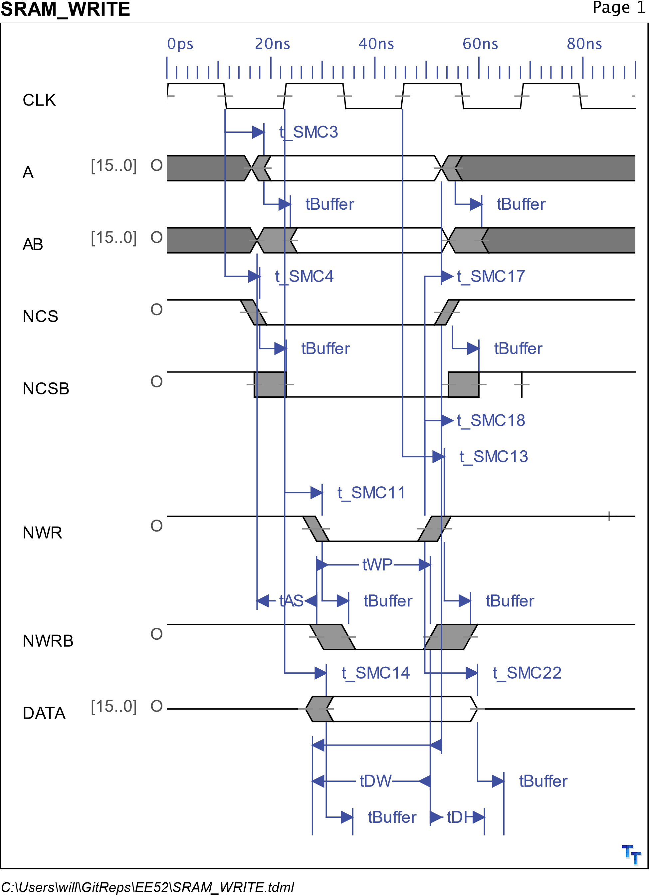

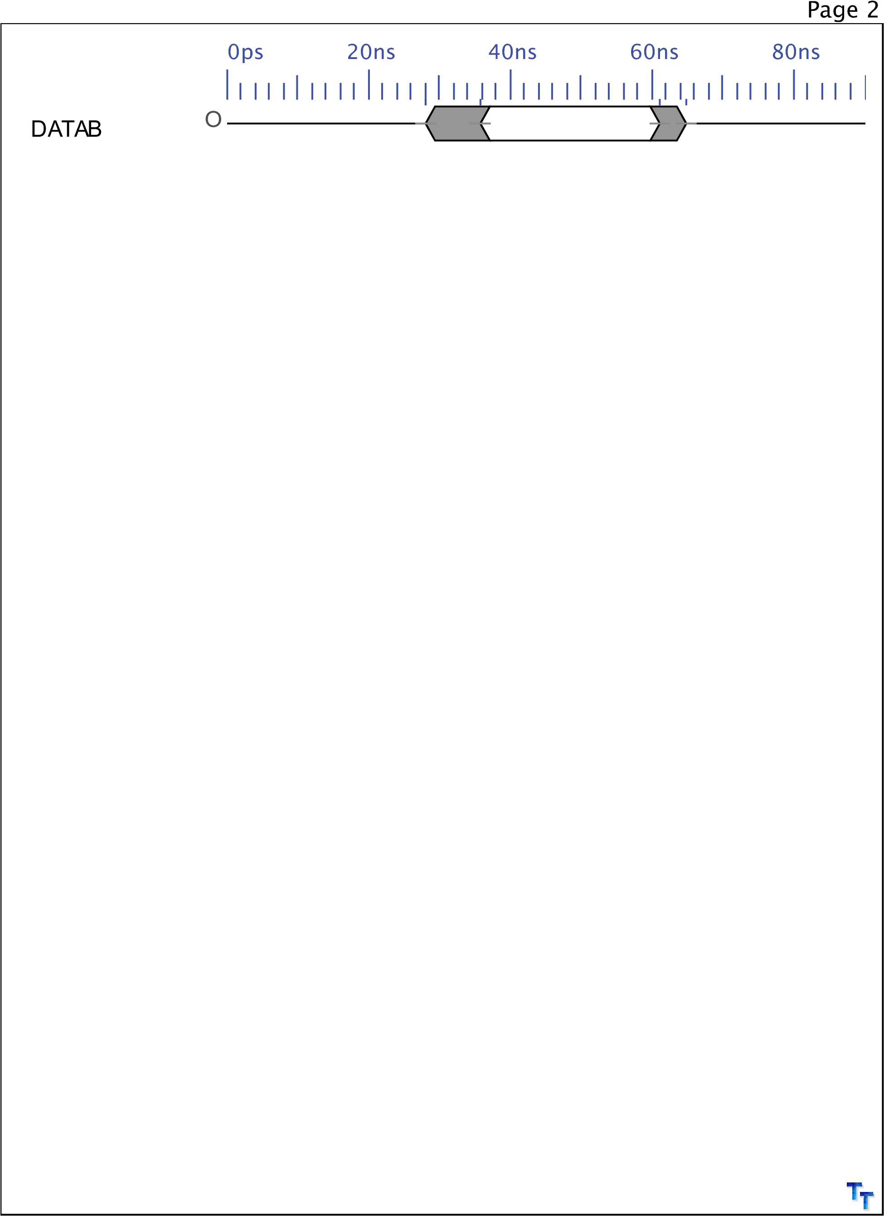



|  |  |  |  |  |  |
| --- | --- | --- | --- | --- | --- |
| General Data |  |  |  |  |  |
| SYMBOL | DEFINITION | DESCRIPTION | MIN | MAX | NOTES |
| t_SMC3 | MCK Falling to  A1-A25 valid | to be defined | 4.9ns | 7.5ns |  |
| tBuffer |  | to be defined | 1.3ns | 5.1ns |  |
| t_SMC14 | MCK Rising to  D0-D15 Valid | to be defined | 4.1ns | 7.9ns |  |
| t_SMC4 | MCK falling to | to be defined | 4.3ns | 6.5ns |  |
|  | CHip Select  Change |  |  |  |  |
| tAS | Address Setup to End of Write | to be defined | 0ns |  |  |
| tDW | Data Setup Time | to be defined | 9ns |  |  |
| tDH | Data Hold Time | to be defined | 0ns |  |  |
| tWR | Address Hold | to be defined | 0ns |  |  |
|  | from End of Write |  |  |  |  |
| tWP | Write Pulse | to be defined | 12ns |  |  |
| t_SMC11 | MCK Rising to | to be defined | 4.8ns | 7.2ns |  |
|  | NWR Active (with wait states) |  |  |  |  |
| t_SMC13 | MCK Rising to  NWR Inactive | to be defined | 4.1ns | 7.9ns |  |
| t_SMC22 | MCK Rising to | to be defined | 10.2ns |  |  |
|  | Data Out Invalid |  |  |  |  |
| t_SMC17 | NWR High to  A1-A25 Change | to be defined | 3.3ns |  |  |
| t_SMC18 | NWR High to | to be defined | 3.3ns |  |  |
|  | Chip Select  Inactive |  |  |  |  |
| Notes:  Results:   1. setup 2. wait state (pulse length)   0 hold parameter | |  |  |  |  |
|

# Appendix C (DRAM Timing)

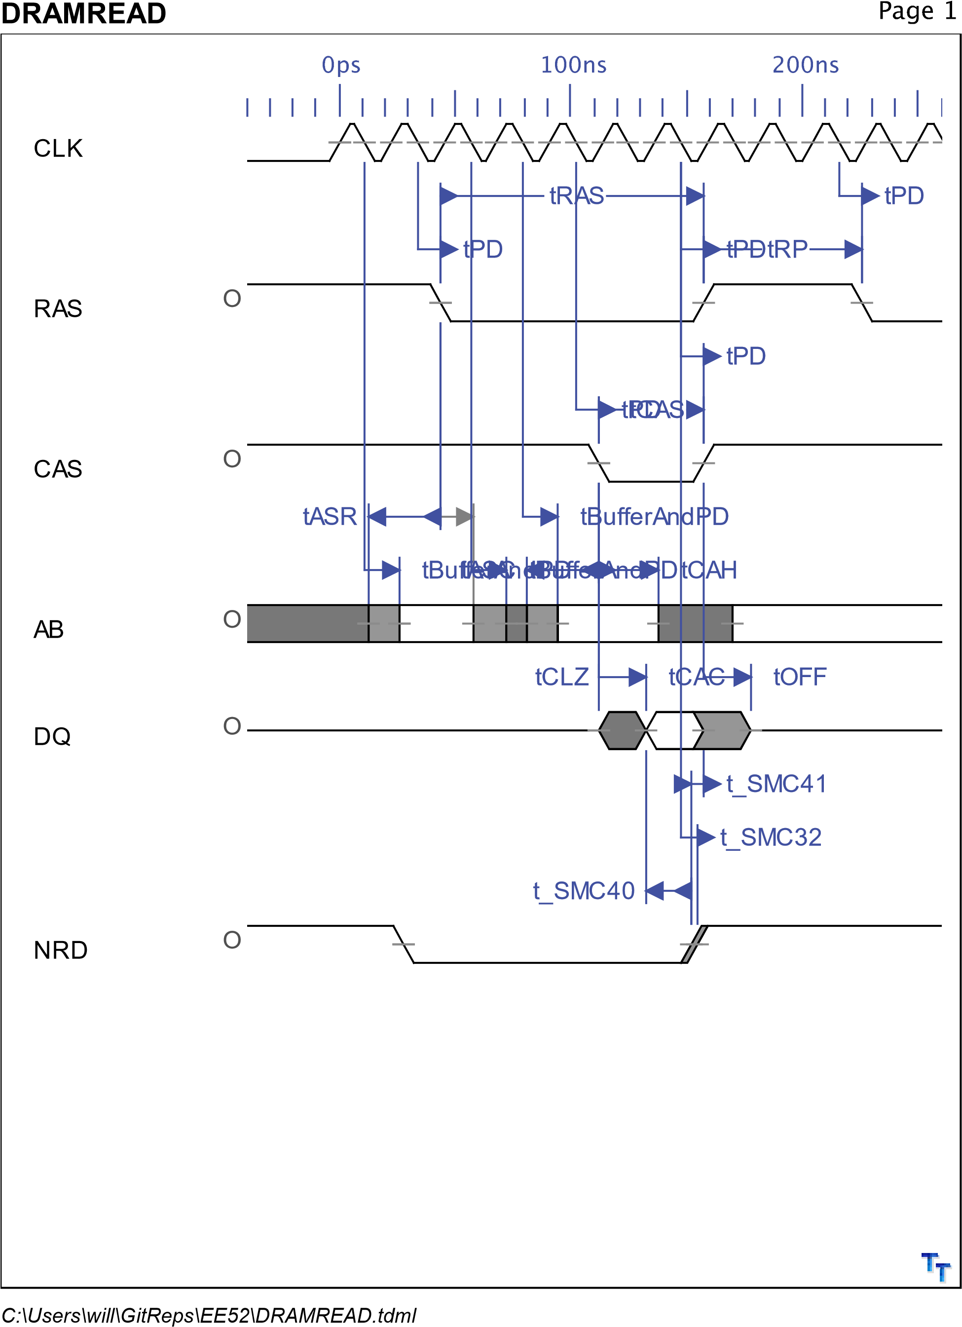



|  |  |  |  |  |  |
| --- | --- | --- | --- | --- | --- |
| General Data |  |  |  |  |  |
| SYMBOL | DEFINITION | DESCRIPTION | MIN | MAX | NOTES |
| tASR | Row-address setup time before RAS low | to be defined | 0ns |  |  |
| tASC | Column-address | to be defined | 0ns |  |  |
|  | setup time before CAS low |  |  |  |  |
| tDS | Data setup time | to be defined | 0ns |  |  |
| tRCS | Read setup time | to be defined |  |  |  |
|  | before CAS low |  |  |  |  |
| tCWL | W low setup time before CAS | to be defined | 20ns |  |  |
| tRWL | W low setup | to be defined |  |  |  |
|  | time before RAS |  |  |  |  |
| tWCS | W low setup time before CAS | to be defined | 0ns |  |  |
| tWSR | W high setup | to be defined | 10ns |  |  |
|  | time  (CAS-before-RAS refresh only) |  |  |  |  |
| tCAH | Column-address hold time after  CAS low | to be defined | 15ns |  |  |
| tDHR | Data hold time | to be defined | 60ns |  |  |
|  | after RAS low |  |  |  |  |
| tDH | Data hold time | to be defined | 15ns |  |  |
| tAR | Column-address | to be defined | 60ns |  |  |
|  | hold time after  RAS low |  |  |  |  |
| tRAH | Row-address  hold time after  RAS low | to be defined | 10ns |  |  |
| tRCH | Read hold time | to be defined | 0ns |  |  |
|  | after CAS high |  |  |  |  |
| tRRH | Read hold time after RAS high | to be defined | 0ns |  |  |
| tWCH | Write hold time | to be defined | 15ns |  |  |
|  | after CAS low |  |  |  |  |
| tWCR | Write hold time after RAS low | to be defined | 60ns |  |  |
| tWHR | W high hold time | to be defined | 10ns |  |  |
|  | (CAS-before-RAS refresh only) |  |  |  |  |
| tCHR | Delay time, RAS low to CAS high | to be defined | 20ns |  |  |
|



|  |  |  |  |  |  |
| --- | --- | --- | --- | --- | --- |
| General Data continued... | |  |  |  |  |
| SYMBOL | DEFINITION | DESCRIPTION | MIN | MAX | NOTES |
| tCRP | Delay time, CAS high to RAS low | to be defined | 0ns |  |  |
| tCSH | Delay time, RAS | to be defined | 80ns |  |  |
|  | low to CAS high |  |  |  |  |
| tCSR | Delay time, CAS low to RAS low | to be defined | 10ns |  |  |
| tRAD | Delay time, RAS | to be defined | 15ns | 40ns |  |
|  | low to  column-address |  |  |  |  |
| tRAL | Delay time, column-address to RAS high | to be defined | 40ns |  |  |
| tCAL | Delay time, | to be defined | 40ns |  |  |
|  | column-address to CAS high |  |  |  |  |
| tRCD | Delay time, RAS low to CAS low | to be defined | 20ns | 60ns |  |
| tRPC | Delay time, RAS | to be defined | 0ns |  |  |
|  | high to CAS low |  |  |  |  |
| tRSH | Delay time, CAS low to RAS high | to be defined | 20ns |  |  |
| tT | Transition time | to be defined | 2ns | 50ns |  |
| tRAS | Non-page-mode pulse duration,  RAS low | to be defined | 80ns | 10000ns |  |
| tCAS | Pulse duration, | to be defined | 20ns | 10000ns |  |
|  | CAS low |  |  |  |  |
| tCLZ | CAS to output in low Z | to be defined | 0ns |  |  |
| tOFF | output disable | to be defined | 0ns | 20ns |  |
|  | time after CAS high |  |  |  |  |
| tBufferAndPD | Buffer propagation delays | to be defined | 1.3ns | 15.1ns |  |
| tPD | CPLD worst | to be defined |  | 10ns |  |
|  | case path |  |  |  |  |
| tCAC | Access time from CAS low | to be defined |  | 20ns |  |
| tRAC | Access time | to be defined |  | 80ns |  |
|  | from RAS low |  |  |  |  |
| tRP | Pulse duration,  RAS high | to be defined | 60ns |  |  |
|



|  |  |  |  |  |  |
| --- | --- | --- | --- | --- | --- |
| General Data continued... | |  |  |  |  |
| SYMBOL | DEFINITION | DESCRIPTION | MIN | MAX | NOTES |
| t_SMC40 | Data Setup time before NRD | to be defined | 7.5ns |  |  |
| t_SMC41 | Data Hold time | to be defined | -3.4ns |  |  |
|  | after NRD rising |  |  |  |  |
| t_SMC32 MCK falling to  NRD inactive | | to be defined | 4.5ns | 6.8ns |  |
|

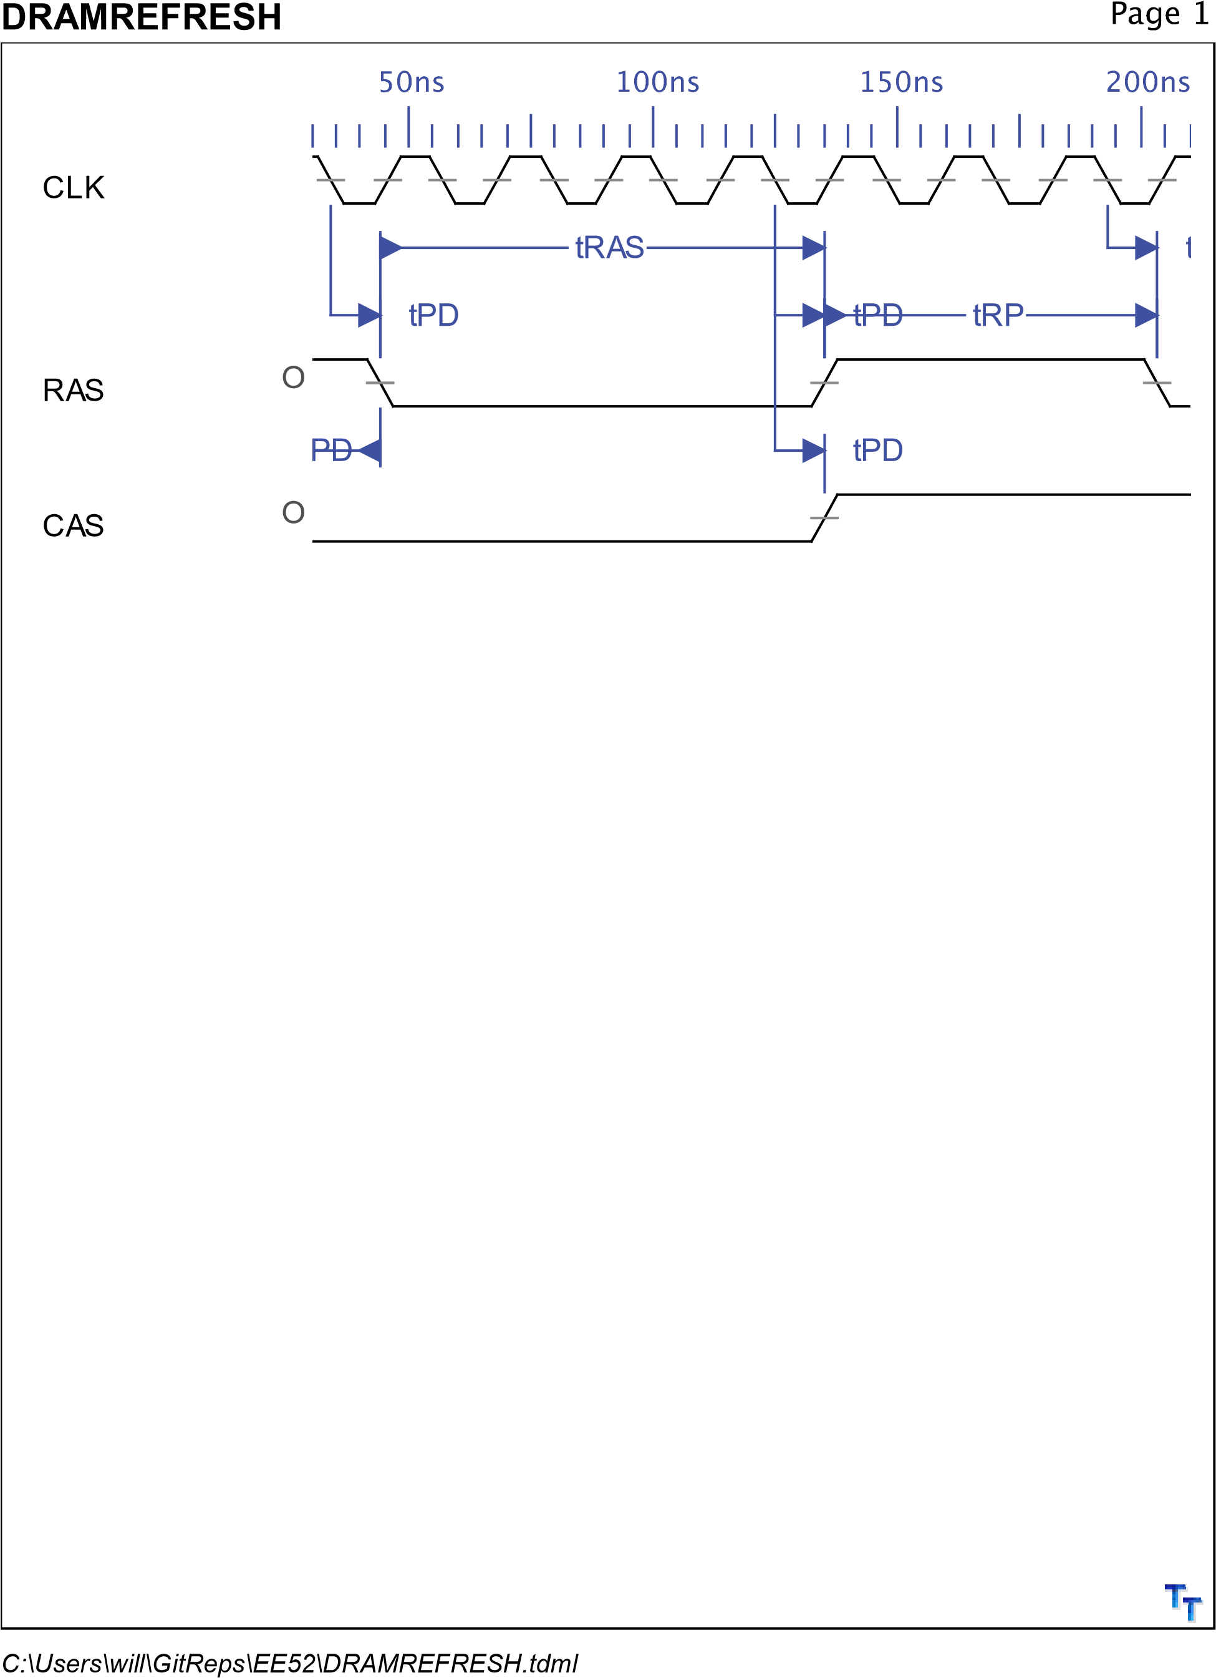



|  |  |  |  |  |  |
| --- | --- | --- | --- | --- | --- |
| General Data |  |  |  |  |  |
| SYMBOL | DEFINITION | DESCRIPTION | MIN | MAX | NOTES |
| tASR | Row-address setup time before RAS low | to be defined | 0ns |  |  |
| tASC | Column-address | to be defined | 0ns |  |  |
|  | setup time before CAS low |  |  |  |  |
| tDS | Data setup time | to be defined | 0ns |  |  |
| tRCS | Read setup time | to be defined |  |  |  |
|  | before CAS low |  |  |  |  |
| tCWL | W low setup time before CAS | to be defined | 20ns |  |  |
| tRWL | W low setup | to be defined |  |  |  |
|  | time before RAS |  |  |  |  |
| tWCS | W low setup time before CAS | to be defined | 0ns |  |  |
| tWSR | W high setup | to be defined | 10ns |  |  |
|  | time  (CAS-before-RAS refresh only) |  |  |  |  |
| tCAH | Column-address hold time after  CAS low | to be defined | 15ns |  |  |
| tDHR | Data hold time | to be defined | 60ns |  |  |
|  | after RAS low |  |  |  |  |
| tDH | Data hold time | to be defined | 15ns |  |  |
| tAR | Column-address | to be defined | 60ns |  |  |
|  | hold time after  RAS low |  |  |  |  |
| tRAH | Row-address  hold time after  RAS low | to be defined | 10ns |  |  |
| tRCH | Read hold time | to be defined | 0ns |  |  |
|  | after CAS high |  |  |  |  |
| tRRH | Read hold time after RAS high | to be defined | 0ns |  |  |
| tWCH | Write hold time | to be defined | 15ns |  |  |
|  | after CAS low |  |  |  |  |
| tWCR | Write hold time after RAS low | to be defined | 60ns |  |  |
| tWHR | W high hold time | to be defined | 10ns |  |  |
|  | (CAS-before-RAS refresh only) |  |  |  |  |
| tCHR | Delay time, RAS low to CAS high | to be defined | 20ns |  |  |
|



|  |  |  |  |  |  |
| --- | --- | --- | --- | --- | --- |
| General Data continued... | |  |  |  |  |
| SYMBOL | DEFINITION | DESCRIPTION | MIN | MAX | NOTES |
| tCRP | Delay time, CAS high to RAS low | to be defined | 0ns |  |  |
| tCSH | Delay time, RAS | to be defined | 80ns |  |  |
|  | low to CAS high |  |  |  |  |
| tCSR | Delay time, CAS low to RAS low | to be defined | 10ns |  |  |
| tRAD | Delay time, RAS | to be defined | 15ns | 40ns |  |
|  | low to  column-address |  |  |  |  |
| tRAL | Delay time, column-address to RAS high | to be defined | 40ns |  |  |
| tCAL | Delay time, | to be defined | 40ns |  |  |
|  | column-address to CAS high |  |  |  |  |
| tRCD | Delay time, RAS low to CAS low | to be defined | 20ns | 60ns |  |
| tRPC | Delay time, RAS | to be defined | 0ns |  |  |
|  | high to CAS low |  |  |  |  |
| tRSH | Delay time, CAS low to RAS high | to be defined | 20ns |  |  |
| tT | Transition time | to be defined | 2ns | 50ns |  |
| tRAS | Non-page-mode pulse duration,  RAS low | to be defined | 80ns | 10000ns |  |
| tCAS | Pulse duration, | to be defined | 20ns | 10000ns |  |
|  | CAS low |  |  |  |  |
| tCLZ | CAS to output in low Z | to be defined | 0ns |  |  |
| tOFF | output disable | to be defined | 0ns | 20ns |  |
|  | time after CAS high |  |  |  |  |
| tBufferAndPD | Buffer propagation delays | to be defined | 1.3ns | 15.1ns |  |
| tPD | CPLD worst | to be defined |  | 10ns |  |
|  | case path |  |  |  |  |
| tCAC | Access time from CAS low | to be defined |  | 20ns |  |
| tRAC | Access time | to be defined |  | 80ns |  |
|  | from RAS low |  |  |  |  |
| tRP | Pulse duration,  RAS high | to be defined | 60ns |  |  |
|



|  |  |  |  |  |  |
| --- | --- | --- | --- | --- | --- |
| General Data continued... | |  |  |  |  |
| SYMBOL | DEFINITION | DESCRIPTION | MIN | MAX | NOTES |
| tCP Pulse duration,  CAS high | | to be defined | 10ns |  |  |
|

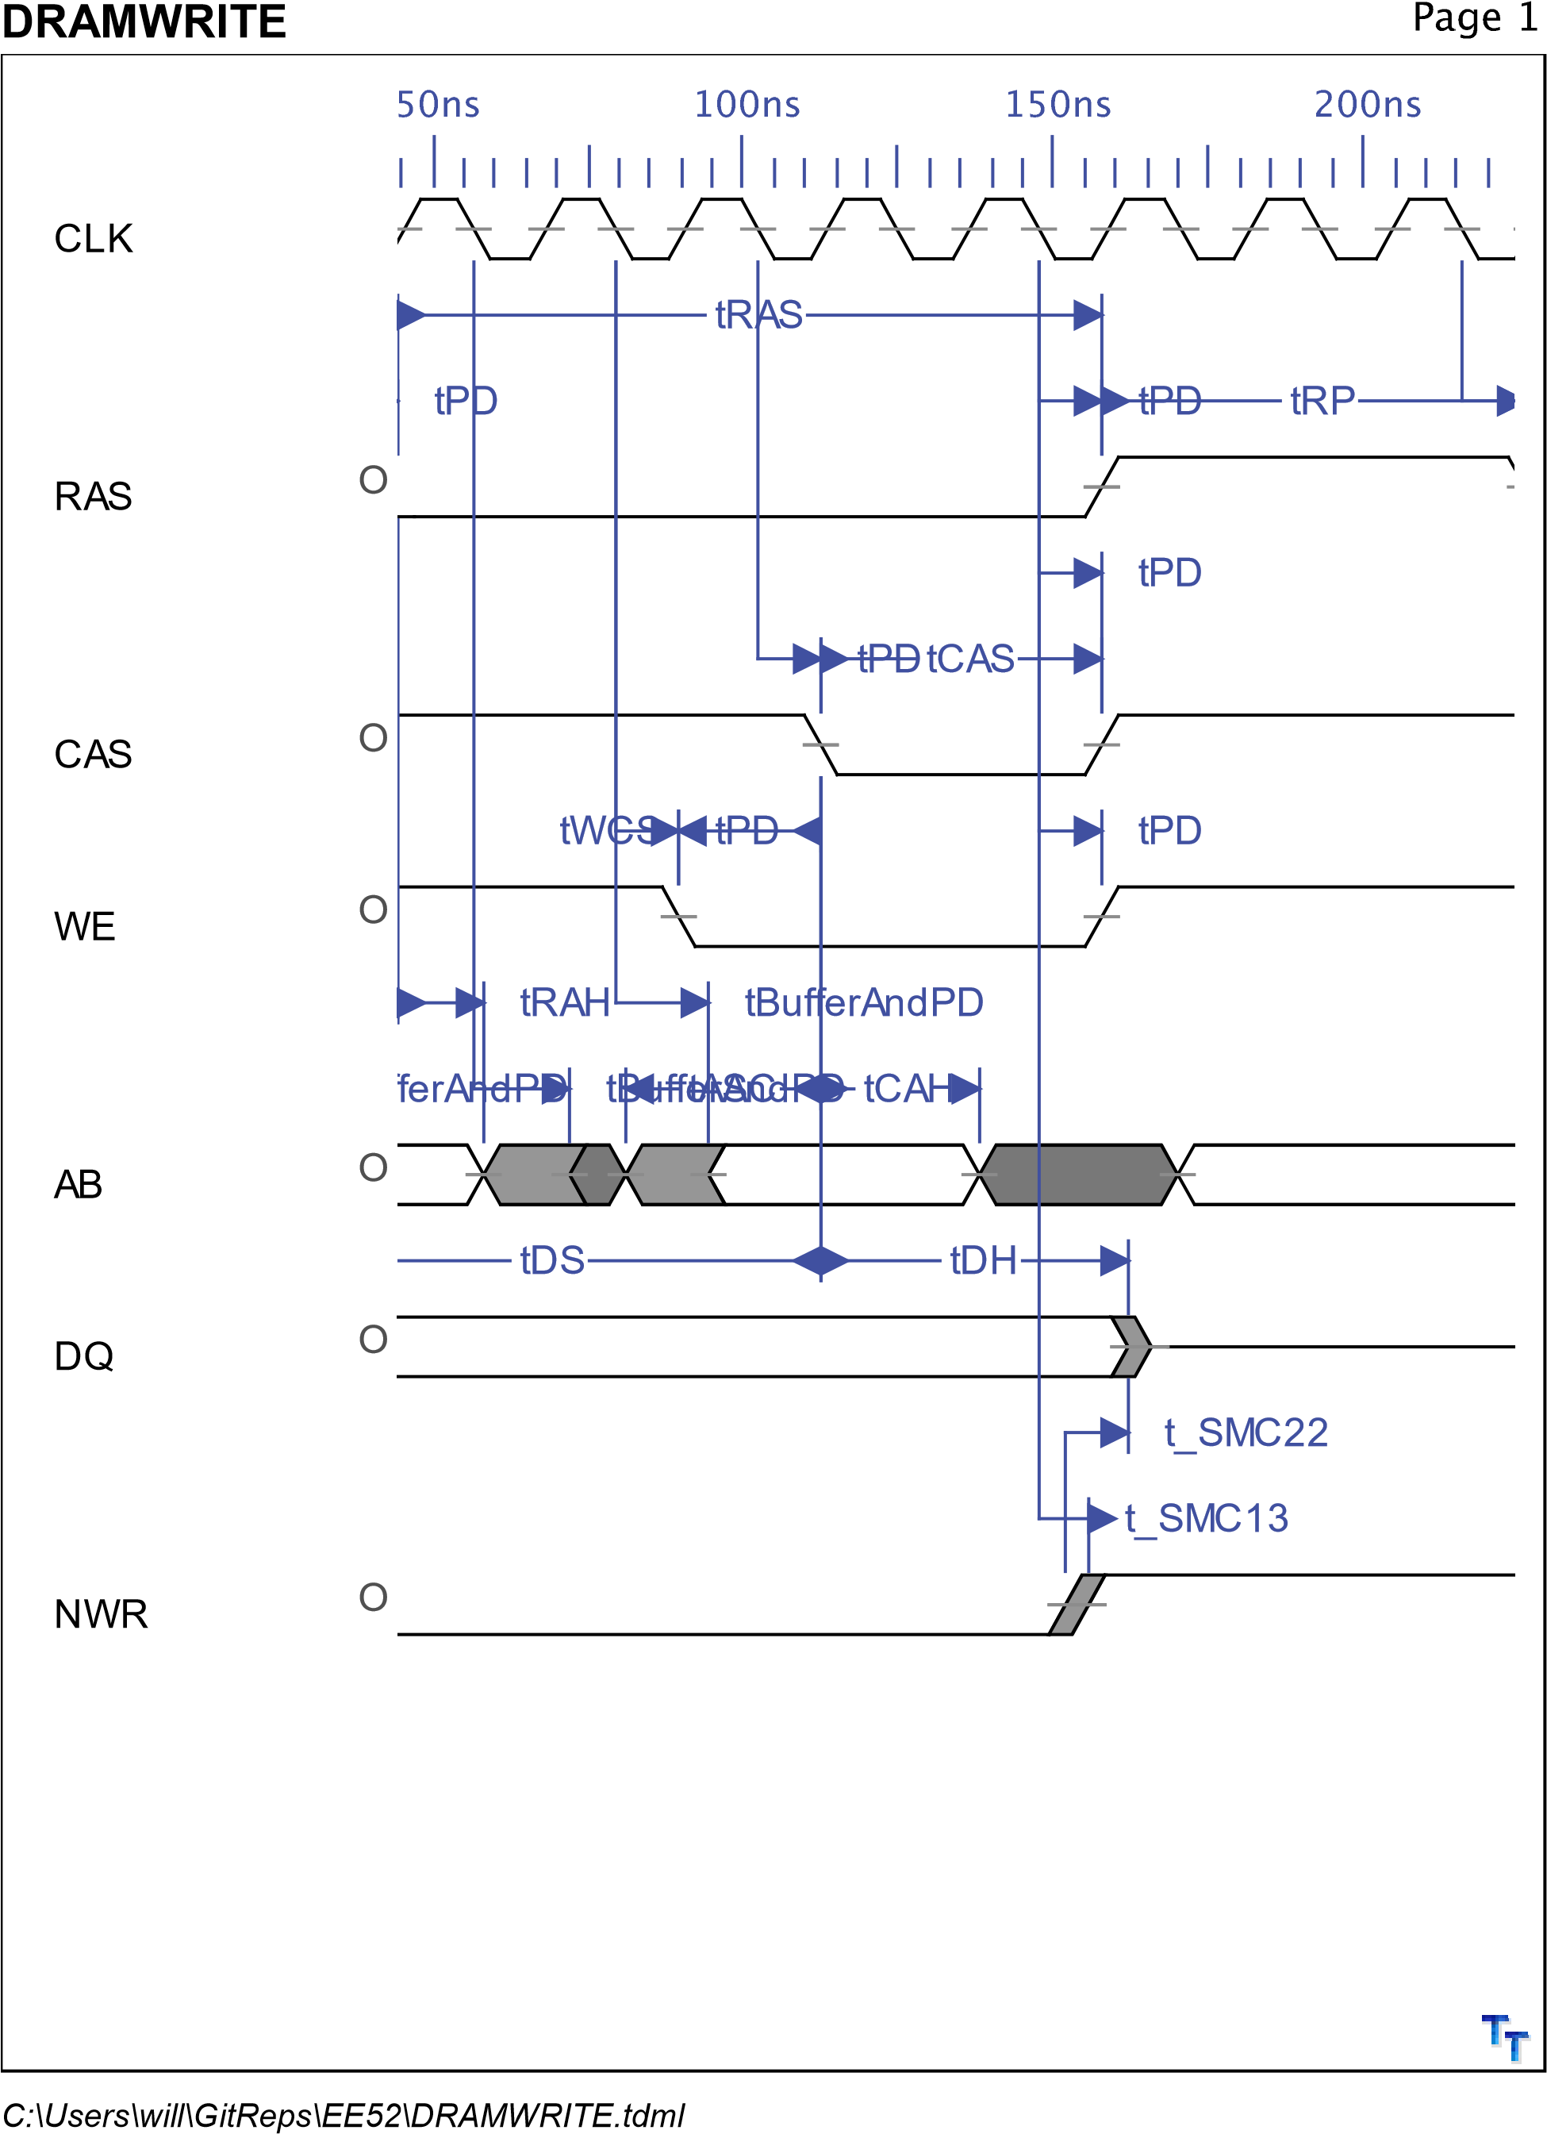



|  |  |  |  |  |  |
| --- | --- | --- | --- | --- | --- |
| General Data |  |  |  |  |  |
| SYMBOL | DEFINITION | DESCRIPTION | MIN | MAX | NOTES |
| tASR | Row-address setup time before RAS low | to be defined | 0ns |  |  |
| tASC | Column-address | to be defined | 0ns |  |  |
|  | setup time before CAS low |  |  |  |  |
| tDS | Data setup time | to be defined | 0ns |  |  |
| tRCS | Read setup time | to be defined |  |  |  |
|  | before CAS low |  |  |  |  |
| tCWL | W low setup time before CAS | to be defined | 20ns |  |  |
| tRWL | W low setup | to be defined |  |  |  |
|  | time before RAS |  |  |  |  |
| tWCS | W low setup time before CAS | to be defined | 0ns |  |  |
| tWSR | W high setup | to be defined | 10ns |  |  |
|  | time  (CAS-before-RAS refresh only) |  |  |  |  |
| tCAH | Column-address hold time after  CAS low | to be defined | 15ns |  |  |
| tDHR | Data hold time | to be defined | 60ns |  |  |
|  | after RAS low |  |  |  |  |
| tDH | Data hold time | to be defined | 15ns |  |  |
| tAR | Column-address | to be defined | 60ns |  |  |
|  | hold time after  RAS low |  |  |  |  |
| tRAH | Row-address  hold time after  RAS low | to be defined | 10ns |  |  |
| tRCH | Read hold time | to be defined | 0ns |  |  |
|  | after CAS high |  |  |  |  |
| tRRH | Read hold time after RAS high | to be defined | 0ns |  |  |
| tWCH | Write hold time | to be defined | 15ns |  |  |
|  | after CAS low |  |  |  |  |
| tWCR | Write hold time after RAS low | to be defined | 60ns |  |  |
| tWHR | W high hold time | to be defined | 10ns |  |  |
|  | (CAS-before-RAS refresh only) |  |  |  |  |
| tCHR | Delay time, RAS low to CAS high | to be defined | 20ns |  |  |
|



|  |  |  |  |  |  |
| --- | --- | --- | --- | --- | --- |
| General Data continued... | |  |  |  |  |
| SYMBOL | DEFINITION | DESCRIPTION | MIN | MAX | NOTES |
| tCRP | Delay time, CAS high to RAS low | to be defined | 0ns |  |  |
| tCSH | Delay time, RAS | to be defined | 80ns |  |  |
|  | low to CAS high |  |  |  |  |
| tCSR | Delay time, CAS low to RAS low | to be defined | 10ns |  |  |
| tRAD | Delay time, RAS | to be defined | 15ns | 40ns |  |
|  | low to  column-address |  |  |  |  |
| tRAL | Delay time, column-address to RAS high | to be defined | 40ns |  |  |
| tCAL | Delay time, | to be defined | 40ns |  |  |
|  | column-address to CAS high |  |  |  |  |
| tRCD | Delay time, RAS low to CAS low | to be defined | 20ns | 60ns |  |
| tRPC | Delay time, RAS | to be defined | 0ns |  |  |
|  | high to CAS low |  |  |  |  |
| tRSH | Delay time, CAS low to RAS high | to be defined | 20ns |  |  |
| tT | Transition time | to be defined | 2ns | 50ns |  |
| tRAS | Non-page-mode pulse duration,  RAS low | to be defined | 80ns | 10000ns |  |
| tCAS | Pulse duration, | to be defined | 20ns | 10000ns |  |
|  | CAS low |  |  |  |  |
| tCLZ | CAS to output in low Z | to be defined | 0ns |  |  |
| tOFF | output disable | to be defined | 0ns | 20ns |  |
|  | time after CAS high |  |  |  |  |
| tBufferAndPD | Buffer propagation delays | to be defined | 1.3ns | 15.1ns |  |
| tPD | CPLD worst | to be defined |  | 10ns |  |
|  | case path |  |  |  |  |
| tCAC | Access time from CAS low | to be defined |  | 20ns |  |
| tRAC | Access time | to be defined |  | 80ns |  |
|  | from RAS low |  |  |  |  |
| tRP | Pulse duration,  RAS high | to be defined | 60ns |  |  |
|



|  |  |  |  |  |  |
| --- | --- | --- | --- | --- | --- |
| General Data continued... | |  |  |  |  |
| SYMBOL | DEFINITION | DESCRIPTION | MIN | MAX | NOTES |
| tBuffer |  | to be defined | 1.3ns | 5.1ns |  |
| t_SMC13 | MCK Falling to | to be defined | 4.1ns | 7.9ns |  |
|  | NWR inactive |  |  |  |  |
| t_SMC22 MCK Rising to  Data out invalid | | to be defined | 10.2ns |  |  |
|

# Appendix D (DRAM Abel Code)

# Appendix E (Software)

# Appendix F (Printed Circuit Board)

# Appendix G (Schematics)