Assignment 4 Facade Pattern
  - Home Theater Implementation in Java 17
Course ShP-2216 Software Design Patterns
Student: Allazhar Kuat
Group: SE-2515

1 Introduction
This project implements the Facade structural design pattern using a home theater. A client starts and ends a movie through a small public API. The facade creates and coordinates five subsystem components, so the client does not need to manage their connections, settings or operation order.
Without a facade, client code would need to lower the screen, adjust lighting, power the devices, connect audio and video, start playback and later reverse the setup. Repeating this sequence would duplicate coordination logic and make clients depend on several device classes.

1 1 Chosen subsystem
The subsystem is a stateful simulation. The amplifier and projector require a powered DVD source. Showing a picture additionally requires active playback and a lowered screen. Invalid ordering produces an exception. Console output represents device operations; the program does not play a real video or control physical equipment.

1 2 Pattern roles
Role | Class | Responsibility
Client | FacadeDemo | Requests movie startup and shutdown through the facade.
Facade | HomeTheaterFacade | Coordinates setup, shutdown and cleanup after failures.
Subsystem | DvdPlayer | Manages power and playback state.
Subsystem | Amplifier | Selects a powered source and validates volume.
Subsystem | Projector | Checks video input, playback and screen position.
Subsystem | Screen | Tracks whether the screen is lowered.
Subsystem | TheaterLights | Validates brightness and restores full lighting.

2 UML Class Diagram
The facade holds references to five components. The amplifier and projector share the same DvdPlayer object. Projector.showPicture receives a Screen parameter and checks its state.
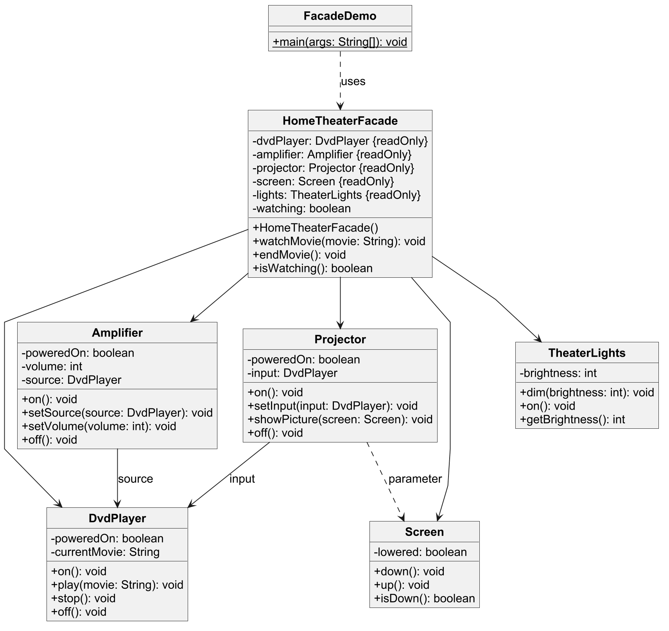
Figure 1. PlantUML class diagram of the facade, client and subsystem classes.
Solid arrows show stored references. Dashed arrows show dependencies, including the client using the facade and the projector receiving a screen. The diagram omits constants, some observation getters, private helpers and the package-private test constructor for readability.
There is no inheritance between the facade and its components. The connection uses object composition. Subsystem classes have no reference to HomeTheaterFacade and remain usable independently.

3 Runtime Demonstration

3 1 Simplified client
HomeTheaterFacade theater = new HomeTheaterFacade();
theater.watchMovie("Interstellar");
theater.endMovie();
The public constructor assembles the components internally. FacadeDemo never creates or calls a subsystem object. A separate package-private constructor accepts components for tests, keeping subsystem types outside the public facade API.

3 2 Coordinated execution
Startup prepares the screen and lighting, powers the DVD player, configures the amplifier and projector, starts playback and shows the picture. Shutdown stops playback before turning off the player, disconnects audio and video, raises the screen and restores lighting.
Get ready to watch: Interstellar
Screen: down
Lights: brightness 10%
DVD player: on
Amplifier: on
Amplifier: DVD player selected
Amplifier: volume 5
Projector: on
Projector: DVD player selected
DVD player: playing Interstellar
Projector: showing movie on the screen
Shutting down the home theater
DVD player: stopped
Projector: off
Amplifier: off
DVD player: off
Screen: up
Lights: brightness 100%

3 3 Invalid requests and repeat use
A null or blank movie title is rejected before changing device state. A second movie cannot start while a session is active. The same facade can start another movie after shutdown, and endMovie can be called again to repeat or retry cleanup.
Invalid request:
Rejected: Movie title must not be blank.
In this model, stop clears the current movie but leaves the DVD player powered on. The player's off method rejects active playback. The facade hides this sequencing rule from its client.

4 Clean Code Principles

4 1 Meaningful names
theater.watchMovie("Interstellar");
theater.endMovie();
The names express client intentions rather than device mechanics. watchMovie describes a complete use case, while endMovie communicates its counterpart. Names such as setSource, setVolume and showPicture identify the responsibilities of subsystem operations.

4 2 Single Responsibility and delegation
amplifier.on();
amplifier.setSource(dvdPlayer);
amplifier.setVolume(MOVIE_VOLUME);
This excerpt from watchMovie coordinates the audio setup. The facade decides the order and supplies the existing player reference. Amplifier itself checks its power, source and volume range. The facade does not duplicate these device rules. Coordinating several calls is still one responsibility: carrying out the movie workflow.

4 3 A public API without subsystem details
public HomeTheaterFacade()
public void watchMovie(String movie)
public void endMovie()
public boolean isWatching()
These public API signatures use a movie title and a boolean status. Clients do not need to pass an amplifier or retrieve a projector. The default constructor assembles the components internally. Component injection is restricted to a package-private constructor used by the test runner.
This reduces the classes that the application client needs to know. It follows the Principle of Least Knowledge from Lecture 6: the client communicates with the facade, and the facade communicates with its own components. Advanced users may still access subsystem classes directly.

4 Clean Code Principles Continued

4 4 Small classes with private state
private boolean lowered;
public void down() {
lowered = true;
System.out.println("Screen: down");
}
Screen owns its position and provides a focused operation to change it. Other classes use its public methods rather than editing the field. Similar boundaries separate playback, sound, projection and lighting. The facade's final component fields prevent reference reassignment; they do not make the devices immutable.

4 5 Validate before changing state
if (brightness < 0 || brightness > FULL_BRIGHTNESS) {
throw new IllegalArgumentException(
"Brightness must be between 0 and 100.");
}
this.brightness = brightness;
TheaterLights rejects an invalid argument before storing it, so a failed request preserves the previous brightness. Amplifier applies the same approach to volume. Device-order violations use IllegalStateException, while invalid supplied values use IllegalArgumentException. Named constants define movie volume, movie brightness and full brightness.

4 6 Preserve failures during coordination
try {
shutdown();
} catch (RuntimeException cleanupFailure) {
failure.addSuppressed(cleanupFailure);
}
This excerpt runs inside the startup exception handler. The original startup failure remains the cause of the reported exception; a cleanup error is attached rather than replacing it. The shutdown helper attempts every cleanup action and collects further failures, so one broken device does not prevent attempts to reset the others.
This handling is best effort. If a device fails to switch off, the facade reports the error and does not claim that the device recovered. The watching flag describes the session, not the physical state of every component.

5 Verification and Design Review

5 1 Verification
The application and test runner compile using Java 17 with --release 17 and -Xlint:all. The demo completes successfully, and the standalone test runner reports:
PASS: 22 test scenarios
Area | Verified behavior
Device state | Playback requires power; stopping precedes DVD shutdown; devices reset their own state.
Arguments | Null sources, blank movie titles and out-of-range volume or brightness are rejected.
Collaboration | Audio and video share the player; projection requires playback and a lowered screen.
Facade | Startup, shutdown, invalid requests, duplicate sessions and reuse behave as specified.
Failure cleanup | Startup rollback, continued shutdown and original exception preservation are checked.

Tests create subsystem objects to verify individual behavior and inject failures. They are separate from FacadeDemo, which uses only HomeTheaterFacade. The subsystem classes contain no back-reference to the facade.

5 2 Benefits and trade offs
The facade reduces client dependencies and centralizes a reusable movie sequence. Changes to device coordination can be made in one place while preserving watchMovie and endMovie. The cost is an extra layer to trace during debugging and a facade that depends on the devices it coordinates. Adding unrelated features could turn it into a god object; separate facades would be preferable for unrelated workflows.
The public API intentionally covers common movie operations. Advanced settings remain available on subsystem classes. Facade differs from Adapter, which translates incompatible interfaces, and Bridge, which separates two independently varying dimensions.

6 Conclusion
HomeTheaterFacade hides component creation, shared audio and video references, default settings, operation order and cleanup coordination. It provides a simple client API over five collaborating, stateful components. The subsystem classes retain their own responsibilities and remain directly accessible to advanced clients without depending on the facade.

7 GitHub Repository
https://github.com/wwezzy/sdp-assignment-4
References: Assignment 4 Facade Pattern Instructions and Lecture 6 slides, ShP-2216 Software Design Patterns, Astana IT University.

