**SDN实验二**

1. 最小时延路径：

首先需要测量链路的时延，lldp_delay可以直接通过交换机的端口获取，echo_delay则需要自行测量，在本次实验中，通过在交换机启动时控制器向交换机发送echo_request数据包，控制器收到echo_reply数据包后，计算出echo_delay。

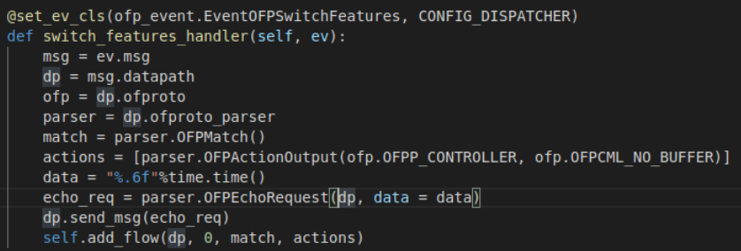

控制器向交换机发送echo_request数据包

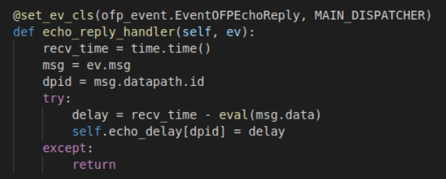

控制器收到echo_reply后计算时延

之后跟据测量出的lldp_delay和echo_delay计算出链路的delay，并将链路的时延作为weight，计算出最短路径

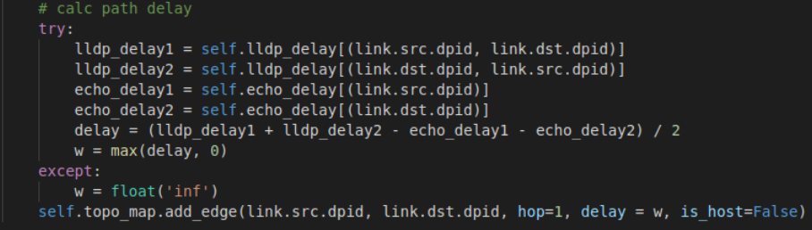

实验结果：

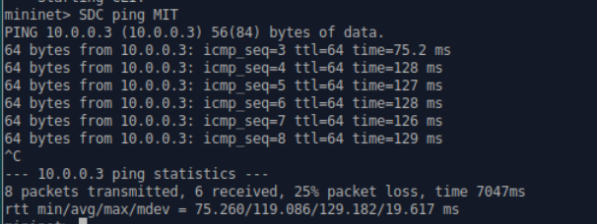



与预先设定的链路时延比较，控制器计算出的路径是时延最短路径。

1. 容忍链路故障：

首先需要捕捉到链路故障，当感知到链路断开或连接后，需要删除链路上相关交换机的流表以及保存的拓扑图中的边，同时下发默认流表，之后控制器计算出新的路径并下发新的流表。

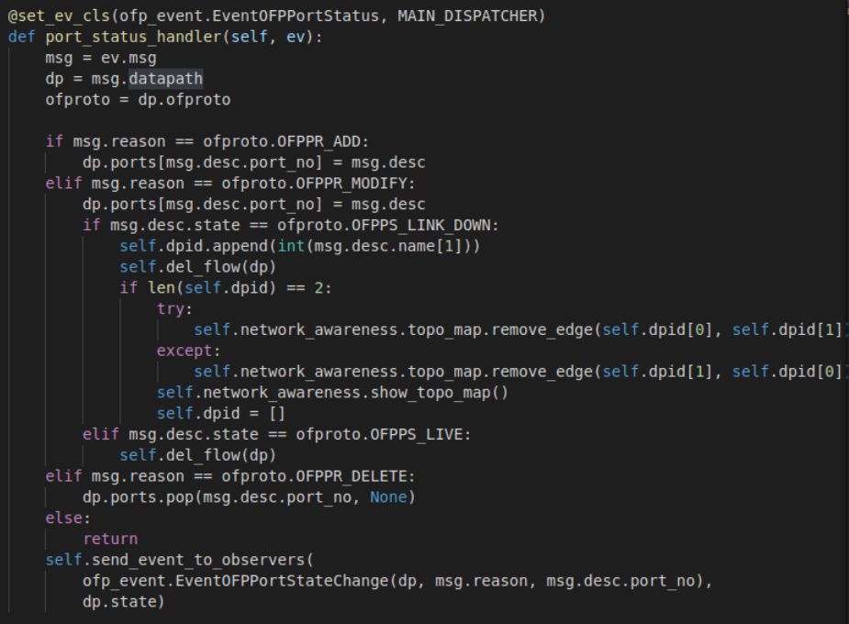

控制器捕捉链路故障并作出对应处理

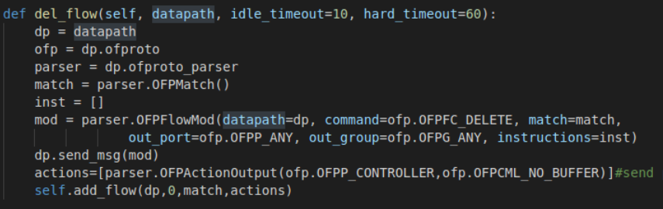

交换机删除当前流表并下发默认流表

实验结果：

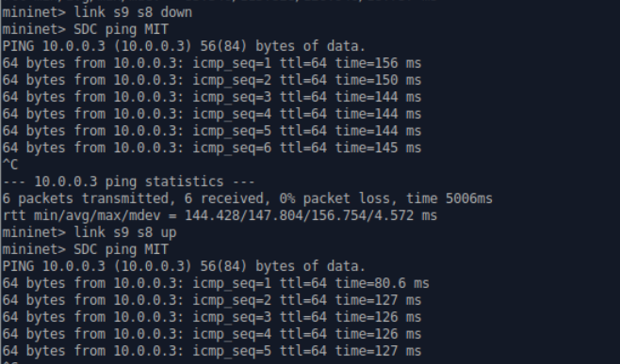

断开s9和s8之间的链路后，控制器重新计算了SDC到MIT的路径，重新连接后，又恢复到之前的路径。

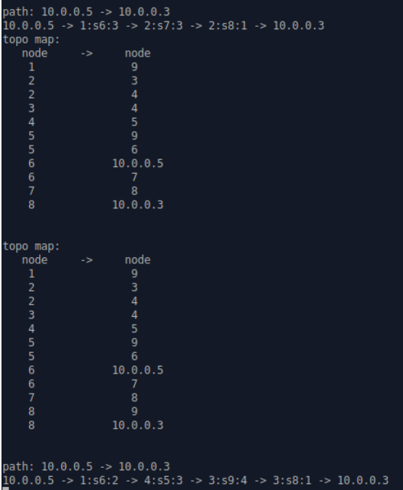

1. 实验中遇到的问题：
2. 当链路断开时，需要删除拓扑图中对应的边（或者直接删除整个拓扑？）
3. 路径正确，时延错误。观察各个交换机的流表发现，可能是arp请求时下发的流表影响了路由，因此提升了下分的路由流表的优先级，同时给arp流表设置了有效时间，超过设置的时间后自动删除。之后问题解决。
4. 实验代码：

network_awareness.py

1. **from** ryu.base **import** app_manager
2. **from** ryu.base.app_manager **import** lookup_service_brick
3. **from** ryu.ofproto **import** ofproto_v1_3
4. **from** ryu.controller.handler **import** set_ev_cls
5. **from** ryu.controller.handler **import** MAIN_DISPATCHER, CONFIG_DISPATCHER, DEAD_DISPATCHER
6. **from** ryu.controller **import** ofp_event
7. **from** ryu.lib.packet **import** packet
8. **from** ryu.lib.packet **import** ethernet, arp
9. **from** ryu.lib **import** hub
10. **from** ryu.topology **import** event
11. **from** ryu.topology.api **import** get_host, get_link, get_switch
12. **from** ryu.topology.switches **import** LLDPPacket
13. **from** ryu.base.app_manager **import** lookup_service_brick
14. **import** networkx as nx
15. **import** copy
16. **import** time

19. GET_TOPOLOGY_INTERVAL = 2
20. SEND_ECHO_REQUEST_INTERVAL = .05
21. GET_DELAY_INTERVAL = 2

24. **class** NetworkAwareness(app_manager.RyuApp):
25. OFP_VERSIONS = [ofproto_v1_3.OFP_VERSION]
27. **def** __init__(self, *args, **kwargs):
28. super(NetworkAwareness, self).__init__(*args, **kwargs)
29. self.switch_info = {}  # dpid: datapath
30. self.link_info = {}  # (s1, s2): s1.port
31. self.port_link={} # s1,port:s1,s2
32. self.port_info = {}  # dpid: (ports linked hosts)
33. self.topo_map = nx.Graph()
34. self.topo_thread = hub.spawn(self._get_topology)
35. self.weight = 'hop'
36. self.switches = None
37. self.lldp_delay={}
38. self.echo_delay={}

41. **def** add_flow(self, datapath, priority, match, actions):
42. dp = datapath
43. ofp = dp.ofproto
44. parser = dp.ofproto_parser
46. inst = [parser.OFPInstructionActions(ofp.OFPIT_APPLY_ACTIONS, actions)]
47. mod = parser.OFPFlowMod(datapath=dp, priority=priority, match=match, instructions=inst)
48. dp.send_msg(mod)

51. @set_ev_cls(ofp_event.EventOFPSwitchFeatures, CONFIG_DISPATCHER)
52. **def** switch_features_handler(self, ev):
53. msg = ev.msg
54. dp = msg.datapath
55. ofp = dp.ofproto
56. parser = dp.ofproto_parser
57. match = parser.OFPMatch()
58. actions = [parser.OFPActionOutput(ofp.OFPP_CONTROLLER, ofp.OFPCML_NO_BUFFER)]
59. data = "%.6f"%time.time()
60. echo_req = parser.OFPEchoRequest(dp, data = data)
61. dp.send_msg(echo_req)
62. self.add_flow(dp, 0, match, actions)
64. @set_ev_cls(ofp_event.EventOFPStateChange, [MAIN_DISPATCHER, DEAD_DISPATCHER])
65. **def** state_change_handler(self, ev):
66. dp = ev.datapath
67. dpid = dp.id
69. **if** ev.state == MAIN_DISPATCHER:
70. self.switch_info[dpid] = dp
72. **if** ev.state == DEAD_DISPATCHER:
73. **del** self.switch_info[dpid]
74. **def** _get_topology(self):
75. _hosts, _switches, _links = None, None, None
76. **while** True:
77. hosts = get_host(self)
78. switches = get_switch(self)
79. links = get_link(self)
81. # update topo_map when topology change
82. **if** [str(x) **for** x **in** hosts] == _hosts **and** [str(x) **for** x **in** switches] == _switches **and** [str(x) **for** x **in** links] == _links:
83. **continue**
84. _hosts, _switches, _links = [str(x) **for** x **in** hosts], [str(x) **for** x **in** switches], [str(x) **for** x **in** links]
85. **for** switch **in** switches:
86. self.port_info.setdefault(switch.dp.id, set())
87. # record all ports
88. **for** port **in** switch.ports:
89. self.port_info[switch.dp.id].add(port.port_no)
91. **for** host **in** hosts:
92. # take one ipv4 address as host id
93. **if** host.ipv4:
94. self.link_info[(host.port.dpid, host.ipv4[0])] = host.port.port_no
95. self.topo_map.add_edge(host.ipv4[0], host.port.dpid, hop=1, delay=0, is_host=True)
96. **for** link **in** links:
97. # delete ports linked switches
98. self.port_info[link.src.dpid].discard(link.src.port_no)
99. self.port_info[link.dst.dpid].discard(link.dst.port_no)
101. # s1 -> s2: s1.port, s2 -> s1: s2.port
102. self.port_link[(link.src.dpid,link.src.port_no)] = (link.src.dpid, link.dst.dpid)
103. self.port_link[(link.dst.dpid,link.dst.port_no)] = (link.dst.dpid, link.src.dpid)
105. self.link_info[(link.src.dpid, link.dst.dpid)] = link.src.port_no
106. self.link_info[(link.dst.dpid, link.src.dpid)] = link.dst.port_no
107. # calc path delay
108. **try**:
109. lldp_delay1 = self.lldp_delay[(link.src.dpid, link.dst.dpid)]
110. lldp_delay2 = self.lldp_delay[(link.dst.dpid, link.src.dpid)]
111. echo_delay1 = self.echo_delay[(link.src.dpid)]
112. echo_delay2 = self.echo_delay[(link.dst.dpid)]
113. delay = (lldp_delay1 + lldp_delay2 - echo_delay1 - echo_delay2) / 2
114. w = max(delay, 0)
115. **except**:
116. w = float('inf')
117. self.topo_map.add_edge(link.src.dpid, link.dst.dpid, hop=1, delay = w, is_host=False)
119. **if** self.weight == 'hop':
120. self.show_topo_map()
121. hub.sleep(GET_TOPOLOGY_INTERVAL)
123. **def** shortest_path(self, src, dst, weight='hop'):
124. **try**:
125. paths = list(nx.shortest_simple_paths(self.topo_map, src, dst, weight=weight))
126. **return** paths[0]
127. **except**:
128. self.logger.info('host not find/no path')
130. **def** show_topo_map(self):
131. self.logger.info('topo map:')
132. self.logger.info('{:^10s}  ->  {:^10s}'.format('node', 'node'))
133. **for** src, dst **in** self.topo_map.edges:
134. self.logger.info('{:^10s}      {:^10s}'.format(str(src), str(dst)))
135. self.logger.info('\n')
137. @set_ev_cls(ofp_event.EventOFPPacketIn, MAIN_DISPATCHER)
138. **def** packet_in_handler(self, ev):
139. msg = ev.msg
140. dpid = msg.datapath.id
141. self.lldp_delay.setdefault(dpid, {})
142. **try**:
143. src_dpid, src_port_no = LLDPPacket.lldp_parse(msg.data)
144. **if** self.switches **is** None:
145. self.switches = lookup_service_brick('switches')
146. **for** port **in** self.switches.ports.keys():
147. **if** src_dpid == port.dpid **and** src_port_no == port.port_no:
148. self.lldp_delay[(src_dpid, dpid)] = self.switches.ports[port].delay
149. **except**:
150. **return**
152. @set_ev_cls(ofp_event.EventOFPEchoReply, MAIN_DISPATCHER)
153. **def** echo_reply_handler(self, ev):
154. recv_time = time.time()
155. msg = ev.msg
156. dpid = msg.datapath.id
157. **try**:
158. delay = recv_time - eval(msg.data)
159. self.echo_delay[dpid] = delay
160. **except**:
161. **return**

shortest_forward.py

1. **from** ryu.base **import** app_manager
2. **from** ryu.controller **import** ofp_event
3. **from** ryu.controller.handler **import** CONFIG_DISPATCHER, MAIN_DISPATCHER, DEAD_DISPATCHER, HANDSHAKE_DISPATCHER
4. **from** ryu.controller.handler **import** set_ev_cls
5. **from** ryu.controller.handler **import** set_ev_cls
6. **from** ryu.ofproto **import** ofproto_v1_3
7. **from** ryu.lib.packet **import** packet
8. **from** ryu.lib.packet **import** ethernet, arp, ipv4, lldp
9. **from** ryu.controller **import** ofp_event
10. **from** ryu.topology **import** event
11. **import** sys
12. **from** network_awareness **import** NetworkAwareness
13. **import** networkx as nx
15. ETHERNET = ethernet.ethernet.__name__
16. ETHERNET_MULTICAST = "ff:ff:ff:ff:ff:ff"
17. ARP = arp.arp.__name__
18. **class** ShortestForward(app_manager.RyuApp):
19. OFP_VERSIONS = [ofproto_v1_3.OFP_VERSION]
20. _CONTEXTS = {
21. 'network_awareness': NetworkAwareness
22. }
24. **def** __init__(self, *args, **kwargs):
25. super(ShortestForward, self).__init__(*args, **kwargs)
26. self.network_awareness = kwargs['network_awareness']
27. self.weight = 'hop'
28. self.mac_to_port = {}
29. self.sw = {}
30. self.path=None
31. self.dpid=[]
33. **def** add_flow(self, datapath, priority, match, actions, idle_timeout=0, hard_timeout=0):
34. dp = datapath
35. ofp = dp.ofproto
36. parser = dp.ofproto_parser
38. inst = [parser.OFPInstructionActions(ofp.OFPIT_APPLY_ACTIONS, actions)]
39. mod = parser.OFPFlowMod(
40. datapath=dp, priority=priority,
41. idle_timeout=idle_timeout,
42. hard_timeout=hard_timeout,
43. match=match, instructions=inst)
44. dp.send_msg(mod)
46. **def** del_flow(self, datapath, idle_timeout=10, hard_timeout=60):
47. dp = datapath
48. ofp = dp.ofproto
49. parser = dp.ofproto_parser
50. match = parser.OFPMatch()
51. inst = []
52. mod = parser.OFPFlowMod(datapath=dp, command=ofp.OFPFC_DELETE, match=match,
53. out_port=ofp.OFPP_ANY, out_group=ofp.OFPG_ANY, instructions=inst)
54. dp.send_msg(mod)
55. actions=[parser.OFPActionOutput(ofp.OFPP_CONTROLLER,ofp.OFPCML_NO_BUFFER)]#send packets to controller
56. self.add_flow(dp,0,match,actions)

59. @set_ev_cls(ofp_event.EventOFPPacketIn, MAIN_DISPATCHER)
60. **def** packet_in_handler(self, ev):
61. msg = ev.msg
62. dp = msg.datapath
63. ofp = dp.ofproto
64. parser = dp.ofproto_parser
66. dpid = dp.id
67. in_port = msg.match['in_port']
69. self.mac_to_port.setdefault(dpid, {})
70. self.sw.setdefault(dpid, {})
72. pkt = packet.Packet(msg.data)
73. eth_pkt = pkt.get_protocol(ethernet.ethernet)
74. arp_pkt = pkt.get_protocol(arp.arp)
75. ipv4_pkt = pkt.get_protocol(ipv4.ipv4)
76. pkt_type = eth_pkt.ethertype
78. # layer 2 self-learning
79. dst_mac = eth_pkt.dst
80. src_mac = eth_pkt.src
82. **if** isinstance(arp_pkt, arp.arp):
83. self.handle_arp(msg, in_port, dst_mac,src_mac, pkt, pkt_type)
85. **if** isinstance(ipv4_pkt, ipv4.ipv4):
86. self.handle_ipv4(msg, ipv4_pkt.src, ipv4_pkt.dst, pkt_type)

89. **def** handle_arp(self, msg, in_port, dst,src, pkt, pkt_type):
90. #just handle loop here
91. #just like your code in exp1 mission2
92. dp = msg.datapath
93. ofp = dp.ofproto
94. parser = dp.ofproto_parser
95. dpid = dp.id
96. header_list = dict((p.protocol_name, p) **for** p **in** pkt.protocols **if** type(p) != str)
97. **if** dst == ETHERNET_MULTICAST **and** ARP **in** header_list:
98. # you need to code here to avoid broadcast loop to finish mission 2
99. dst_ip=header_list[ARP].dst_ip
100. **if** (dpid,src,dst_ip) **not** **in** self.sw:
101. self.sw[(dpid,src,dst_ip)]=in_port
102. **elif** self.sw[(dpid,src,dst_ip)]!=in_port: #drop the packet
103. **return**
104. self.mac_to_port[dpid][src]=in_port
105. **if** dst **in** self.mac_to_port[dpid]:
106. out_port=self.mac_to_port[dpid][dst]
107. **else**:
108. out_port=ofp.OFPP_FLOOD
109. actions=[parser.OFPActionOutput(out_port)]
110. #install flow
111. **if** out_port!=ofp.OFPP_FLOOD:
112. match=parser.OFPMatch(in_port=in_port,eth_dst=dst,eth_src=src)
113. self.add_flow(dp,1,match,actions,10,30)
114. data=msg.data
115. out=parser.OFPPacketOut(datapath=dp,buffer_id=msg.buffer_id,in_port=in_port,actions=actions,data=data)
116. dp.send_msg(out)
118. **def** handle_ipv4(self, msg, src_ip, dst_ip, pkt_type):
119. parser = msg.datapath.ofproto_parser
120. dpid_path = self.network_awareness.shortest_path(src_ip, dst_ip,weight='delay')
121. **if** **not** dpid_path:
122. **return**
123. self.path=dpid_path
124. # get port path:  h1 -> in_port, s1, out_port -> h2
125. port_path = []
126. **for** i **in** range(1, len(dpid_path) - 1):
127. in_port = self.network_awareness.link_info[(dpid_path[i], dpid_path[i - 1])]
128. out_port = self.network_awareness.link_info[(dpid_path[i], dpid_path[i + 1])]
129. port_path.append((in_port, dpid_path[i], out_port))
130. self.show_path(src_ip, dst_ip, port_path)
132. # send flow mod
133. **for** node **in** port_path:
134. in_port, dpid, out_port = node
135. self.send_flow_mod(parser, dpid, pkt_type, src_ip, dst_ip, in_port, out_port)
136. self.send_flow_mod(parser, dpid, pkt_type, dst_ip, src_ip, out_port, in_port)
138. # send packet_out
139. _, dpid, out_port = port_path[-1]
140. dp = self.network_awareness.switch_info[dpid]
141. actions = [parser.OFPActionOutput(out_port)]
142. out = parser.OFPPacketOut(
143. datapath=dp, buffer_id=msg.buffer_id, in_port=in_port, actions=actions, data=msg.data)
144. dp.send_msg(out)
146. **def** send_flow_mod(self, parser, dpid, pkt_type, src_ip, dst_ip, in_port, out_port):
147. dp = self.network_awareness.switch_info[dpid]
148. match = parser.OFPMatch(
149. in_port=in_port, eth_type=pkt_type, ipv4_src=src_ip, ipv4_dst=dst_ip)
150. actions = [parser.OFPActionOutput(out_port)]
151. self.add_flow(dp, 2, match, actions, 10, 30)
153. **def** show_path(self, src, dst, port_path):
154. self.logger.info('path: {} -> {}'.format(src, dst))
155. path = src + ' -> '
156. **for** node **in** port_path:
157. path += '{}:s{}:{}'.format(*node) + ' -> '
158. path += dst
159. self.logger.info(path)

162. @set_ev_cls(ofp_event.EventOFPPortStatus, MAIN_DISPATCHER)
163. **def** port_status_handler(self, ev):
164. msg = ev.msg
165. dp = msg.datapath
166. ofproto = dp.ofproto
168. **if** msg.reason == ofproto.OFPPR_ADD:
169. dp.ports[msg.desc.port_no] = msg.desc
170. **elif** msg.reason == ofproto.OFPPR_MODIFY:
171. dp.ports[msg.desc.port_no] = msg.desc
172. **if** msg.desc.state == ofproto.OFPPS_LINK_DOWN:
173. self.dpid.append(int(msg.desc.name[1]))
174. self.del_flow(dp)
175. **if** len(self.dpid) == 2:
176. **try**:
177. self.network_awareness.topo_map.remove_edge(self.dpid[0], self.dpid[1])
178. **except**:
179. self.network_awareness.topo_map.remove_edge(self.dpid[1], self.dpid[0])
180. self.network_awareness.show_topo_map()
181. self.dpid = []
182. **elif** msg.desc.state == ofproto.OFPPS_LIVE:
183. self.del_flow(dp)
184. **elif** msg.reason == ofproto.OFPPR_DELETE:
185. dp.ports.pop(msg.desc.port_no, None)
186. **else**:
187. **return**
188. self.send_event_to_observers(
189. ofp_event.EventOFPPortStateChange(dp, msg.reason, msg.desc.port_no),
190. dp.state)