**PrintScript 1.0 Manual**

1. **Installation**
2. **Download Repository**

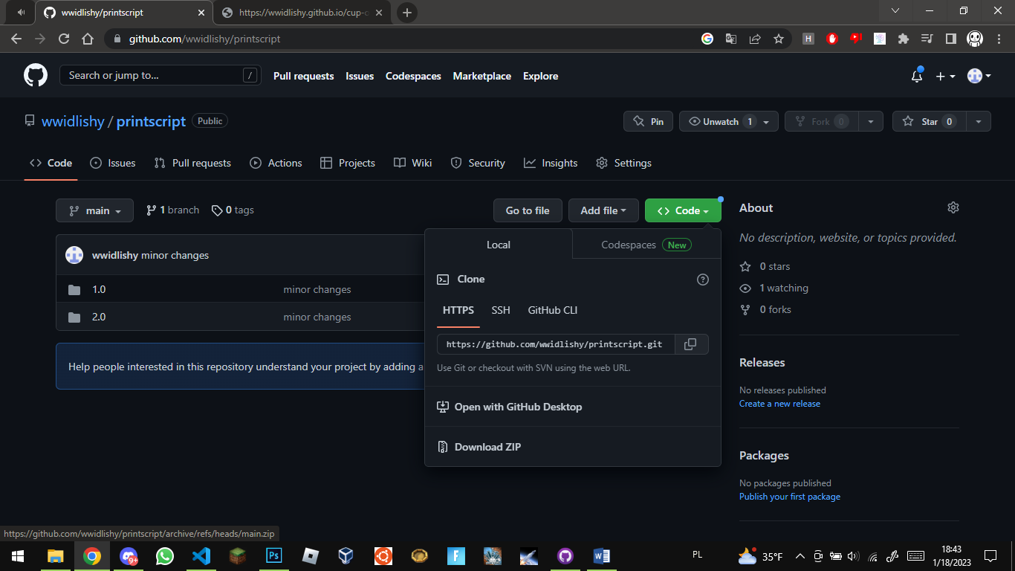

1. **Extract it**
2. **Open extracted files folder**
3. **Open 1.0 folder**
4. **Create C:\PrintScript folder**
5. **Copy printscript.exe from 1.0 to C:\PrintScript directory**
6. **Open start menu and type environment variables**

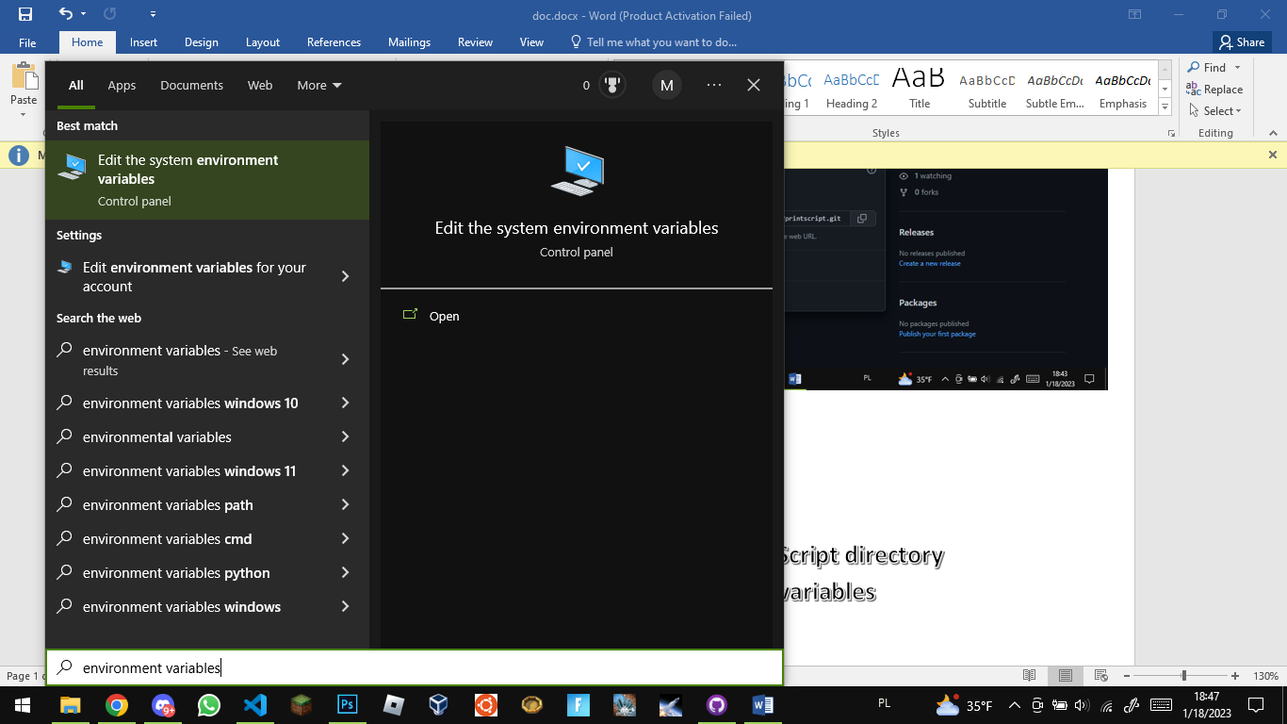

1. **Hit enter**
2. **Click on envirement variables**
3. **Select path and cilk edit**
4. **New, C:\PrintScript\, ok**
5. **Done**
6. **Programming**
7. **Everything you tube in the script is printed, except for new line characters, spaces and tabs**
8. **Type #s to add space character**
9. **#nl for new line character**
10. **#tab for tab character (also you can do it by #s#s#s#s)**