Nama Kelompok :

Widya Lintang Lestari 232310037

Joshua Taftfarel P. c 232310002

Praktikum

MatKul : Lab. Algoritma & Struktur Data

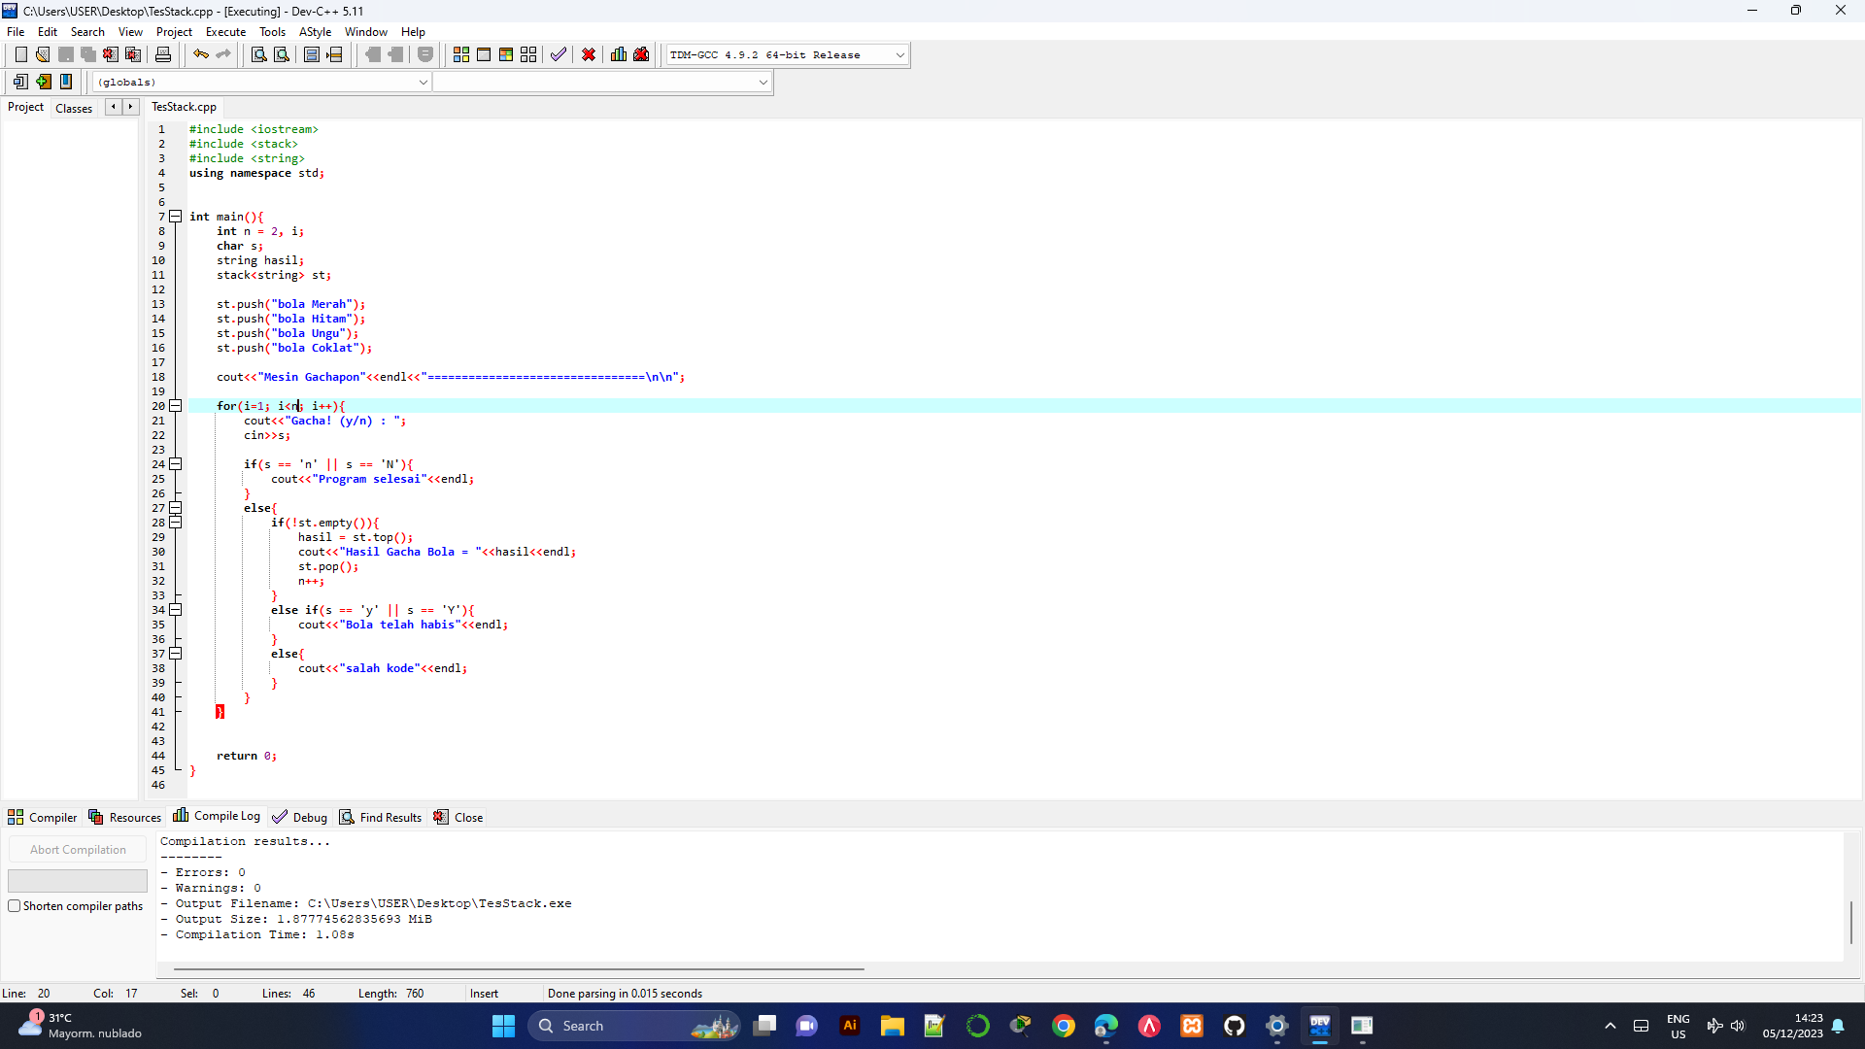

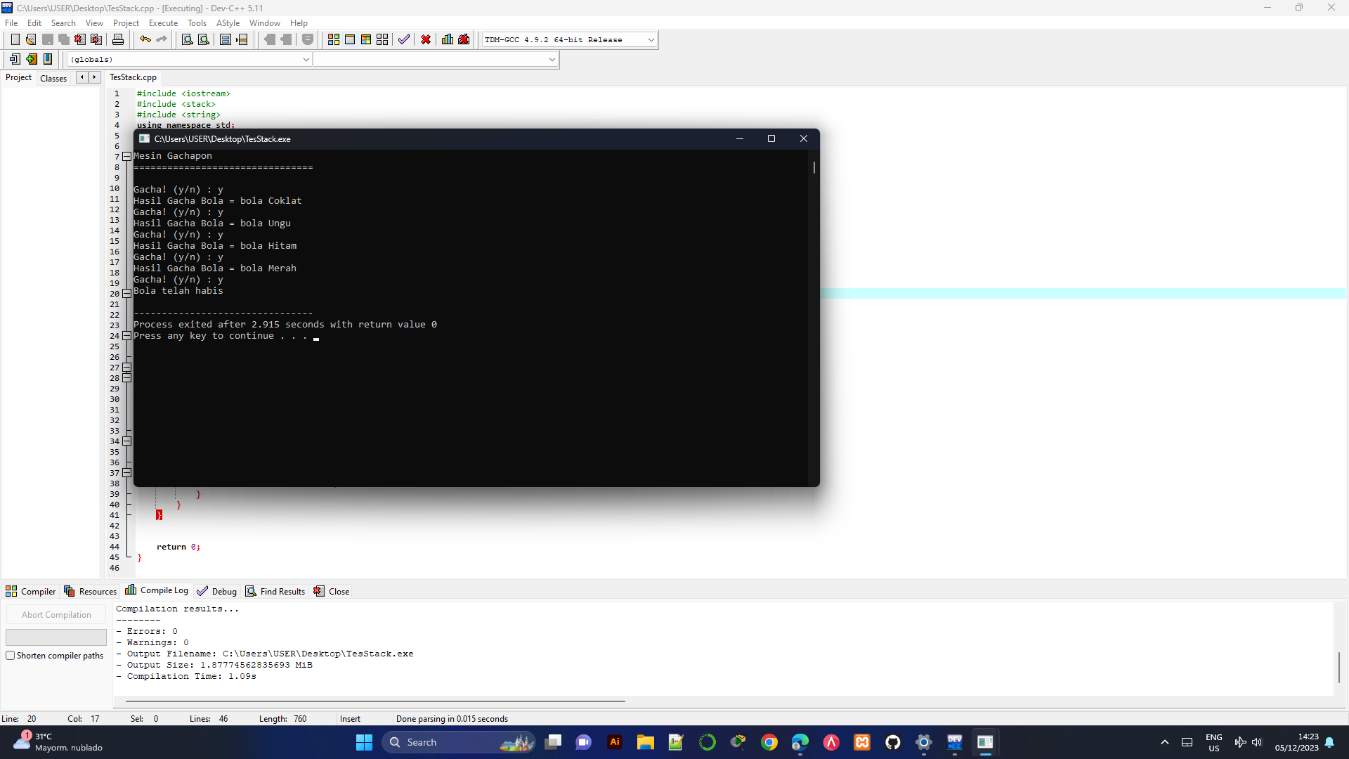

#include <iostream>

#include <stack>

#include <string>

using namespace std;

int main(){

int n = 2, i;

char s;

string hasil;

stack<string> st;

st.push("bola Merah");

st.push("bola Hitam");

st.push("bola Ungu");

st.push("bola Coklat");

cout<<"Mesin Gachapon"<<endl<<"================================\n\n";

for(i=1; i<n; i++){

cout<<"Gacha! (y/n) : ";

cin>>s;

if(s == 'n' || s == 'N'){

cout<<"Program selesai"<<endl;

}

else{

if(!st.empty()){

hasil = st.top();

cout<<"Hasil Gacha Bola = "<<hasil<<endl;

st.pop();

n++;

}

else if(s == 'y' || s == 'Y'){

cout<<"Bola telah habis"<<endl;

}

else{

cout<<"salah kode"<<endl;

}

}

}

return 0;

}