**Object Detection in Lakes**

Shijie Li, Lichao Sun, William Willie Wells

**Abstract**—Our project aims at the object detection in the background of lakes. Our results will benefit the future research such as the study of ecosystems in the water system of lakes. In our project, we set three objectives according to the difficulty of detection and complexity of backgrounds in the images. Accordingly, we designed corresponding approaches and evaluation methods to guarantee the quality of our project results.

**Index Terms**— object detection, computer vision, lakes, water system.

**1 INTRODUCTION**

In our project, we aim to detect the objects in the background of lakes and part of the land. This object detection in lakes is quite useful in both industry and scientific research. By detecting the object in the lake, it helps the researcher to better study the environment around lake and focus on the real target. This is an important preprocessing step before any further investigation. In our project, we plan to use edge detection as well as key point feature measurement to identify the object in images involving lakes. We also use machine learning to categorize the objects in the lakes for helping us to build the GPS database.

**2 RELATED WORK**

————————————————

* *Shijie Li is with the Department of Physics & Astronomy, University of Nebraska-Lincoln, Lincoln, NE 68588. E-mail: shijie.li@huskers.unl.edu.*
* *Lichao Sun is with the Department of Computer Science, University of Nebraska-Lincoln, Lincoln, NE 68588. E-mail: james.sun137@gmail.com.*
* *William Willie Wells is with the Department of Computer Science, University of Nebraska-Lincoln, Lincoln, NE 68588. E-mail: wwilliewells@gmail.com*

There are several reference literatures that discuss similar topic. In the reference [1], the author discussed some methods to detect the small surface objects under certain weather conditions that make the color contrast low and add difficulties to the detection through the color or illumination channels. The reference [2] discussed the approach to categorize the objects and events using the machine learning techniques. Reference [3] presented an approach to recognize the bridges in satellite images using neural network. These references provide us several useful ways of object detections in the lake environment with different conditions that will affect the speed and quality of detection. However, in our project, although we will also use similar approaches, we will focus on the lake environment, which is not widely studied. This specialty of lake system will simplify our detection work. It will make object and event categorization more accurate since we will have fewer factors from the surrounding environment to be concerned about. We will detect objects according to the difference of color, illumination and textures between the objects and the lakes. Also we will recognize the ordinary objects (such as animals, humans and boats) and land by comparing their sizes, shapes and connectivity. So it is advancement from our project.

**3 PROBLEM DEFINITION**

Our group objective is to detect boats on lake and return its location. The aim of this detection is to understand participation patterns of anglers in local and regional water systems. The agriculture and natural resources research would like to be able to quantify the amount of fishing effort (hours fishing per unit area and number of anglers per unit area) within a single lake. Recreational anglers do not use the entire habitat equally, but there is currently no quantitative description of how they use a water system. By quantifying where anglers fish agriculture and natural resources researchers can correlate non-catch-related factors (e.g. distance to a boat ramp, distance to other boats) and catch-related factors (i.e. depth, slope, underwater structure) to quantify what anglers are selecting as desirable target regions. This will allow fishery managers to predict how management actions (like building a new boat ramp) will impact the spatial distribution of their clients, anglers. This will be valuable when creating new reservoirs. So, first we needed to collect enough images to test the robustness of our future algorithms. The images we collected satisfied the requirements that to detect an object in a water system. These images are the inputs, and outputs are the objects which we find after we implement our algorithm. It is interesting and useful to detect objects. Scientists who study nature science benefit from tools like this that assist them in their research. This makes their work easier. Also, this technique can be used in cameras and other projects, like robotics or satellites to detect objects on or in a water system. First, we want to identify the objects on a lake. When this works, it also can be implemented to detect objects on the sea or other water systems. After that, we want to recognize and categorize the objects. Here we can use some easy objects, which can be replaced by the techniques that just care about object identification and categorization. This can make our project stronger and more useful. Our goal is detecting the boats in a lake and determining their location through GPS data. We plan to develop a GPS database. We will update a count of how many anglers are present per unit area in this database. We can implement the basic object identification in our project later.

**4 IMAGES**

We have two sources to get the images. We get the images from Brian Harmon who is a master student in Agriculture and Natural Resources department. He also is the person that developed our main image set and worked with us to locate the boat in the lake, which assists in the study of Angler Behavior in Response to Management Actions on Nebraska Reservoirs. Brian Harmon provided us with 374 images that were taken using 2 separate cameras. Each camera was moved twice, giving a total of three locations per camera. He provided us with an excel sheet depicted the GPS location of the boat he used in each image. We used images from online source on Google Images when we implemented the machine learning algorithm. Fig.1 & 2 images is from Brian. Fig. 3 & 4 images are from online source. The images have similar backgrounds but use different scales and different objects which can test our algorithm’s robustness and accuracy. Our group tested more than ten images with different objects for each background to make sure our algorithm is working fine. All images at most contain animals, land, and boats in the same background.

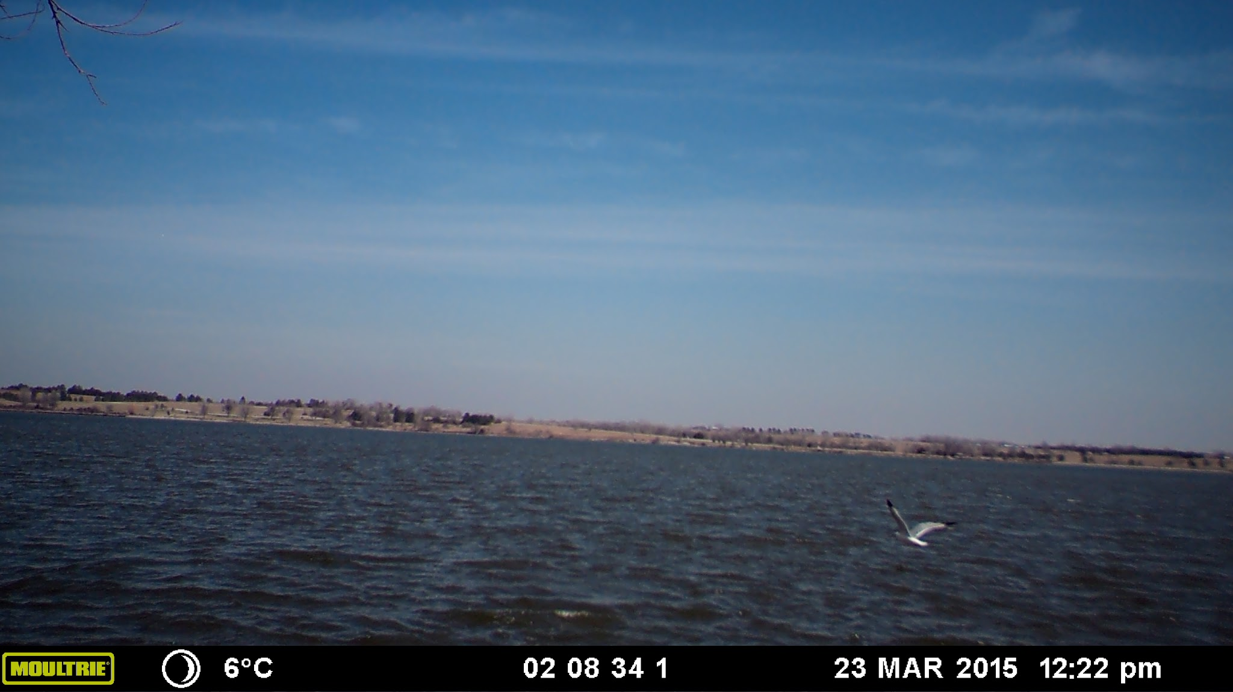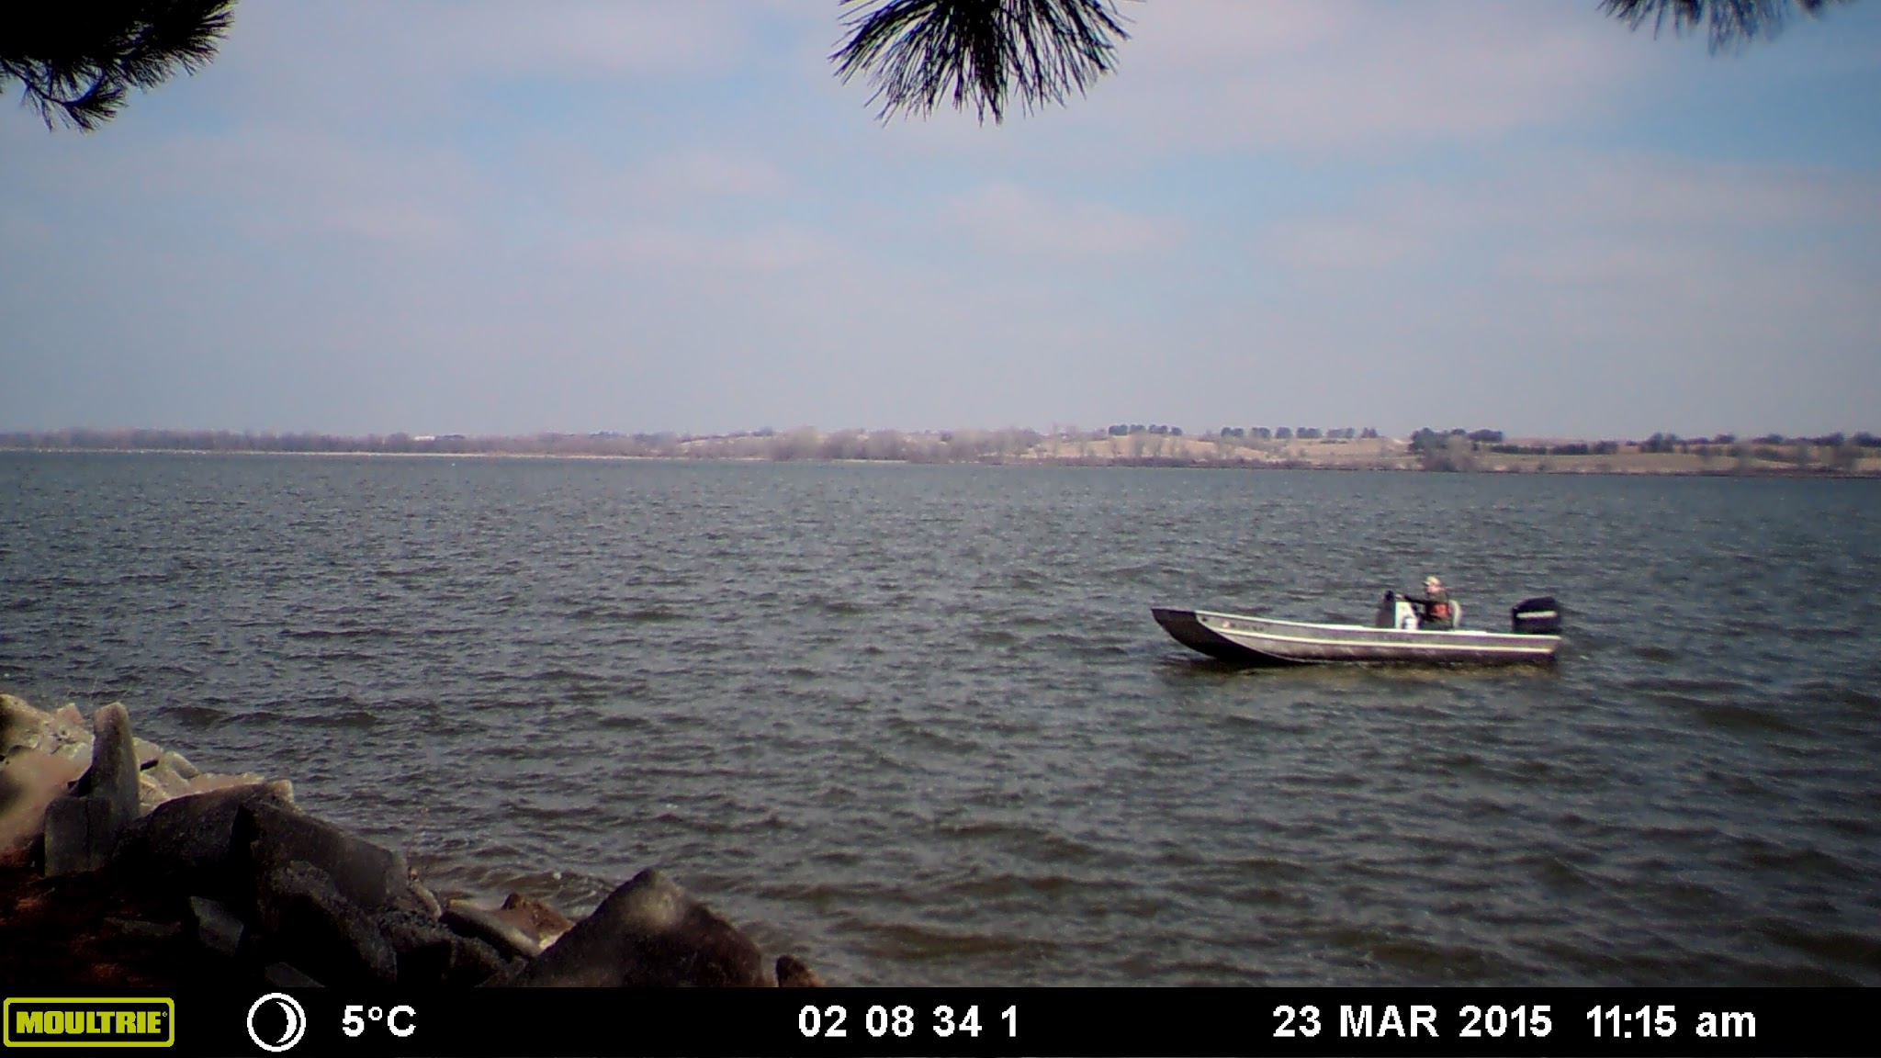

Fig. 1 no boat in the lake Fig. 2 boat in the lake

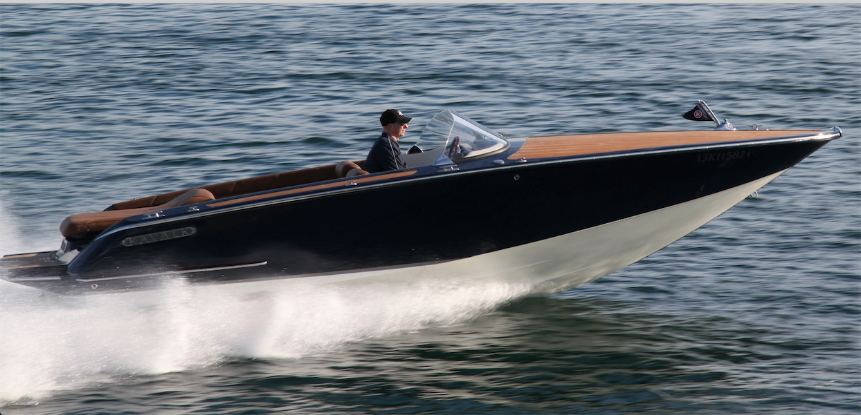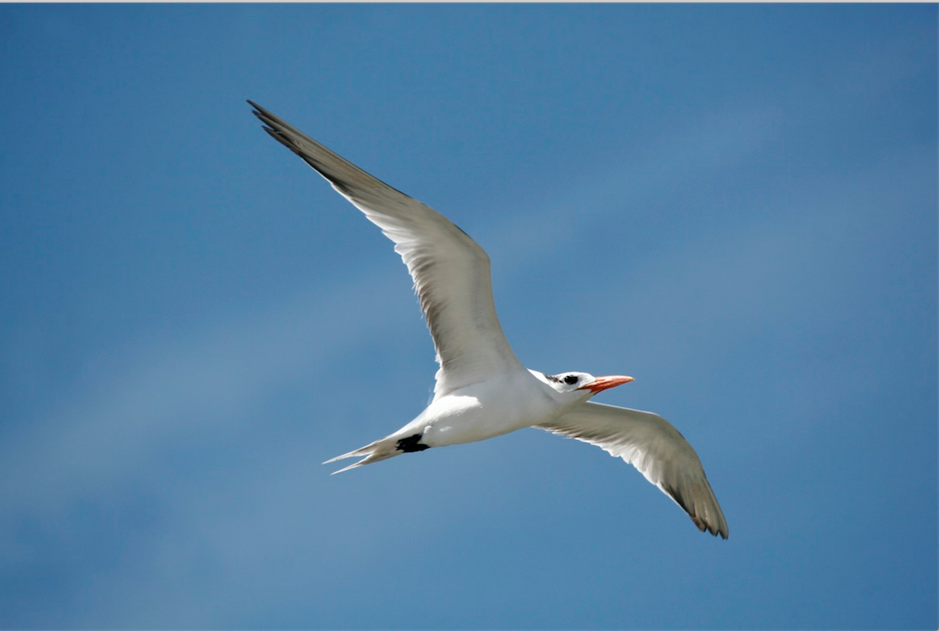

Fig. 3 boats for machine learning Fig. 4 birds for machine learning

**5 APPROACH**

We will preprocess the set of color images we obtain to isolate the portion which is water. We will then convert the color images to grayscale images. We will use a basic canny edge detector to get the edges for each image. We will use the image coordinate points of these objects as well as the respective color values in the original images to assist in classifying each object as either a boat, or bird.

5.1 Object Detection

The detection process involves reading in the desired image. Converting the original image to grayscale. Cropping the footer from the grayscale image. Each image contains a mostly black footer. The crossing of the actual scene to this footer interfered with segmenting out the horizon and edge detection. Thus, the footer was removed. Mean shift segmentation was applied to the cropped image. Majority vote is then used to select which row is the horizon. This horizontal horizon removal is the source of much woe, since the horizon in only one of the six different camera orientations is anything close to resembling horizontal orientation. Edge detection is then implemented. Custom derivatives are created and are used to produce horizontal and vertical derivatives of a [11,11] Gaussian. From these DoG, partial derivatives and outer products of the grayscale image with the removed horizon are computed and added to the image to strengthen the edges. The MATLAB function edge is then used with canny as the type of edge detector, a sigma value of 0.3 and a threshold value of 0.7. A sliding window search with window size [50,50] is used. The window size is increased by 4 on each side every 10 pixels in depth. The natural logarithm of the amount of edge pixels in the window divided by the window size is computed. If this value is greater than the previous maximum value the location of the sliding window is saved. A row-by-row search is commenced on the sliding window to locate a smaller object within the window. The resulting bounding box of the object is output and superimposed on the original color image.

5.2 Classification

We faced many difficulties in our project. One difficulty is we might classify a bird as a boat. In our algorithm, we detected objects such as land segments, waves and trees, but not the desired boat. We need to find a way to separate them. That is why we want to classify the boat and other objects. Then we can use this to help locate the boat. We chose boats and birds as our two classes the boat and bird. If we can classify these two objects, we also can classify other objects with the same algorithm. We download 39 images for each bird and boat category. The images used have different sizes and some images have very large sizes. So, we created our own function called imchange.m to solve this problem. This function can set all images to one size in a directory. We used this function to set all images to a reasonable size, which improved our algorithm’s efficiency. We load the images, and set part of them as training set and other remaining images as testing set. Then, we use these images in the training set to build the feature with bagofFeature function[4] which is a good way to build features from images. After we have the features of the images, we choose to use Support Vector Machine(SVM) algorithm to build the Machine Learning function. Last part is testing and evaluating this function’s result to see how accurate it is. You can find more details in Part 6 Evaluation.

5.3 Construction of GPS database

To achieve our purpose of locating the boat from the relative position in the image, we need to build the GPS database that corresponds to the camera used and the relative position of the boat in each image. This work was done in the following work flow as shown in the Fig 5.



Fig. 5 Workflow of the construction of GPS database

As shown in the figure, given the collected images from Bian, we first use the object detection method to find out the candidate objects that may be the boat pixels. Then we sent the pixel matrices of the first 10 most probable candidate to the function of image classifications to recognize the boat pixels. Then for each boat pixel matrix, we calculated its average row and column number in its original image as the image location or relative location in the image, saved that information and linked this image location to the GPS position provided by Brian’s device measurements. These linkages were saved as the table in the format shown in the following figure(Fig 6). And the data of our project is in the file *GPS_Location_Database.xlsx*.

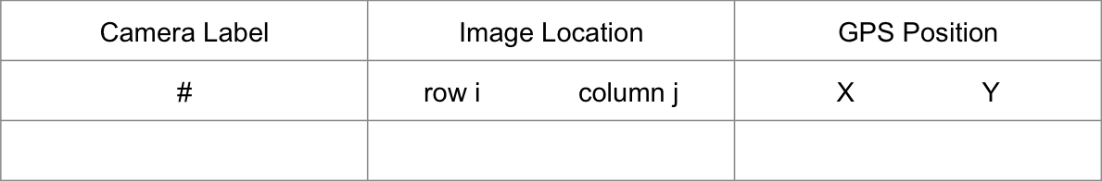

Fig. 6 GPS position look up table

In this section, the first key stage of the workflow is the object detection, because we need to select out the pixel matrix that contain the boat. Since the method used in the first few sections failed at some special cases, here we used the color-based segmentation for the boat detection. And we uses the original size(1512×2688) of image to perform the clustering. The main steps are listed here: 1. Convert RGB image to LAB image; 2. Cluster image pixels based on colors and illumination using K-Means algorithm; 3. Choose the cluster that contains the most of boat pixels based on illumination; 4. Pick the segments according to the pixel connectivity; 5. Return the averaged row and column position of the segments of interest. Here the LAB color space is derived from the CIE XYZ tristimulus values [5]. The LAB space consists of a luminosity layer 'L', chromaticity-layer 'A' indicating where color falls along the red-green axis, and chromaticity-layer 'B' indicating where the color falls along the blue-yellow axis. All of the color information is in the 'A' and 'B' layers. In our project, since the boats and the background environment in the images show more difference in the color space, we assigned much more weight to the color channels A and B for K-Means clustering. However, after clustering, we only used the luminosity layer to pick out the cluster with most of the boat pixels and cut out the segments of the boat candidates for the following manipulation. Here is one example demonstrating how the segmentation works in the following Fig 7.

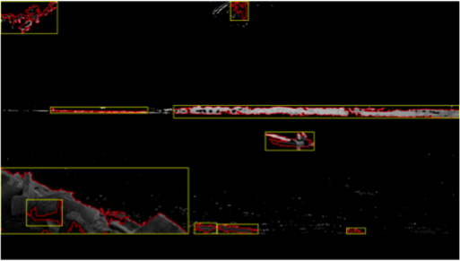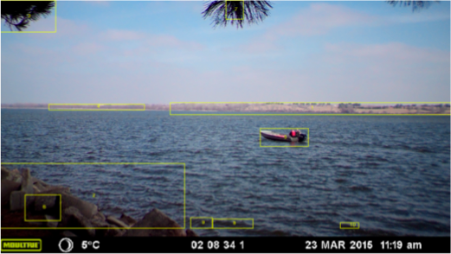

Fig 7 Segmentation using luminosity (left) and boat candidates in original image (right)

**6 EVALUATION**

Approach evaluation will include amount of TP versus FP. A true positive (TP) hit will consist of correctly identifying an object within a lake. A false positive (FP) will be an object identified by our algorithm that is not the desired object. We will use human evaluation of our image dataset to identify true positives. This is what the performance of our algorithm will be tested against.

Evaluation result for objective 1:

The detection process was able to detect a boat in 62 of 132 images with boats in them. The accuracy of the boat detection algorithm is currently 46.97%. Boats that were close to the horizon, within 30 pixel from the water’s edge, have about a 1% detection rate. Precise segmentation of the water line would help increase this accuracy. Boats that were facing away from the camera, perpendicular to the field of view, were detected approximately 10% of the time.

Evaluation result for objective 2:

Here are two part of results. First I test each five new birds and boats images which are downloaded on Google Images website. These ten images are not belong to testing set and training set. I got 100% accuracy of them. Here are two example images below:

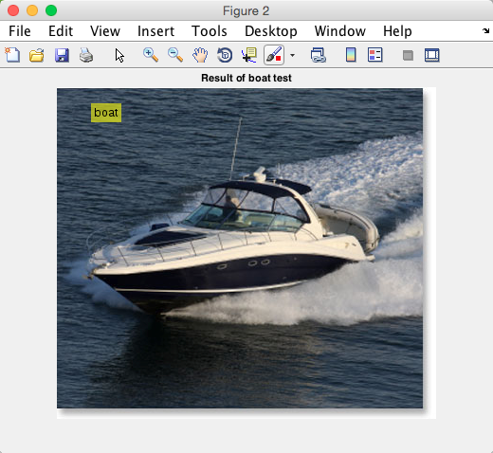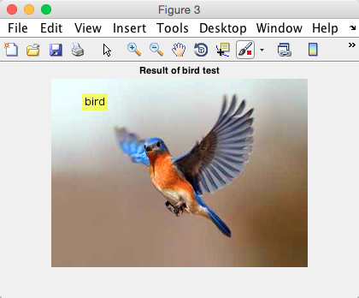

Since I just test few testing can not see how accurate it is. So I also get the result of the testing set which contains more images and it should give a better result. Here are two images of the testing set results:

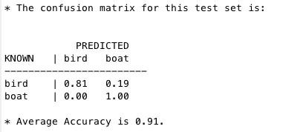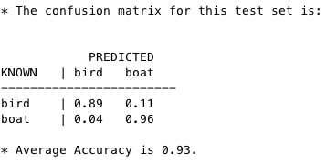

Since when we choose the training set and use them to get the features, we randomly choose the images, so each time we try to rebuild the whole model, the result will change. In any results, we can see we can get at least 80% or high accuracy which proves our algorithm works.

Evaluation result for objective 3:

Due to the limit of image data size and the similarity of geometries between the boat and environment (such as land and wave shadow), the recognition accuracy of the boats in the image is very low, less than 60%, although the test set accuracy is 83%. So we had to correct it manually at the end of the object recognition to obtain a reliable GPS database.

**7 Contribution of each team members**

Team works(for all members): 1) Almost one meeting per week, usually meeting around 2 hours. Sometimes, the meeting lasts more than 6 hours. 2) Working on the proposal, presentation, and final report together. 3) All of us try to solve the problem by our own ideas first, then we put all good ideas and algorithm parts together.

Personal works:

**William Willie Wells**: We did not separate the tasks efficiently at the beginning. We all did some sort of object detection. I continued with object detection. I attempted using K-means as well as just a minus image both of those methods failed for me. I have worked approximately 4 hours a day some weeks with the bulk of the actual time worked on the weekend, waiting for results. The rest of the weeks I worked at least 6 hours total on the project that week.

**Lichao Sun**: At beginning, I used my own ideas to try to finish all three objectives once, including use the edge detection and some my own made function to remove background of the image. Then, I use the result of part one, I use them to calculate the center point(i, j) of the boat object and use the this information to build the database. Later, we discussed each works and decide to separate the works for each of us, and find the better way to solve each part. Then, I focus on the classification part with machine learning. Also, I help with my team members when they face some new problems, like the idea of how to use my result in their objectives and how to create the database.

Hours: At least 4 hours per week, total hours should be more than 28 hours

**Shijie Li**: I focused on the color-based segmentation to detect the boats in the images and construct the GPS database using the measurement data provided by Brian. Also I tested the image classification algorithm introduced by Lichao during the GPS database construction.

Hours: About 4 hours every week were spent on this project since Spring Break this semester.

**ACKNOWLEDGEMENT**

The authors want to thank the support from all collaborators, Dr. Samal, and Brian Harmon.

**REFERENCES**

1. Baojun Qi, Tao Wu, hangen He, Tingbo Hu, Real-Time Detection of Small Surface Objects Using Weather Effects, 10th Asian Conference on Computer Vision
2. Li-Jia Li, Li Fei-Fei, book chapter in “Studies in Computational Intelligence – Computer Vision”, Vol 285/2010
3. Roger Trias-Sanz, Nicolas Lomenie, Automatic Bridge Detection in High-Resolution Satellite Images, Computer Vision Systems, Third International Conference ICVS 2003
4. Mathworks online source, “Image Category Classification Using Bag of Features”, <http://www.mathworks.com/help/vision/examples/image-category-classification-using-bag-of-features.html>
5. Mathworks online source, “Color-based Segmentation Using K-Means Clustering”, <http://www.mathworks.com/help/images/examples/color-based-segmentation-using-k-means-clustering.html>