# WWIV Telnet Server Help Index

What is it?
WWIV Telnet Server is a server type process which listens on the TCP/IP port specified in the Preferences for an inbound telnet connection, and spawns WWIV 5.0 for each session. It also keeps track of the status of each node and the remote IP address of the client.

Installation
Copy WTelnetServer.exe into your WWIV home directory (for example: C:\BBS). Execute the program (either by double-clicking on the Icon from the Windows Explorer, or from the command line.)
Before you first use the program, you must configure it. You do this from the Preferences button.

Normal Operation
Preferences | Launches the Preferences dialog where you make configuration changes.
Start Server | Starts the telnet server. After it is started, you will see items under the Node Status list. If the server is not running, this list will be empty.
Stop Server | Stops the telnet server
Help | What you are reading right now
Exit | Terminates this program. If the server is started, it will be stopped before exiting; however any existing connections (copies of WWIV5) should remain active on Windows 2000. On Windows 95/98 users may be disconnected.

# Preferences - General

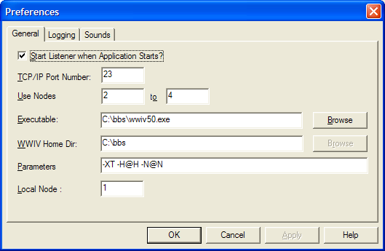

Options

Start Listener when Application Starts? | Should WWIV Telnet Server auto-start listening for connections at startup. If this box is not checked, you will need to execute the Start Server command from the main menu.
TCP/IP Port Number | The Port number on which to listen. This is normally port 23 (the default telnet port)
Use Nodes | Enter the starting and ending node numbers which the server should use. For example 2 to 4 means the 1st connections get nodes 2, up through node 4. If no nodes are available, the caller is returned "BUSY"
Executable | This is the full path to the WWIV executable (normally wwiv50.exe or wwiv50nd.exe)
WWIV Home Dir | This is the directory which contains the WWIV 5.0 executable and also will be the current working directory for the WWIV process.
Parameters | Enter the parameters used to invoke WWIV. Macros for use here are:  @H - Socket Handle  @N - Node Number  Normally, this should be "-XT -H@H -N@N"
Local Node | If this is not 0, then when you use the Run Local Node command, WWIV will be started with this node number.

# Preferences - Logging

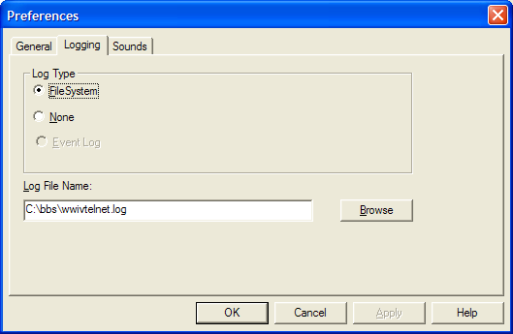

Options

Log Type | Specifies the type of log file to use. Currently there is only None, and File System
File System | A log file should be written containing status information and logon/log off information
None | No logging should occur
Log File Name | Name of the log file. This is only used of the Log Type is set to FileSystem.

# Preferences - Sounds

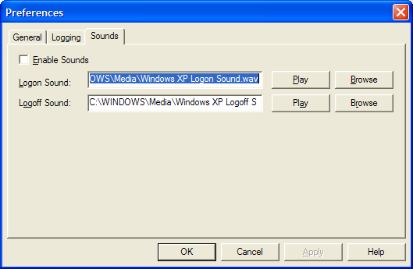

Options

Enable Sounds | Should WWIV Telnet Server play sounds on logon and log off. If checked, WWIV will use the sounds specified for Logon Sound and Logoff Sound.
Logon Sound | The sound file (WAV or MID) to play when a caller logs on to WWIV
Logoff Sound | The sound file (WAV or MID) to play when a caller logs off from WWIV

Note: You can use the Play button to play the sound selected.

#No Help Available

No help is available for this area of the window.
# No Help Available

No help is available for this message box.

<< If you wish to author help specific to each message box prompt, then remove the AFX_HIDP_xxx values from the [ALIAS] section of your .HPJ file, and author a topic for each AFX_HIDP_xxx value. For example, AFX_HIDP_INVALID_FILENAME is the help topic for the Invalid Filename message box. >>

main_index
HIDD_DIALOG_PREFERENCES
HIDD_DIALOG_LOGGING
HIDD_DIALOG_SOUNDS
HID_HT_NOWHERE
AFX_HIDP_default

