

软 件 测 试 报 告

测试名称： | 盒子http 接口测试
所属项目： | V-BOX | 所属模块：
报告编号：
当前版本： | 1.0
编写者： | 李云 | 编写日期： | 2018.01.26
审核人： |  | 审批日期：
s
目录
目录 1
1 概述 1
1.1 测试目的 1
2 测试环境 2
2.1 硬件环境 2
2.2 软件环境 2
3 测试方案 2
3.1 测试方法 2
3.2 人员和进度 2
4 测试过程 3
4.1 基本功能测试 3
4.2 多盒子 寄存器列表读取测试 5
4.3 数据类型读写测试（只读帐号） 5
4.4 数据类型读写测试（读写写帐号） 6
4.5 网页监控点分组名称更新，删除，名称修改 7
5 测试结果 13
5.1 测试结果 13
6 附录 14
Client测试代码 14

- 概述
  - 测试目的
盒子 http api的接口功能测试和稳定性测试。
- 测试环境
  - 硬件环境
设备名 | 版本 | 配置 | 数量
V-BOX |  |  | 1
  - 软件环境
1，软件 jmeter

- 脚本语言 python
- 服务器地址：http://192.168.45.186:8686/box-data/api/{acturl}
- 外网服务器地址：http://api.v-box.net/box-data/api/{acturl}

- 测试方案
  - 测试方法
- 功能测试：通过python编写脚本，向api发送数据，查看服务器返回结果。
- 稳定性测试：通过jmeter设置并发线程组和持续时间，向服务器发送数据，查看服务器返回结果。
  - 人员和进度
人员：李云
时间：2018-01-26

- 测试过程
  - 基本功能测试（内/外网）
- we-data/login接口：
推送数据：alias=779789937%40qq.com&password=4297f44b13955235245b2497399d7a93&isremeber=1
返回结果：
{"code":200,"msg":"ok","reqId":"1516861083764","result":{"utype":1,"sid":"9c4b87948d3241ad9f83f05d16d8813a"}}
复合预期
2，其他接口的测试数据查看压缩包
  - 稳定性测试（内/外网）
编号 | 线程名称 | 线程数量 | 并发线程 | 间隔时间 | 持续时间
1 | we-data/login | 1 | 1 | 1 | 1s
2 | we-data/boxs | 400 | 400 | 20s | 14400s/4h
3 | we-data/realgroups | 400 | 400 | 20s | 14400s/4h
4 | we-data/realdata | 400 | 400 | 20s | 14400s/4h
5 | we-data/updrealdata | 600 | 500 | 25s | 14400s/4h
6 | we-data/monitors | 400 | 400 | 20s | 14400s/4h
7 | we-data/historydata | 600 | 600 | 26s | 14400s/4h
8 | we-data/alarmdata | 500 | 500 | 30s | 14400s/4h
脚本线程如下:
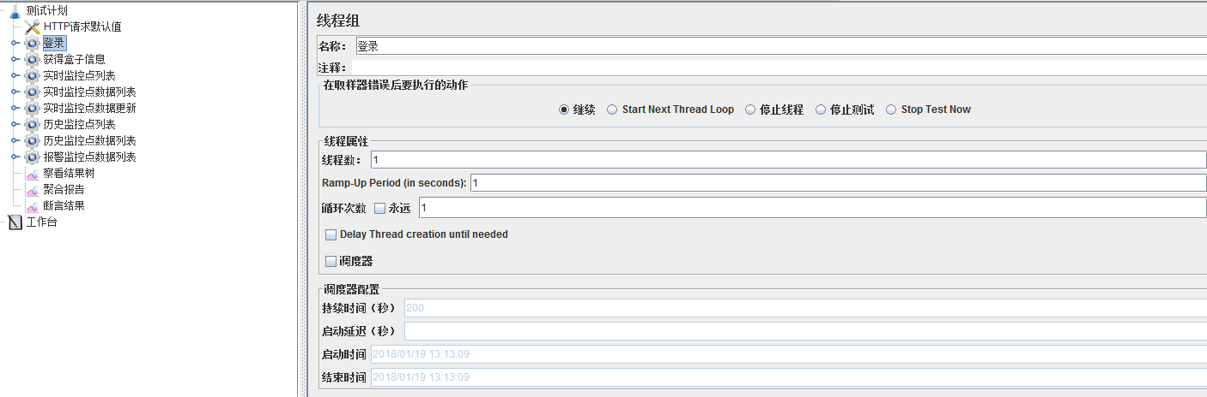
结果判定：返回码不等于200都认为测试不通过。
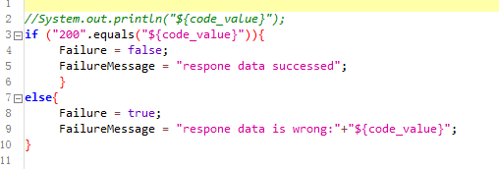
- 测试结果
  - 测试结果
功能测试：
编号 | 接口 | 功能结果
1 | we-data/login | 正常
2 | we-data/boxs | 正常
3 | we-data/realgroups | 正常
4 | we-data/realcfgs | 正常
5 | we-data/realdata | 正常
6 | we-data/updrealdata | 正常
7 | we-data/monitors | 正常
8 | we-data/historydata | 正常
9 | we-data/alarmdata | 正常
稳定性测试：
内网4h：
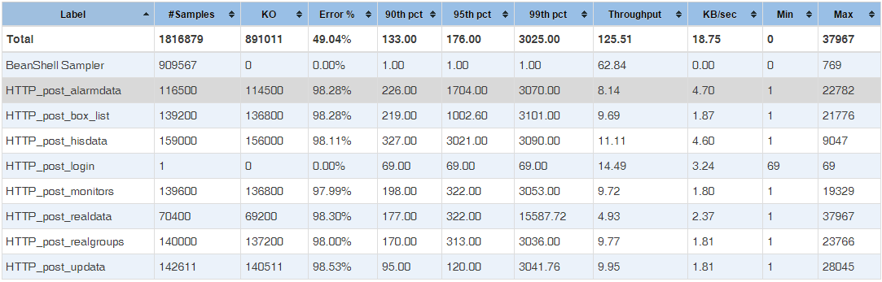
外网4h：
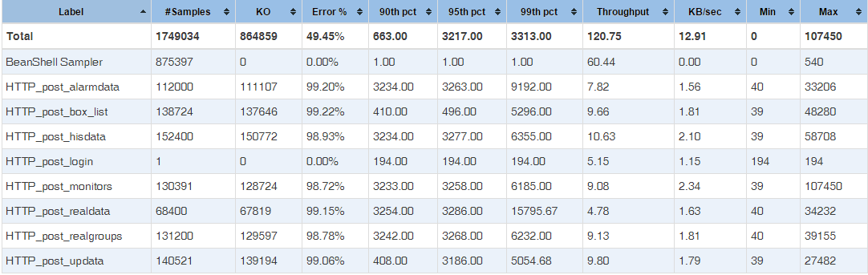
- 附录
Python接口测试代码
# coding:utf8
# 功能遍历
__author__ = 'admin'
import os
import urllib2
import urllib
import json
import hashlib
import time
DEBUG = 1
# 当前时间戳
nowtime = lambda : int(round(time.time()*1000))
# 常量设置
urlbase = "http://api.v-box.net/box-data/api/"
#urlbase = "http://192.168.45.186:8686/box-data/api/"
comdic = {"comid":"1","compvtkey":"27a010966282423fbd202bf3f45267c0","isremeber":1}
keyval="key=f1cd9351930d4e589922edbcf3b09a7c"
# md5计算
def cal_md5(string):
p = hashlib.md5()
p.update(string)
return p.hexdigest()
# 字典排序和组装
def sign_value(srcdic):
# 对字典 的 键值 进行 升序排序
new_dic = sorted(srcdic.iteritems(),key=lambda x:x[0],reverse=False)
print new_dic
s = ""
for k,v in new_dic:
s += "%s=%s&"%(k,v)
srcsign = s + keyval
md5value = cal_md5(srcsign)
if DEBUG:
print srcsign
print md5value
return md5value
def sorted_dic(dic):
new_list = sorted(dic.iteritems(),key=lambda x:x[0],reverse=False)
return dict(new_list)
def post_run(url,data,common):
newurl = urlbase + url
reqq = urllib2.Request(newurl,data=data)
reqq.add_header("common",common)
reqq.add_header("Content-Type",'application/x-www-form-urlencoded')
reqq.add_header('User-Agent','Mozilla/5.0 (Windows NT 6.1; WOW64) AppleWebKit/537.36 (KHTML, like Gecko) Chrome/31.0.1650.63 Safari/537.36')
reqq.add_header("connection","Keep-Alive")
reqq.add_header("Host", "192.168.45.186:8686")
if DEBUG:
print reqq.header_items()
print reqq.data
req = urllib2.urlopen(reqq) # 发起post
return req.read()
# 登录
def login():
f = open(".\\login.txt","a+")
url = "we-data/login"
postdate = {"alias":"779789937@qq.com","password":"123123","isremeber":1}
# 把password进行md5计算
newpasw=postdate.get('password')
postdate['password']=cal_md5(newpasw)
# body_value = json.dumps(postdate)
body_value = urllib.urlencode(postdate)
# 把时间给ts
comdic['ts']=nowtime()
# 组合sign
ss=("alias=%s&comid=%s&compvtkey=%s&isremeber=%d&password=%s&ts=%ls&%s"%(postdate.get('alias'),comdic.get("comid"),comdic.get("compvtkey"),postdate.get('isremeber'),postdate.get("password"),comdic.get("ts"),keyval))
comdic['sign'] = cal_md5(ss)
# 组装comm
nnew = "{"+"\""+"comid"+"\":\"1\"," +"\""+"compvtkey"+"\":\"27a010966282423fbd202bf3f45267c0\"," +"\""+"ts"+"\":%ld,"%(comdic.get('ts'))+"\""+"sign"+"\":\"%s\""%(comdic.get('sign'))+"}"
if DEBUG:
print comdic
print nnew
# 返回sid
p = post_run(url,data=body_value,common=nnew)
f.write(body_value+"\n")
f.write(p+"\n")
f.close()
ress = json.loads(p)
sid = ress.get("result").get('sid')
if DEBUG:
print sid
return sid
# 获得盒子数据
def get_boxs(sid):
f = open(".\\boxs.txt","a+")
url = "we-data/boxs"
# 把时间给ts
comdic['ts']=nowtime()
# 组合sign
ss=("comid=%s&compvtkey=%s&sid=%s&ts=%ls&%s"%(comdic.get("comid"),comdic.get("compvtkey"),sid,comdic.get("ts"),keyval))
newssi = cal_md5(ss)
# 组装comm
nnew = "{"+"\""+"comid"+"\":\"1\"," +"\""+"compvtkey"+"\":\"27a010966282423fbd202bf3f45267c0\"," +"\""+"sid"+"\":\"%s\""%(sid)+",\""+"ts"+"\":%ld,"%(comdic.get('ts'))+"\""+"sign"+"\":\"%s\""%(newssi)+"}"
if DEBUG:
print ss
print comdic
print nnew
# 返回所有的盒子
p = post_run(url,data=None,common=nnew)
# 获取boxid
f.write(p+"\n")
f.close()
t = json.loads(p)
ll = t.get("result").get("list")
boxidl = []
for each in ll:
p = each.get('boxList')
for eachp in p:
boxidl.append(eachp.get('boxId'))
if DEBUG:
print t
print ll
print boxidl
return boxidl
def get_box_realgroups(sid,boxid):
f = open(".\\realgroup.txt","a+")
url = "we-data/realgroups"
# 数据
post_date = {"boxId":2}
post_date["boxId"]=boxid
body_value = urllib.urlencode(post_date)
# 把时间给ts
comdic['ts']=nowtime()
# 组合sign
ss=("boxId=%d&comid=%s&compvtkey=%s&sid=%s&ts=%ls&%s"%(boxid,comdic.get("comid"),comdic.get("compvtkey"),sid,comdic.get("ts"),keyval))
newssi = cal_md5(ss)
# 组装comm
nnew = "{"+"\""+"comid"+"\":\"1\"," +"\""+"compvtkey"+"\":\"27a010966282423fbd202bf3f45267c0\"," +"\""+"sid"+"\":\"%s\""%(sid)+",\""+"ts"+"\":%ld,"%(comdic.get('ts'))+"\""+"sign"+"\":\"%s\""%(newssi)+"}"
if DEBUG:
print ss
print comdic
print nnew
# 返回所有的盒子
p = post_run(url,data=body_value,common=nnew)
f.write(body_value+"\n")
f.write(p+"\n")
f.close()
if DEBUG:
print p
t = json.loads(p)
grouplist = t.get("result").get("list")
b = []
for each in grouplist:
b.append(each.get("groupId"))
return b
# 3.实时监控点配置列表
def get_box_realgroupcnf(sid,boxid,groupid,pagesize,pageindex):
f = open(".\\realgroupcnf.txt","a+")
url = "we-data/realcfgs"
# 数据
post_date = {"boxId":2,"groupId":1,"pageIndex":1,"pageSize":1}
post_date["boxId"]=boxid
post_date["groupId"] = groupid
post_date["pageIndex"] = pageindex
post_date["pageSize"] = pagesize
body_value = urllib.urlencode(post_date)
# 把时间给ts
comdic['ts']=nowtime()
# 组合sign
ss=("boxId=%d&comid=%s&compvtkey=%s&groupId=%d&pageIndex=%d&pageSize=%d&sid=%s&ts=%ls&%s"%(boxid,comdic.get("comid"),comdic.get("compvtkey"),groupid,pageindex,pagesize,sid,comdic.get("ts"),keyval))
newssi = cal_md5(ss)
# 组装comm
nnew = "{"+"\""+"comid"+"\":\"1\"," +"\""+"compvtkey"+"\":\"27a010966282423fbd202bf3f45267c0\"," +"\""+"sid"+"\":\"%s\""%(sid)+",\""+"ts"+"\":%ld,"%(comdic.get('ts'))+"\""+"sign"+"\":\"%s\""%(newssi)+"}"
if DEBUG:
print ss
print comdic
print nnew
# 返回所有的盒子
p = post_run(url,data=body_value,common=nnew)
f.write(body_value+"\n")
f.write(p+"\n")
f.close()
if DEBUG:
print p
t = json.loads(p)
# 4.实时监控点数据列表,返回monitorid
def get_box_realdate(sid,boxid,groupid,pagesize,pageindex):
f = open(".\\realdate.txt","a+")
url = "we-data/realdata"
# 数据
post_date = {"boxId":2,"groupId":1,"pageIndex":1,"pageSize":1}
post_date["boxId"]=boxid
post_date["groupId"] = groupid
post_date["pageIndex"] = pageindex
post_date["pageSize"] = pagesize
body_value = urllib.urlencode(post_date)
# 把时间给ts
comdic['ts']=nowtime()
# 组合sign
ss=("boxId=%d&comid=%s&compvtkey=%s&groupId=%d&pageIndex=%d&pageSize=%d&sid=%s&ts=%ls&%s"%(boxid,comdic.get("comid"),comdic.get("compvtkey"),groupid,pageindex,pagesize,sid,comdic.get("ts"),keyval))
newssi = cal_md5(ss)
# 组装comm
nnew = "{"+"\""+"comid"+"\":\"1\"," +"\""+"compvtkey"+"\":\"27a010966282423fbd202bf3f45267c0\"," +"\""+"sid"+"\":\"%s\""%(sid)+",\""+"ts"+"\":%ld,"%(comdic.get('ts'))+"\""+"sign"+"\":\"%s\""%(newssi)+"}"
if DEBUG:
print ss
print comdic
print nnew
# 返回所有的盒子
p = post_run(url,data=body_value,common=nnew)
f.write(body_value+"\n")
f.write(p+"\n")
f.close()
if DEBUG:
print p
t = json.loads(p)
listl = t.get("result").get("list")
monilist = []
for each in listl:
monilist.append(each.get("monitorId"))
if DEBUG:
print monilist
return monilist
# 对数据进行更新
def update_real_data(sid,monitorid,value):
f = open(".\\update.txt","a+")
url = "we-data/updrealdata"
post_date = {"monitorId":2,"value":1}
post_date["monitorId"]=monitorid
post_date["value"] = value
body_value = urllib.urlencode(post_date)
# 把时间给ts
comdic['ts']=nowtime()
# 组合sign
ss=("comid=%s&compvtkey=%s&monitorId=%d&sid=%s&ts=%ls&value=%s&%s"%(comdic.get("comid"),comdic.get("compvtkey"),monitorid,sid,comdic.get("ts"),value,keyval))
newssi = cal_md5(ss)
# 组装comm
nnew = "{"+"\""+"comid"+"\":\"1\"," +"\""+"compvtkey"+"\":\"27a010966282423fbd202bf3f45267c0\"," +"\""+"sid"+"\":\"%s\""%(sid)+",\""+"ts"+"\":%ld,"%(comdic.get('ts'))+"\""+"sign"+"\":\"%s\""%(newssi)+"}"
if DEBUG:
print ss
print comdic
print nnew
# 返回所有的盒子
p = post_run(url,data=body_value,common=nnew)
f.write(body_value+"\n")
f.write(p+"\n")
f.close()
if DEBUG:
print p
t = json.loads(p)
# 获得历史监控点,chage =1 传送boxid,chage !=1 不发送boxid
def get_his_monitor_date(sid,chage,boxid):
f = open(".\\monitors.txt","a+")
url = "we-data/monitors"
post_date = {"boxId":2}
post_date["boxId"]=boxid
body_value = urllib.urlencode(post_date)
# 把时间给ts
comdic['ts']=nowtime()
# 组合sign
if chage == 1:
ss=("boxId=%d&comid=%s&compvtkey=%s&sid=%s&ts=%ls&%s"%(boxid,comdic.get("comid"),comdic.get("compvtkey"),sid,comdic.get("ts"),keyval))
else:
ss=("comid=%s&compvtkey=%s&sid=%s&ts=%ls&%s"%(comdic.get("comid"),comdic.get("compvtkey"),sid,comdic.get("ts"),keyval))
newssi = cal_md5(ss)
# 组装comm
nnew = "{"+"\""+"comid"+"\":\"1\"," +"\""+"compvtkey"+"\":\"27a010966282423fbd202bf3f45267c0\"," +"\""+"sid"+"\":\"%s\""%(sid)+",\""+"ts"+"\":%ld,"%(comdic.get('ts'))+"\""+"sign"+"\":\"%s\""%(newssi)+"}"
if DEBUG:
print ss
print comdic
print nnew
# 返回所有的盒子
if chage == 1:
p = post_run(url,data=body_value,common=nnew)
f.write(body_value+"\n")
else:
p = post_run(url,data=None,common=nnew)
f.write(p+"\n")
f.close()
if DEBUG:
print p
t = json.loads(p)
tt = t.get("result").get("list")
hismoni = []
for each in tt:
hismoni.append(each.get("monitorId"))
return hismoni
# 获得历史数据
def get_his_data_list(sid,chage,monitorid,monitorbegin,monitorend,pagesize,pageindex):
f = open(".\\his_date.txt","a+")
url = "we-data/historydata"
post_date = {}
# 把时间给ts
comdic['ts']=nowtime()
post_date["monitorId"] = monitorid
post_date["pageIndex"] = pageindex
post_date["pageSize"] = pagesize
# 组合sign
if chage == 1:
body_value = urllib.urlencode(post_date)
ss=("comid=%s&compvtkey=%s&monitorId=%d&pageIndex=%d&pageSize=%d&sid=%s&ts=%ls&%s"%(comdic.get("comid"),comdic.get("compvtkey"),monitorid,pageindex,pagesize,sid,comdic.get("ts"),keyval))
elif chage == 2:
body_value = "monitorBeginTime=%s&monitorId=%d&pageIndex=%d&pageSize=%d"%(monitorbegin,monitorid,pageindex,pagesize)
ss=("comid=%s&compvtkey=%s&monitorBeginTime=%s&monitorId=%d&pageIndex=%d&pageSize=%d&sid=%s&ts=%ls&%s"%(comdic.get("comid"),comdic.get("compvtkey"),monitorbegin,monitorid,pageindex,pagesize,sid,comdic.get("ts"),keyval))
elif chage == 3:
body_value = "monitorEndTime=%s&monitorId=%d&pageIndex=%d&pageSize=%d"%(monitorend,monitorid,pageindex,pagesize)
ss=("comid=%s&compvtkey=%s&monitorEndTime=%s&monitorId=%d&pageIndex=%d&pageSize=%d&sid=%s&ts=%ls&%s"%(comdic.get("comid"),comdic.get("compvtkey"),monitorend,monitorid,pageindex,pagesize,sid,comdic.get("ts"),keyval))
elif chage == 4:
body_value = "monitorBeginTime=%s&monitorEndTime=%s&monitorId=%d&pageIndex=%d&pageSize=%d"%(monitorbegin,monitorend,monitorid,pageindex,pagesize)
ss=("comid=%s&compvtkey=%s&monitorBeginTime=%s&monitorEndTime=%s&monitorId=%d&pageIndex=%d&pageSize=%d&sid=%s&ts=%ls&%s"%(comdic.get("comid"),comdic.get("compvtkey"),monitorbegin,monitorend,monitorid,pageindex,pagesize,sid,comdic.get("ts"),keyval))
newssi = cal_md5(ss)
# 组装comm
nnew = "{"+"\""+"comid"+"\":\"1\"," +"\""+"compvtkey"+"\":\"27a010966282423fbd202bf3f45267c0\"," +"\""+"sid"+"\":\"%s\""%(sid)+",\""+"ts"+"\":%ld,"%(comdic.get('ts'))+"\""+"sign"+"\":\"%s\""%(newssi)+"}"
if DEBUG:
print ss
print comdic
print nnew
print body_value
# 返回所有的盒子
p = post_run(url,data=body_value,common=nnew)
f.write(body_value+"\n")
f.write(p+"\n")
f.close()
if DEBUG:
print p
t = json.loads(p)
# 获得报警数据
def get_alarm_data_list(sid,chage,boxid,monitorbegin,monitorend,pagesize,pageindex,state,alarmtype,alarmlevel):
f = open(".\\alarm.txt","a+")
url = "we-data/alarmdata"
post_date = {}
# 把时间给ts
comdic['ts']=nowtime()
ss = ""
# 组合sign
if chage == 1:
body_value = "boxId=%d&pageIndex=%d&pageSize=%d&state=%d"%(boxid,pageindex,pagesize,state)
ss=("boxId=%d&comid=%s&compvtkey=%s&pageIndex=%d&pageSize=%d&sid=%s&state=%d&ts=%ls&%s"%(boxid,comdic.get("comid"),comdic.get("compvtkey"),pageindex,pagesize,sid,state,comdic.get("ts"),keyval))
elif chage == 2:
body_value = "boxId=%d&monitorBeginTime=%s&pageIndex=%d&pageSize=%d&state=%d"%(boxid,monitorbegin,pageindex,pagesize,state)
ss=("boxId=%d&comid=%s&compvtkey=%s&monitorBeginTime=%s&pageIndex=%d&pageSize=%d&sid=%s&state=%d&ts=%ls&%s"%(boxid,comdic.get("comid"),comdic.get("compvtkey"),monitorbegin,pageindex,pagesize,sid,state,comdic.get("ts"),keyval))
elif chage == 3:
body_value = "boxId=%d&monitorEndTime=%s&pageIndex=%d&pageSize=%d&state=%d"%(boxid,monitorend,pageindex,pagesize,state)
ss=("boxId=%d&comid=%s&compvtkey=%s&monitorEndTime=%s&pageIndex=%d&pageSize=%d&sid=%s&state=%d&ts=%ls&%s"%(boxid,comdic.get("comid"),comdic.get("compvtkey"),monitorend,pageindex,pagesize,sid,state,comdic.get("ts"),keyval))
elif chage == 4:
body_value = "boxId=%d&monitorBeginTime=%s&monitorEndTime=%s&pageIndex=%d&pageSize=%d&state=%d"%(boxid,monitorbegin,monitorend,pageindex,pagesize,state)
ss=("boxId=%d&comid=%s&compvtkey=%s&monitorBeginTime=%s&monitorEndTime=%s&pageIndex=%d&pageSize=%d&sid=%s&state=%d&ts=%ls&%s"%(boxid,comdic.get("comid"),comdic.get("compvtkey"),monitorbegin,monitorend,pageindex,pagesize,sid,state,comdic.get("ts"),keyval))
elif chage == 5:
body_value = "alarmType=%d&boxId=%d&pageIndex=%d&pageSize=%d&state=%d"%(alarmtype,boxid,pageindex,pagesize,state)
ss=("alarmType=%d&boxId=%d&comid=%s&compvtkey=%s&pageIndex=%d&pageSize=%d&sid=%s&state=%d&ts=%ls&%s"%(alarmtype,boxid,comdic.get("comid"),comdic.get("compvtkey"),pageindex,pagesize,sid,state,comdic.get("ts"),keyval))
elif chage == 6:
body_value = "alarmLevel=%d&boxId=%d&pageIndex=%d&pageSize=%d&state=%d"%(alarmlevel,boxid,pageindex,pagesize,state)
ss=("alarmLevel=%d&boxId=%d&comid=%s&compvtkey=%s&pageIndex=%d&pageSize=%d&sid=%s&state=%d&ts=%ls&%s"%(alarmlevel,boxid,comdic.get("comid"),comdic.get("compvtkey"),pageindex,pagesize,sid,state,comdic.get("ts"),keyval))
elif chage == 7:
body_value = "alarmLevel=%d&alarmType=%d&boxId=%d&pageIndex=%d&pageSize=%d&state=%d"%(alarmlevel,alarmtype,boxid,pageindex,pagesize,state)
ss=("alarmLevel=%d&alarmType=%d&boxId=%d&comid=%s&compvtkey=%s&pageIndex=%d&pageSize=%d&sid=%s&state=%d&ts=%ls&%s"%(alarmlevel,alarmtype,boxid,comdic.get("comid"),comdic.get("compvtkey"),pageindex,pagesize,sid,state,comdic.get("ts"),keyval))
elif chage == 8:
body_value = "alarmLevel=%d&alarmType=%d&boxId=%d&monitorBeginTime=%s&monitorEndTime=%s&pageIndex=%d&pageSize=%d&state=%d"%(alarmlevel,alarmtype,boxid,monitorbegin,monitorend,pageindex,pagesize,state)
ss=("alarmLevel=%d&alarmType=%d&boxId=%d&comid=%s&compvtkey=%s&monitorBeginTime=%s&monitorEndTime=%s&pageIndex=%d&pageSize=%d&sid=%s&state=%d&ts=%ls&%s"%(alarmlevel,alarmtype,boxid,comdic.get("comid"),comdic.get("compvtkey"),monitorbegin,monitorend,pageindex,pagesize,sid,state,comdic.get("ts"),keyval))
# 对字典排序
# new_post = sorted_dic(post_date)
# body_value = urllib.urlencode(post_date)
newssi = cal_md5(ss)
# 组装comm
nnew = "{"+"\""+"comid"+"\":\"1\"," +"\""+"compvtkey"+"\":\"27a010966282423fbd202bf3f45267c0\"," +"\""+"sid"+"\":\"%s\""%(sid)+",\""+"ts"+"\":%ld,"%(comdic.get('ts'))+"\""+"sign"+"\":\"%s\""%(newssi)+"}"
if DEBUG:
print ss
print comdic
print nnew
print body_value
p = post_run(url,data=body_value,common=nnew)
f.write(body_value+"\n")
f.write(p+"\n")
f.close()
if DEBUG:
print p
t = json.loads(p)
if __name__=="__main__":
boxid = 0
sid = login()
print '------------------------get_box_id--------------------------\n'
boxidlist = get_boxs(sid)
if DEBUG:
print boxidlist
for eachbox in boxidlist:
boxid = int(eachbox)
# 获得盒子的groupid
print '------------------------get_group_id------------------------\n'
p = get_box_realgroups(sid,boxid=boxid)
if DEBUG:
print p
for i in p:
# 获得具体的配置
print "--------------get_real_group_config-------------------------\n"
get_box_realgroupcnf(sid,boxid=boxid,groupid=i,pagesize=100,pageindex=1)
# 获得监控点数据列表
print "--------------get_real_date_list-----------------------------\n"
try:
monitor = get_box_realdate(sid,boxid=boxid,groupid=i,pagesize=200,pageindex=1)
for each in monitor:
print "-----------------------to_updata_value----------------------------\n"
update_real_data(sid,each,"1")
except Exception,e:
print "------no monitor data-----\n"
print "message:"+e.message
pass
print "--------------------------get_his_monitor_date--------------------------\n"
try:
hismoni = get_his_monitor_date(sid,1,boxid)
for eachhis in hismoni:
print "--------------------------get_his_data_list_with_nobegin_noendtime---------------\n"
get_his_data_list(sid,1,eachhis,monitorbegin=None,monitorend=None,pagesize=10,pageindex=1)
print "--------------------------get_his_data_list_with_begin---------------------------\n"
get_his_data_list(sid,2,eachhis,monitorbegin="2018-01-24 13:35",monitorend=None,pagesize=200,pageindex=1)
print "--------------------------get_his_data_list_with_endtime-------------------------\n"
get_his_data_list(sid,3,eachhis,monitorbegin=None,monitorend="2018-01-24 13:40",pagesize=200,pageindex=1)
print "--------------------------get_his_data_list_with_begin_endtime--------------------\n"
get_his_data_list(sid,4,eachhis,monitorbegin="2018-01-24 13:35",monitorend="2018-01-24 13:40",pagesize=100,pageindex=1)
except Exception,e:
print "---------------------no his monitor data-----------------------------\n"
print "message:"+e.message
pass
print "--------------------------get_alarm_date--------------------------\n"
try:
for eachs in [1,2]:
state = eachs
for eachtype in [0,1]:
alarmtype = eachtype
for eachle in [1,2,3]:
alarmlevel = eachle
for chage in xrange(1,9):
print "--------------------------get_alarm_data_with_state_%d_alarmtype=%d_alarmlevel=%d_chage=%d---------------\n"%(state,alarmtype,alarmlevel,chage)
get_alarm_data_list(sid,chage=chage,boxid=boxid,monitorbegin="2018-01-24 13:35",monitorend="2018-01-24 13:40",pagesize=200,pageindex=1,state=state,alarmtype=alarmtype,alarmlevel=alarmlevel)
except Exception,e:
print "---------------------no alarm data-----------------------------\n"
print "message:"+e.message
pass

