Bill McG… (name truncated for public internet post)

February 27, 2022

Foundations of Programming: Python

Assignment 05

GitHub Link: https://github.com/wwm787/Assignment_05

# List and Dictionaries in Python

# Introduction

In this document I am showing a Python script that modifies the previous assignment 4 script that used ‘Lists’ in a CD Inventory Program. For this assignment, the code is modified to use a ‘List’ of ‘Dictionaries’ as a 2D Table. There are also two labs (LAB05_A and LAB05_B).

# Assignment 05 – CD Inventory Program Using Python 2D Dictionaries

In assignment 05, the script allows the user to inventory a CD collection. The program asks the user to either load data from a text file, add item to memory, view inventory, delete an item from memory, save to text file or exit the program.

* Lines 3 – 9: declare variables for user input, dictionary inner list, outer list to hold data and dictionary data types
* Lines 10 – 14: declare row counter for use in delete choice and assign output filename to a string variable
* Lines 28 – 36:
  + Clear old table from memory
  + Open text file as read only
  + Parse each row with for loop and load into list with strip() method to remove leading and trailing spaces and split() method to split the string into a list (lstRow)
  + Create dictionary key and value and append dictionary row to outer table, then close the text file
* Lines 37 – 43:
  + Allow the user to append data to memory
  + Use input() function to get CD ID, Title and Artist
  + Create dictionary row and append to outer table
* Lines 45 – 49: Simple for loop with print to show current inventory (covered in previous assignments)
* Lines 51 – 58:
  + Allow the user to delete an item based on the Item ID (Integer)
  + The for loop parses the list of lists containing the dictionary
  + The code looks for the inputted item in the dictionary key ‘ID’ value
  + If a match is found, then a counter number is assigned that corresponds to the row number
  + The pop() function is used on the outer list to delete the row item were the match was found
* Lines 60 – 69:
  + Allow the user to save the current items stored in memory to the text file
  + The text file is open in write mode
  + The first for loop parses each row of data and the second for loop parses each item in the row and adds a comma to make it a CSV. Then the data is written to the text file and the file is closed.

1. # declare variables
2. # replaced list of lists with list of dicts
3. strChoice **=** "" # User input
4. lstTbl **=** []  # list of lists to hold data
5. dicRow **=** {}  # dictionary (replaced List lstRow)
6. #declare dictionary data types
7. intID **=** 0
8. strTitle **=** ""
9. strArtist **=** ""
11. rowToDelete **=** 0 # counter for delete functionality
13. strFileName **=** "CDInventory.txt"  # data storage file
14. objFile **=** None  # file object
16. # Get user Input
17. print("The Magic CD Inventory\n")
18. **while** True:
19. # Menu allowing the user to choose:
20. print("[l] load Inventory from file\n[a] Add CD\n[i] Display Current Inventory")
21. print("[d] delete CD from Inventory\n[s] Save Inventory to file\n[x] exit")
22. strChoice **=** input("l, a, i, d, s or x: ").lower()
23. print()
24. # Program exit
25. **if** strChoice **==** "x":
26. **break**
27. # Load from text file
28. **if** strChoice **==** "l":
29. lstTbl.clear()
30. objFile **=** open(strFileName, "r") # open text file as read only
31. **for** row **in** objFile:
32. lstRow **=** row.strip().split(",")
33. dicRow **=** {"ID": int(lstRow[0]), "CD Title": lstRow[1], "CD Artist": lstRow[2]}
34. lstTbl.append(dicRow)
35. objFile.close() # close text file
36. # Append to existing data within program variables not text file
37. **elif** strChoice **==** "a":
38. strID **=** input("Enter an ID (Integer Only!): ")
39. strTitle **=** input("Enter the CD\"s Title: ")
40. strArtist **=** input("Enter the Artist\"s Name: ")
41. intID **=** int(strID)
42. dicRow **=** {"ID": int(intID), "CD Title": strTitle, "CD Artist": strArtist}
43. lstTbl.append(dicRow)
44. # Display current inventory in memory (not text file)
45. **elif** strChoice **==** "i":
46. print("ID", "Artist, Title")
47. **for** row **in** lstTbl:
48. print(**\***row.values(), sep **=** ", ")
49. print("\n")
50. # Allow user to input the ID they wish to delete
51. **elif** strChoice **==** "d":
52. intIDtoDelete **=** input("Enter ID of CD that you want to delete: ")
53. deleteID **=** int(intIDtoDelete)
54. rowToDelete **=** 0
55. **for** row **in** lstTbl:
56. **if** lstTbl[rowToDelete]["ID"] **==** deleteID:
57. lstTbl.pop(rowToDelete)
58. rowToDelete **+=** 1
59. # Save to text file
60. **elif** strChoice **==** "s":
61. objFile **=** open(strFileName, "w") # open text file write mode
62. **for** row **in** lstTbl:
63. strRow **=** ""
64. **for** item **in** row.values():
65. strRow **+=** str(item) **+** ","
66. strRow **=** strRow[:**-**1] **+** "\n"
67. objFile.write(strRow)
68. objFile.close() # close text file
69. print("Data saved to text file!\n")
70. **else**:
71. print("Please choose either l, a, i, d, s or x!\n")
72. print("Data saved to text file!\n")
73. **else**:
74. print("Please choose either l, a, i, d, s or x!\n")

        Listing – CDInventory.py demo

Figure –CDInventory.py run in Spyder

Figure - CDInventory.py run in Spyder

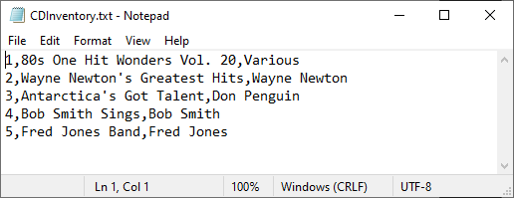

Figure – CDInventory.txt

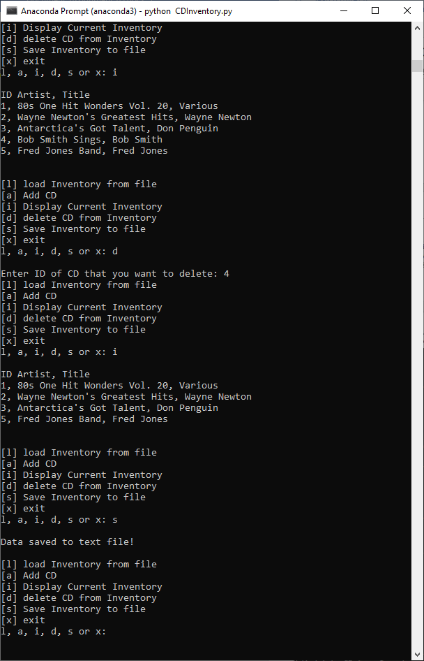

Figure --CDInventory.py run in terminal window

# LAB 05-A: Working with Files and Lists:

This lab works by using the a 2D List (ie inner and outer list) to append data, read data from a text file, write data to a text file, display current inventory and exit the program.

* If add is selected,
  + then the script opens two input() functions for artist and title
  + assigned the artist and title values to a list and then appends that list to a list of lists
* If write is selected,
  + Open text file for write
  + Parse each row in list of lists and add a comma to the end of each item
  + Write to the text file and close the text file
* If read is selected,
  + Clear old table from memory
  + Open text file as read only
  + Parse each row with for loop and load into list with strip() method to remove leading and trailing spaces and split() method to split the string into a list (lstRow)
  + Append to list of list (ie lstTbl)
* If display is selected, a simple script is run to print out the current values stored in memory

# LAB 05-B: Working with Files and Dictionaries:

This lab is similar to Lab 05-A, except with a dictionary as the inner data structure.

# Summary

In summary, I learned the difference between a dictionary and a list. A list is used to store several items within a single variable. The list stores data sequentially via an index which starts at 0. Whereas a dictionary stores data in pairs with a key and a value. As an example, a dictionary entry may have a key called ‘ID’ with a value that is ‘11’. Another example is an actual dictionary where the word is the key, and the definition is the value. Elements in lists are accessed by the index value. While dictionary elements are accessed by the key value. An example the of how dictionaries are different can be seen in line 63 of CDInventory.py in the appendix. The search was limited to a specific key ‘ID’ value and not an index as would be the case in a list.

# Appendix

## Listing CDInventory.py

1. #------------------------------------------#
2. # Title: CDInventory.py
3. # Desc: Script for Assignment 05
4. # Change Log: (Who, When, What)
5. # Bill McGinty, 2022-Feb-27, Created File
6. #------------------------------------------#
8. # declare variables
9. # replaced list of lists with list of dicts
10. strChoice **=** "" # User input
11. lstTbl **=** []  # list of lists to hold data
12. dicRow **=** {}  # dictionary (replaced List lstRow)
13. #declare dictionary data types
14. intID **=** 0
15. strTitle **=** ""
16. strArtist **=** ""
18. rowToDelete **=** 0 # counter for delete functionality
20. strFileName **=** "CDInventory.txt"  # data storage file
21. objFile **=** None  # file object
23. # Get user Input
24. print("The Magic CD Inventory\n")
25. **while** True:
26. # Menu allowing the user to choose:
27. print("[l] load Inventory from file\n[a] Add CD\n[i] Display Current Inventory")
28. print("[d] delete CD from Inventory\n[s] Save Inventory to file\n[x] exit")
29. strChoice **=** input("l, a, i, d, s or x: ").lower()
30. print()
31. # Program exit
32. **if** strChoice **==** "x":
33. **break**
34. # Load from text file
35. **if** strChoice **==** "l":
36. lstTbl.clear()
37. objFile **=** open(strFileName, "r") # open text file as read only
38. **for** row **in** objFile:
39. lstRow **=** row.strip().split(",")
40. dicRow **=** {"ID": int(lstRow[0]), "CD Title": lstRow[1], "CD Artist": lstRow[2]}
41. lstTbl.append(dicRow)
42. objFile.close() # close text file
43. # Append to existing data within program variables not text file
44. **elif** strChoice **==** "a":
45. strID **=** input("Enter an ID (Integer Only!): ")
46. strTitle **=** input("Enter the CD\"s Title: ")
47. strArtist **=** input("Enter the Artist\"s Name: ")
48. intID **=** int(strID)
49. dicRow **=** {"ID": int(intID), "CD Title": strTitle, "CD Artist": strArtist}
50. lstTbl.append(dicRow)
51. # Display current inventory in memory (not text file)
52. **elif** strChoice **==** "i":
53. print("ID", "Artist, Title")
54. **for** row **in** lstTbl:
55. print(**\***row.values(), sep **=** ", ")
56. print("\n")
57. # Allow user to input the ID they wish to delete
58. **elif** strChoice **==** "d":
59. intIDtoDelete **=** input("Enter ID of CD that you want to delete: ")
60. deleteID **=** int(intIDtoDelete)
61. rowToDelete **=** 0
62. **for** row **in** lstTbl:
63. **if** lstTbl[rowToDelete]["ID"] **==** deleteID:
64. lstTbl.pop(rowToDelete)
65. rowToDelete **+=** 1
66. # Save to text file
67. **elif** strChoice **==** "s":
68. objFile **=** open(strFileName, "w") # open text file write mode
69. **for** row **in** lstTbl:
70. strRow **=** ""
71. **for** item **in** row.values():
72. strRow **+=** str(item) **+** ","
73. strRow **=** strRow[:**-**1] **+** "\n"
74. objFile.write(strRow)
75. objFile.close() # close text file
76. print("Data saved to text file!\n")
77. **else**:
78. print("Please choose either l, a, i, d, s or x!\n")