**Homework, SQL Joins**

**All tables for the orion library are in the orion subdirectory**

**All tables for the train library are in the train subdirectory**

1. **Use an Inner Join**

Produce a report containing **Employee_Name** and calculated years of service (YOS) as of December 31, 2007, by joining **orion.Employee_Addresses** and **orion.Employee_Payroll** on **Employee_ID**. Label the columns and provide appropriate titles as noted below. Limit the report to employees where YOS > 30. Order the output alphabetically by **Employee_Name**.

The **orion.Employee_Addresses** table contains the **Employee_Name** column.

The **orion.Employee_Payroll** table contains the **Employee_Hire_Date** column.

Both **orion.Employee_Addresses** and **orion.Employee_Payroll** contain columns named **Employee_ID**.

Use TITLE1 and TITLE2 statements to produce title lines. The first line should read Employees with More than 30 Years of Service. The second line should read As of December 31, 2007

Age/years of service calculations can be difficult to render precisely. In this course, you use the following:  
 **YOS** =**int(('31DEC2007'd= Employee_Hire_Date)/365.25)**Others might use the INTCK function:

**YOS=intck('year',Employee_Hire_Date,'31DEC2007'd)**

**Requested output (partial):**

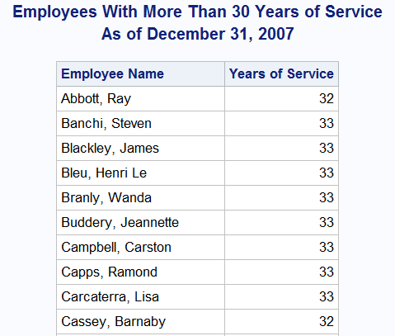

1. **Use an Outer Join**

Join **orion.Sales** and **orion.Employee_Addresses** on **Employee_ID** to create a report showing the names and cities of all Orion Star employees, and if an employee is in Sales, the job title. Present the report in alphabetical order by city, job title, and name.

The **orion.Sales** table contains a record for every employee in the Sales Department and includes columns **Employee_ID** and **Job_Title**.

The **orion.Employee_Addresses** table contains a record for every employee and includes **Employee_ID**, **Employee_Name**, and **City**.

Requested Output (Partial);

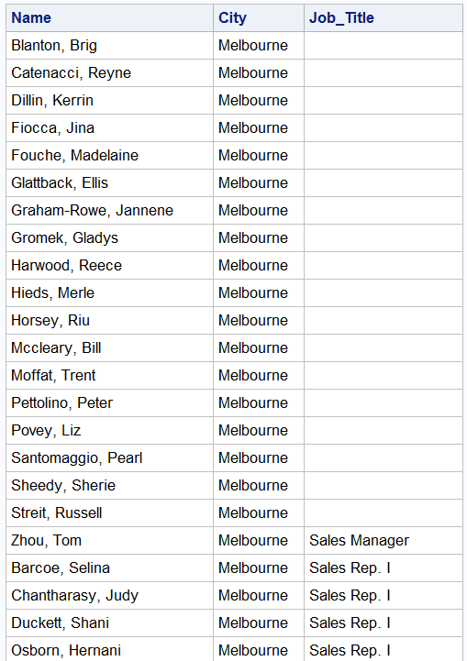

1. **Joining Multiple Tables**

Create a report showing Orion Star Internet customers residing in the U.S. or Australia who purchased foreign manufactured products, that is, a product that was not manufactured in their country of residence. The report should be titled **US and Australian Internet Customers Purchasing Foreign Manufactured Products** and should display the customers’ names and the number of foreign purchases made. Present the information so that those with the largest number of purchases appear at the top of the report, and customers who have the same number of purchases are displayed in alphabetical order.

**Employee_ID** 99999999 is a dummy ID that can be used to identify Internet orders. The data that you need can be found in the listed columns of the following tables:

**orion.Product_Dim** contains

**Product_ID**

**Supplier_Country**

**orion.Order_Fact** contains

**Product_ID**

**Customer_ID**

**orion.Customer** contains

**Customer_ID**

**Country**

Requested Output:

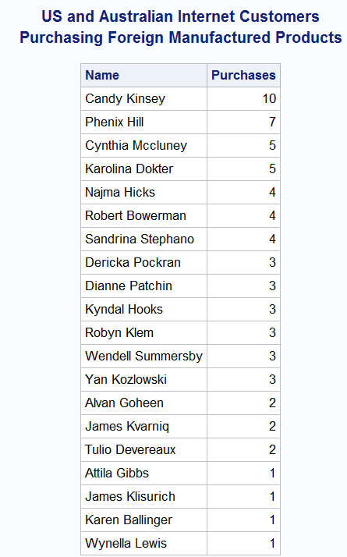

1. **Joining Multiple Tables**

Create a report of Orion Star employees with more than 30 years of service as of December 31, 2007. Display the employee’s name, years of service, and the employee’s manager’s name. Order the report alphabetically by manager name, by descending years of service, and then alphabetically by employee name. Label the columns and title the report as shown in the sample output.

The data that you need can be found in the listed columns of the following tables:

**orion.Employee_Addresses** contains

**Employee_ID**

**Employee_Name**

**orion.Employee_Payroll** contains

**Employee_ID**

**Employee_Hire_Date**

**orion.Employee_Organization** contains

**Employee_ID**

**Manager_ID** (**Employee_ID** of the person’s manager)

Requested Output (Partial):

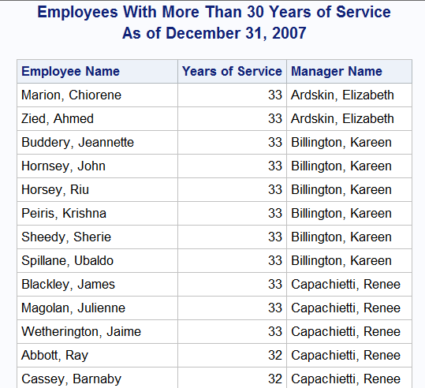

1. **Use an inner join with orion.employee payroll and orion.employee_addresses to produce the following report:**

**Partial output:**

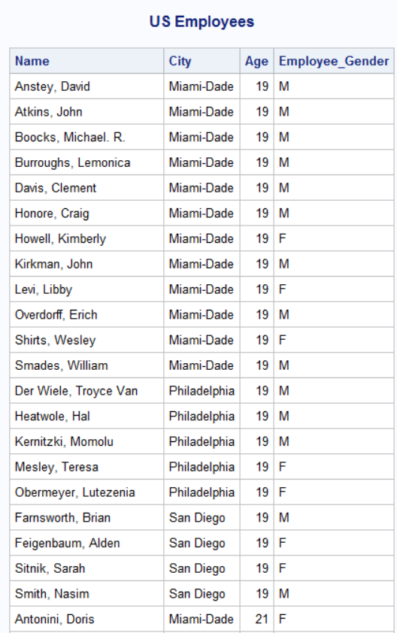

1. **Use an inner join with** train.staffmaster and train.payrollmaster to produce the following report. The reports contains the names (first initial with period followed by last name), jobcodes, and genders of employees who live in New Jersey. The report is ordered by job gender and job code.

Partial Output:

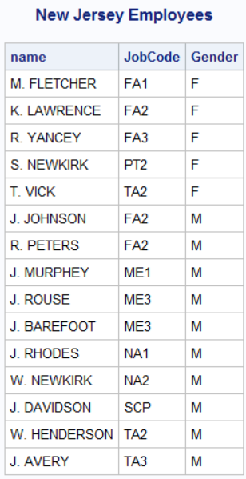

1. 1. Use the following program to create the datasets t1 and t2.

**data** t1 t2;

call streaminit(**54321**);

do id=**1**,**7**,**4**,**2**,**6**,**11**,**9**;

chol=int(rand("Normal",**240**,**40**));

sbp=int(rand("Normal",**120**,**20**));

output t1;

end;

do id1=**2**,**1**,**5**,**7**,**3**,**9**;

chol=int(rand("Normal",**240**,**40**));

sbp=int(rand("Normal",**120**,**20**));

output t2;

end;

run;

title "t1";

**proc** **print** data=t1 noobs;**run**;

title "t2";

**proc** **print** data=t2 noobs;**run**;

title;

* 1. Use the coalesce function with an inner join (on equal id’s) to create the following report.

Complete output:

