CP2602- Plinazolin Efficacy Trial

Objective: Evaluate the efficacy of plinazolin (trade name Vertento) for the management of Cowpea Cucrlio (Chalcodermus aeneus) in southern pea (Vigna unguiculata).

Experimental Design:
Randomized complete block design with four replications

Single-factor treatment design
- Application rate of plinazolin

Application Rate:
- 0 fl oz/A (control)
- 1.1 fl oz/A
- 1.6 fl oz/A
- 2.0 fl oz/A

The cowpea variety Cornet Pinkeye Purplehull will be used for this study.

Plots are 4 rows wide and 25 feet long. Plots will be separated by two rows of non-treated buffer. Blocks will be separated by a 5 ft. alley.
The total trial area is 26 rows wide by 125 ft. long

The pesticide will be applied once using a backpack sprayer at the initiation of flowering.

Data:
10 plants (5 plants per row) from the middle of the two inner rows of each plot will be sampled for data collection. Traits will be collected per plot.

Traits:
- Planting date
- Stand count
- Number of mature pods
- Weight of mature pods (g)
- Number of seed from 10 pods
- Weight of seed from 10 pods (g)
- Number of punctured seeds from 10 pods
- Number of non-punctured (clean) seeds

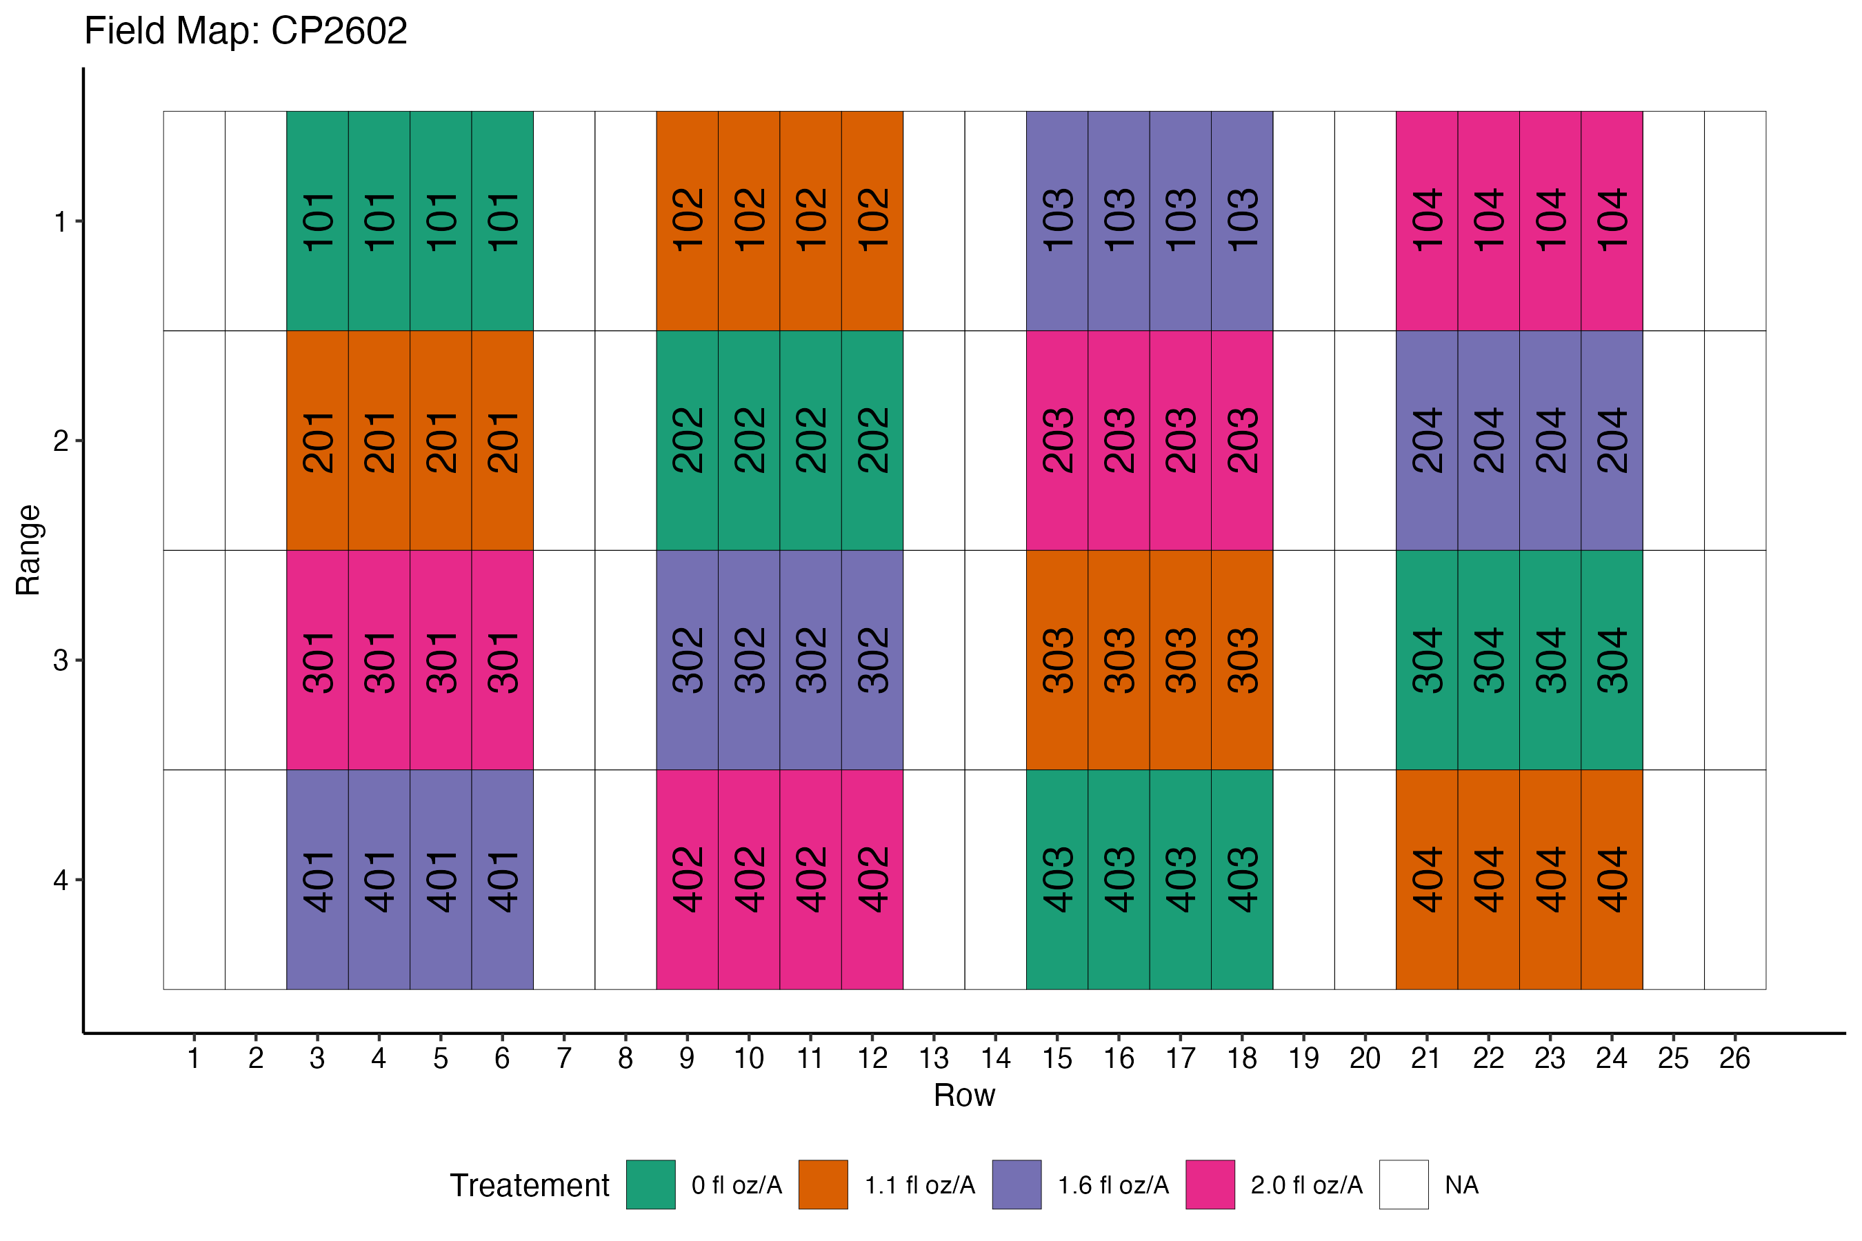
Fig. 1 – Field layout. Note: The alleys separating ranges are not shown. Figure not to scale.

