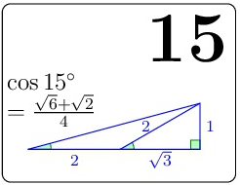 | $$\sqrt{{\left(2+\sqrt{3}\right)}^{2}+1^{2}}$$  $$=\sqrt{8+4\sqrt{3}}$$  $$=\sqrt{2(4+2\sqrt{3})}$$ | $$=\sqrt{2}*\sqrt{4+2\sqrt{3}}$$  $$=\sqrt{2}*\sqrt{{\sqrt{3}}^{2}+2\sqrt{3}{+1}^{2}}$$  $$=\sqrt{2}*\sqrt{\sqrt{3}+1}$$  $$=\sqrt{6}*\sqrt{2}$$

