通信业列表
the iPhone (June 2007)

Nokia Siemens Networks (April 1, 2007)

the NSA call database scandal (May 2006)

videoblog (2005)

VeriChip (2005) is a Radio Frequency IDentification device

SkyDSL (200?)



Wi-Fi (2004)



newscorp (November 12, 2004)

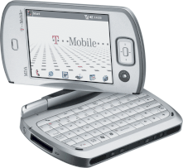

smartphones (2004) began to make up an increasingly large part of the mobile phone market

3G mobile phone systems (2003)

Nullsoft Streaming Video (2003)

podcasting (2003)

WorldCom (July 21, 2002) went bankrupt

Voice over IP (200?)

Ultra Wideband (200?)

Digital terrestrial television (2002)

the Information Awareness Office (January 2002)

300,000,000 computers on the Internet (2001)

the U.S.-China spy plane incident (April 1, 2001)

AOL purchased Time Warner (January 11, 2001) Time Warner was
created in 1990 by the merger of Time Inc. and Warner Communications

ASIMO (2000) is a humanoid robot

interactive voice response

Napster (1999) was the first peer-to-peer file sharing network

Big Brother (September 1999)

ADSL (1999) was introduced in many countries with downstream rates
starting at 256 kbit/s and 8 Mbit/s as the current maximum transfer speed,

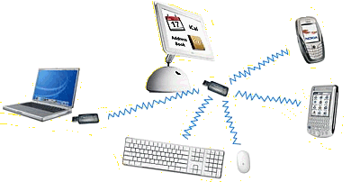

Bluetooth (May 20, 1999) is an industrial specification for wireless personal area networks

Iridium communications service (November 1, 1998)

The Highwaymen (1998) Ken Auletta

the Digital Millennium Copyright Act (October 28, 1998)

News (January 17, 1998) of the Lewinsky scandal first broke on the Drudge Report website, which reported
that Newsweek editors were sitting on a story by investigative reporter Michael Isikoff exposing the affair

Webby Awards (1996)

ICQ (November 1996)

Hotmail (July 4, 1996)

the Apache HTTP Server (April 1996) became the most popular server on the net

the Palm Pilot PDA (1996) was released

Telecommunications Act (February 8, 1996)

Dragon (1995) released discrete word dictation-level speech recognition software. It was the first time dictation
speech recognition technology was available to consumers. IBM and Kurzweil followed a few months later.
In 1997 Dragon introduced "Naturally Speaking", the first "continuous speech" dictation software available
(meaning you no longer need to pause between words for the computer to understand what you're saying)

VeriSign (1995) is a company that operates a diverse array of network
infrastructure, including two of the Internet's thirteen root nameservers

Deutsche Telekom AG (1995)

Kevin Mitnick (February 15, 1995) was arrested by the FBI

the NSFNET Backbone Service, operating since 1987, was successfully transitioned (April 30, 1995)
to a new architecture, where traffic is exchanged at interconnection points called Network access points

E-mail spamming (1994)

America Online (1994) announced that it had reached 1 million subscribers

Justin Hall (1994) who began eleven years of personal blogging while a student at Swarthmore College, is generally
recognized as one of the earliest bloggers. The term "weblog" was coined by Jorn Barger in December 1997.



the World Wide Web Consortium (1994) creates standards that Web developers should
try to conform to, in order to maximize the ability of others to access their Web sites

online editions of the major newspapers (1990s)



the World Wide Web Wanderer (June, 1993) was a perl based web crawler that was first deployed to
measure the size of the World Wide Web. The Software was developed at MIT by Matthew Gray. Later
in 1993, it was used to generate an index called the "Wandex", providing the first search engine on the web

Wired magazine (March 1993)

the High Frequency Active Auroral Research Program (1993)

SMS (1992)



the Internet Society (1992) is the parent corporation of the Internet
Architecture Board and the Internet Engineering Task Force

Ipswitch (1992) released Ws_ftp

mobilcom AG (1991)

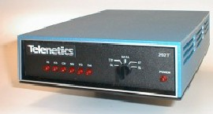

the SupraFax 14400 (1991) ran at the 14.4 kbit/s rate



Pretty Good Privacy (1991)

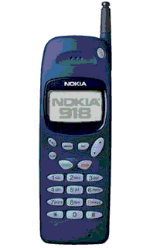

second generation mobile phone systems (1991) such as GSM, IS-136 ("TDMA"), iDEN and IS-95
("CDMA") began to be introduced. The first digital cellular phone call was made in the United States
in 1990, in 1991 the first GSM network opened in Europe

Big Brother Awards (1990)

GPS-based automotive navigation systems (1990)

the Hubble Space Telescope (April 4, 1990) was put in space by pace NASA's Space Shuttle Discovery

the www (1990) as well as http, html and urls were invented by Tim Berners-Lee at Cern

ISDN (1990s)

the first of 24 satellites (February 14, 1989) that form the current GPS constellation
(Block II) was placed into orbit. The 52nd GPS satellite since the beginning in 1978
was launched November 6, 2004 aboard a Delta II rocket

the first dial-up internet service provider (1989) was world.std.com

email clients (1988)

most dialup modems follow the Hayes Command Set (1988) it was originally developed for the Hayes Smartmodem 2400

Radio Data System (1987)

the File Transfer Protocol (October 1985) was first developed in 1971 for
implementation on hosts at M.I.T. In 1985 ftp was defined by the RFC 959 documnet

the Domain Name System (1984) was introduced by Paul Mockapetris.
Symbolics.com became the first registered commercial domain name

the cordless telephone (1980s)

Racal Telecom (1983)

the TCP/IP protocol (January 1, 1983) began to be used for ARPAnet and the Defense Data Network

:-)

emoticons (1982)

Telemarketing

bulletin board systems (1980s)

the first cell phone network with automatic roaming (September 1981) was started in Saudi Arabia

the router (1980)

voicemail (1980s)

telephone cards (1980s)

first-generation wireless telephone technology (early 1980s)

the first commercial cellular telephone network (1979) was installed in Tokyo by NTT

delivermail (1979)

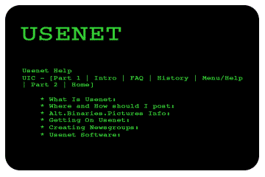

UUCP (1978) stands for Unix to Unix Copy Protocol, and is a computer program and protocol allowing
remote execution of commands and transfer of files, email and netnews between Unix computers
not connected to the Internet proper. In 1979 Tom Truscott and Jim Ellis of Duke University created
Usenet a distributed Internet discussion system that evolved from a general purpose UUCP network.
Now widely recognized concepts and terms such as "FAQ" and "spam" were originated on the usenet

the Foreign Intelligence Surveillance Act (1978)

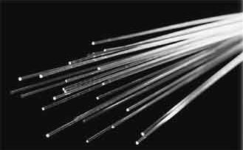

fiber-optic communication systems (1975)

modern fax machines (1970s)

cctv (1970s)

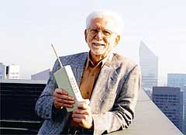

modern mobile telephony (April 3, 1973) is considered to have started when
Motorola employee Martin Cooper placed a call to rival AT&T's Bell Labs
while walking the streets of New York City talking on Motorola DynaTAC

the Watergate scandal (June 17, 1972-1974)

@

the use of the at sign (1971) was introduced by Ray Tomlinson. Email had started in 1965

Accuracy in Media (1969)

Menwith Hill (1966)

the ISBN system (1966)

country calling codes (1964) were defined by the ITU

infowars

Citizens' band radio (1960s)

radar warning receivers

road-rule enforcement cameras (1960s)

LORAN-C (1957)

answering machines (1957)

Teleprompter (1950s)

flat rates

1-800 numbers

hearing aids

NSA (December 10, 1951)

Cable television

Nineteen Eighty-Four (June 8, 1949)

the 0G generation of mobile telephones (1945)

GEE (March 1942)

walkie-talkies (1940)

the War of the Worlds (October 30, 1938)

the Federal Communications Commission (1934)

Telex (1930s)

Hellschreiber (1929)

disinformation

Edward Bernays' Propaganda (1928)

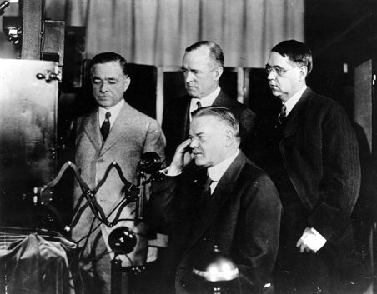

the first long distance television transmission (April 7, 1927) was over telephone lines from
Washington, DC to New York City. The image shown was of then Commerce Secretary Herbert Hoover

Hill & Knowlton (1927)

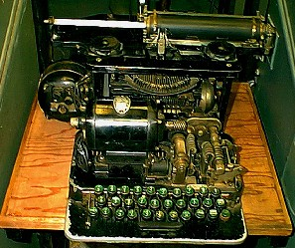

the Model 12 (1922) was the first general purpose teletype

the Sedition Act (1918)

the telephone booth became common in industrialized countries in the (1910s)

the American Messenger Company (1907) was renamed United Parcel Service in 1919

radar (1904)

Very high frequency

Shortwave

Longwave

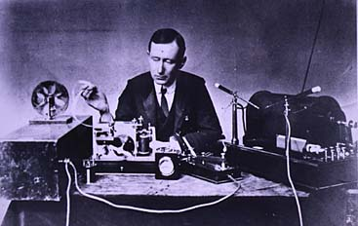

Guglielmo Marconi (December 11, 1901) transmitted first long
distance communication using electromagnetic or radio waves

blue pages

yellow pages

white pages

Erfindung der Kathodenstrahlröhre (1897) Ferdinand Braun

Nikola Tesla (1893) made the first public demonstration of radio communication

Heinrich Hertz (1888) detects and produces radio waves for the first time. Radio waves are
called Hertzian waves until renamed by Guglielmo Marconi, who calls them radiotelegraphy waves

AT&T (March 3, 1885)

the megaphone (1878)

the first telephone exchange opened (1878) in New Haven, Connecticut

Emile Berliner invented the first microphone on (March 4, 1877) but
the first useful microphone was invented by Alexander Graham Bell

Patentantrag für ein Telefon durch Alexander Graham Bell (1876) wenige Stunden vor Elisha Grays Antrag

Speakers' Corner (1872)

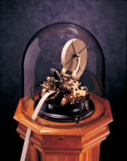

ticker tape machines (1870s-1960s)

the International Telegraph Union (May 17, 1865)

erster funktionsfähiger Fernsprecher (1861) Philipp Reis

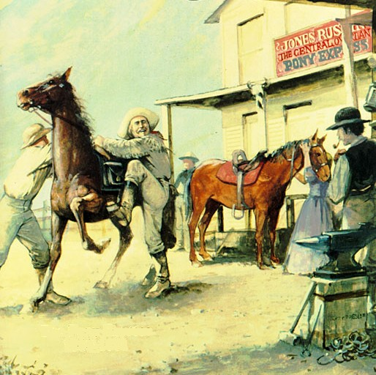

the Pony Express (April 3, 1860 - August 1861)

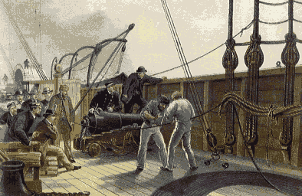

the first transatlantic telegraph cable (1858) between North America and Europe worked for only
one month. It had been laid been laid by Cyrus Field who laid a new, more durable cable in 1866.
The first direct transatlantic telephone cable was laid by Werner von Siemens in 1875

the British Post Office first encouraged people to install letter boxes to facilitate the delivery of mail in 1849

AP (1848)

Samuel Morse sent the telegraph message "What hath God wrought" (May 24, 1844) from the
Supreme Court room in Washington, D.C. to his assistant, Alfred Vail, in Baltimore, Maryland

the first commercial electrical telegraph (April 9, 1839) was constructed by Sir Charles Wheatstone and
Sir William Fothergill Cooke. It used the deflection of needles to represent messages and started operating
over thirteen miles (twenty-one kilometres) of the Great Western Railway on

Samuel Morse independently developed an electrical telegraph (1837)

the billboard (1835)

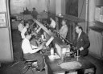

Agence Havas (1835) was founded as the first news agency in the world.
Today it is known as Agence Française de Presse.

adhesive postage stamps (1834)

Morse code (1830s)

the semaphore (1684)

post boxes (17th century)

the first printed newspaper was published (1605)

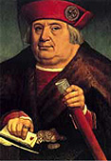
Franz von Taxis (1495) established the Reichspost

flyers

lighthouses (ca. 300 bc)

following the advice of Li Si, Qin Shi Huang (213 bc) ordered all
philosophy books and history books from states other than Qin to be burned

drums

pigeon post

advertising
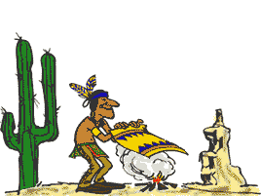

smoke signal

