**BeBox**

   BeBox本是为BeOS操作系统设计的硬件平台，不过最后全球只卖出了1800台，目前在eBay上的价格已经是几万美元难求。

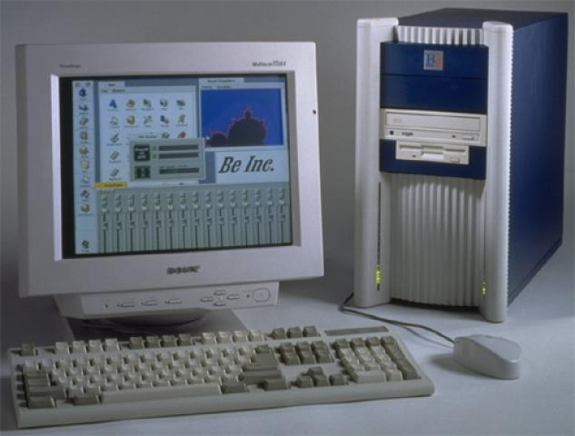

BeBox的故事从1990年开始，原型机使用一个At&T Hobbit处理器，到1991年已经设计出了30种原型机，处理器也升至5个。不过使用Hobbit处理器的BeBox从没有交付到用户手中，因为At&T在1994年停止了Hobbit处理器的生产。随后这款计算机改用了IBM的PowerPC处理器。

    面板上的两列LED指示灯分别同主机内部两个CPU相连，能够实时显示CPU的运行情况。

In October 1995, Be, Inc. unveiled its first (and last) computer, the BeBox.

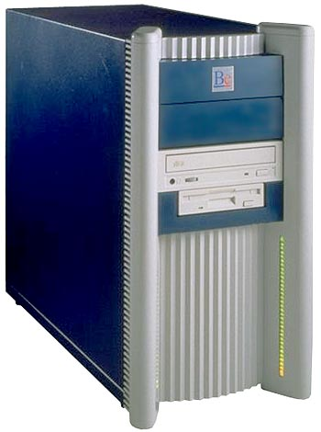

Be was founded in 1990 by Jean-Louis Gass? former manager of the French Apple subsidiary.  
For almost 5 years, 12 engineers from Apple, NeXT and Sun designed the BeBox and its operating system, BeOs. The total design cost was about US$9 million.   
  
BeBox hadware was based on a dual PowerPC 603 C.P.U. running at 66 MHz (later 133 MHz). The motherboard was not really innovative but featured a large range of Input/Output ports, including IDE and SCSI HDD interfaces, standard PC card slots, MIDI, audio, infrared ports plus a special GeekPort for hardware experiments.   
  
The Be Operating System was also developed from the ground up. It aimed to be an alternative to the "Heavy weight" Windows and Mac OS's, which were handicaped by backward compatibility hardware and software issues.   
BeOs was a clear and clean multi-processor (up to 8), multi-threading, multi-tasking, GUI-based operating system, optimized for digital media management.  
The first BeBox machines were mainly intended for use by software developers, BeOs was delivered with Metrowerks CodeWarrior and C++ languages.

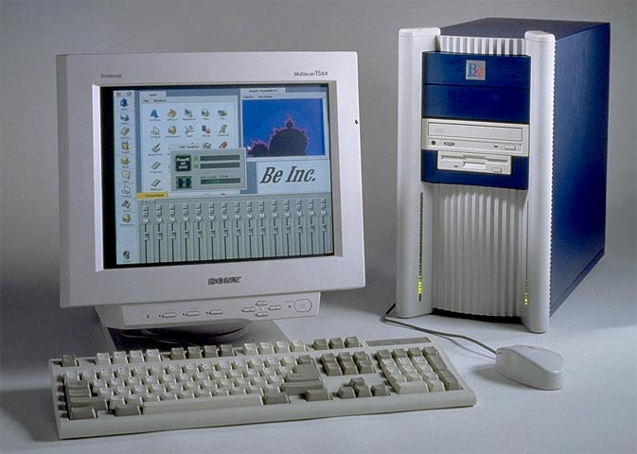

In spite of its numerous advanced features, the BeBox never met the success expected by its designers, mainly because it was compatible with nothing else in the computing industry. Less than 2000 machines were delivered between October 1995 and January 1997, when production ceased.   
  
In 1996, BeOs was ported to Apple PowerPC machines but Apple eventually preferred the NeXT basis for its future Mac OS X. Two years later, BeOs ran on Intel machines.   
  
Because of the small size of the company and the competition from much larger competitors, the Be adventure finally ended on Novembre 2001 when the company sold all of its intellectual property and technology assets to Palm. Just before this happened, J.L. Gass?offered for free the lastest version of his OS (R5) to Intel PC users.   
Nowadays, Although marginal, BeOs is still alive, and new releases and updates are regularly announced by the BeOs community.

**主要参数**

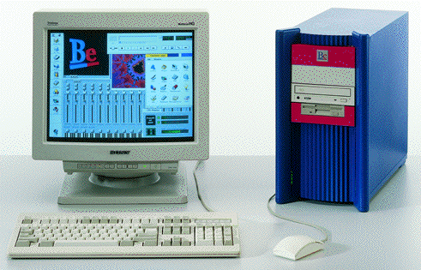

|  |  |
| --- | --- |
|  |  |

|  |  |
| --- | --- |
| **NAME** | BeBox |
| **MANUFACTURER** | Be |
| **TYPE** | Professional Computer |
| **ORIGIN** | U.S.A. |
| **YEAR** | October 1995 |
| **END OF PRODUCTION** | 1997 |
| **KEYBOARD** | Standard PC-AT |
| **CPU** | Two RISC-based PowerPC 603 or 603e |
| **SPEED** | 66 or 133 MHz |
| **RAM** | Up to 256 MB (up to 8 72-pin SIMM modules) |
| **ROM** | Unknown |
| **TEXT MODES** | 80 columns x 25 lines |
| **GRAPHIC MODES** | 640x480 to 1600x1200 |
| **COLORS** | 256 to 16.7 million |
| **SOUND** | 16-bit stereo sound system - Dual MIDI channels |
| **SIZE / WEIGHT** | 21 (W) x 39.8 (H) x 46.1 (D) cm |
| **I/O PORTS** | 4xserial, Parallel, 3xInfrared, SCSI II, 2xjoystick, 2xMidi, GeekPort |
| **BUILT IN MEDIA** | 3.5'' 1.44 MB FDD, SCSI & IDE HDD |
| **OS** | BeOs |
| **POWER SUPPLY** | Built-in 240W PSU |
| **PERIPHERALS** | 3 x PCI and 5 x ISA card slots |
| **PRICE** | Unknown |

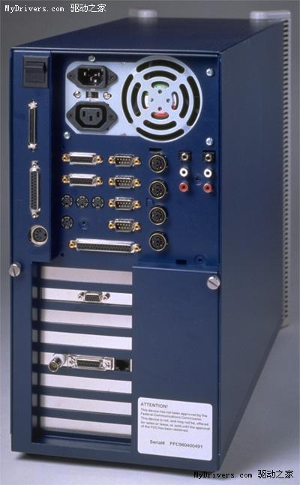

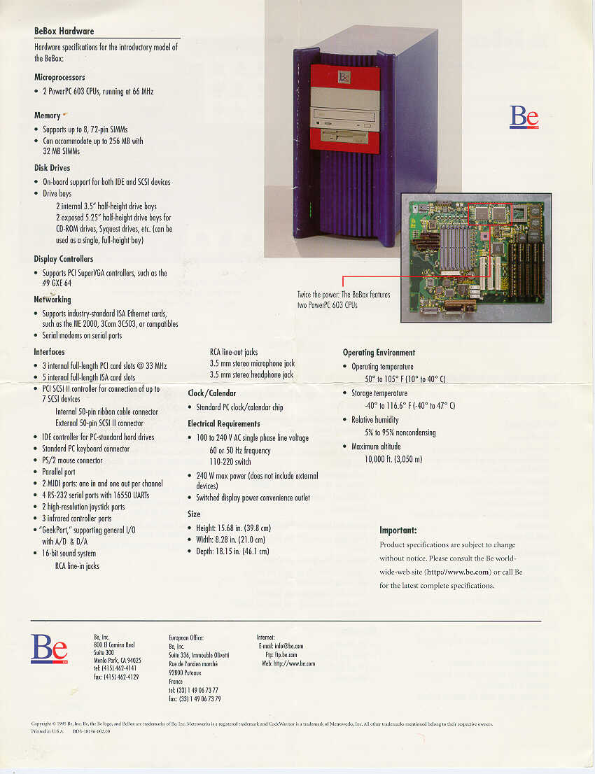

**详解**

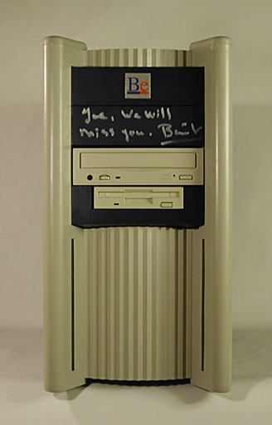

This is my BeBox, signed by all of the employees! It was presented to me on may last day at Be.

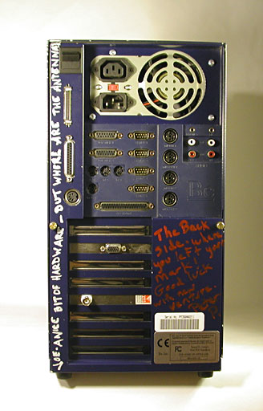

My favorite side of the computer! There are 26 IO connectors, plus two power connectors.

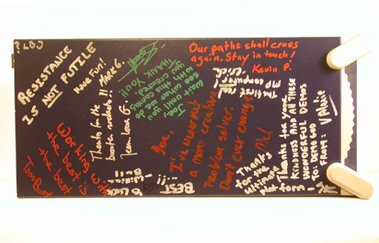

Top (This is where JLG signed)

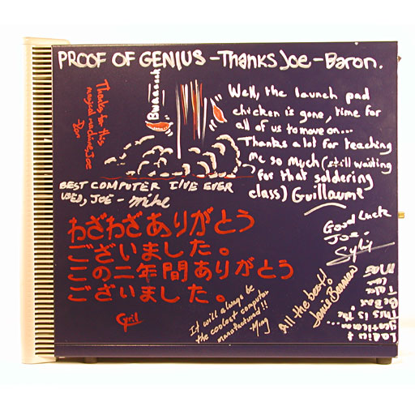

Right Side

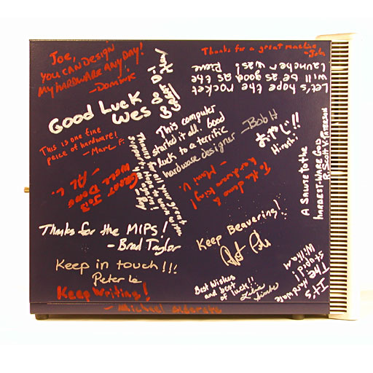

Left Side

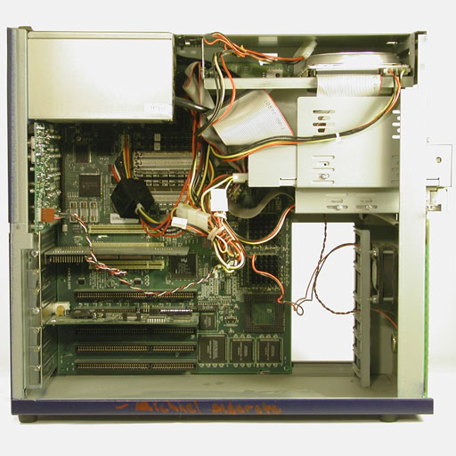

The insides

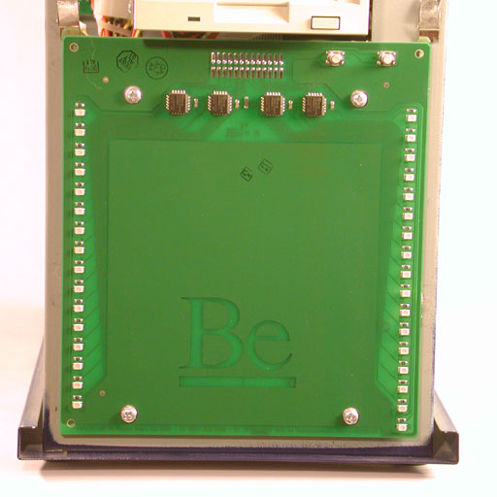

Das Blinken Lights

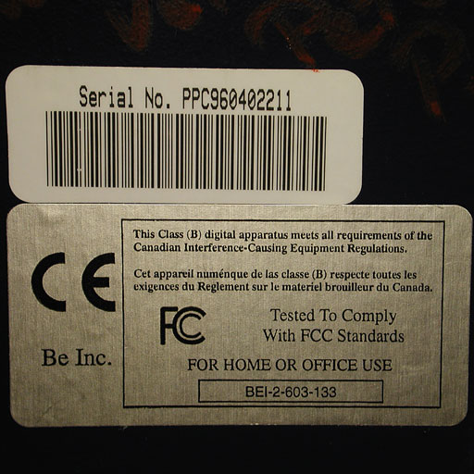

The Serial Number

**FCC Testing**

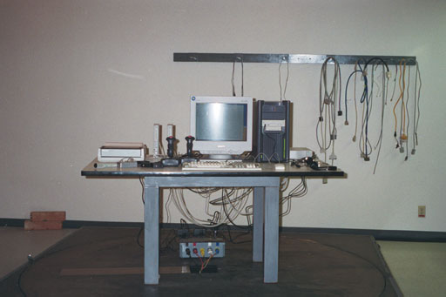

The BeBox at the FCC test lab

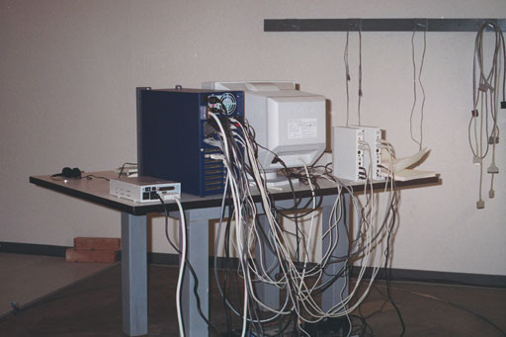

That's 29 cables! (every plug on the unit must have a working device attatched, so we even had headphones plugged into the jack on the CD player!

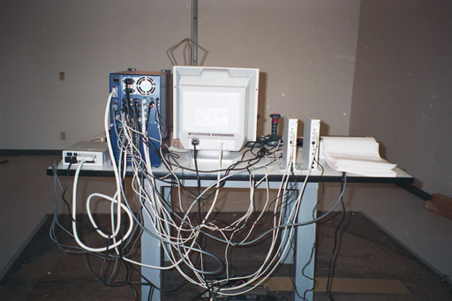

We even had to buy two Midi boxes, and a printer, just for testing!

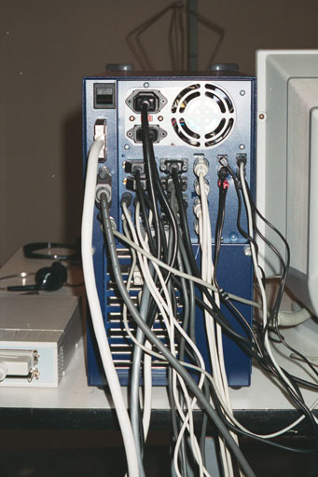

Here's a close up.

**The BeBox that never was...**

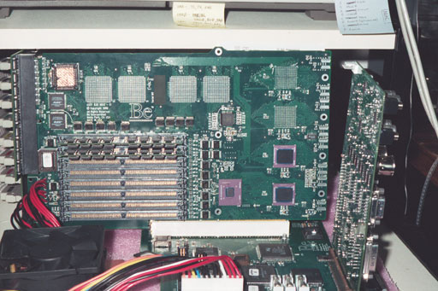

No, This is not really a quad 604 BeBox, It's just a really good Photoshop mock-up.

Oh, by the way, the chip covered in copper tape in the upper left corner is "Shampoo", and the twin chips below are her helpfull cousins "Lin-Lin" and "Ran-Ran"

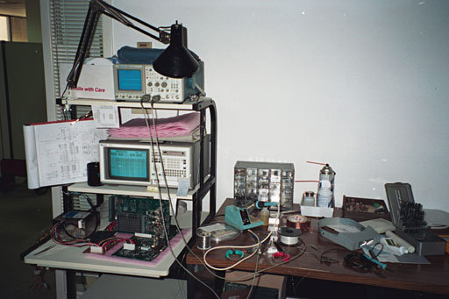

No comment

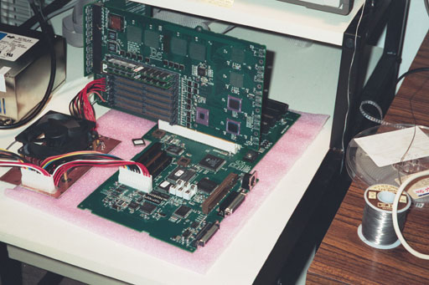

You didn't see this!

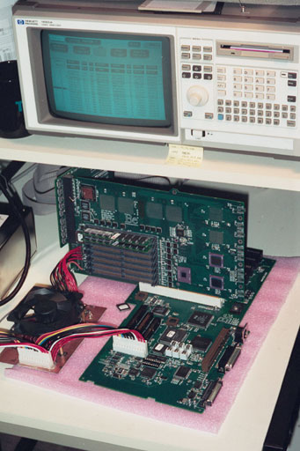

Or this.

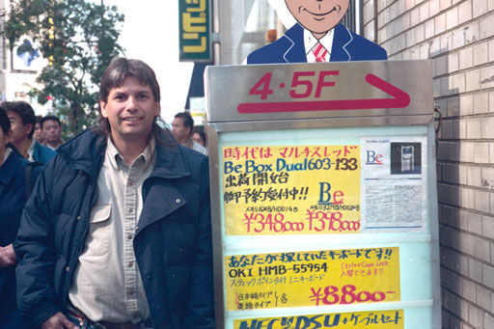

**相关网站**

• [The BeBox Zone](http://www.bebox.nu/)

• [BeBox Photo Gallery (Joseph Palmer: Be HW Engineer)](http://www.josephpalmer.com/BeBox/BeBox.shtml)

• [Pinout for the GeekPort connector](http://pinouts.ru/Motherboard/GeekPort_pinout.shtml)

**参考文献**

http://www.old-computers.com/MUSEUM/computer.asp?st=1&c=1142  
http://www.josephpalmer.com/BeBox/BeBox.shtml  
http://en.wikipedia.org/wiki/BeBox