**Compucolor II**

Compucolor II在1977年推出，被视为是第一台彩色个人计算机的鼻祖，当时的配备是Intel 8080A处理器，可从屏幕右侧的插槽插入软盘。

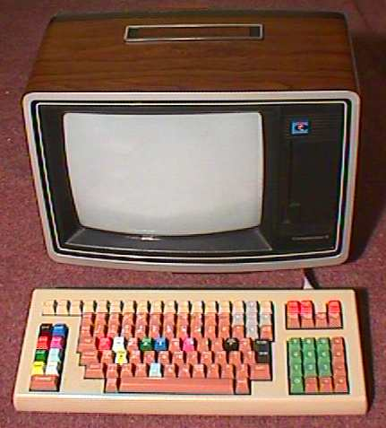

|  |  |
| --- | --- |
| Introduced: | 1977 |
| Original Price: |  |
| CPU: | Intel 8080A |
| Memory: | 48K |
| Operating System: | CompuColor ROM BASIC |
| Input/Output: | Built-in 53KB floppy disk drive, keyboard and monitor; numeric keypad; serial port; external floppy disk drive port |
| Bus: | N/A |
| Other Items in Collection: | Full documentation; users group newsletters; some software |
| Items Needed: | Star Trek program |

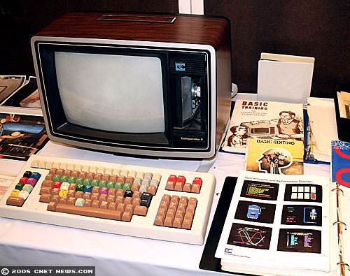

这款称之为Compucolor II的计算机在1977年推出，附带的是一款13英寸的电视。Compucolor II采用Intel 8080A 处理器，Compucolor II也被认为是世界上首款彩色计算机。

|  |  |
| --- | --- |
|  |  |

|  |  |
| --- | --- |
| **NAME** | CompuColor II |
| **MANUFACTURER** | ISC (Intelligent Systems Corp) |
| **TYPE** | Home Computer |
| **ORIGIN** | U.S.A. |
| **YEAR** | 1977 |
| **BUILT IN LANGUAGE** | CompuColor Basic |
| **KEYBOARD** | Full-stroke keyboard with colorful keys! Separate numeric keypad, function keys and arrow keys |
| **CPU** | Intel 8080A |
| **CO-PROCESSOR** | Intel CRT controller |
| **RAM** | 16, 32 or 48 kb depending on models |
| **ROM** | 16 kb |
| **TEXT MODES** | 40 x 24, 64 x 32 |
| **GRAPHIC MODES** | 128 x 128 |
| **COLORS** | 8 colors |
| **I/O PORTS** | Keyboard, monitor, serial port, external disk drive |
| **BUILT IN MEDIA** | 5.25'' disk-drive (51,2 kb, 40 tracks, average access time 400ms, transfer rate 76,8 Kb/s), built-in the monitor |
| **POWER SUPPLY** | Built-in PSU |
| **PERIPHERALS** | Additional disk drive |
| **PRICE** | $1495 (USA, 1980) 16k model: 1770 http://www.techcn.com.cn/uploads/201001/1263815491Ct8weAH2.gif(France, 1980) 32k model: 2103 http://www.techcn.com.cn/uploads/201001/1263815491Ct8weAH2.gif(France, 1980) |

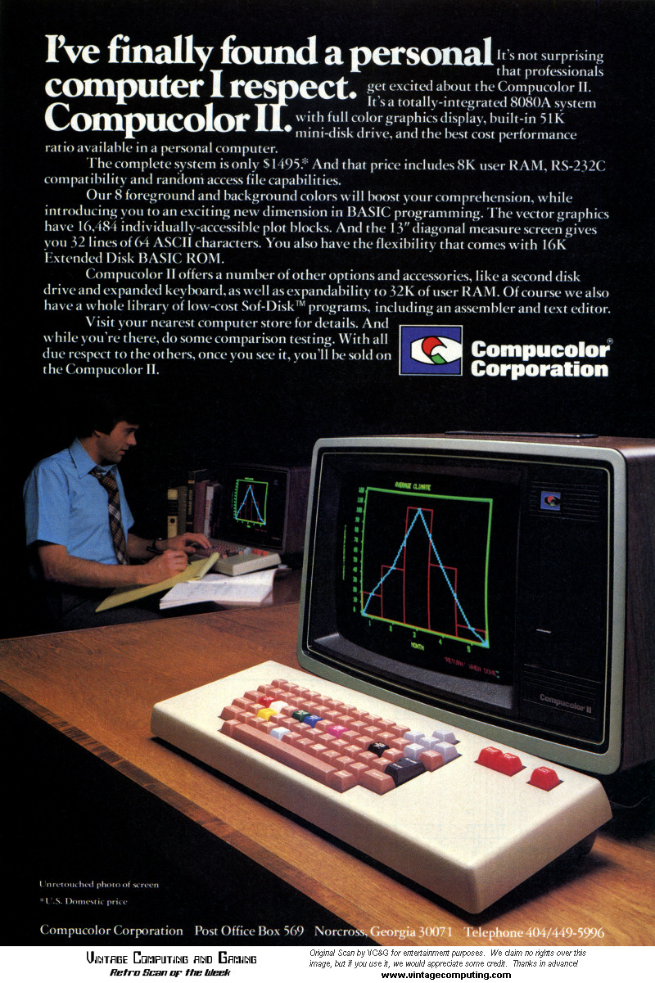

目录

• [简介](http://www.techcn.com.cn/index.php?doc-view-140236.html#1)

• [主要参数](http://www.techcn.com.cn/index.php?doc-view-140236.html#3)

• [主要规格](http://www.techcn.com.cn/index.php?doc-view-140236.html#5)

• [参考文献](http://www.techcn.com.cn/index.php?doc-view-140236.html#7)

简介[回目录](http://www.techcn.com.cn/index.php?doc-view-140236.html" \l "section)

The CompuColor II was an early home computer introduced in 1977 by Intelligent Systems Corporation. It was a lower-cost version of the Compucolor, which is credited with being the first home computer system with built-in color graphics, designed to hit the home computer price points.[1] Unlike its predecessor, it was an "all-in-one" computer, meaning that mainboard, monitor and floppy disk drive were integrated into one case.

To lower costs, the original CompuColor's custom monitor and housing was re-packaged into a standard RCA 13" color television set, from which the TV-tuner controls section was removed. The machine was based on the Intel 8080 and used an Intel-supplied graphics chip that provided 128 by 128 in 8 colors. The system was sold with as little as 8kB of RAM, expandable up to 48kB, and offered with one of three keyboards, which attached to the computer with a ribbon cable. A ROM-based BASIC was also included (apparently a pirated, but improved version of Microsoft BASIC).

The original CompuColor used an 8-track tape for storage, but this proved unreliable. In the CompuColor II, it was replaced with a 53kB 5,25" floppy disk drive, which was placed on the right side of the screen instead of the TV-tuner controls section. The file system drivers were not changed, which resulted in the Operating System continuing to think it was interfacing with a tape drive: When a file was deleted, the files beyond that point on the disk were moved to fill the empty space, using the 8kB portion of RAM dedicated to the video as a buffer.

Most software for this computer was written by hobbyists, with some software written by third-parties. Intelligent Systems Corporation created a few software titles of their of own. The most important title for the CompuColor II was probably a game called "Startrek". The predecessor CompuColor was advertised with the screen showing the game running from the 8-track tape.

主要参数[回目录](http://www.techcn.com.cn/index.php?doc-view-140236.html" \l "section)

Compucolor II Manufacturer Intelligent Systems Corp.   
Release date 1977   
Retail availability 1977-1993   
Operating system CompuColor OS   
CPU Intel 8080A   
Memory 8 KB (up to 32 KB)

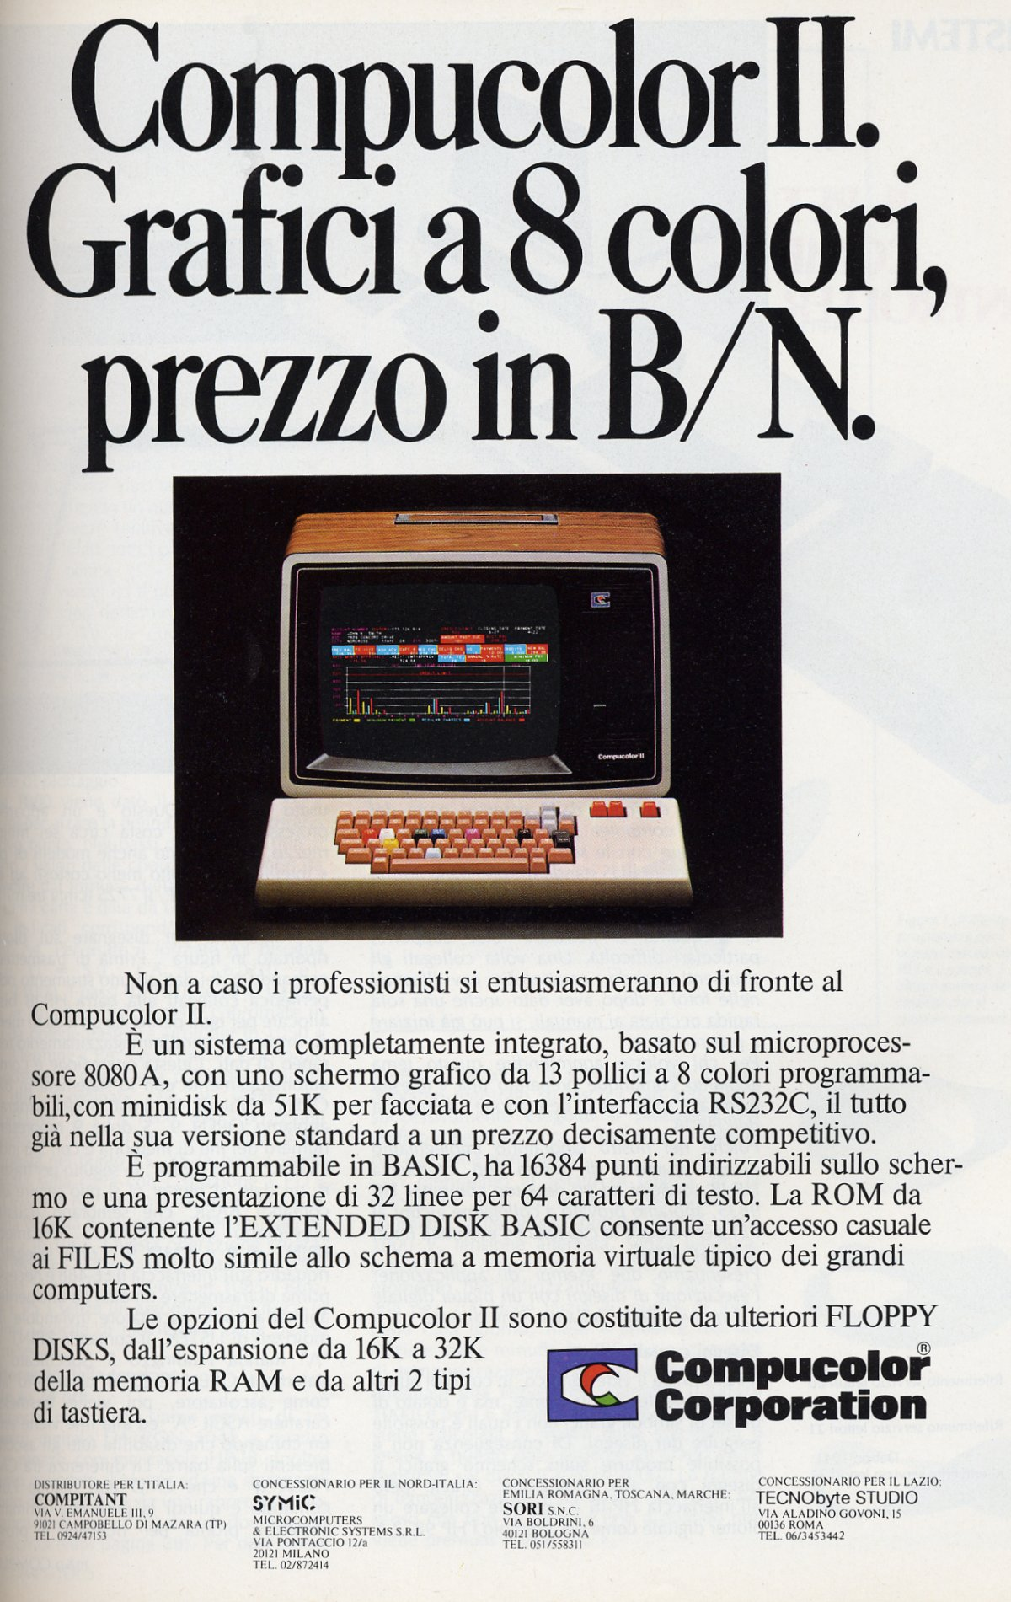

主要规格[回目录](http://www.techcn.com.cn/index.php?doc-view-140236.html" \l "section)

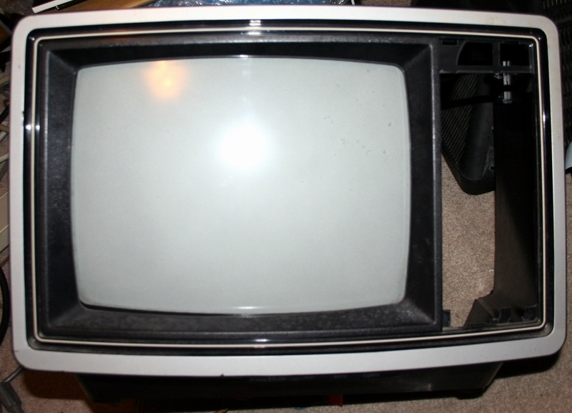

|  |  |
| --- | --- |
| **Description** |  |
| Manufacturer | Intelligent Systems Corp./Compucolor Corp. |
| Model | CompuColor II |
| Date Announced | 1977 |
| Date Canceled | Unknown |
| Number Produced | Thousands |
| Country of Origin | USA |
| Price | $1,500 and up |
| Current Value | $500+ |
|  |  |
| **Specifications** |  |
| Processor | Intel 8080 |
| Speed | 2 MHz |
| RAM | 16K-48K |
| ROM | 16K |
| Storage | Bult-in 5.25" disk drive |
| Expansion | None |
| Bus | None |
| Video | Built-in color video - 8 color, 128x128 resolution + text modes. |
| I/O | Modem port (serial?) |
| OS Options | Proprietary |
|  |  |
| Notes | The Compucolor II was built on the chassis of an RCA 13"color television set. The tuner was removed and replaced by the built-in disk drive and the computer board was placed below the picture tube. |
|  |  |
| Related Items in Collection | Manuals, software |
| Related Items Wanted | Additional software, disks, disk formatting program |

The Compucolor II in my collection arrived, was visually inspected and was promptly put on a variac and very slowly powered up to, hopefully, recondition the capacitors. It didn't work and I had a couple of firecrackers.

Those were quickly replaced only to expose some other issues with the high-voltage video control board.

As it stands the system is in mid-repair but I've decided to post some images anyway.

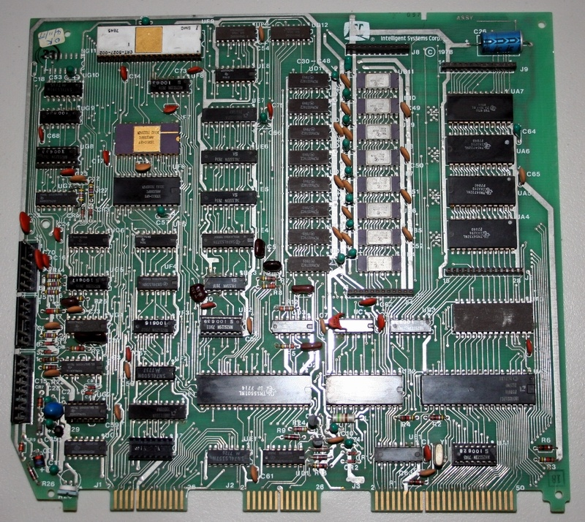

The Compucolor II computer is, for the most part, contained on this single board.

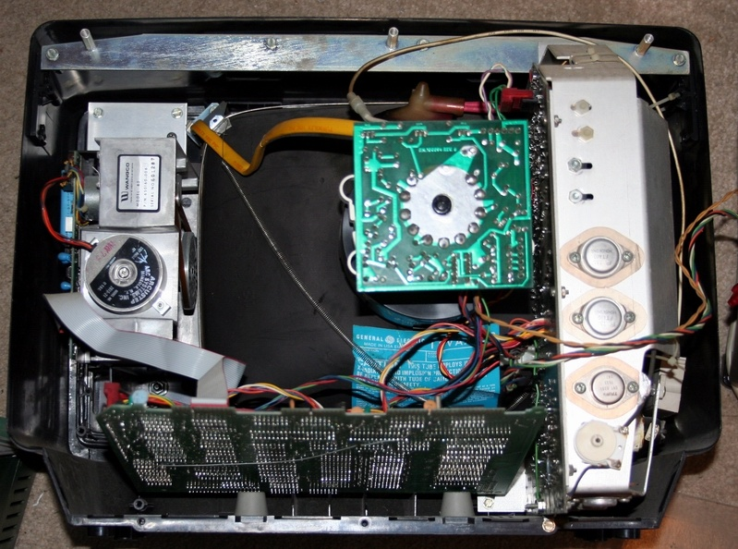

The board rests under the video tube in the hollowed out RCA TV chassis.

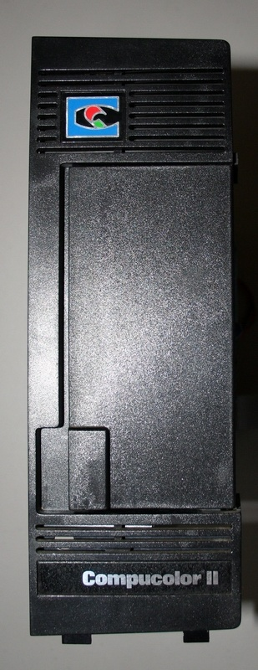

Missing from the above pictures is the CompuColor II disk drive which was removed for inspection and to get it out of the way.

参考文献[回目录](http://www.techcn.com.cn/index.php?doc-view-140236.html" \l "section)

<http://en.wikipedia.org/wiki/Compucolor_II>

<http://www.vintage-computer.com/compucolorii.shtml>