**HP 3000**

1972年惠普推出具有划时代意义的第一台个人计算工具：HP-35掌上科学计算器，并将工程计算尺淘汰。1973年，以HP 3000微电脑进军计算机领域。惠普小型通用计算机系统成为计算机界第一套数据分布式处理系统。

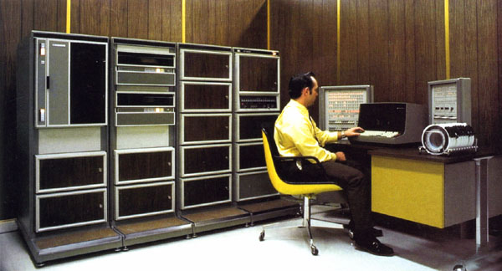

目录

• [HP 3000简介](http://www.techcn.com.cn/index.php?doc-view-141753.html#1)

• [HP 3000服务器退出历史舞台](http://www.techcn.com.cn/index.php?doc-view-141753.html#3)

• [Early HP 3000 history](http://www.techcn.com.cn/index.php?doc-view-141753.html#5)

• [背景：HP公司发展史](http://www.techcn.com.cn/index.php?doc-view-141753.html#7)

* • [相关链接](http://www.techcn.com.cn/index.php?doc-view-141753.html#9)
* • [参考文献](http://www.techcn.com.cn/index.php?doc-view-141753.html#11)

HP 3000简介[回目录](http://www.techcn.com.cn/index.php?doc-view-141753.html" \l "section)

The HP 3000 series is a family of minicomputers released by Hewlett-Packard in 1973. It was designed to be the first minicomputer delivered with a full featured operating system with time-sharing. The first models were withdrawn from the market until speed improvements could be made. It ultimately became known as a reliable and powerful business system. Early models had large cabinets with front panels, while later models were made that fit into desks using only terminal consoles for diagnostics, with bootstrap routines in ROM. Models ranged from a system sometimes used by a single user, to models that supported over two thousand users.

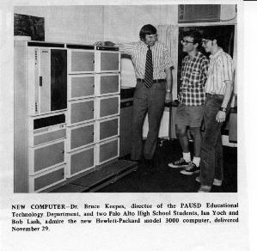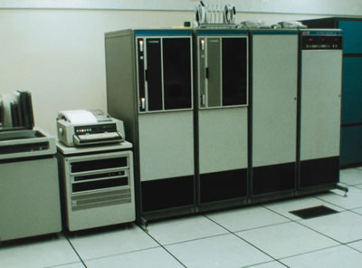

It was one of the last proprietary minicomputer systems to be retired by its vendor, outlasting the PDP-11-descended Digital Equipment Corporation VAX, which was acquired by Compaq and then ultimately by Hewlett Packard. After almost 30 years, a five-year phase-out period for the now-named e3000 series servers was announced in November 2001. HP extended this period twice. No more new e3000s are being sold, although used systems continue to be sold for upgrades on a third-party reseller market. Support from the vendor to customers for the HP 3000 continues through Dec. 31, 2010. Many third party firms are supporting the system for customers through the year 2013 and beyond. Some customers continue to use the HP 3000 in companies worldwide, especially in manufacturing and e-commerce industries, while others have migrated to business server systems made by HP and others.

HP 3000服务器退出历史舞台[回目录](http://www.techcn.com.cn/index.php?doc-view-141753.html" \l "section)

2001-11-22消息：惠普HP 3000服务器从星期三开始逐步退出舞台，这一个经典系列终于成为了经济衰退的牺牲品。

惠普公司建议消费者改用其它的惠普服务器，它将提供帮助。

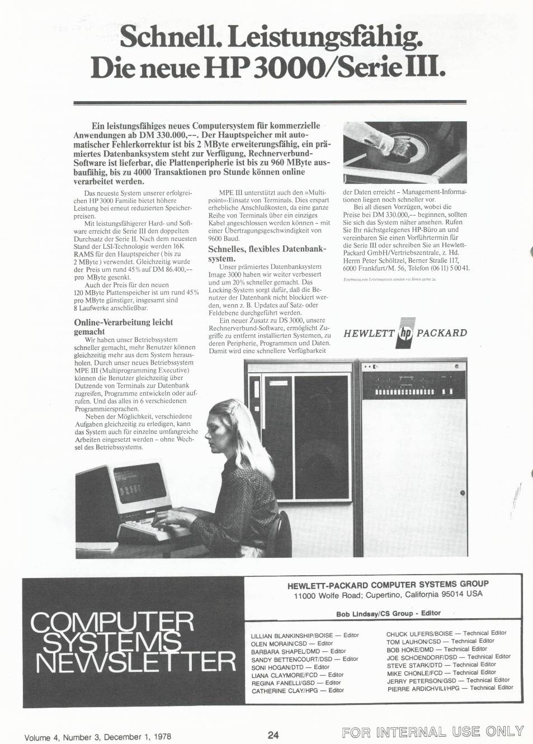

HP 3000从1972年上市，到现在已经有30年的历史。几年来该系统的支持、软件、销售和客户都在不断受到侵蚀。HP 3000的拥甭将在星期三的晚间在加州开会向它道别。

经济萧条促使惠普不断的裁员。它正准备和康柏合并，并努力在Unix服务器市场和Sun、IBM等对手竞争。康柏也曾面对过同样的难题，当时它决定取消使用Alpha芯片的Unix服务器，在Tru64版的Unix系统中使用英特尔的Itanium 系列芯片。这是一个艰难的转变，客户必须要把所有的软件翻到新的硬件平台上，这会导致他们投向其它公司的怀抱。

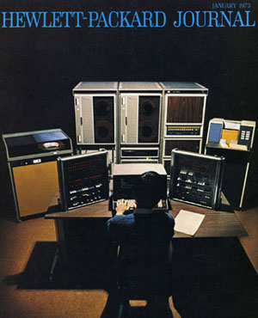

IBM的iSeries系列（也叫做AS/400）和HP 3000 类似，一直以来也有它将要寿终正寝的传言。但是IBM 不断重申对它的支持。HP 3000运行的是MPE系统，但是公司在服务器上的重点是9000 Unix服务器和NetServer系列的英特尔服务器。

HP 3000 系统的销售和升级将延续到2003年11月1日。惠普将提供迁移服务，贷款，咨询和外包服务。3000系列的支持将持续到2007年1月1日。新型的3000使用的是和 Unix服务器同样的硬件，拥有这些系统的客户将免费升级到Unix。

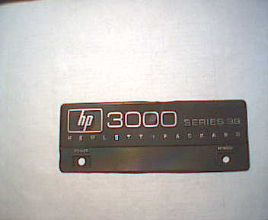

3000 当年是为了替代HP 2000，此前惠普放弃了和IBM大型机竞争的“Omega”，而3000正好填补了这一空白。在1972年和1973年，HP 3000最早的版本由于性能上的缺陷退出了市场。1975年的系列II才获得了成功。HP 3000 的用户少一些，但是都很忠诚，特别是在卫生，信用社和零售业。

Early HP 3000 history[回目录](http://www.techcn.com.cn/index.php?doc-view-141753.html" \l "section)

By Bob Green  
  
With HP announcing its sunset for the HP 3000 in 2007, I thought some of you might be feeling nostalgic for some history. The original 16-bit HP 3000 (later called “the Classic”) was released in 1972 and re-engineered into a 32-bit RISC processor in the 1980s.   
  
**Background (1964-1969)**

The HP 2000 Time-Shared Basic System (1968) was HP’s first big success in computers. The 2000 line was based on the 2116 computer, basically a DEC PDP-8 stretched from 12 to 16 bits. HP inherited the design of the 2216 computer when it acquired Data Systems, Inc. in 1964 from Union Carbide. The 2000 supported 16 to 32 time-sharing users, writing or running BASIC programs.

This product was incredibly successful, especially in schools. The original 2000A system was created by two guys working in a corner: Mike Green, who went on to found Tandem much later, and Steve Porter, who also went on to found his own computer company. Heavy sales of the 2000 brought the computer division of HP its first positive cash flow, and with it the urge to “make a contribution.” The engineers and programmers in Cupertino said to themselves, “If we can produce a time-sharing system this good using a junky computer like the 2116, think what we could accomplish if we designed our own computer.”

**Abortive First Try (1969-1970)**

The project to design a new computer, code-named “Omega,” brought new people into the Cupertino Lab, people who had experience with bigger operating systems on Burroughs and on IBM computers. The Omega team came up with a 32-bit mainframe: It was stack-oriented, had 32-bit instructions, data and I/O paths, eight index registers, up to 4 megabytes of main memory, up to four CPUs sharing the same memory and bus, both code segmentation and data segmentation, and a high-level systems programming language instead of Assembler; it was capable of multiprogramming from the start, and had support for many programming languages (not just BASIC as on the 2000).

The Omega was designed to compete with big CPUs. But Omega looked too risky to management. HP would have had to borrow long-term funds to finance the lease of machines to compete directly with IBM. So it was cancelled. Some of the Omega architects left HP, but most stayed. “Several people who remained took to wearing black-velvet armbands, in mourning for the cancelled project,” according to Dave Packard in his 1995 book, The HP Way.

**The 16-Bit Alpha (1970-71)**

Most of the Omega team were re-assigned to the Alpha project. This was an existing R&D project to produce a new 16-bit computer design. The Omega engineers and programmers were encouraged to continue with their objectives, but to limit themselves to a 16-bit machine. Alpha was Omega squeezed into 16 bits: 128 KB of main memory (max), one index register, and Huffman coding to support the many address modes desired (P+- for constants, DB+ for global variables, Q- for parameters, Q+ for local variables, and S- for expression evaluation).

**Same People, Smaller Hardware, Bigger Software**

The original design objectives for the Omega Operating System were limited to multiprogrammed batch. The Omega designers put off time-sharing to a later release that would be supported by a front-end communications processor. The cancellation of Omega gave the software designers another year to think of features that should be included in the Alpha Operating System.

As a result, the software specifications for this much smaller machine were now much more ambitious that those for the bigger Omega. They proposed batch, time-sharing and real-time processing, all at the same time, all at first release, and all without a front-end processor.

The instruction set of the Alpha was designed by the systems programmers who were going to write the compilers and operating system for the machine. The prevailing “computer science” philosophy of the day was that if the machine architecture was close to the structure of the systems programming languages, it would be easier to produce efficient, reliable software for the machine and you wouldn’t need to use Assembler (that is, a high-level language would be just as efficient and the code would be much easier to maintain).

The Alpha was a radical machine and it generated infectious enthusiasm. It had virtual memory, recursion, SPL instead of Assembler, friendly MPE with consistent batch and online capabilities instead of OS-360 with its obscure command syntax, variable-length segments instead of inflexible pages, and stacks instead of registers. The Alpha was announced as the HP 3000 with a fancy cabinet of pizza-oven doors, available in four colors. Prospective users were assured that it would support 64 users in 128 KB of memory.

**Harsh Realities (1972-73): 200 Pounds of Armor on a 90-Pound Knight**

I worked at Cupertino at the time and was assigned to coordinate the production of the ERS (External Reference Specifications) for the new software. I was as excited as everyone else. The first inkling I had that the HP 3000 was in trouble came in an MPE design meeting to review the system tables needed in main memory. Each of the ten project members described his part of MPE and his tables: code segment table, data segment table, file control blocks, etc. Some tables were memory-resident and some were swappable. When the total memory-resident requirements were calculated, they totaled more than the 128 KB maximum size of the machine.

MPE wouldn’t fit, so everyone squeezed: The programmers squeezed in 18-hour days, seven days a week trying to get MPE to work. Managers were telling their bosses that there was no problem, they just hadn’t had a chance to “optimize” MPE yet. When they did, the managers maintained, it would all turn out as originally promised. So marketing went on selling the machines to the many existing happy users of the HP 2000. As the scheduled date for the first shipment approached, the Cupertino factory was festooned with banners proclaiming “November Is a Happening.”

The first HP 3000 was shipped November 1, 1972 to Lawrence Livermore Hall of Science in Berkeley, California. But it was incomplete: It had no spooling, no real-time, etc. It supported only two users, and it crashed every 10 to 20 minutes. Customers who had been promised 64 terminals and who were used to the traditional HP reliability became increasingly frustrated and angry.

Eventually the differences between the HP 3000 reality and the HP 3000 fantasy became so large and well-known that there was even a news item in ComputerWorld magazine about it — the first bad press ever for HP. Bill and Dave were not amused. The product was withdrawn from the market for a short time.

**Struggling to Restore Lost Credibility (1973-74)**

Hewlett-Packard had no experience with bad publicity from low-quality products. Paul Ely was brought in from the successful Microwave Division to straighten out the computer group. The first priority was to help out the existing HP 3000 users, the ones who had trusted HP and placed early orders. Many of them received free 2000 systems to tide them over until the 3000 was improved. The second priority was to focus the programmers’ energy on fixing the reliability of MPE.

Once the HP managers realized the magnitude of the 3000 disaster, the division was in for lean times. Budgets and staffs that had swollen to handle vast projected sales were cut to the bone. Training, where I worked, was cut from 70 people to fewer than 20 in one day. HP adopted a firm “no futures” policy in answering customer questions (a policy that lasted for years after the HP 3000 trauma, but was forgotten by the time of the Spectrum-RISC project). The new division manager was strictly no nonsense. Many people had gotten in the habit of taking their coffee breaks in the final-assembly area, and kibitzing with the teams testing the new 3000s. Ely banned coffee cups from the factory floor and instituted rigorous management controls over the prima donnas of the computer group.

By continuing to work long weeks, the programmers managed to reduce MPE crashes from 48 a day to two, and to increase users from two to eight. Marketing finally took a look at what the 3000 could actually do, and found a market for it as a replacement for the IBM 1130. They sold the 3000 as a machine with more software capability than an IBM 1130 that could be available to a number of users at once instead of just one. Eventually the 3000 became a stable, useful product. To my mind, this happened when someone discovered the “24-day time bomb” bug. If you kept your HP 3000 running continuously for 24 days (2^31 milliseconds) without a shutdown or a crash, the internal clock register would overflow and the system would suddenly be set back by 25 days!

**The Comeback: Fulfilling the Promise (1975-76)**

The original 3000 had a minimum usable memory size of 96 KB and a maximum of 128 KB — not much of an expansion. The Series II went beyond that 16-bit limitation by adding “bank” registers for each of the key pointers (that is, code segment, data segment, and so on). Thus the Series II could support up to 512 KB, a much more reasonable configuration for the software power of MPE.

The choice of SPL as the HP 3000 machine language instead of Assembler truly began to pay off now in an avalanche of excellent software: The IMAGE database (again, two guys working in a corner: Jon Bale and Fred White) was soon joined by compilers for COBOL and RPG, a screen handler, and other tools to support transaction processing.

Concurrent, consistent batch and time-sharing was now a reality and the goal of concurrent real-time was finally dropped as unrealistic. The HP 3000 hardware now matched the software written for it. Business users discovered that the 3000 was great for online transaction processing; they dragged Hewlett-Packard firmly into the commercial information processing world.

At last, with the Series 64 in 1982, the 3000 reached the original target of 64 users on a single machine.

P.S. For another interesting history of the HP 3000, read HP’s Early Computers, Part Three: The Strongest Castle: The Rise, Fall and Rise of the HP 3000 by Chris Edlar at www.3k.com/papers/hp3000_history.html.

背景：HP公司发展史[回目录](http://www.techcn.com.cn/index.php?doc-view-141753.html" \l "section)

惠普（HP）公司是世界上最大的电脑公司之一。早在1997年，其计算机产品的营业收入就占其总收入的80％以上，仅次于蓝色巨人IBM，无可争议地位居电脑行业第二名。当时，惠普公司也是全球著名的电子测试测量仪器公司，它拥有超过29000种各类电子产品。此外，该公司也经营网络产品、医疗电子设备、化学分析系统、袖珍计算器和电子元件，工厂和销售部门分布于美国28座城市，以及欧洲、加拿大、拉丁美洲和亚太地区。

有趣的是，这家公司与硅谷的诞生有着最直接的联系，60多年前，公司创业的汽车库现已成为电脑发展史上重要的历史见证。也就是说，回顾惠普的成长道路，必须从硅谷和“硅谷之父”说起。

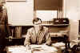“硅谷之父”是美国斯坦福大学弗雷德·特曼（F.Terman）教授。本世纪30年代初，目光远大的特曼以电气工程系教授身份出任副校长，他决心把“铁路大王”老斯坦福赠予学校的土地中划出579英亩，在旧金山附近的圣克拉拉，以帕洛阿托（Palo Alto）为中心创建一个高科技的“斯坦福研究区”——以斯坦福大学为中心，集研究、开发、生产、销售于一体的工业园区，这就是后来闻名于世的“硅谷”。

在大学传统“象牙塔”里创办企业，第一个“吃螃蟹”者是需要胆识的。特曼首先想到了他的两个学生——比尔·休利特（B.Hewllet）和戴维·帕卡德（D.Packard）。

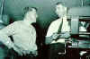出身于斯坦福医学院教师世家的休利特，与在律师家庭长大的帕卡德都是特曼教授的研究生。1934年，两人同去科罗拉多山脉进行一次为期两周的远足野营，共同志向和爱好使他们结为形影不离的挚友，保持了长达半个多世纪的友谊和伙伴关系。在特曼的鼓励和支持下， 他们开始筹划创办一家私人公司，并且在1937年8月举行第一次“正式”会议，会议议题是“创业计划的初步组织规划和工作纲要”。第二年， 已经结婚的帕卡德夫妇迁入帕洛阿托市安德森大街3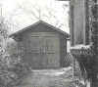76号，休利特也在附近租下一间小屋。于是，在帕卡德屋后仅有一个车位的简陋汽车库里，两人走出了创业的第一步。 他们当时仅有538元流动资金，全部“固定资产”则是：一个工作台、一部钻床、一把螺丝刀、一把电烙铁、一把钢锯和买来的若干电子零件。1939年元旦，两人正式签署合伙企业协议，用掷硬币的方式决定将谁的名字放在前。不用说，休利特赢了，合伙企业被注册为“休利特—帕卡德公司” ，简称HP公司，取自Hewllet-Packard的第一个字母，在我国则通译为惠普公司。

下一步该怎么办？又是特曼给他们出了个好主意。他建议惠普公司从制造阻容式音频振荡器入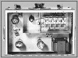手， 并安排了另一位斯坦福大学毕业生、 国际电话电报公司副总裁为他们投资500元。 帕卡德回忆说：“到那年圣诞节，我们已制造出音频振荡器产品。我们把它放在壁炉架上，给它照了像，编了一本两页的推销小册子，按照特曼提供的名单，把小册子送给大约25家可能的用户……”这是惠普公司的第一件产品，名叫HP200A，售价仅54美元。令人惊讶的是居然很快就有了订单，有人还寄来支票。恰好碰到迪斯尼乐园拍摄电影《幻想世界》急等着使用这种仪器， 他们一下就卖出8台，据说现在还有一台仍在好莱坞使用。就这样，惠普公司创业第一年站住了脚跟，但销售收入仅5369美元，利润才有微不足道的1563美元。

1940年， 惠普公司逐步扩大业务范围， 产品增加到8种，从车库搬到Page Mill大街395号一栋租用的大楼内。 公司向仅有的3名员工发放了第一笔圣诞奖金——每人5美元。1941年，珍珠港事件爆发，惠普已有了17名员工，年销售额达到10万美元；1943年，惠普为海军研究实验室开发信号发生器和雷达干扰器等产品， 率wpeD.gif (91780 字节)先进入微波设备制造领域；1945年，当应征入伍的休利特复员返回帕洛阿托，发现自己已经是这家拥有数百万资产的大型公司副总裁。 当时，惠普已经建造了自己的Redwood大楼，帕卡德告诉他，如果今后电子行业不景气，这栋大楼可以改造成食品杂货店。然而，改作食品店的危机并没有降临，相反，惠普公司一路顺风高速成长，于1947年8月18日转制为股份有限公司。 比起休利特和帕卡德来，特曼教授显得更高兴。他逢人便讲惠普崛起的“神话”，向那些可能的投资者们宣传靠近大学办企业的种种优势。“去找休利特或者帕卡特谈谈吧，有惠普在前面带路，”特曼由衷地说，“你们一定能迅速成为第二个、第三个惠普。”

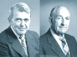特曼精心播下的种子， 不断地发芽、抽叶、开花、结果。1955年，有7家公司来硅谷办厂，1960年增加到32家，到1965年斯坦福研究园区正式建立时，这里已经集中了近70家高新技术企业， 众星捧月般簇拥着斯坦福大学；其中，惠普公司租用的土地就超过100万平方英尺。70年代后期，休利特和帕卡德还联名向斯坦福大学捐赠了一座现代化的“特曼大楼”，永远纪念他们的恩师。他们创业的那间汽车库，1989年被加利福尼亚州政府正式命名为“硅谷诞生地”，成为美国珍贵的历史文物。

从50年代至60年代，惠普公司进入到它的高速扩张时期。在休利特和帕卡德的运筹下，它不仅坚持技术创新，开发新产品，而且用一系列收购行动，把公司的触角迅速伸进电子仪器设备的诸多领域。例如，1951年，特曼教授的另一位研究生艾尔·巴利特在攻读学位的同时，替惠普公司研制出一种高速频率计数器HP524A，使测量高频所需的时间，从原来10分钟下降到2秒。巴利特带领的设计小组开发的相关产品越来越多，其销售额累计达10亿美元之巨。再例如，从1958年惠普首次收购加州一家wpe11.jpg (15876 字节)图形记录仪制造公司F. L.Moseley，跻身于绘图仪行业之后， 1961年，再次收购Sanborn公司，闯进电子医疗设备领域；1965年，它以同样的方式收购了宾夕法尼亚州F&M科技公司， 强行进入分析仪器领地。这种收购或购并行动，一直延续到90年代末：1989年，连工作站电脑的早期霸主——阿波罗计算机公司也成为惠普的“囊中之物”；1997年，为了增强公司支持电子商务的实力，惠普又将电子支付系统厂商VeriFone“收为己有”。

无论从何种意义上讲，1957年对惠普公司都是“重要转折关头的一年”（帕卡德语）。首先是这年11月，惠普股票首次上市，公司市场价值猛增至4800万美元；其次是罗马条约的签署，使惠普得以迅速开拓海外市场，在欧洲建立了办事处和生产基地。然而，这些，都不及当年另一件大事重要，它不仅确立了惠普的发展宗旨，而且也影响到电脑业界经营管理方法的变革。

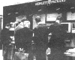旧金山以北约70公里有一家名叫索诺马（Sonoma）的旅馆，1957年初，休利特和帕卡德将20多位高级经理带到这里，举行了一次为期两天的高峰会议。帕卡德告诉大家，惠普现在已有1200多人，尽管公司发展壮大了，但仍然必须保持小公司那种亲密无间的气氛。而休利特强调指出，惠普公司的信念应该是：相信任何人都愿意努力工作，并能创造性地工作，只要赋予他们适宜的环境，他们就一定能成功。会议中，休利特和帕卡德把事前草拟的一系列公司宗旨提交给与会者讨论。 最初的宗旨共有6个（利润、顾客、业务领域、发展、职工和公民义务），其基本核心是“客户第一，重视个人，争取利润”。这些宗旨后来又经过多次修改，并围绕它们制定出各种规划和具体作法，形成了被业界赞誉为“惠普之道”（HP Way）的经营管理模式。

从汽车库里走出来的惠普再次登上新的台阶：1962年，公司首次被《财富》杂志列为全美最大500家企业名录里，虽然仅位居第460名。1964年，在纪念公司诞生20周年时，休利特正式出任总裁，帕卡德则担任了董事长；1965年，惠普的营业收入超过1650万美元，员工达到9000人。

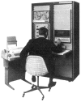然而，60年代中期的惠普还不是一家电脑公司，计算机产业是IBM和DEC公司的领地。帕卡德曾造访过DEC公司和王安电脑公司，他甚至也想到以2500万的代价买下DEC，但因种种原因没有成交。1964年，在“惠普之道”的精神感召下，两位工程师决心自己动手试制计算机。凯·马格尔比和保罗·斯托夫特向帕卡德建议说，他们可以设计一种控制器，把惠普的电子测试仪器与打印机、绘图仪连接起来，实现自动化操作。帕卡德于是委任马格  
尔比组建一个攻关小组， 于当年9月完成了惠普的第一台电子计算机HP2116，不久便发展为HP2110系列电脑产品；攻关小组的技术骨干，后来也成为该公司设在硅谷库帕蒂诺的惠普计算机分部的核心。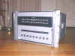

从照片上看，HP2116电脑的外形根本不象是电脑，因为它本来就是电子仪器的控制器。惠普的销售人员很快发现，许多客户仅单独购买HP2116，而不愿成套买进自动电子测量仪器。也就是说，HP2116作为单独的电脑，要比作为仪器控制器好卖得多。休利特和帕卡德终于领悟到这一信息的重要性——惠普必须跟上潮流，重新布署企业战略，以技术创新的姿态，大步跨进电脑时代。

库帕蒂诺的工程师比他们的老板想得更远，他们迅速研制出一种32位计算机原型。若立即上马这个被命名为“奥米加” 的项目，将意味着与IBM发生正面冲突。休利特审时度势后对工程师讲：“ 不要攻打一个层层设防的山头，特别是当山上的军队比你自己强大时，更不要轻举妄动。”他下令暂时取消了这一项目。但是，几位主要经理和工程师不愿意轻易放手，他们瞒着老板在密室里继续干，但把目标调整为研制16位机型。1972年，他们“私自”完成的机器，作为惠普公司第一台多功能电脑推向市场，这就是大受客户青睐的HP3000小型机。

wpe19.jpg (16042 字节)惠普公司在个人计算工具领域最大的贡献是率先研制出科学计算器。美国著名科幻作家阿瑟·克拉克写过一部《畅游2001年宇宙空间》的科幻小说。有一天，他幻想着未来电脑工程师将采用什么样的计算工具，并且画了一张草图。1968年圣诞节前夕， 有人告诉他惠普公司正在销售一种HP9100A型台式计算器。克拉克立即凑钱买了一台，他惊讶地发现，HP9100A计算器的模样居然酷似他画的那幅草图。

HP9100A台式计算器的发明者是青年工程师汤姆·奥斯本， 以前在另一公司工作时就设计出与打字机大小差不多的电子计算器。奥斯本向许多公司推荐他的发明，但没有人理睬。休利特和帕卡德一眼看出这种机器的商业前景，马上派出一个研制组与奥斯本合作。由于当时还没有大规模集成电路，HP9100A的设计异常复杂，印刷电路板就有14层之多。HP9100A完成后， 参与研制HP9100的惠普工程师接受了休利特交给的另一任务——将HP9100“缩小”到可以放进衬衫口袋中。“缩微”后的袖珍机，仍将具有计算三角函数、对数函数和双曲函数等功能。一位资深的商业营销者警告休利特说，袖珍机不会有市场，人们已经习惯了计算尺。 休利特却认为，300多年前奥却德发明的对数计算尺早就应该淘汰，他坚信人们必定会喜欢上惠普的“电子计算尺”。

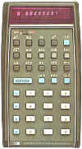休利特是对的。1972年，惠普公司宣布“掌上型”科学计算器HP35问世。这种袖珍机重255克， 有35个按键（即被命名为HP35的原因），可以快速方便完成计算尺所能做的一切运算， 售价仅395美元。三年之内，HP35大红大紫，售出30万台之多。此后，1973年惠普迅速推出第一台超小型商业计算器HP80；1974年跟着推出可编程计算器HP65；1979年研制出第一台可以显示数字和字母的计算器HP41C……这类计算器及其后代的销售总量， 现在已经超过1500万台，使传统的对数计算尺彻底退出了历史舞台。

面对滚滚而来的个人电脑浪潮，惠普公司也曾坐失良机，错过了一次领先世界的巨大机遇。众所周知，1976年乔布斯和沃兹奈克创立苹果公司前，曾四处寻找合作伙伴。身为惠普工程师的沃兹奈克首先找的就是惠普，但惠普拒绝了他们的请求，才迫使沃兹奈克卖掉自己心爱的HP计算器充当创业资本，与乔布斯共同竖起了苹果公司的大旗。惠普虽然失去了充当个人电脑旗手的机会，但他们毕竟很快就加入进来。为了保持公司的青春活力， 1977年， 休利特和帕卡德选择斯坦福大学毕业生、46岁的约翰·杨（H.Young）为公司总裁和法定继承人，并在第二年让他接任了首席执行官（CEO）。在约翰·杨任期内，惠普公司于1980年推出首台个人电脑HP85；1982年利用32位“超芯片”技术研制出HP9000计算机，并集中优势兵力，向个人电脑打印机进军。

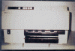80年代惠普在电脑各领域都获得巨大的成功。 早在1982年，惠普就推出它的第一台激光打印机HP2680，体积有冰箱那么大，售价超过10万美元，带头发动了打印机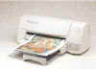更新换代的革命。1984年，它相继推出可以与个人电脑连接的喷墨打印机和激光打印机。1990年，惠普又推出售价低廉的的激光打印机 LaserJet 。HP创始人之一帕卡德自豪地称，LaserJet已是激光打印机的代名词，已被业界公认为世界标准。截至1993年，该公司的第1000万台激光打印机顺利下线，已售出的各类打印机总数则超过2000万台。

90年代初，休利特和帕卡德虽然都已退休，但他们继续参加董事会决策。1992年，当约翰·杨年满60岁时，休利特和帕卡德一致认为，应该趁他俩还健在，为公司挑选一位更年轻的“舵手”。董事会确定路维斯·普莱特（L. Platt）为最佳人选，请这位51岁的商业管理硕士接任惠普总裁和CEO。1996年3月26日，帕卡德去世，普莱特又兼任董事会主席，集三大职务于一身。 在他的指挥下，惠普成功实施多元化经营策略，保持了高速成长，不仅登上全球个人电脑厂商排行榜前三位，1998年在《财富》500家企业排行榜上也已攀升至全美第14位和全球第42位。

作为美国硅谷最大的公司，惠普之路已经走过了60余年。它不仅是重量级的电脑和相关产品企业，而且担负着测量仪器研制销售重任，在日趋激烈的竞争面前，难免顾此失彼。

1999年3月2日，普莱特宣布了一件惊人之举：惠普公司将一分为二，实施战略性的重组计划。其中，测试测量产品部、元器件部、化学分析部和医疗仪器部联合组成新的测量仪器公司；而计算机及相关部门则继续拥有“惠普”名称，重组为惠普计算及成像产品公司。从此而后，电脑业界的目光将聚焦于轻装上阵的惠普计算及成像产品公司身上。

计算与成像产品公司沿用“惠普”的名称。1999年7月17日，普莱特任命卡莉·弗瑞娜（C.Fiorina）担任新公司总裁和CEO，自己将退休离任。时年45岁的弗瑞娜，拥有MIT自然科学硕士等多项学位， 曾任朗讯（Lucent）科技公司全球服务部门总裁等职务，被《财富》杂志列为“全美商业最有能力的女人之一”。历史悠久的惠普公司上下齐心，弗瑞娜和员工们都坚信他们完全有能力谱写互联网业的第二次辉煌。

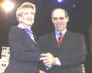2001年9月4日，IT业界再次爆出惊人消息：惠普公司以250亿美元的价格，按换股方式收购了著名电脑制造商康柏（Compaq）电脑公司。这项并购将使两家电脑、打印机和电脑伺服器巨头合二为一，从而超出目前在个人电脑行业排名第一的戴尔电脑公司。合并后的新公司总部将设在原惠普公司总部所在地——美国加利福尼亚州的帕洛阿托，由弗瑞娜担任董事会主席兼CEO，雇员多达14.5万人，将在160多个国家展开业务，与IT行业领头羊IBM公司并驾齐驱。此次收购对于弗瑞娜来说堪称一次大胆和冒险的举动，她在试图将新惠普转变成一个业务更为广泛的电脑、软件和服务供应商。

人们由理由相信，新的惠普公司将继续沿着“惠普之道”继续走下去。

相关链接[回目录](http://www.techcn.com.cn/index.php?doc-view-141753.html" \l "section)

• Edler, C [The Rise, Fall and Rise of the HP 3000](http://www.3k.com/index_papers_hp3000_history.html) - more early history.

• [HP3000 FAQ](http://www.3k.com/twiki/bin/view/TWiki/HP3000FAQ)

• [The 3000 NewsWire news blog for HP3000 news, archives](http://www.3000newswire.com/blog)

• [Bitsavers](http://bitsavers.org/pdf/hp/3000/) has PDF scans of HP 3000 hardware and software manuals - but use a mirror site.

• [Printing HP3000 MPE/iX to Windows](http://www.brooksnet.com/hp3000remoteprinting.html) printing software.

• [HP Computer Museum](http://www.hpmuseum.net/exhibit.php?class=3&acc=32) also has PDF scans of manuals.

• HP 3000 General Information Manual [Sep 79](http://hpmuseum.net/document.php?catfile=408), [Oct 1984](http://hpmuseum.net/document.php?catfile=208)

• [HP 3000 Performance (text file)](http://bitsavers.org/pdf/hp/3000/HP_3000_Performance.txt)

• ["HP SYSTEM/3000 system description" promotional material Nov 1971](http://aics-research.com/first3k.html)

• [November 19, 2001: HP Sunsets Its Proprietary e3000 Server Line](http://www.itjungle.com/tfh/tfh111901.html)

• [November 14, 2001 Hewlett-Packard phases out server line, the line will be phased out over a five-year period](http://news.com.com/Hewlett-Packard+phases+out+server+line/2100-1001_3-275842.html)

• [hp.com: HP is committed to continued support of HP e3000 installations](http://www.hp.com/products1/evolution/e3000/index.html)

• [HP e3000 transition program FAQ](http://www.hp.com/products1/evolution/e3000/faq.html)

• [Classic Genealogy and PA-RISC Systems Performance Spreadsheets](http://www.allegro.com/papers/)

参考文献[回目录](http://www.techcn.com.cn/index.php?doc-view-141753.html" \l "section)

http://en.wikipedia.org/wiki/HP_3000  
http://www.3000newswire.com/subscribers/RobelleTechMPE-02Feb.html  
http://www.cnetnews.com.cn/2001/1122/39924.shtml