**IBM 5100**

1975年，美国IBM公司推出了现代个人电脑的鼻祖--IBM 5100。在IBM推出IBM 5100的同年，比尔·盖茨和保罗·艾伦创立微软公司

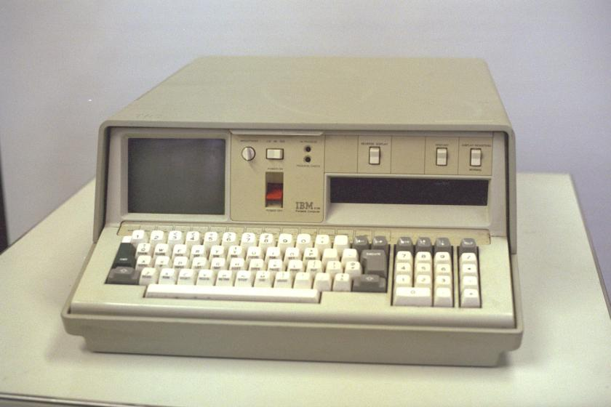

1980年时，IBM找微软开发操作系统。其实IBM早就意识到个人电脑的巨大潜在市场。早在1975年，他们就推出了IBM 5100。但是其高昂的价格（1万美金）无法被个人用户所接受。于是他们启动了一个叫“象棋”（”Project Chess”）的秘密项目，准备研发新一代个人电脑，代码为“橡子”（”Acorn”）。“橡子”后来被改名为“个人电脑”（Personal Computer/PC）。1981年8月12日，IBM PC（IBM 5150）被正式推出。不到四个月的时间，它就登上了时代杂志，被誉为年度风云人物（man of the year）。从此以后，IBM PC和它的克隆机们开始进入了家庭和企业。今天的台式机还是那时候IBM PC的延续。

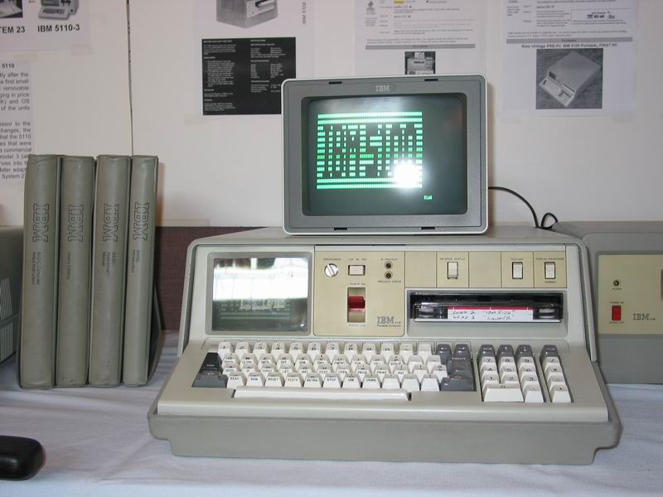

目录

• [IBM 5100主要参数](http://www.techcn.com.cn/index.php?doc-view-140237.html#1)

• [Laptop的诞生](http://www.techcn.com.cn/index.php?doc-view-140237.html#3)

• [主要资料](http://www.techcn.com.cn/index.php?doc-view-140237.html#5)

• [IBM PC早期开拓史](http://www.techcn.com.cn/index.php?doc-view-140237.html#7)

* • [参考文献](http://www.techcn.com.cn/index.php?doc-view-140237.html#9)

IBM 5100主要参数[回目录](http://www.techcn.com.cn/index.php?doc-view-140237.html" \l "section)

IBM 5100 Manufacturer IBM

Type Professional Computer   
Release date September 1975 (1975-09)   
Introductory price From $8975 (BASIC with 16KB) to $19,975 (BASIC+APL with 64KB)   
Discontinued 1978   
CPU IBM PALM processor clocked at 1.9MHz   
Memory 16KB to 64KB RAM (with 16KB iterations), 32KB to 64KB ROM   
Input Keyboard   
Weight 24 kg   
Successor IBM 5110

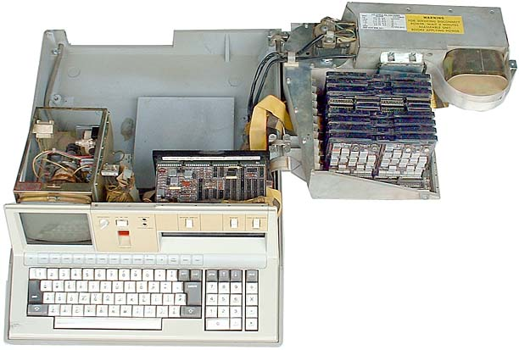

|  |  |
| --- | --- |
| Key Dates: | Announced September 9, 1975 (Just eight months after the Altair 8800) |
| Original Price: | $8975 to $19,975 depending on memory (16K, 32K, 48K or 64K) and language (APL, BASIC, or both) options Companion printer IBM 5103, $3675 (132-column dot matrix, 80 characters per second) Auxiliary tape drive IBM 5106, $2300 |
| CPU: | IBM circuit module |
| Memory: | 16K-64K |
| Operating System: | BASIC and/or APL |
| Input/Output: | Built-in 5" monochrome monitor with 16-line by 64-character display; built-in tape drive with 204KB capacity; proprietary printer connection for 5103 printer and 5106 auxiliary tape drive |
| Bus: | N/A |
| Other Items in Collection: | Numerous tapes, documentation, IBM 5103 printer |
| Items Needed: | IBM 5106 auxiliary tape drive |

|  |  |
| --- | --- |
| http://www.techcn.com.cn/uploads/201001/12633158434ZkbsPb8.gif | http://www.techcn.com.cn/uploads/201001/1263315843zBLsTEwR.gif |

|  |  |
| --- | --- |
| **NAME** | M18 series |
| **MANUFACTURER** | Ice-Felix |
| **TYPE** | Professional Computer |
| **ORIGIN** | Romania |
| **YEAR** | 1975 |
| **END OF PRODUCTION** | 1981 |
| **BUILT IN LANGUAGE** | None |
| **KEYBOARD** | Depending on the video terminal used |
| **CPU** | East Europ閍n version of the Intel 8080 |
| **SPEED** | Unknown |
| **RAM** | 64 KB |
| **ROM** | Unknown |
| **TEXT MODES** | Depending on the video terminal used, mostly 80 x 25 |
| **GRAPHIC MODES** | None |
| **COLORS** | Monochrome |
| **SOUND** | Unknown |
| **I/O PORTS** | Parallel and Seriel |
| **BUILT IN MEDIA** | Magnetic tapes or punch cards |
| **OS** | M18-ROS and enhanced versions, later CP/M |
| **PERIPHERALS** | Serial printer, paper tape and card reader-puncher, magnetic tape drive, |
| **PRICE** | Unknown |

Laptop的诞生[回目录](http://www.techcn.com.cn/index.php?doc-view-140237.html" \l "section)

在很多人心里，IBM公司1975年发布的IBM 5100才应该是最早的便携式计算机。IBM 5100的出现甚至比PC机还早了五年。

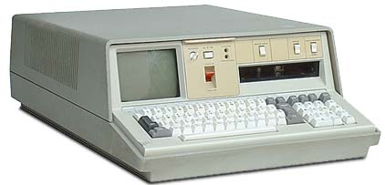

IBM 5100虽然重达五十磅，但就在它诞生的六七年前,同样64KB存储, 内置磁带驱动器，可外接打印机的一台电脑则要重达一千磅。

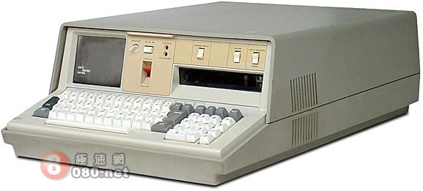

在当时，电脑的选择非常少，能和5100媲美的更是罕见。这是台功能齐备的系统－－内置显示器，键盘和数据存储器。最高配置价格达到近两万美元。它是专门为专家设计用来解决科学计算问题，而不是像今天这样为商业用户和所有爱好者准备的。

|  |  |  |  |  |  |  |  |  |  |  |  |  |  |  |  |  |  |  |  |  |  |  |  |  |  |
| --- | --- | --- | --- | --- | --- | --- | --- | --- | --- | --- | --- | --- | --- | --- | --- | --- | --- | --- | --- | --- | --- | --- | --- | --- | --- |
| 当年IBM 5100一共有12个不同型号可选。价格都相当昂贵   |  |  |  |  | | --- | --- | --- | --- | | 存储器 | 编程语言 | | | |  | APL | BASIC | Both | | 16K | A1 - $8,975 | B1 - $9,975 | C1 - $10,975 | | 32K | A2 - $11,975 | B2 - $12,975 | C2 - $13,975 | | 48K | A3 - $14,975 | B3 - $15,975 | C3 - $16,975 | | 64K | A4 - $17,975 | B4 - $18,975 | C4 - $19,975 | | http://www.techcn.com.cn/uploads/200912/1261973801ol4aD3Pz.jpg |

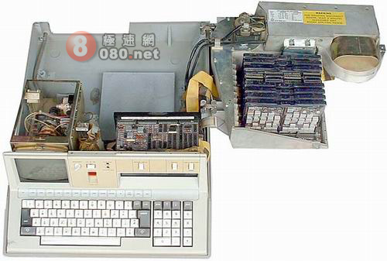

5100侧面有铰链，可以方便的打开安装各种系统组件

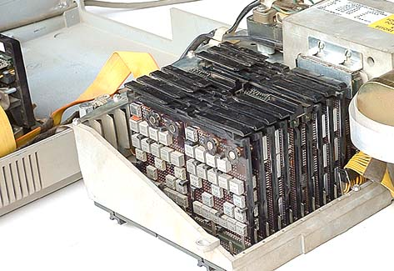

5100的电路板上基本都是IBM专用的银色金属集成电路芯片

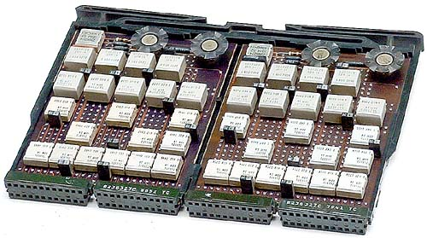

5100内部不是和现在计算机一样的单独中央处理器。下面的电路板就是它的“处理器”－－总共十五个巨大芯片

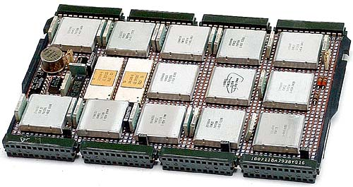

|  |
| --- |
| • http://www.techcn.com.cn/uploads/200912/1261973801P9wXFteJ.jpg  IBM 5100计算机芯片组广告  “存储多达48,000比特信息，小巧依然，可以放进缝衣针眼” |

早期的IBM 5100使用的是不可复写的磁带驱动器，后期型号采用了外置的八英寸软驱。后来发布的5120用上了内置软驱。

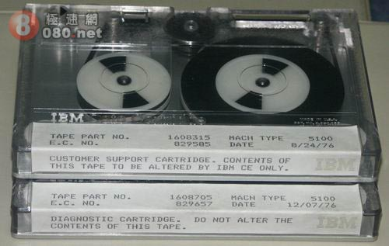

我们找到了一组IBM 5100计算机官方宣传图片，一起来看看吧

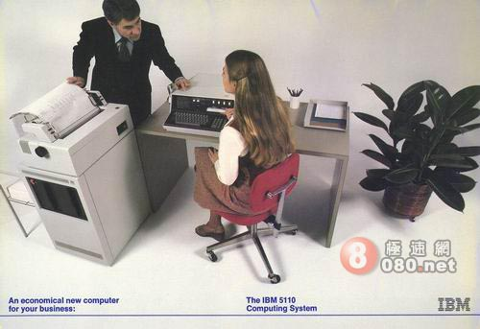

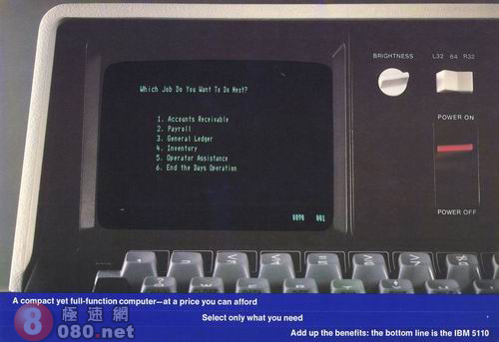

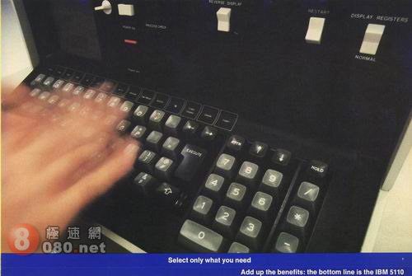

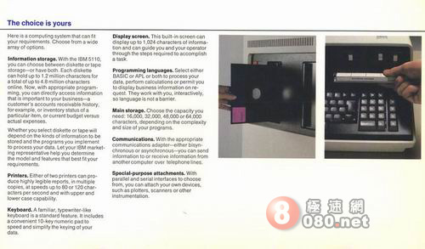

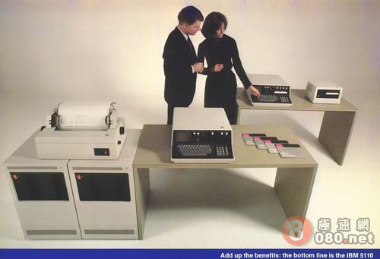

在1975年它可是顶级产品哦！！

主要资料[回目录](http://www.techcn.com.cn/index.php?doc-view-140237.html" \l "section)

IBM Portable PC

|  |  |
| --- | --- |
| **Model:** | 5100 |
| **Introduced:** | September, 1975 |
| **Price:** | US $19,975 w/ 64K RAM |
| **Weight:** | 55 pounds |
| **CPU:** | IBM proprietary, 1.9MHz |
| **RAM:** | 16K, 64K max |
| **Display:** | 5" monochrome monitor |
|  | 64 X 16 text |
| **Storage:** | Internal 200K tape (DC300) |
| **Ports:** | tape / printer I/O port |
| **OS:** | APL and/or BASIC |
| **Serial #:** | |  |  | | --- | --- | | BASIC: | 10-11503 | | APL: | 10-13616 | |

|  |
| --- |
| http://www.techcn.com.cn/uploads/200912/1261974256uzpoYoC4.jpg |

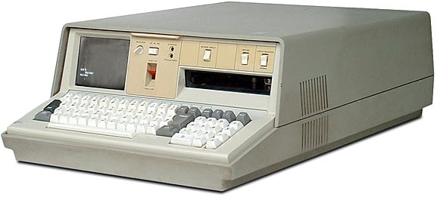

The Model 5100 is IBM's first microcomputer, i.e. not a mainframe, and is also considered the world's first portable computer. Although at 55-pounds, it might best be described as "self-contained" rather than "portable".   
  
There were very few other computers available at the time, and nothing even close to the capabilities of the 5100. It is a very complete system - with a built-in monitor, keyboard, and data storage. It was also very expensive - up to US$20,000. It was specifically designed for professional and scientific problem-solvers, not business users or hobbyists.

|  |  |  |  |  |  |  |  |  |  |  |  |  |  |  |  |  |  |  |  |  |  |  |  |  |  |
| --- | --- | --- | --- | --- | --- | --- | --- | --- | --- | --- | --- | --- | --- | --- | --- | --- | --- | --- | --- | --- | --- | --- | --- | --- | --- |
| There are twelve different models of the 5100.  They were all rather expensive:   |  |  |  |  | | --- | --- | --- | --- | | Memory | Programming language | | | |  | APL | BASIC | Both | | 16K | A1 - $8,975 | B1 - $9,975 | C1 - $10,975 | | 32K | A2 - $11,975 | B2 - $12,975 | C2 - $13,975 | | 48K | A3 - $14,975 | B3 - $15,975 | C3 - $16,975 | | 64K | A4 - $17,975 | B4 - $18,975 | C4 - $19,975 | | http://www.techcn.com.cn/uploads/200912/1261974256dDv9vtk8.jpg |

Apparently, APL was a difficult task for IBM to accomplish with an interpreter in the 5100, so instead they wrote an emulation program so that the S/360 mainframe version of APL could be run instead -- The 5100 is like a desktop IBM S/360 mainframe computer which only runs APL.   
  
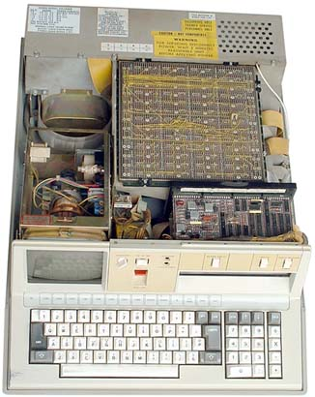Opening the 5100, you encounter an upside-down circuit board with thousands of sharp wires sticking straight up.   
  
What are they? This is the bottom of the backplane in which all of the circuit board plug into.   
  
Some jumpers can also be installed here for different configuration options.   
  
As seen below, it swings open on hinges to allow access the circuit boards, and for easy access to all of the other system components.   
  
  
In 1978, IBM 5100 was superseded by the [IBM 5110](http://oldcomputers.net/ibm5110.html) line of computers.   


  
Most of the circuit boards have unusual IBM proprietary silver-colored metal integrated circuit (IC) chips.   
  


There isn't a discrete CPU (Central Processing Unit) as in modern computers, the circuit board seen below is the "processor" - it has over 15 large chips.



|  |
| --- |
| http://www.techcn.com.cn/uploads/200912/1261974256vW6yjfKr.jpg  Caption: "HAYSTACK IN THE NEEDLE - This computer chip contains 48,000 separate bits of information, yet it fits inside the eye of a common sewing needle.   Such chips made possible IBM's new, 50-pound portable computer which can be carried to the business problems it was designed to solve." |

IBM PC早期开拓史[回目录](http://www.techcn.com.cn/index.php?doc-view-140237.html" \l "section)

       虽然它不是第一台PC，但1981年的IBM PC却触发了上世纪80年代初的个人电脑革命。IBM其实早在1973年已经开始了所谓的“特别电脑”计划APL Machine Portable (SCAMP)，其后陆续推出多种类似产品，直至1981年的IBM 5150推出时定名为IBM PC。

 　　根据文献显示，IBM 5150的设计脱离了正常流程，这是为了一洗IBM 5100的颓风，更好地对抗当时红透半边天的Apple II。IBM专门安排了一支团队进行所谓的“象棋计划”，抛弃一切的繁文缛节，全速开工，目的只为尽快将后继产品推出市场。

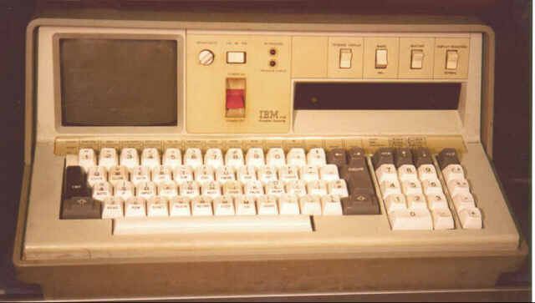

　　IBM 5150有多成功？他们本来预计其五年的销量是24万台左右，但结果是一个月的销量已经达到这个数字了！

　　根据IBM官方表示，IBM PC是首台使用通用组件的个人电脑，没想到随着首台IBM PC克隆产品的出现，这也成了缠绕他们多年的恶灵。

　　到80年代中期，克隆PC逐渐开始蚕食先行者IBM的市场份额。因为IBM PC使用的是随处可得的配件，其它厂商很容易就可以生产出自己的产品及反编译BIOS文件。1983年，Compaq推出首台IBM PC克隆产品并马上成为热门产品。

　　IBM当时可能其实是想让其产品更加专利化的，IBM内部一直有人主张推动硬件产品专利以防止被随意复制。可惜IBM的律师太无能，输掉了对Compaq的官司，从前打开了克隆大潮的闸门，什么人都可以生产兼容PC了。

　　今天，23年过去了，IBM以17.5亿美元的价格将其令人尊敬的PC业务出售给了中国的联想集团。要说这对PC市场将带来何种影响还为时尚早，尽管如此，毫无疑问的是IBM的个人电脑历史已经到了尽头。现在让我们最后回顾一下IBM PC短短的二十多年历史里一些光辉的时刻吧：

　　1973　首次官方展示APL Machine Portable (SCAMP)的原型－IBM 5100的先驱　  
　  
　　1975　九月正式宣布IBM 5100“便携式计算机”售价8975-19975美元，使用盒式磁带机，重量是当时已算十分“苗条”的50磅。该系统主要为工程师，分析员和统计学家设计

　　1977　世界第一台Apple II电脑于6月5日开始发售，处理器为1MHz和4KB内存

　　1978　根据IBM 5100扩充而成的IBM 5110于1月推出，企业可以用之进行销售数字分析、调节资源、实现总分类帐等其它财务工作的自动化。主内存大小在16KB-64KB之间，配备一个1024字节的显示屏

　　1980　IBM Displaywriter（剧作家）于六月推出，这是一种售价为7895美元的“低价”台式字处理系统。系统包括一台显示器、键盘、打印机和可以存储100页文本的存储设备。用户还可以以26185美元的代价升级成一台具有三显示器，具有纸处理系统的高速打印机

　　1981　微软用一种至今仍有争议的方式授权MS-DOS操作系统给IBM未来的PC使用

　　1981　在IBM 5150 PC发布前一个月，IBM推出了System/23 Datamaster这种同时具有文字和数据处理功能的机器。这种具有4.4MB磁盘存储空间，售价9830美元的系统销售对象是小型商业、企业单位

　　1981　8月12日推出该公司为世人所熟知的首台IBM PC。这台售价3000美元的IBM 5150的心脏是Intel的4.77MHz的8088处理器，16KB内存（可升级至256KB），捆绑微软的BASIC以及后来被称为PC的“杀手级应用”的VisiCalc电算表软件

　　1983　Compaq推出首台IBM PC兼容机

　　1984　IBM首台面向普通家庭的PC Jr.发布，仍然使用Intel的8088芯片，价格为669美元

　　1986　世界首台RISC架构的工作站PC/RT发布，具有1MB内存和40MB硬盘

　　1986　四月推出首台膝上型电脑IBM PC Convertible（ThinkPad的前身），取代了1984年2月推出的手提箱大小的IBM Portable。

参考文献[回目录](http://www.techcn.com.cn/index.php?doc-view-140237.html" \l "section)

<http://oldcomputers.net/ibm5100.html>  
<http://en.wikipedia.org/wiki/IBM_5100>  
http://www.old-computers.com/museum/computer.asp?st=1&c=1021