**The Digital Equipment Corporation PDP-10**

The Digital Equipment Corporation PDP-10 (1964-1983) is one of the most influential computers in history in more ways than can be listed here. It was the foundation of the DECsystem-10 and the DECSYSTEM-20 and ran a variety of operating systems including TOPS-10, ITS, WAITS, TYMCOM-X, TENEX, and TOPS-20. It was the first widely used timesharing system. It was the basis of the ARPANET (now Internet). It was the platform upon which many of today's popular applications were first developed including EMACS, TeX, ISPELL (the first spell-checker), and Kermit. TOPS-10 (Timesharing OPerating System-10) preceded TOPS-20 by many years (TOPS-10 circa 1964; TOPS-20 circa 1976). Its command language is familiar to anybody who has used RT-11, CP/M, or DOS, all of which were based on it. TOPS-10 supported interactive timesharing, batch processing, and realtime applications simultaneously — a difficult mix to accommodate, even today.

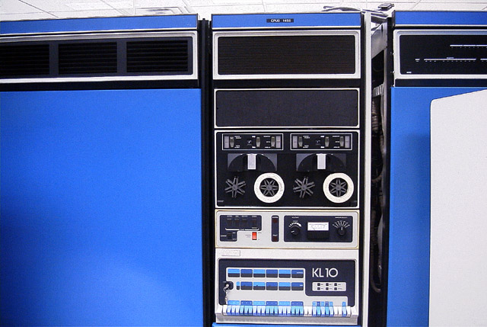

DECsystem-1090 KL10-DA #1456, originally owned by Sikorsky Aircraft Corporation, now at the The Retro-Computing Society of RI. Other PDP-10 models include the original KA10, the KI10, and the KS10. Unlike the relatively featureless DECSYSTEM-20, the -10 featured DECtapes (center), dials and gauges, and a visible control panel with lights and switches. Memory is in separate cabinets with lights across the top (right).

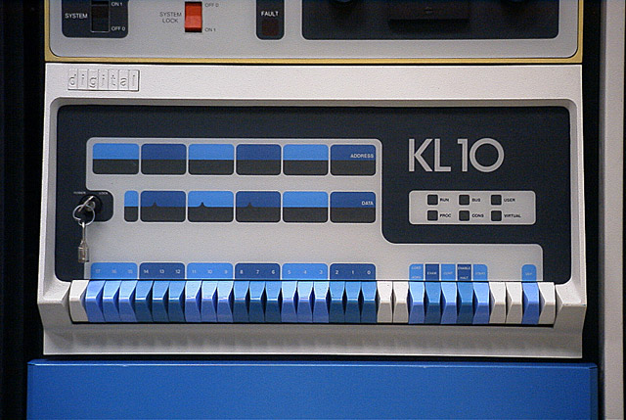

The front panel is actually a separate computer, a PDP-11/40, that acts as a communications front end for the -10 (the large DEC-20s used the same front end, but kept it hidden from view).

The 1090 shown above is quite massive, including about 10 full-size cabinets (CPU, channels, memory, communications, and 9-track tape), plus three [RP06](http://www.columbia.edu/cu/computinghistory/rp06.html) disk drives, an RP07 disk drive, a card reader, and a line printer, weighing approximately 12500 pounds all together, over six tons.

*Photos:* [The Retro-Computing Society of RI](http://www.rcsri.org/), August 2001. For a large perspective view of the KL10 CPU and memory cabinet string, [CLICK HERE](http://www.columbia.edu/cu/computinghistory/kl10-4.html). For a large view of the disk and tape drives, [CLICK HERE](http://www.columbia.edu/cu/computinghistory/kl10-5.html).

[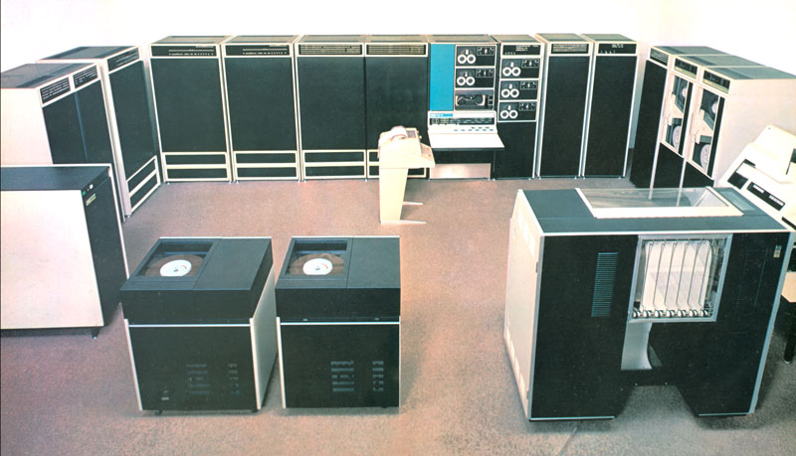](http://www.columbia.edu/cu/computinghistory/ka10.jpg)

This is the older and first PDP-10 model, a KA10 in a large configuration (click image or maximize browser to enlarge): disk drives and printer in the foreground, CPU and DECtapes right center, memory cabinets to its left and a swapping disk and controller to their left, then data channels and 9-track tapes to its right. Sitting on the floor near the KA10 control panel: the [Teletype](http://www.columbia.edu/cu/computinghistory/teletype.html) console. Just above the control panel and below the bottom DECtape drive is a paper-tape reader/punch. Photo: from a DECsystem-10 sales brochure, courtesy of Michael Thompson, [Retro-Computing Society of RI](http://www.rcsri.org/).

[CLICK HERE](http://www.columbia.edu/cu/computinghistory/pdp10-ad.html) to see a 1969 PDP-10 advertisement with a picture of a small KA10 configuration (2.4MB).

**LINKS**

*(January-Aug 2001)* Caution: Links go stale faster than anybody can keep up with.

TS10: Tim Stark's PDP-10 emulator (First released 7 March 2001):

<ftp://ftp.trailing-edge.com/pub/ts10/> (FTP)

<http://www.sourceforge.net/projects/ts10> (CVS)

Daniel Seagraves / Hans Pufal's PDP-10 emulator (in progress):

<ftp://aconit.org/pub/dec-10/>

Bob Supnik's SIMH PDP-1/4/7/8/9/10/11/15 emulator:

<http://www.tiac.net/users/mps/retro/index.html>

Miscellaneous PDP-10 emulators in various stages of development:

<http://www.tmk.com/ftp/decus-sig-tapes/vlt00a/vmslt00a/pdp10/>

Dan Murphy's TENEX and TOPS-20 Papers

<http://www.opost.com/dlm/tenex/index.html>

[Les Earnest: SAIL Away](http://www.opost.com/dlm/tenex/index.html)

<http://www.stanford.edu/~learnest/sailaway.htm>

DECsystem-10 Kermit:

[The PDP-10 Kermit webpage](http://www.columbia.edu/kermit/pdp10.html)

DECSYSTEM-20 Kermit:

[The PDP-10 Kermit webpage](http://www.columbia.edu/kermit/pdp10.html#dec20)

Tim Shoppa's PDP-10 Software Archive:

<http://pdp-10.trailing-edge.com/>

Joe Smith's 36 bits forever!:

<http://www.inwap.com/pdp10/>

The PDP-10 newsgroup:

<news:alt.sys.pdp10>

The Kermit newsgroup:

<news:comp.protocols.kermit.misc>  
[Archives](ftp://kermit.columbia.edu/kermit/newsgroups/) (1994-present)   
[On Google](http://groups.google.com/groups?hl=en&lr=&ie=UTF-8&group=comp.protocols.kermit.misc)

The Info-Kermit Digest

[Info-Kermit Digest Archives](http://www.columbia.edu/cu/computinghistory/infokermit.html) (1983-1995)

Paul Allen's PDP Planet:

<http://www.pdpplanet.com>

The Retro-Computing Society of Rhode Island:

<http://www.rcsri.org/>