**Sol-20**

Sol-20

The Sol Computer was developed by Bob Marsh, Lee Felsenstein and Gordon French. Bob founded his company, Processor Technology, in April 1975 making 4K RAM memory boards for the Altair (cause MITS couldn't make a working memory board)   
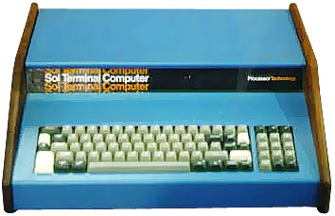In June 1975, Bob and Les Solomon (technical editor of Popular Electronics) dreamed up the Sol-20 computer, Bob had a bunch of cheap walnut that he originally intented to use in a digital clock, he didn't want it to go to waste and used it in the Sol-20 (see picture).   
  
About 10,000 of them were produced, some as kits, some as pre-builts. Based on the Intel 8080 microprocessor, this machine occupies a special niche in computer history for technical and esthetic reasons. It was one of the earliest to include a keyboard interface and support circuitry for full implementation of every 8080 function. It was a pioneer towards modern video output boards by having a design that actually put up alphanumeric characters on the screen, using a form of distributed processing that didn't lean on the CPU for all processing.   
  
There were several models of the SOL-20 system :

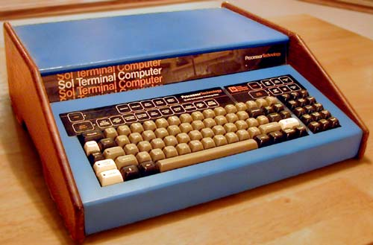

- The SOL System I ($1649 in kit or $2129 assembled), with SOL Operating System, 8 KB RAM, a 12" TV/Monitor, and a cassette recorder with BASIC software tape.   
  
- The SOL System II ($1883 in kit or $2283 assembled), is a SOL System I with 16 KB.   
  
- The SOL System III ($4750 in kit or $5450 assembled), is a system II with 32 KB RAM, a video monitor, the HELIOS II Disk Memory System and a DISK BASIC floppy.

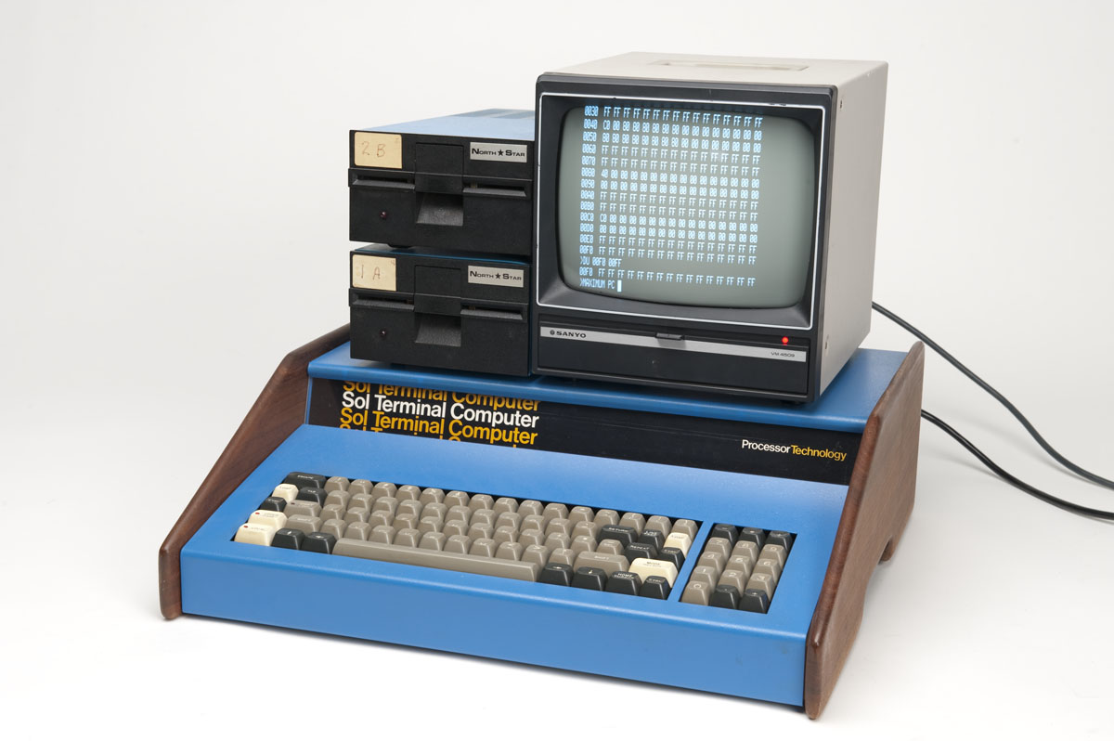

1976年出现的Sol-20，强调了微型计算机之间的连接。从外形来看，的确很有创意

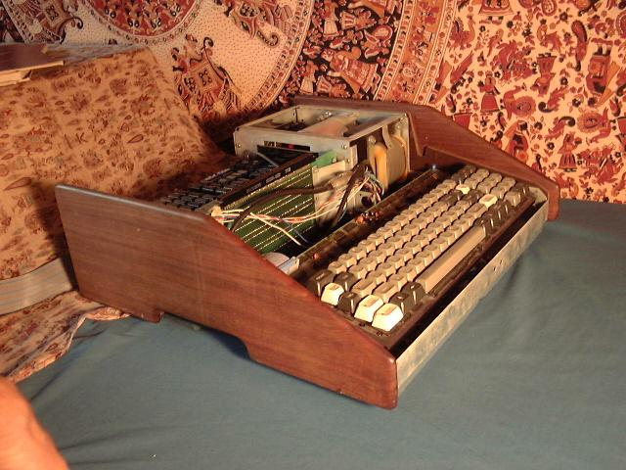

这是基于8080芯片的计算机Processor Technology Sol-20

目录

• [主要指标](http://www.techcn.com.cn/index.php?doc-view-140239.html#1)

• [介绍](http://www.techcn.com.cn/index.php?doc-view-140239.html#3)

• [参考文献](http://www.techcn.com.cn/index.php?doc-view-140239.html#5)

主要指标[回目录](http://www.techcn.com.cn/index.php?doc-view-140239.html" \l "section)

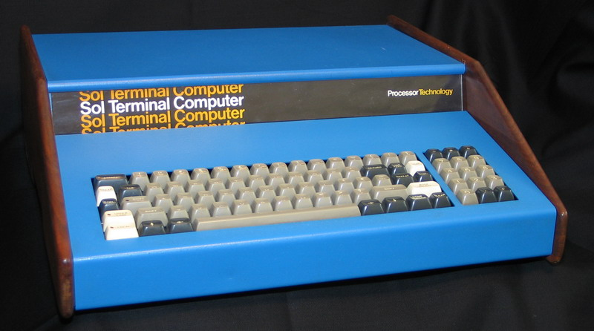

|  |  |  |  |  |  |  |  |  |  |  |  |  |  |  |  |  |  |  |  |  |  |  |  |  |  |  |  |  |  |  |  |  |  |  |  |  |  |  |  |  |  |
| --- | --- | --- | --- | --- | --- | --- | --- | --- | --- | --- | --- | --- | --- | --- | --- | --- | --- | --- | --- | --- | --- | --- | --- | --- | --- | --- | --- | --- | --- | --- | --- | --- | --- | --- | --- | --- | --- | --- | --- | --- | --- |
| |  |  |  | | --- | --- | --- | |  |  |  |  |  |  | | --- | --- | | **NAME** | SOL - 10 / 20 | | **MANUFACTURER** | Processor Technology Corp | | **TYPE** | Professional Computer | | **ORIGIN** | U.S.A. | | **YEAR** | End of 1976 | | **BUILT IN LANGUAGE** | Unknown | | **KEYBOARD** | QWERTY full-stroke keyboard | | **CPU** | Intel 8080A | | **RAM** | 8k, 16k or 32k (up to 48 KB) | | **VRAM** | 1 KB | | **ROM** | 1 KB | | **TEXT MODES** | 64 x 16 | | **GRAPHIC MODES** | None | | **COLORS** | Unknown | | **SOUND** | Unknown | | **I/O PORTS** | RS 232, cassette, S100 Bus | | **OS** | CONSOL OS | | **POWER SUPPLY** | Unknown | | **PRICE** | Unknown | |

介绍[回目录](http://www.techcn.com.cn/index.php?doc-view-140239.html" \l "section)

Named for "The wisdom of Solomon", or possibly Popular Electronics magazine editor Les Solomon, since the Sol-20 made its first appearance on the cover of that magazine.

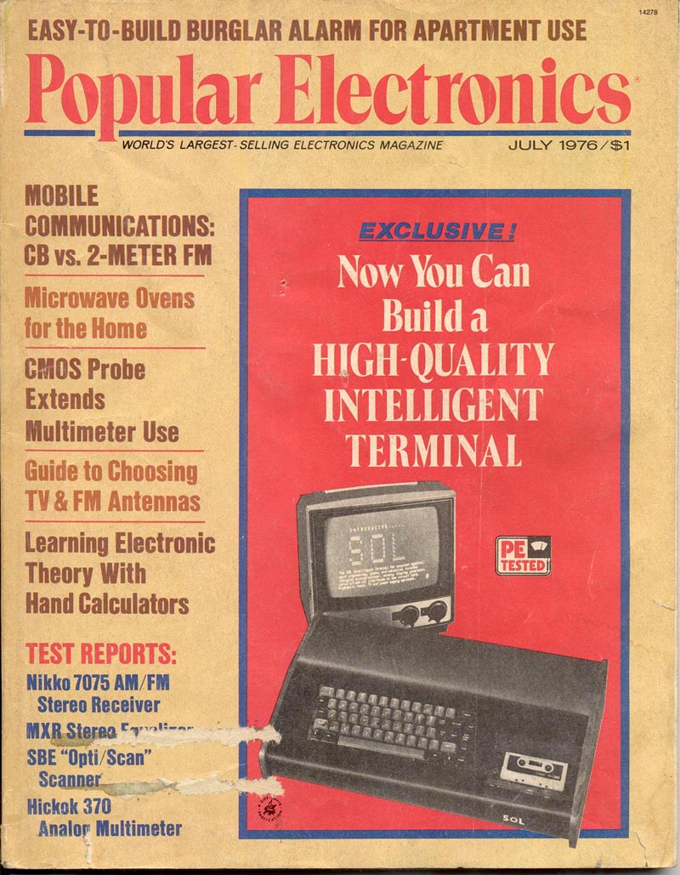

Electronics Engineer and "Home Brew Computer Club" president Lee Felsenstein designed the Sol-20, as well as the famous Osborne 1 computer five years later.   
  
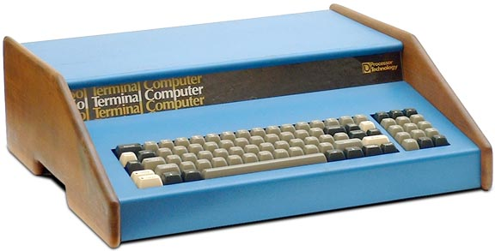  
  
Like many other computers, the Sol-20 was envisioned as something other than what it became. Originally designed as a simple terminal to communicate with other devices, it evolved into a full-fledged S-100 based computer.

From this came the Sol-10 and Sol-20. They both have the Sol-PC as the motherboard, but include a case, keyboard and power supply. The '10' lacks the vertical expansion backplane of the '20', as seen below, and the '10' also has a simpler keyboard, a smaller power supply, and cost about $200 less. Actually, very few, if any, Sol-10 computer were sold, but advertisements and articles from 1977 do mention it.   
  
As one of the first personal computers with an built-in keyboard, the Sol-20 is very stylish, with a blue metal case and actual walnut side panels. Not many commercially available computer have wooden components! (Update: Both the NorthStar Horizon and Ohio Scientific C2-4P also have wooden parts)

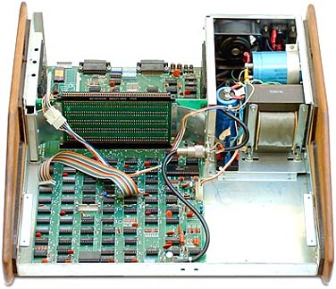  
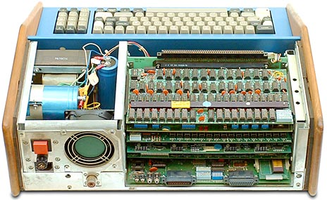

The expansion cards in the Sol-20 fit horizontally, but are very tight - some cards have to be removed two at a time because the components on one cards will hit those of an adjacent cards during removal. Why didn't they make the system taller with more room? Apparently the wood side panels determined the system size - the panels were only (cheaply) available in these dimensions.   
  
About 10,000 (mostly Sol-20s) were sold - approximately 5,000 kits and 5,000 assembled units. The kits were half the price, but risky to assemble - it might not ever work, and you won't get your money back.

Like all early computer systems, data storage was usually on cassette tape drives, since they were cheap and abundant - the Sol even has the cassette interface built-in. But tapes are very slow and often fail to save or load the data properly.   
  
Enter the Helios II Disk Memory System, the giant dual 8-inch floppy drive system for the Sol-20. Also available as a kit or fully assembled (it was an interesting time...), the Helios II cost $1895 (kit) or $2295 assembled.

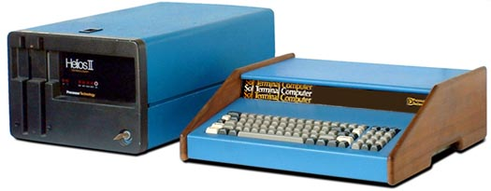

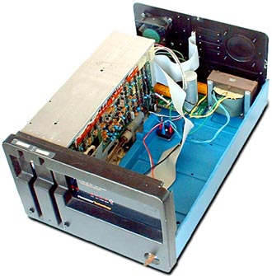The Helios II is built around the Persci 8-inch dual drive, and can store 384K of data per disk. This drive has to be the most unique drive in existance:

• There is just one motor which spins both floppy disks simultaneously.

• There is a single linear positioning servo which moves the heads for both drives at the same time.

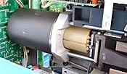

• The hub and head can be electro-mechanically disengaged from one floppy disk independently of the other.

• The floppy disks are electro-mechanically ejected - use the push button to request the disk to be returned to you.

• Data can be copied from one disk to the other without utilizing the host computer's processor.   
In effect, you have two drives for a lower price.   
Unfortunately, due to the complexity, the Helios II Disk Memory Systems is unreliable and requires periodic re-calibration.   
  
Why is there so much empty space inside the Helios II? If you have the Helios II **model 4**, there are **two** dual-drives for a total of **four** floppy drives.

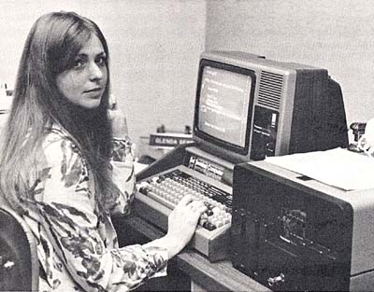



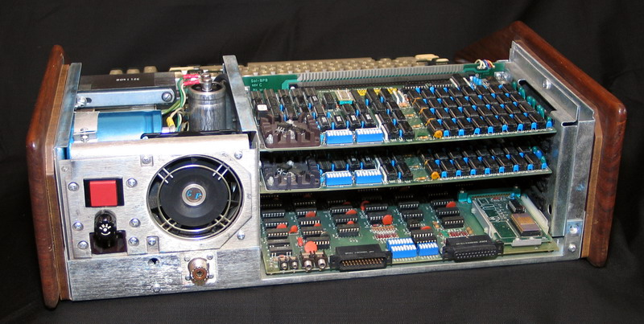

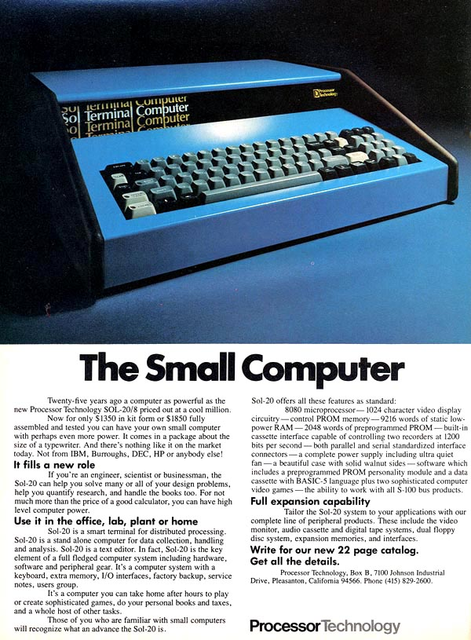

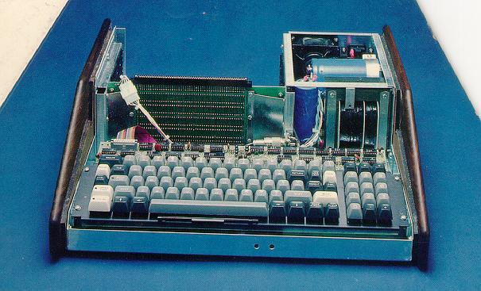



参考文献[回目录](http://www.techcn.com.cn/index.php?doc-view-140239.html" \l "section)

<http://www.digibarn.com/collections/systems/sol-20/>  
<http://oldcomputers.net/sol-20.html>  
http://www.sol20.org/